GBI Air Quality Monitor IoT Platform – Detailed Operational Workflows
This document outlines the step-by-step operational workflows and data lifecycles that power the GBI Air Quality Monitoring platform. It is designed to guide non-technical stakeholders through end-to-end user journeys while providing precise execution steps for backend engineers, frontend developers, and system administrators.
________________________________________________________________

1. Document Overview & Purpose
An enterprise IoT platform is a living system where millions of data points move continuously between hardware, message brokers, processing clusters, and browser screens. This document breaks down that continuous activity into seven core operational workflows:
1. End-to-End Telemetry Ingestion Pipeline: From physical air sampling to live browser visualization.
2. Automated Alerting & Notification Lifecycle: How safety breaches trigger instant mobile alerts and warning emails.
3. Asynchronous Branded Report Generation: Step-by-step execution of custom PDF and CSV report downloads.
4. Hardware Onboarding & Lifecycle Management: How devices are registered, assigned, monitored, and decommissioned.
5. Secure Authentication & Session Governance: How users log in, manage tokens, and how admins enforce bans.
6. Premium Monetization & Subscription Upgrade Flow: The journey from a free account to unlocked premium capabilities.
7. Stateless Device Heartbeat & Liveness Evaluation: How the system automatedly detects when hardware loses power.
[CODE]
+-------------------------------------------------------------------------------+
| GBI AIR QUALITY PLATFORM WORKFLOWS |
+-------------------------------------------------------------------------------+
| [Hardware Edge] ---> [Ingestion Plane] ---> [Processing API] ---> [Client UI]|
| | | | |
| (Air Sampling) (Shared MQTT) (Atomic Postgres) (Glassmorphic)|
+-------------------------------------------------------------------------------+
________________________________________________________________

2. End-to-End Telemetry Ingestion Pipeline
This workflow describes the exact journey of a single environmental reading as it travels from physical hardware in a living room to a user's web dashboard across the globe.
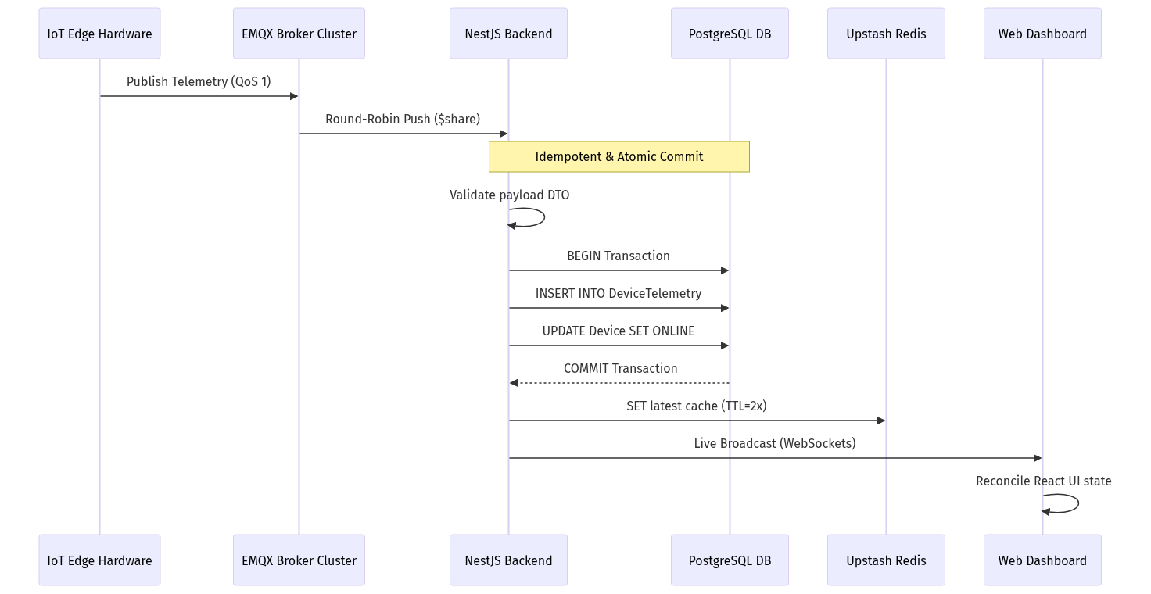

Step-by-Step Execution
1. Hardware Sampling & Packet Creation: The IoT hardware samples physical air sensors (PM2.5, CO2, VOCs, Temperature, Humidity). It constructs a JSON packet containing a unique cryptographic messageId and current timestamp.
2. Secure MQTT Publication: The hardware connects over SSL/TLS (port 8883) to the EMQX Broker Cluster and publishes the packet to topic telemetry/GBI-DEV-001 using Quality of Service 1 (guaranteeing delivery).
3. Shared Subscription Round-Robin: The EMQX broker catches the packet. Because our backend nodes subscribe using a shared queue ($share/gbi_backend/telemetry), EMQX routes this exact packet to exactly one active NestJS backend server, ensuring optimal load distribution.
4. Idempotent Transactional Ingestion:
- The backend MqttConsumer receives the packet and runs strict DTO validation.
- It attempts to insert the telemetry and update the parent device's status and lastHeartbeatAt inside an atomic prisma.$transaction.
- Duplicate Shield: If network lag caused the broker to redeliver the packet, PostgreSQL's composite unique index ([deviceId, messageId, timestamp]) triggers a P2002 error. The consumer catches this, silently drops the duplicate, and halts further execution.
5. Real-Time State Serialization: Once the transaction commits successfully, the backend serializes the exact JSON payload and stores it in Redis under key device:GBI-DEV-001:latest with a dynamic TTL set to twice the offline cutoff window.
6. Live Dashboard Broadcast: Simultaneously, the RealtimeModule pushes the telemetry packet over WebSockets or Server-Sent Events (SSE) directly to the authenticated user's open dashboard.
7. Client UI Reconciliation: The Next.js dashboard receives the live socket packet. React reconciles the state, triggering subtle micro-animations on the memoized metric cards (e.g., updating a rising CO2 trend arrow) without causing full-page re-renders.
________________________________________________________________

3. Automated Alerting & Notification Lifecycle
When a sensor detects that air quality has crossed safe operating boundaries (e.g., CO2 rising above 1,500 ppm in a conference room), the system executes an automated safety protocol.
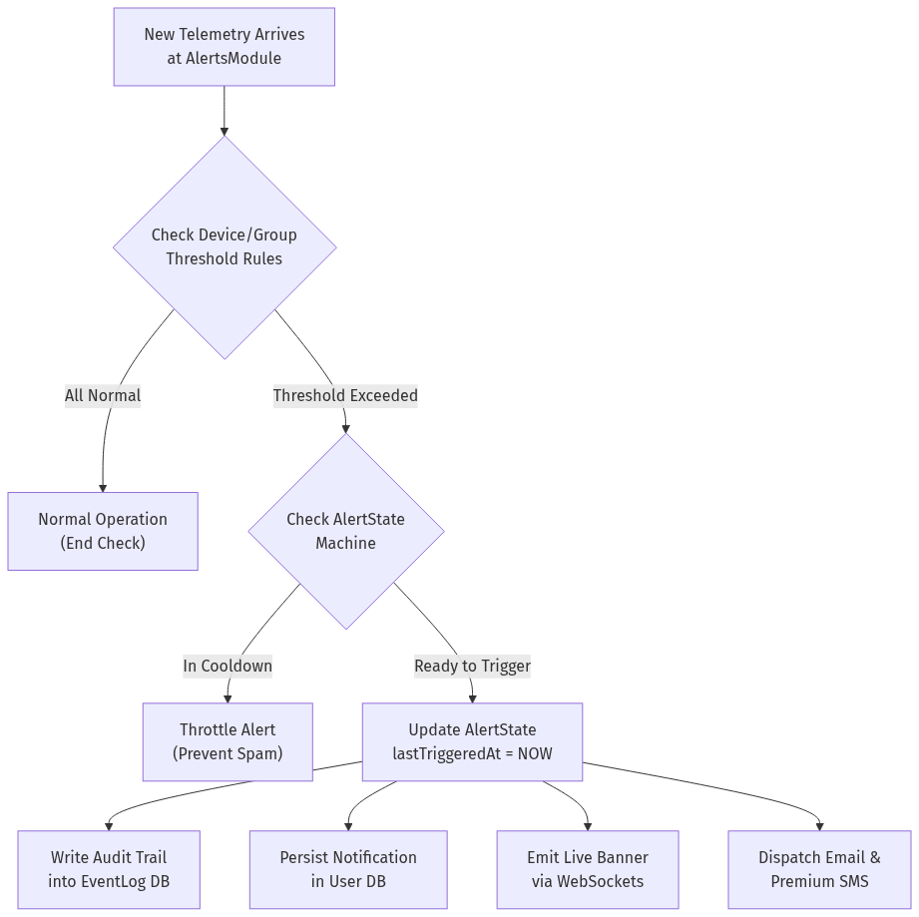

Step-by-Step Execution
1. Trigger Evaluation: Incoming telemetry is passed directly to the AlertsModule. The engine fetches the user's customized JSON threshold schemas (DeviceThreshold or GroupThreshold).
2. Rule Comparison: The module compares current metrics against configured condition operators (e.g., co2 > 1000 ppm). If all metrics are within normal ranges, processing concludes immediately.
3. State Machine Throttling (`AlertState`): If a breach is detected, the engine queries AlertState.
- If an alert was already triggered for this parameter recently and is still inside its mandatory cooldown window (e.g., 30 minutes), the system suppresses redundant notifications to prevent spamming the user.
- If the alert is new or past its cooldown, lastTriggeredAt is updated to current server time.
4. Audit Logging: An immutable audit record is committed to the EventLog table, documenting the specific device ID, parameter, breached value, and exact timestamp.
5. Multi-Channel Dispatch:
- In-App: A notification entry is saved to the database (isRead = false).
- WebSockets: An emergency alert packet is broadcast to the frontend, instantly sliding down a red warning banner on the user's dashboard.
- Email & Premium SMS: The system connects to SendGrid to dispatch an urgent safety warning email. For Premium tier accounts, a high-priority SMS or WhatsApp notification is triggered via integrated messaging gateways.
________________________________________________________________

4. Asynchronous Branded Report Generation
Generating high-resolution, long-duration analytical reports (like 30 days of 5-minute air quality averages across multiple office floors) requires intensive database aggregation and CPU rendering. The system processes these requests asynchronously to maintain snappy API performance.
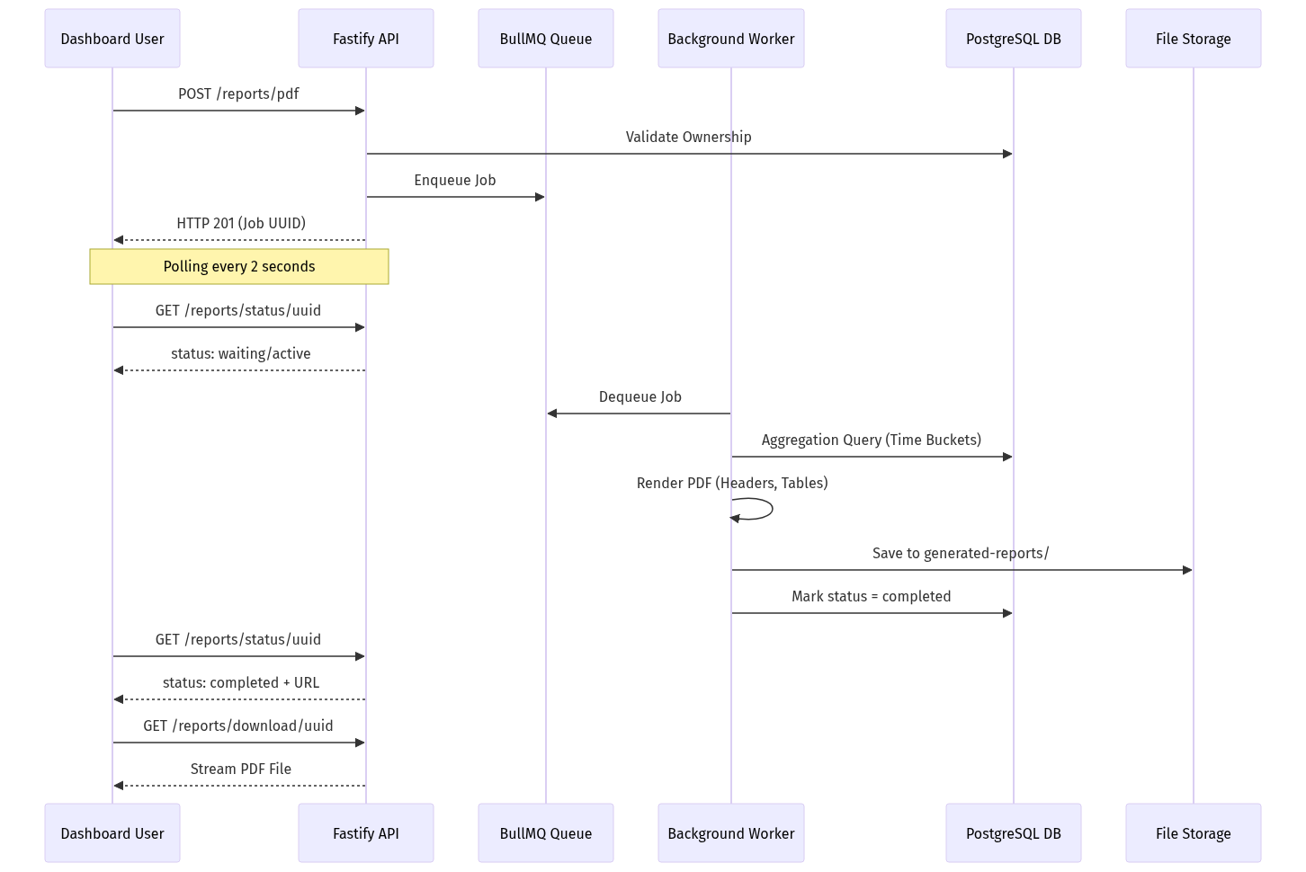

Step-by-Step Execution
1. Report Request: The user configures a custom report on the frontend (selecting devices, parameters like PM2.5 and CO2, date ranges, and aggregation intervals such as 15 minutes). The client submits POST /reports/pdf.
2. Ownership Validation & Enqueueing: The ReportsController validates that the requesting user securely owns all specified devices. It creates a record in GeneratedReport (with a 24-hour cleanup expiration), pushes a job into the BullMQ reports queue, and immediately returns HTTP 201 with the generated jobId.
3. Frontend Status Polling: The user's browser transitions to a loading state with a progress indicator, polling GET /reports/status/:jobId every 2 seconds.
4. Background Data Aggregation: A dedicated background ReportsProcessor worker picks up the job. It executes an advanced, time-bucketed SQL query against PostgreSQL, grouping raw historical telemetry into structured time intervals and calculating exact mathematical averages for each bucket.
5. PDF Construction & Branding (`PdfService`):
- The worker initializes PDFKit. It draws a professional GBI company header, report title, and generation timestamp.
- It embeds a low-opacity GBI watermark logo centered across all pages.
- It constructs a clean, bordered data table, iterating through time buckets and formatting cells with correct units (µg/m³, ppm, °C).
- It dynamically computes page breaks and appends professional footers with page numbering.
6. Persistence & Completion: The rendered PDF buffer is written to secure storage (generated-reports/). The database status is updated to completed, recording the relative file path.
7. One-Click Streamed Download: On the next polling cycle, the frontend receives status: "completed" along with a secure download URL. The browser executes a redirect to GET /reports/download/:jobId. The backend sets Content-Type: application/pdf and streams the file directly to the user's hard drive.
________________________________________________________________

5. Hardware Onboarding & Lifecycle Management
Physical devices progress through a strict lifecycle from factory registration to active user assignment and eventual decommissioning.
[CODE]
+-------------------------------------------------------------------------------+
| DEVICE LIFECYCLE STATE MACHINE |
+-------------------------------------------------------------------------------+
| [Factory Stock] ---> [Admin Registered] ---> [User Claimed / Assigned] |
| | | |
| (Bulk Excel Import) (Active Heartbeat Streaming) |
| | |
| [Decommissioned / Soft Deleted] <--- [Unassigned] <----+ (Missed Heartbeats) |
+-------------------------------------------------------------------------------+

Step-by-Step Execution
1. Admin Bulk Registration: System administrators navigate to the Admin Portal and upload an Excel spreadsheet (.xlsx) containing hundreds of factory serial numbers via POST /admin/devices/bulk. The backend parses the file, skips duplicates, and inserts records into Device with status = OFFLINE.
2. Physical Installation & Pairing: The physical device is mounted in a building and powered on. It connects to the Wi-Fi network and establishes its secure MQTT connection.
3. User Claiming: The customer logs into their dashboard, clicks "Add Device," and inputs the unique serial number. The system creates a DeviceAssignment and UserDevice record, linking the hardware to the user's account with a custom nickname (e.g., "Conference Room B").
4. Active Operation: The device begins transmitting telemetry. The ingestion engine updates its state to ACTIVE upon receiving non-null sensor readings.
5. Decommissioning & Soft Deletion: When a building lease ends or hardware is upgraded, the admin executes POST /admin/devices/:id/unassign or PATCH /admin/devices/:deviceId/delete. The device is marked isDeleted = true. The MQTT consumer instantly ignores any further transmissions from this serial number.
________________________________________________________________

6. Secure Authentication & Session Governance
To protect sensitive IoT data and prevent unauthorized administrative access, the platform enforces rigorous session governance.
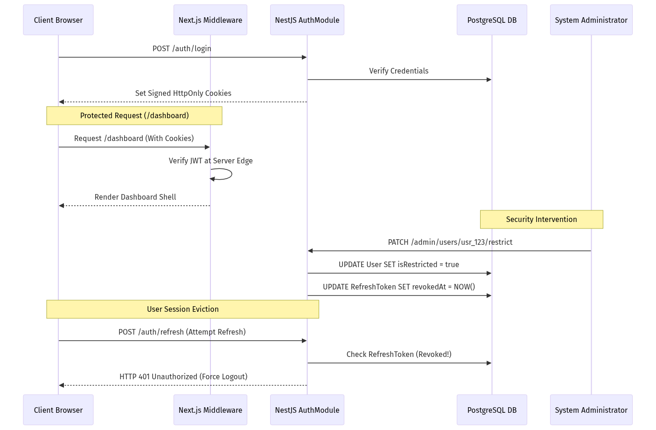

Step-by-Step Execution
1. Secure Authentication: The user logs in via email/password or Google OAuth. The AuthModule verifies credentials and generates a short-lived Access JWT (15 mins) and a long-lived Refresh JWT (7 days).
2. HttpOnly Cookie Transmission: Instead of sending tokens in raw JSON to be stored in vulnerable localStorage (where malicious scripts could steal them), the backend sets secure, signed, HttpOnly cookies.
3. Edge Route Protection (`middleware.ts`): When the user navigates to /dashboard, Next.js Middleware intercepts the request on the server before transmitting page bundles. It cryptographically validates the cookie. If valid, the page renders perfectly; if missing or expired, the middleware instantly redirects to /login.
4. Automated Token Rotation: When the 15-minute access token expires, the client calls /auth/refresh. The backend validates the refresh token in PostgreSQL, issues a fresh token pair, and rotates the old refresh token to prevent replay attacks.
5. Instant Admin Restriction Execution: If a user account is flagged for suspicious activity, an administrator clicks "Ban User" on the Admin Hub (PATCH /admin/users/:id/restrict).
- PostgreSQL flags isRestricted = true and instantly stamps revokedAt = NOW() across all active refresh tokens for that user ID.
- When the user's access token expires minutes later and their browser attempts to refresh, the backend detects the revocation, returns 401 Unauthorized, clears all browser cookies, and forcibly ejects the user to the login screen.
________________________________________________________________

7. Premium Monetization & Subscription Upgrade Flow
The platform offers a seamless upgrade path from free-tier monitoring to unlocked premium enterprise capabilities.
[CODE]
+-------------------------------------------------------------------------------+
| PREMIUM UPGRADE LIFECYCLE WORKFLOW |
+-------------------------------------------------------------------------------+
| [Free Dashboard] ---> [Checkout Paywall] ---> [Webhook Verification] |
| | | | |
| (2 Device Limit) (Razorpay / PhonePe) (Crypto Signature Validated) |
| | |
| [Unlocked Features] <--- [Database Updated] <-------+ |
| (PDFs, Unlimited Devices, High-Speed Queues) |
+-------------------------------------------------------------------------------+

Step-by-Step Execution
1. Paywall Encounter: A free-tier user attempts to add a 3rd IoT device or click "Generate Branded PDF." A sleek glassmorphic modal appears explaining the benefits of Premium access.
2. Secure Payment Gateway Checkout: The user selects an annual subscription and clicks "Upgrade." The frontend initializes the Razorpay or PhonePe checkout interface. The user securely completes the transaction using UPI, credit card, or net banking.
3. Cryptographic Webhook Verification: The payment gateway fires an asynchronous webhook back to the backend (POST /subscriptions/webhook). The NestJS server computes an HMAC SHA256 cryptographic signature to verify invoice authenticity, preventing fraudulent transactions.
4. Subscription Activation: The backend inserts an active record into Subscription and PremiumSubscription, setting the user's isPremium = true and stamping premiumExpiry = NOW() + 365 Days. An audit log is committed to PremiumHistory.
5. Instant Feature Unlocking: The next time the user's browser polls or navigates, their upgraded token context unlocks premium dashboard features. They can now onboard unlimited hardware, access 1-year data archives, utilize priority PDF report queues, and configure WhatsApp emergency alerts.
________________________________________________________________

8. Stateless Device Heartbeat & Liveness Evaluation
This workflow details how the backend cluster automatedly detects when physical hardware in a remote warehouse suffers a power outage or network failure.
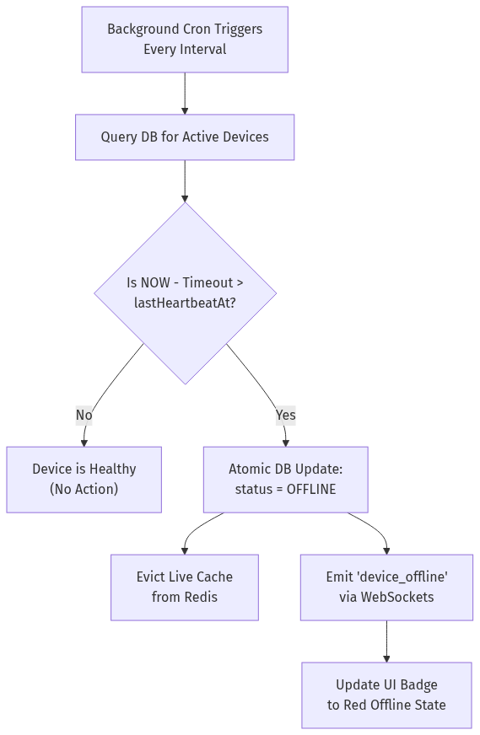

Step-by-Step Execution
1. Stateless Scheduler Execution: Every few minutes, a precision background cron job (@nestjs/schedule) awakens inside the backend cluster.
2. Database Liveness Query: Because tracking memory timers inside individual servers fails in a load-balanced cluster, the cron queries the singular source of truth: PostgreSQL Device.lastHeartbeatAt.
3. Cutoff Evaluation: The cron calculates the maximum allowable silence window: OfflineCutoff = IntervalSeconds * ThresholdMisses. It evaluates: WHERE NOW() - OfflineCutoff > lastHeartbeatAt AND status != 'OFFLINE'.
4. Atomic State Mutation: For all matching orphaned devices, PostgreSQL executes an atomic UPDATE Device SET status = 'OFFLINE'.
5. Cache Eviction & Broadcast:
- The backend instantly deletes any stale live cache keys (device:{id}:latest) from Redis to ensure no client can fetch outdated telemetry.
- Surviving backend nodes catch the status mutation and broadcast an emergency device_offline WebSocket packet.
6. Dashboard UI Alert: The user's browser catches the socket event. The device's visual status badge instantly transitions from a glowing green ONLINE state to a solid red OFFLINE indicator, and an entry is logged in the user's Event History.

