Project Plan

Client: Islam Yasser.

Project Name: Digital Air Conditioner Screen

Synopsis: Initial document, its valid until 6-4-2018

Version: 1.0

Issue Date: 2-4-2018

Prepared by: Testing Team- Development Team

Authorized by: Mohammed Hassan - Islam Yasser

**Amendment History**

Version Issue Date Changes

Version 1 3/4/2018 Initial version.

Version 2 12/4/2018 updating project life cycle & communication plan sections

**Table of Contents**

1 Introduction

1.1 Document Purpose

1.2 Associated Documents

1.3 Project Plan Maintenance.

2 Project Scope

2.1 Outline of Client’s Objectives

2.1.1 Objectives

2.1.2 Success Criteria

2.1.3 Risks

3 Deliverables

3.1 To client

3.2 From client

4 Project Approach

4.1 Project Lifecycle Processes

4.2 Organization

4.2.1 Project Team

5 Communications Plan

6 Work Plan

6.1 Work Breakdown Structure

7 Risk Management.

8. Configuration and Change Management

**1 Introduction**

## **1.1 Document Purpose**

It’s an outline plan for digital Air Conditioner Screen project, which will guide the testing team and developing team among the project period, it’s also contains the most important headlines for the whole process of the project.

## **1.2 Associated Documents**

This document associated with Software Requirement Specification document(SRS), Software Design Document(SDD), Test plan Document(TPD), Requirement Traceability Matrix(RTM), Structured Interview Questionnaire(SIQ), work breakdown structure(WBS).

## **1.3 Project Plan Maintenance**

Any change requests will be updated by the Management Team, it should be approved by both the Testing team and the Development team, it should be tracked at the RTM document and updated at the project plan, project schedule documents.

# **2 Project Scope**

It is a system for controlling the degree of temperature, typically to maintain a cool atmosphere in warm conditions or to maintain a warm atmosphere in cool conditions.

This system should support three modes which are temperature and fan display on LCD with size 2*16, temperature adjust in the range of 16 to 32 degree with default temperature 16, and fan adjust in three levels low, medium and high with default speed low. But the system does not support dealing with touch screen Displays, wireless communication between buttons and LCD nor dealing with voltage less or more than 9 volts.

It should be user friendly as possible to deal with simple users.

.

## **2.1 Outline of Client’s Objectives**

### **2.1.1 Objectives**

WindoEgypt is a lead air conditioner company that serves many customers in different regions, it seeks a simple screen supports its latest air conditioners, it should support a simple remote system to control the air conditioner modes through LCD screen.

### **2.1.2 Success Criteria**

Project must meet the customer requirements need, it should support all agreed criteria, it should be delivered on time, with in the given budget

### **2.1.3 Risks**

Lack of budget supported to the project.

Delay in delivery time.

The delivered system far from the customer’s need.

Doesn’t support all agreed criteria.

This section is explained in details in RMP external document.

# **3 Deliverables**

## **3.1 To client**

Client should receive a simple remote system which contains 4 buttons to control the LCD screen, it shall support the following modes:

1. Temperature and Fan displayed together mode
2. Temperature adjustment mode.
3. Fan speed adjustment mode.

The system shall support simple 4 push buttons to control the system, its hard wired connected with the LCD Screen.

The client also will receive

1. The project plan document.
2. SRS Document.
3. SDD document.
4. Test Plan Document.
5. RTM Document.
6. Hardware.
7. Code.

## **3.2 From client**

Answers to any question from the development team or the testing team.

Any needed support or enquiry about the nature of the project.

Deliveries:

1.SIQ.

2.CRS.

3.Budget needed.

# **4 Project Approach**

## **4.1 Project Lifecycle Processes**

We are following V-model life cycle which consists of two main phases Verification phase and Validation phase

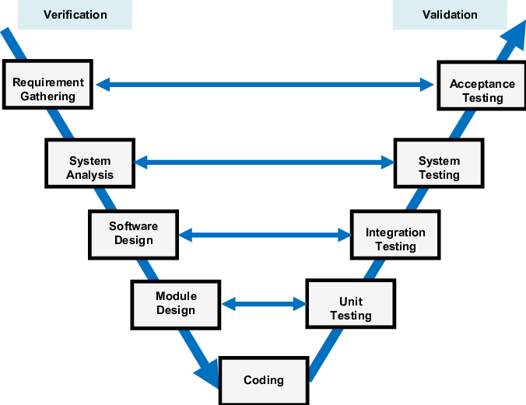

**Verification Phases:**

* Requirement Gathering

In the requirements analysis phase, the first step in the verification process, the requirements of the system are collected by analyzing the needs of the user(s). This phase is concerned with establishing what the ideal system has to perform. However, it does not determine how the software will be designed or built. Usually, the users are interviewed and a document called the user requirements document is generated.

* System Analysis

Systems design is the phase where system engineers analyze and understand the business of the proposed system by studying the user requirements document. They figure out possibilities and techniques by which the user requirements can be implemented. If any of the requirements are not feasible, the user is informed of the issue. A resolution is found and the user requirement document is edited accordingly.

* Software Design

The phase of the design of computer architecture and software architecture can also be referred to as high-level design. The baseline in selecting the architecture is that it should realize all which typically consists of the list of modules, brief functionality of each module, their interface relationships, dependencies, database tables, architecture diagrams, technology details etc. The integration testing design is carried out in the particular phase.

* Module Design

The module design phase can also be referred to as low-level design. The designed system is broken up into smaller units or modules and each of them is explained so that the programmer can start coding directly. The low level design document or program specifications will contain a detailed functional logic of the module

* Coding

The developed software code which simulates the logic explained in the module design. Which can be written using various programming languages.

**Validation Phases:**

* Acceptance Testing

User Acceptance Test (UAT) Plans are developed during the Requirements Analysis phase. Test Plans are composed by business users. UAT is performed in a user environment that resembles the production environment, using realistic data. UAT verifies that delivered system meets user's requirement and system is ready for use in real time.

* System Testing

System Tests Plans are developed during System Design Phase. Unlike Unit and Integration Test Plans, System Test Plans are composed by client's business team. System Test ensures that expectations from application developed are met. The whole application is tested for its functionality, interdependency and communication. System Testing verifies that functional and non-functional requirements have been met. Load and performance testing, stress testing, regression testing, etc., are subsets of system testing.

* Integration Testing

Integration Test Plans are developed during the Architectural Design Phase. These tests verify that units created and tested independently can coexist and communicate among themselves. Test results are shared with customer's team.

* Unit Testing

In the V-Model, Unit Test Plans (UTPs) are developed during module design phase. These UTPs are executed to eliminate bugs at code level or unit level. A unit is the smallest entity which can independently exist, e.g. a program module. Unit testing verifies that the smallest entity can function correctly when isolated from the rest of the codes/units.

## **4.2 Organization**

### **4.2.1 Project Team**

|  |  |
| --- | --- |
| **Member** | **Role** |
| Abdullah Fathy | Developer |
| Dina Helmy | Tester |
| Enas Taher | Tester |
| Engy Zinhom | Tester |
| Esmail Samy | Developer |
| Hadeel Yamni | Tester |
| Hagar Mohamed | Developer |
| Saber Osman | Developer |
| Sara Rashwan | Developer |
| Sara Safwat | Tester |
| Yasmeen Yehia | Tester |
| Youssef Medhat | Developer |

### 

# **5 Communications Plan**

# **Between the team members:**

1. An online working group is created to discuss any issues or change requests.
2. A stand up meeting is held every 2 days.
3. Use Configuration management tool (TortoiseGit) to enable working with no conflict and this section is described in CM plan.

**Between Team Members and Client:**

1. Access is given to the client to check the artifacts regularly through repository.
2. SIQ meeting is held to make a direct channel of questions and answers.
3. Phone calls in case of urgent needs.
4. Weekly meeting.

# **6 Work Plan**

## **6.1 Work Breakdown Structure**

This section is created separately in excel sheet named ACS_WBS.xlsx.

# **7 Risks Management**

This section is made separately in excel sheet named ACS_RMP.xlsx

# **10 Configuration Management Plan**

This section made separately in ACS_CM.doc document.

