Project Plan

Client: Islam Yasser.

Project Name: Digital Air Conditioner Screen

Synopsis: Initial document, its valid until 6-4-2018

Version: 1.0

Issue Date: 2-4-2018

Prepared by: Testing Team- Development Team

Authorized by: Mohammed Hassan - Islam Yasser

**Amendment History**

Version Issue Date Changes

Version 1 3/4/2018 Initial version.

**Table of Contents**

1 Introduction

1.1 Document Purpose

1.2 Associated Documents

1.3 Project Plan Maintenance.

2 Project Scope

2.1 Outline of Client’s Objectives

2.1.1 Objectives

2.1.2 Success Criteria

2.1.3 Risks

3 Deliverables

3.1 To client

3.2 From client

4 Project Approach

4.1 Project Lifecycle Processes

4.2 Project Management Processes

4.3 Project Support Processes

4.4 Organization

4.4.1 Project Team

4.4.2 Mapping Between <Organization> and Client

5 Communications Plan

6 Work Plan

6.1 Work Breakdown Structure

7 Risk Management.

8. Configuration and Change Management

**1 Introduction**

## **1.1 Document Purpose**

It’s an outline plan for digital Air Conditioner Screen project, which will guide the testing team and developing team among the project period, it’s also contains the most important headlines for the whole process of the project.

## **1.2 Associated Documents**

This document associated with Software Requirement Specification document, Software Design Document, Test plan Document, Requirement Traceability Matrix, Structured Interview Questionnaire.

## **1.3 Project Plan Maintenance**

Any change requests will be updated by the Management Team, it should be approved by both the Testing team and the Development team, it should be tracked at the RTM document and updated at the project plan, project schedule documents.

# **2 Project Scope**

It is a system for controlling the degree of temperature, typically to maintain a cool atmosphere in warm conditions or to maintain a warm atmosphere in cool conditions.

This system should support three modes which are temperature and fan display on LCD with size 2*16, temperature adjust in the range of 16 to 32 degree with default temperature 16, and fan adjust in three levels low, medium and high with default speed low. But the system does not support dealing with touch screen Displays, wireless communication between buttons and LCD nor dealing with voltage less or more than 9 volts.

It should be user friendly as possible to deal with simple users.

.

## **2.1 Outline of Client’s Objectives**

### **2.1.1 Objectives**

WindoEgypt is a lead air conditioner company that serves many customers in different regions, it seeks a simple screen supports its latest air conditioners, it should support a simple remote system to control the air conditioner modes through LCD screen.

### **2.1.2 Success Criteria**

Project must meet the customer requirements need, it should support all agreed criteria, it should be delivered on time, with in the given budget

### **2.1.3 Risks**

Lack of budget supported to the project.

Delay in delivery time.

The delivered system far from the customer’s need.

Doesn’t support all agreed criteria.

This section is explained in details in Risk Management section in this document.

# **3 Deliverables**

## **3.1 To client**

Client should receive a simple remote system which contains 4 buttons to control the LCD screen, it shall support the following modes:

1. Temperature and Fan displayed together mode
2. Temperature adjustment mode.
3. Fan speed adjustment mode.

The system shall support simple 4 push buttons to control the system, its hard wired connected with the LCD Screen.

The client also will receive

1. The project plan document.
2. SRS Document.
3. SDD document.
4. Test Plan Document.
5. RTM Document.
6. Hardware.
7. Code.

## **3.2 From client**

Answers to any question from the development team or the testing team.

Any needed support or enquiry about the nature of the project.

Deliveries:

1.SIQ.

2.CRS.

3.Budget needed.

# **4 Project Approach**

## **4.1 Project Lifecycle Processes**

This is where the overall approach to the project is described, explaining how the work gets done. What is the overall approach to undertaking the project work? Is the project split into major phases? How are requirements being captured? Is there a prototyping activity before solidifying the requirements? What sorts of integration and testing activities are there? For a management consultancy project what kinds of reviews will there be, and how will input be accepted?

## **4.2 Project Management Processes**

This is a description of those processes used to manage and control the project. It is critical that this section at a minimum describes the formal process to control project changes. It could also include such things as the risk management process, and how performance information is captured and reported (which may be expanded on in the Communications Plan section later in this document).

## **4.3 Project Support Processes**

This is a description of those processes that typically happen throughout the project lifecycle and support the various other activities. Often includes such processes as configuration management, release control, how the support infrastructure will be used, etc.

## **4.4 Organization**

### **4.4.1 Project Team**

|  |  |
| --- | --- |
| **Member** | **Role** |
| Abdullah Fathy | Developer |
| Dina Helmy | Tester |
| Enas Taher | Tester |
| Engy Zinhom | Tester |
| Esmail Samy | Developer |
| Hadeel Yamni | Tester |
| Hagar Mohamed | Developer |
| Saber Osman | Developer |
| Sara Rashwan | Developer |
| Sara Safwat | Tester |
| Yasmeen Yehia | Tester |
| Youssef Medhat | Developer |

### 

### **4.4.2 Mapping Between Organization and Client**

Show how your organization maps onto the client, and what occurs at each level of the mapping. For instance, in addition to a mapping between your project manager and the client’s, there may be an executive mapping between the organizations, perhaps a project steering group with joint membership, a mapping between QA departments, etc.

# **5 Communications Plan**

**Between the team members:**  
• A group on Facebook is created to negotiate if there is any issue or conflict.  
• A meeting is held every 2 days.  
• Use Configuration management to enable working with no conflict and this section is described in CM plan.  
  
 **Between Leaders and Client:**  
• Use configuration management as a viewer.  
• SIQ to make a direct channel of questions and answers.  
• By mail with team leader.  
• Weekly meeting.

# **6 Work Plan**

## **6.1 Work Breakdown Structure**

This section is created separately in excel sheet named WBS.xlsx.

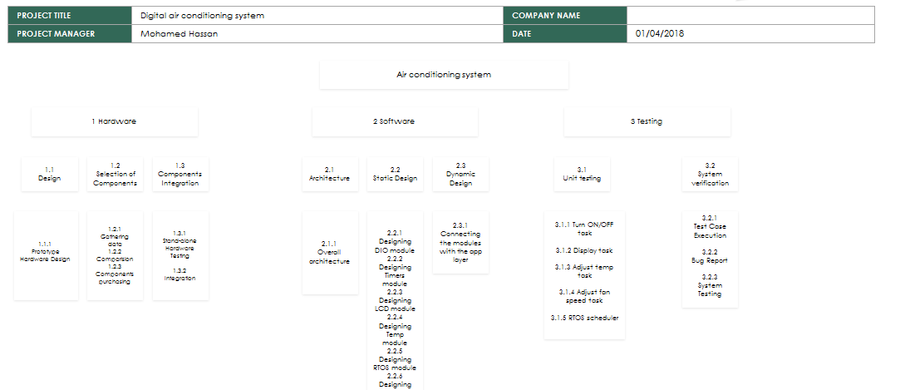

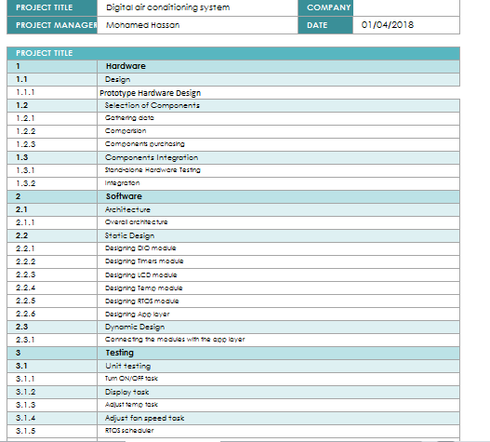

# **7 Risks Management**

This section is made separately in excel sheet named Risk Management Plan.xlsx



# **10 Configuration Management Plan**

This section made separately in cm document.

