Software Requirements Specification

for

Air Conditioner

**Version 2.0**

**Prepared by Development Team**

**2/4/2018**

**Table of Contents**

**Table of Contents ii**

**Revision History ii**

**1. Introduction 1**

1.1 Purpose 1

1.2 Product Scope 1

1.3 Definitions, Acronyms and abbreviations 1

1.4 References 1

1.5 Overview 1

**2. Overall Description 2**

2.1 Product Perspective 2

2.2 Product Functions 2

**3. External Interface Requirements 3**

3.1 User Interfaces 3

3.2 Hardware Interfaces 3

3.3 Software Interfaces 5

3.4 Communications Interfaces 5

**4. Functional Requirements : 4**

4.1 Use Cases 6

**5. Appendix A: Glossary 14**

**Revision History**

|  |  |  |  |
| --- | --- | --- | --- |
| **Name** | **Date** | **Reason For Changes** | **Version** |
| Sara Safwat,  Hadeel Yamni | 3/4/2018 | Initial Review | 1.0 |
| Hadeel Yamni | 15/4/2018 | Checking fixing of missing Functional Requirements | 1.1 |
| Hadeel Yamni | 16/4/2018 | Checking version fixing and removal of un relevant data in introduction section | 2.0 |

# Introduction

## Purpose

The purpose of the Software Requirements Specification document is to clearly define the system under development, namely “AIR Conditioner System”. It will illustrate the purpose and complete declaration for the development of system. It will also explain system constraints and interfaces.  This product is targeting “Air Conditioner users”.

## Product Scope

Our Air Conditioner is a system for controlling the degree of temperature, typically to maintain a cool atmosphere in warm conditions or to maintain a warm atmosphere in cool conditions.

Our system supports three modes which are temperature and fan display on LCD with size 2*16, temperature adjust in the range of 16 to 32 degree with default temperature 16, and fan adjust in three levels low, medium and high with default speed low. But the system does not support dealing with touch screen Displays, wireless communication between buttons and LCD nor dealing with voltage less or more than 9 volts.

We made it as user friendly as possible to deal with simple users.

## Definitions, Acronyms and abbreviations

A table of definitions, acronyms and abbreviations is provided in **Appendix A.**

## References

IEEE STD 830-1998 IEEE Recommended Practice for Software Requirements Specifications.

## Overview

This document is designed to provide information to both the client and the technical designers of the software. Section one is a brief overview of the product, including definitions and references.

The remainder of this document includes three sections and appendixes.

The second one provides a more detailed description of the product.

The third section provides a list of the functional requirements of the system.

The fourth is about its nonfunctional requirements.

# Overall Description

This section will give an overview of the whole system. The system will be explained in its context to show how the system interacts with other systems and introduce its basic functionality. It will also describe the type of stakeholders that will use the system and what functionality is available.

## Product Perspective

The system is an air conditioner remote control. The main purpose of the system is displaying the air conditioner temperature and fan speed. It also provides options for the user to adjust them. The remote has a friendly user interface. The objective of our product is using the technology to have control of the air conditioner without doing any effort.

The system will cost approximately 300 EGP.

Also it will be configurable to add more features.

## Product Functions

The project will consist of 3 main parts:

* A Microcontroller for handling the different tasks in the System.
* LCD for monitoring the system status and the adjustment options.
* Four push button to control the system.

1-The Microcontroller is the main brain of the system which communicate between the

different components of the system and also doing all the processing needed to

accomplish any task.

2-The LCD (Liquid Crystal Display) is used to display the different modes:

1. Current temperature and fan speed.
2. Adjust the temperature.
3. Adjust the fan speed.

3- Four push button:

1. The first is used to turn On/Off the system.
2. The second is used to change between modes
3. The third and the forth are used to increase and decrease the temperature degree in the temperature adjusts mode and the fan speed in adjust fan mode.

When the system is turn on it won’t respond to any command for 5 seconds which is called “Delay Starts” and also when it turn off it won’t respond to any command for 5 seconds which is called “Delay Stop”.

# 3.External Interface Requirements

## 3.1 User Interface

User will deal with LCD displaying information about fan speed, operation mode, with 5 push buttons that allow user to switch between modes of operation to control the system

## Hardware Interface

Including character LCD size (2*16) connected with 5 press buttons to interact with functionality of system with a voice indicator that varies with every press or every mode state of the system

1-2*16-character LCD

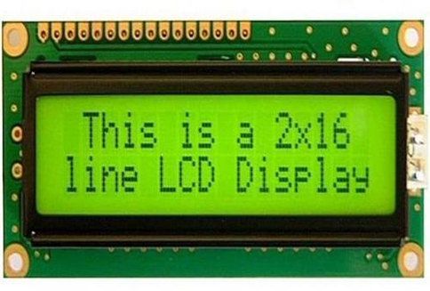

2- Push button 3- Buzzer

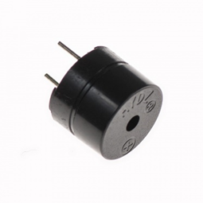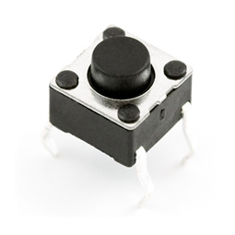

4-avr microcontroller

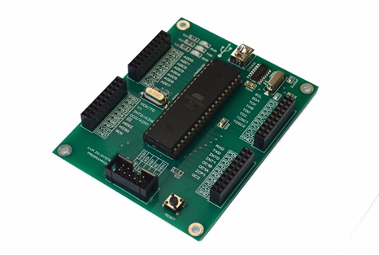

## 3.3 Software Interfaces

Eclipse IDE that runs on Microsoft windows and ubuntu platforms with minimum requirements, also preinstalled Java JDK, JRE API’s making an environmental variable path, and integrated commercial components. Identify you can use this IDE for C Programming methodologies, to connect Hardware platform with PC you have to install WinAvr tool that contain GCC cross tool compiler, then to make it ready install USBASP Hardware driver if you use Windows 8 and later

## 3.4 Communications Interfaces

Using USB UART communication protocol that copy .hex files into AVR processor ROM, verifying the code to be implemented correctly on the target

# Functional Requirements:

This section clarifies all the requirements and responsibilities of the whole system.

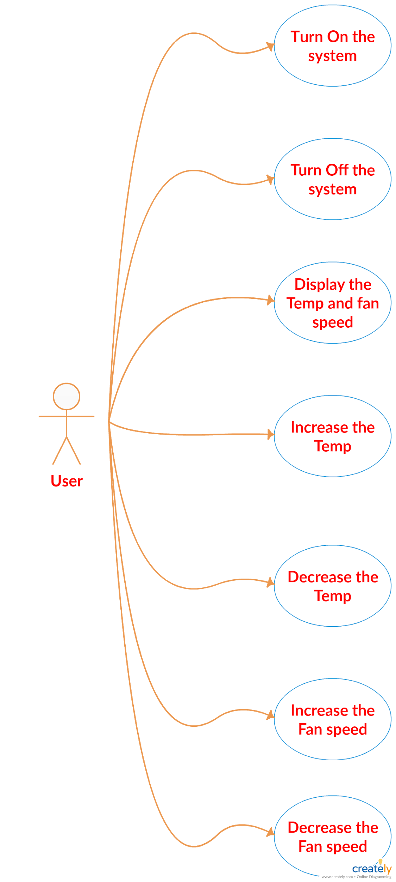

## Use Cases:

### Start the system

|  |  |
| --- | --- |
| **Use Case Name** | Turn ON |
| **Use Case ID** | S001 |
| **Description** | To show how the system should behave when starting the system. |
| **Actors** | The user |
| **Triggers** | The user wants to start the system. |
| **Preconditions** | The system Starts only if the system was off. |
| **Basic Path** | 1-The user pushes the ON/OFF button.  2-If the system was off, the system will start and takes 5 secs to start its functionality and to start responding to the push buttons. |
| **Alternative Paths** | If the user pushes the ON/OFF button more than once during the 5 sec after first press, the system will not respond. |
| **Post Conditions** | 1-In case of starting the system the LCD will display the default temp and all the buttons are ready to be used.  2-In case of stopping the system the system will shut down and the LCD will turn off after 5 sec. |
| **Exception Paths** | If the user wanted to turn on the system while being on it will turn OFF. |

### Stop the system

|  |  |
| --- | --- |
| **Use Case Name** | Turn OFF |
| **Use Case ID** | S002 |
| **Description** | To show how the system should behave when stopping the system. |
| **Actors** | The user |
| **Triggers** | The user wants to stop the system. |
| **Preconditions** | The system Starts only if the system was off. |
| **Basic Path** | 1-The user pushes the ON/OFF button.  2-If the system was on, the system will stop and takes 5 sec to stop it's functionality . |
| **Alternative Paths** | If the user pushes the ON/OFF button more than once during the 5 sec after first press, the system will not respond. |
| **Post Conditions** | 1-In case of stopping the system the system will shut down and the LCD will turn off after 5 sec. |
| **Exception Paths** | If the user wanted to turn off the system while being off it will turn on. |

### 4.1.3Display Mode

|  |  |
| --- | --- |
| **Use Case Name** | Display Mode |
| **Use Case ID** | S003 |
| **Description** | To show how the system should behave when being on the display mode |
| **Actors** | The user |
| **Triggers** | The user wants to display current speed and current temp. |
| **Preconditions** | 1-The system is already ON for 5 sec. |
| **Basic Path** | 1-The user pushes the Mode button.  2-The LCD will display that the current mode is display mode or adjust mode.  3- In case that the current mode is display mode, the LCD will show the current temp and the current fan speed. |
| **Alternative Paths** | 1-If the user pushed the mode button multiple times it will circulate between display mode, adjust fan speed mode and adjust temp mode. |
| **Post Conditions** | Depending on how many times the user will push the mode button, the system will switch between display mode, adjust temp mode or adjust fan speed mode successfully. |
| **Exception Paths** | .  1- If the user pushed the mode button within 5 secs after the system is turned on or off the system will not respond. |

### 4.1.4Adjust temp mode

|  |  |
| --- | --- |
| **Use Case Name** | Adjust temp mode |
| **Use Case ID** | S004 |
| **Description** | To show how the system should behave when entering the temperature adjust mode. |
| **Actors** | The user |
| **Triggers** | The user wants to adjust the current temperature. |
| **Preconditions** | 1-The system is already ON for 5 sec. |
| **Basic Path** | 1-The user pushes the Mode button.  2-The LCD will display that the current mode is display mode or adjust mode.  3-In case that the current mode is temperature adjust mode, a cursor on the LCD will show that we are in temperature speed adjust mode. |
| **Alternative Paths** | 1-If the user pushed the mode button multiple times it will circulate between display mode, adjust fan speed mode and adjust temp mode. |
| **Post Conditions** | Depending on how many times the user will push the mode button, the system will switch between display mode , adjust temp mode or adjust fan speed mode successfully. |
| **Exception Paths** | 1- If the user pushed the buttons within 5 sec after the system is turned on or off the system will not respond. |

### 4.1.5Adjust fan speed mode

|  |  |
| --- | --- |
| **Use Case Name** | Adjust fan speed mode |
| **Use Case ID** | S005 |
| **Description** | To show how the system should behave when entering the fan speed mode. |
| **Actors** | The user |
| **Triggers** | The user wants to adjust the current fan speed. |
| **Preconditions** | 1-The system is already ON for 5 sec. |
| **Basic Path** | 1-The user pushes the Mode button.  2-The LCD will display that the current mode is display mode or adjust mode.  3-In case that the current mode is fan speed adjust mode, a cursor on the LCD will show that we are in fan speed adjust mode. |
| **Alternative Paths** | 1-If the user pushed the mode button multiple times it will circulate between display mode, adjust fan speed mode and adjust temp mode. |
| **Post Conditions** | Depending on how many times the user will push the mode button, the system will switch between display mode , adjust temp mode or adjust fan speed mode successfully. |
| **Exception Paths** | 1- If the user pushed the buttons within 5 sec after the system is turned on or off the system will not respond. |

**4.1.6 Increasing temperature**

|  |  |
| --- | --- |
| **Use Case Name** | Increasing temperature |
| **Use Case ID** | S006 |
| **Description** | To show how the system should behave when increasing the temperature. |
| **Actors** | The user |
| **Triggers** | Increasing the temperature. |
| **Preconditions** | 1-The system must be ON.  2-The user must be on the temperature adjust mode to control the temperature.  3-The user must press the increase temperature button. |
| **Basic Path** | 1- If the system is on the adjust temp mode , the user will be able to increase or decrease the temp.  2-the user press the increase temperature button to increase the temperature |
| **Alternative Paths** | 1-If the user pressed on increase temperature button for a long time , it will act as only one button press. |
| **Post Conditions** | 1- If the system is on the adjust temp mode , the temp will increase and will be displayed on the LCD. |
| **Exception Paths** | 1- If the user tried to increase the temperature while being in the display mode the system will not respond.  2- If the user tried to increase the temperature during 5 sec after the system starts the system will not respond.  3-If the user wanted to increase the temp above 32 the system will not respond. |

**4.1.7 Decreasing temperature**

|  |  |
| --- | --- |
| **Use Case Name** | Decreasing temperature |
| **Use Case ID** | S007 |
| **Description** | To show how the system should behave when decreasing the temperature. |
| **Actors** | The user |
| **Triggers** | decreasing the temperature. |
| **Preconditions** | 1-The system must be ON.  2-The user must be on the temperature adjust mode to control the temperature.  3-The user must press the decrease temperature button. |
| **Basic Path** | 1- If the system is on the adjust temp mode , the user will be able to increase or decrease the temp.  2-the user press the decrease temperature button to decrease the temperature |
| **Alternative Paths** | 1-If the user pressed on decrease temperature button for a long time , it will act as only one button press. |
| **Post Conditions** | 1- If the system is on the adjust temp mode , the temp will decrease and will be displayed on the LCD. |
| **Exception Paths** | 1- If the user tried to decrease the temperature while being in the display mode the system will not respond.  2- If the user tried to decrease the temperature during 5 sec after the system starts the system will not respond.  3-If the user wanted to decrease the temp below 16 the system will not respond. |

**4.1.8 Increasing Fan speed**

|  |  |
| --- | --- |
| **Use Case Name** | Increasing Fan speed |
| **Use Case ID** | S008 |
| **Description** | To show how the system should behave when increasing fan speed. |
| **Actors** | The user |
| **Triggers** | Increasing the fan speed. |
| **Preconditions** | 1-The system must be ON.  2-The user must be on the fan speed adjust mode to control the fan speed.  3-The user must press the increase fan speed button. |
| **Basic Path** | 1- If the system is on the adjust fan speed mode , the user will be able to increase the fan speed.  2-the user press the increase fan speed button to increase the fan speed. |
| **Alternative Paths** | 1-If the user pressed on increase fan speed button for a long time , it will act as only one button press. |
| **Post Conditions** | 1- If the system is on the adjust fan speed mode , the fan speed will increase and will be displayed on the LCD. |
| **Exception Paths** | 1- If the user tried to increase the fan speed while being in the display mode the system will not respond.  2- If the user tried to increase the fan speed during 5 sec after the system starts the system will not respond. |

**4.1.9 Decreasing Fan speed**

|  |  |
| --- | --- |
| **Use Case Name** | Decreasing Fan speed |
| **Use Case ID** | S009 |
| **Description** | To show how the system should behave when decreasing fan speed. |
| **Actors** | The user |
| **Triggers** | decreasing the fan speed. |
| **Preconditions** | 1-The system must be ON.  2-The user must be on the fan speed adjust mode to control the fan speed.  3-The user must press the decrease fan speed button. |
| **Basic Path** | 1- If the system is on the adjust fan speed mode , the user will be able to decrease the fan speed.  2-the user press the decrease fan speed button to decrease the fan speed. |
| **Alternative Paths** | 1-If the user pressed on decrease fan speed button for a long time , it will act as only one button press. |
| **Post Conditions** | 1- If the system is on the adjust fan speed mode , the fan speed will decrease and will be displayed on the LCD. |
| **Exception Paths** | 1- If the user tried to decrease the fan speed while being in the display mode the system will not respond.  2- If the user tried to decrease the fan speed during 5 secs after the system starts the system will not respond. |

# 

**5. APPENDIX A**

This appendix contains all the definitions, acronyms and abbreviations.

|  |  |
| --- | --- |
| **Acronyms** | **Stands for** |
| LCD | liquid-crystal display |
| IDE | integrated development environment |
| JDK | Java Development Kit |
| JRE | Java Runtime environment |
| API | Application Programming Interface |
| PC | Personal computer |