Component Design Document

For LCD MODULE

**Table of Contents**

Revision History 1

*1. Introduction* 2

1.1 Objective 2

1.2 Context Diagram 2

2. *External Interface* 2

2.1 <file name.h> 2

3. *Static Design* 2

3.1 Files 2

3.2 Types 3

3.3 Symbol Define <#define> 3

3.4 Const 3

3.5 Interface (Services) 3

*4.* *Dynamic Design* 4

4.1 Mode Management 4

4.2 Sequence Diagram 4

*5.* *Shared Resources* 4

5.1 Analysis 4

5.2 Protection 4

6. *Configuration Parameters* 4

6.1 Pre-compile time 4

6.2 Link time 5

6.3 Post-build 5

*7.* *Configuration Constrains* 5

*8.* *Integration Constrains* 5

*9.* *History* 5

Revision History

|  |  |  |  |
| --- | --- | --- | --- |
| **Name** | **Date** | **Reason For Changes** | **Version** |
| Saber Osman | 18/4/2018 | Make the first LCD Design Document | 1.0 |
| Saber Osman | 21/4/2018 | Make some modification after review | 1.0.1 |
|  |  |  |  |
|  |  |  |  |
|  |  |  |  |

# *1. Introduction*

## Objective

This module is used to monitor fan and temperature status and if there is an adjustment it will show the result after any change.

## Context Diagram

## 

## 

# *External Interface*

## <DIO.h>

### Types

|  |  |
| --- | --- |
| Data Type | Description |
|  |  |

### Interface

|  |  |
| --- | --- |
| Function | Description |
| Dio_WritePin() | This function takes two arguments the pin name and the value which will be assigned to it if high or low. |

### Const

### Symbol <#defines>

## <Delay.h>

### Types

|  |  |
| --- | --- |
| Data Type | Description |
|  |  |

### Interface

|  |  |
| --- | --- |
| Function | Description |
| Delay_ms() | This function makes a delay in milliseconds with the desired value which will be passed to it through input argument. |
| Delay_us() | This function makes a delay in milliseconds with the desired value which will be passed to it through input argument. |

### Const

### Symbol <#defines>

# *Static Design*

## Files

### Used Files

|  |  |
| --- | --- |
| FILE NAME | Description |
| LCD_priv.h | Contains all defines and functions which will be used in LCD_prog.c file |
| LCD_config.h | Contains all configuration parameters that control the animation on lCD. |
| LCD_int.h | Introduce all function’s prototypes which will be given to the user. |
| LCD_prog.c | Contains the functionality which will make the LCD works as we want. |

### Files Inclusion

## 

## 3.2 Types

|  |  |
| --- | --- |
| Req ID | DIO_001 |
| Covers | HLD_004 |
| Name | DIO_pinName |
| Type | Enumeration |
| Range | It’s Configuration |
| Description | ------------------------ |

## Symbol Define <#define>

|  |  |
| --- | --- |
| Req ID | DIO_001 |
| Covers | HLD_004 |
| Name | DIO_pinName |
| Type | Enumeration |
| Range | It’s Configuration |
| Description | ------------------------ |

## Const

|  |  |
| --- | --- |
| Req ID | DIO_001 |
| Covers | HLD_004 |
| Name | DIO_pinName |
| Type | Enumeration |
| Range | It’s Configuration |
| Description | ------------------------ |

## Interface (Services)

|  |  |  |  |
| --- | --- | --- | --- |
| Req ID | LCD_001 | | |
| Covers | HLD_004 | | |
| Name/protoTypes | void LCD_voidInitialize(void); | | |
| Service ID | Enumeration | | |
| Re-entrant / Non re- entrant | It’s Configuration | | |
| Synchronous/Asynchronous | ------------------------ | | |
| Return Value | | Void | No Return Value |
| Input parameter | | Void | No Input Parameter |
| Output parameter | | Void | No Output Parameter |
| Input /Output Parameter | | Void | No Input/ Output Parameter |

|  |  |  |  |
| --- | --- | --- | --- |
| Req ID | LCD_002 | | |
| Covers | HLD_004 | | |
| Name/protoTypes | void LCD_voidWriteString_CustomPosition(u8 *u8Pointer2Array); | | |
| Service ID | Enumeration | | |
| Re-entrant / Non re- entrant | It’s Configuration | | |
| Synchronous/Asynchronous | ------------------------ | | |
| Return Value | | Void | No Return Value |
| Input parameter | | Pointer to unsigned integer | Pointer refers to the start of the string which will be displayed on LCD |
| Output parameter | | Void | No Output Parameter |
| Input /Output Parameter | | Void | No Input/ Output Parameter |

|  |  |  |  |
| --- | --- | --- | --- |
| Req ID | LCD_003 | | |
| Covers | HLD_004 | | |
| Name/protoTypes | void LCD_voidWriteStringCurrentPosition(u8 *u8Pointer2Array, u8 xpos, u8 ypos); | | |
| Service ID | Enumeration | | |
| Re-entrant / Non re- entrant | It’s Configuration | | |
| Synchronous/Asynchronous | ------------------------ | | |
| Return Value | | Void | No Return Value |
| Input parameter | | Pointer to unsigned integer | Pointer refers to the start of the string which will be displayed on LCD |
| unsigned integer | Refer to x axis position from it the string will be printed. |
| unsigned integer | Refer to y axis position from it the string will be printed. |
| Output parameter | | Void | No Output Parameter |
| Input /Output Parameter | | Void | No Input/ Output Parameter |

# *Dynamic Design*

## Mode Management

<Draw the state diagram for the component if it’s not exist don’t draw it >

## Sequence Diagram

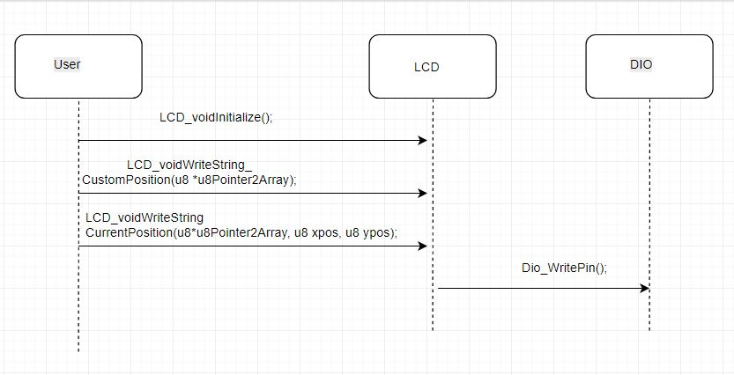

\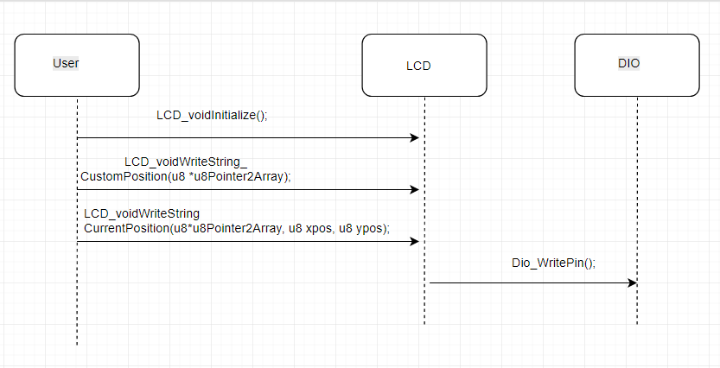

# *Shared Resources*

## Analysis

### There is no shared Variables

## Protection

### There is no shared Variables

## 

# *Configuration Parameters*

## Pre-compile time

|  |  |
| --- | --- |
| Symbol Name | Description |
| #define LCD_u8_DATA_PIN_0 | Choose LCD DATA PIN 0 from UC Pins |
| #define LCD_u8_DATA_PIN_1 | Choose LCD DATA PIN 1 from UC Pins |
| #define LCD_u8_DATA_PIN_2 | Choose LCD DATA PIN 2 from UC Pins |
| #define LCD_u8_DATA_PIN_3 | Choose LCD DATA PIN 3 from UC Pins |
| #define LCD_u8_DATA_PIN_4 | Choose LCD DATA PIN 4 from UC Pins |
| #define LCD_u8_DATA_PIN_5 | Choose LCD DATA PIN 5 from UC Pins |
| #define LCD_u8_DATA_PIN_6 | Choose LCD DATA PIN 6 from UC Pins |
| #define LCD_u8_DATA_PIN_7 | Choose LCD DATA PIN 7 from UC Pins |
| #define LCD_u8_RS_PIN | LCD RESET PIN |
| #define LCD_u8_RW_PIN | LCD Read/Write PIN |
| #define LCD_u8_ENABLE_PIN | LCD ENABLE PIN |
| #define LCD_u8_Set_Display_BIT | Set display off/on from control command register |
| #define LCD_u8_Set_Cursor_BIT | Set cursor off/on from control command register |
| #define LCD_u8_Blink_Cursor_BIT | Set Blink cursor off/on from control command register |
| #define LCD_u8_Set_DataLength_BIT | Set interface data length from Function Set Control Command |
| #define LCD_u8_Active_Line_BIT | open one line on screen or two from Function Set Control Command |
| #define LCD_u8_Font_Type_BIT | Display font type (5*11 or 5*8) from Function Set Control Command |

## Link time

## Post-build

# *Configuration Constrains*

There is possibility to create 32 Dio_PIN_N, when N number of PINS doesn’t exceed 32

# *Integration Constrains*

# *History*

`

|  |  |
| --- | --- |
| Date | Description |
| 18/4/2018 | Creating the template |
| 21/4/2018 | Editing for sequence diagram,  Shared resources, configuration constrains and integration constrains |

**Appendix A: Glossary**