Component Design Document

For

<OS Module>

**Table of Contents**

Revision History 1

*1. Introduction* 2

1.1 Objective 2

1.2 Context Diagram 2

2. *External Interface* 2

2.1 STD_TYPES.h 2

2.2 Timer.h ………………………………………………………………………………………...2

3. *Static Design* 2

3.1 Files 2

3.2 Types 3

3.3 Symbol Define 3

3.4 Const 3

3.5 Interface (Services) 3

*4.* *Dynamic Design* 4

4.1 Mode Management 4

4.2 Sequence Diagram 4

*5.* *Shared Resources* 4

5.1 Analysis 4

5.2 Protection 4

6. *Configuration Parameters* 4

6.1 Pre-compile time 4

6.2 Link time 5

6.3 Post-build 5

*7.* *Configuration Constrains* 5

*8.* *Integration Constrains* 5

*9.* *History* 5

Revision History

|  |  |  |  |
| --- | --- | --- | --- |
| **Name** | **Date** | **Reason For Changes** | **Version** |
| Youssef Medhat | 17/4/2018 | Created | 1.0 |
|  |  |  |  |
|  |  |  |  |
|  |  |  |  |
|  |  |  |  |

# *1. Introduction*

## Objective

The RTOS module is responsible of the management of the software different tasks and synchronization between them .It also control each task periodicity and start time.

## Context Diagram

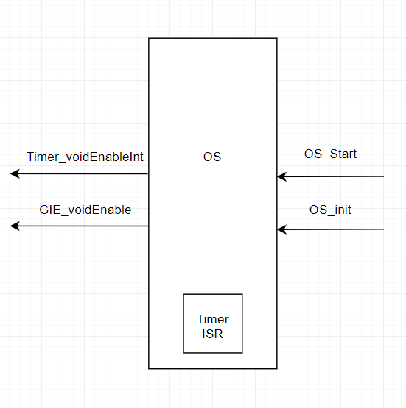

# *External Interface*

## File name: STD_TYPES.h

### Types

|  |  |
| --- | --- |
| U8 | unsigned char |
| U16 | unsigned short int |
| U32 | unsigned long int |

## File name: Timer_int.h

# Static Design

## Files

### Used Files

|  |  |
| --- | --- |
| FILE NAME | Description |
| OS.h | Contains all the public interfaces and functions to be available for anyone who uses the OS driver |
| OS.c | Contains the implementation of those interfaces and functions used in OS driver |
| OS_cfg.h | Contains the different configuration that the user can use for the OS driver |
| OS_cfg.c | Contains the implementation of those configuration selected by the user in the OS driver |

### Files Inclusion

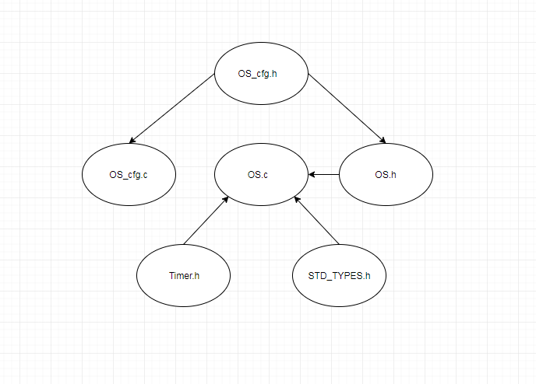

## Types

|  |  |
| --- | --- |
| Requirement ID | OS_001 |
| Covers | HLD_001 |
| Name | OS_cfg_t |
| Type | Structure |
| Range | void (*pftask)(void)  u16 periodicity |
| Description | It use to configure the specifications of each task which are the task function name and periodicity |

## Const

|  |  |
| --- | --- |
| Requirement ID | OS_002 |
| Covers | HLD_001 |
| Name | OS_cfg |
| Type | OS_cfg_t array |
| Range | It’s an empty array |
| Description | It’s an array contains the configuration specs of each task and to be filled by the configurator |

|  |  |
| --- | --- |
| Requirement ID | OS_003 |
| Covers | HLD_001 |
| Name | NoOfTasks |
| Type | u8 |
| Range | Number of tasks |
| Description | Its describe the number of the task in the system to be configure |

## Interface (Services) OS_int

|  |  |  |  |
| --- | --- | --- | --- |
| Requirement ID | OS_004 | | |
| Covers | HLD_001 | | |
| Name/prototypes | void OS_init (void); | | |
| Service ID | fr_001 | | |
| Re-entrant / Non re- entrant | Non re- entrant | | |
| Synchronous/Asynchronous | Synchronous | | |
| Return Value | | void | No return value |
| Input parameter | | void | No input parameters |
| Output parameter | | void | No output parameters |
| Input /Output Parameter | | void | No input/Output parameters |

|  |  |  |  |
| --- | --- | --- | --- |
| Requirement ID | OS_004 | | |
| Covers | HLD_001 | | |
| Name/prototypes | void OS_Start (void); | | |
| Service ID | Fr_002 | | |
| Re-entrant / Non re- entrant | Non re- entrant | | |
| Synchronous/Asynchronous | Synchronous | | |
| Return Value | | void | No return value |
| Input parameter | | void | No input parameters |
| Output parameter | | void | No output parameters |
| Input /Output Parameter | | void | No input/Output parameters |

# *Dynamic Design*

## Mode Management

## Sequence Diagram

The OS module doesn’t use any other interfaces or communicate with other module it just mange the calling each task on time and also responsible of the management of the each task periodicity

# *Shared Resources*

## Analysis

## Protection

# *Configuration Parameters*

## Pre-compile time

## Link time

## Post-build

# *Configuration Constrains*

# *Integration Constrains*

You have to call the OS_init before start running the OS.

# *History*

18/4/2018: Document Created

20/4/2018: Fill the sequence mode section