Component Design Document

For

<Buzzer Module>

**Table of Contents**

Revision History 2

*1. Introduction* 3

1.1 Objective 3

1.2 Context Diagram 3

2. *External Interface* 3

2.1 <file name.h> 3

3. *Static Design* 4

3.1 Files 4

3.2 Types 5

3.3 Symbol Define <#define> 5

3.4 Const 5

3.5 Interface (Services) 6

*4.* *Dynamic Design* 6

4.1 Mode Management 6

4.2 Sequence Diagram 6

*5.* *Shared Resources* 6

5.1 Analysis 6

5.2 Protection 6

6. *Configuration Parameters* 7

6.1 Pre-compile time 7

6.2 Link time 7

6.3 Post-build 7

*7.* *Configuration Constrains* 7

*8.* *Integration Constrains* 7

*9.* *History* 7

Revision History

|  |  |  |  |
| --- | --- | --- | --- |
| **Name** | **Date** | **Reason For Changes** | **Version** |
| Ismail samy | 17th April 2018 | Create the template | 1.0 |
|  |  |  |  |
|  |  |  |  |
|  |  |  |  |
|  |  |  |  |

# *1. Introduction*

## Objective

Buzzer will perform a specific tone during user interactions with the system as indicator for actions that performed

## Context Diagram

# *External Interface*

## <STD_TYPES.h>

### Types

|  |  |
| --- | --- |
| Data Type | Description |
| u8 | typedef unsigned char |
| u16 | typedef unsigned short int |
| u32 | typedef unsigned long int |
| u46 | typedef double |
| S8 | typedef signed int |

## <Buzzer_Config.h>

### Types

|  |  |
| --- | --- |
| Data Type | Description |
| #define | Buzzer_u8_PIN_0 DIO_u8_PIN_0 |

## <Buzzer_Init.h>

### Types

|  |  |
| --- | --- |
| Data Type | Description |
| u8 | typedef unsigned char |

### Interface

|  |  |
| --- | --- |
| Function | Description |
| extern Void Buzzer_voidSetBuzzerOn(void) | Set buzzer ON |
| extern Void Buzzer_voidSetBuzzerOff(void) | Set buzzer OFF |

## <Buzzer_Prog.c>

### Interfaces

|  |  |
| --- | --- |
| Function | Description |
| DIO_voidSetPinValue | Set buzzer PIN HIGH OR LOW |

# *Static Design*

## Files

### Used Files

|  |  |
| --- | --- |
| FILE NAME | Description |
| STD_TYPES.h | Includes standard type definitions |
| Buzzer_prog.c | Includes the implementation of functions |
| Buzzer_Init.h | includes function prototypes |
| Buzzer_Config.h | includes Pin configurations |

### Files Inclusion

Buzzer_Init.h

Buzzer_Config.h

Buzzer_Prog.c

STD_TYPES.h

## Types

|  |  |
| --- | --- |
| Req ID | DIO_001 |
| Covers | HLD_004 |
| Name | DIO_pinName |
| Type | Enumeration |
| Range | It’s Configuration |
| Description | ------------------------ |

## Symbol Define <#define>

|  |  |
| --- | --- |
| Req ID | DIO_001 |
| Covers | HLD_004 |
| Name | DIO_pinName |
| Type | Enumeration |
| Range | It’s Configuration |
| Description | ------------------------ |

## Const

|  |  |
| --- | --- |
| Req ID | DIO_001 |
| Covers | HLD_004 |
| Name | DIO_pinName |
| Type | #define |
| Range | It’s Configuration |
| Description | ------------------------ |

## Interface (Services)

|  |  |  |  |
| --- | --- | --- | --- |
| Req ID | BUZ_001 | | |
| Covers | HLD_00 | | |
| Name/protoTypes | Void Buzzer_voidSetBuzzerOn(void) | | |
| Service ID | Enumeration | | |
| Re-entrant / Non re- entrant | It’s Configuration | | |
| Synchronous/Asynchronous | ------------------------ | | |
| Return Value | | Void | DESCRIPTION |
| Input parameter | | Void | DESCRIPTION |
| Output parameter | | Void | DESCRIPTION |
| Input /Output Parameter | | Void | DESCRIPTION |

# *Dynamic Design*

## Mode Management

<Draw the state diagram for the component if it’s not exist don’t draw it >

## Sequence Diagram

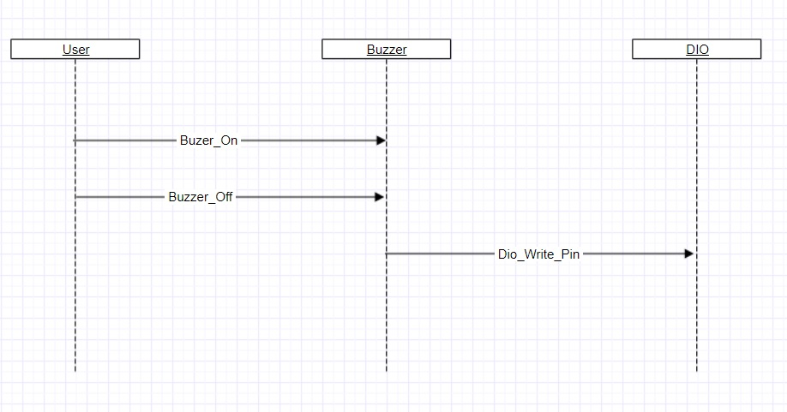

# *Shared Resources*

## Analysis

### There is no shared Variables

## Protection

### There is no shared Variables

# *Configuration Parameters*

## Pre-compile time

### < #define Buzzer_u8_PIN_0 DIO_u8_PIN_0>

## Link time

### el variable el const ely bn3ml beh configuration zy fel dio

## Post-build

### <lma el configuration tb2a bt3ml fel run-time>

# *Configuration Constrains*

There is possibility to create 32 Dio_PIN_N, when N number of PINS doesn’t exceed 32

# *Integration Constrains*

Inclusion for Buzzer­_Init.h, Buzzer_Config.h to initialize the module drivers

# *History*

|  |  |
| --- | --- |
| Date | Description |
| 18/4/2018 | Editing for sequence diagram,  Shared resources, configuration constrains and integration constrains |