Software Requirements Specification
for
Air Conditioner
Version 1.0 approved
Prepared by Development Team
2/4/2018
Table of Contents
Table of Contents ii
Revision History ii
1. Introduction 1
1.1 Purpose 1
1.2 Document Conventions 1
1.3 Intended Audience and Reading Suggestions 1
1.4 Product Scope 1
1.5 References 1
2. Overall Description 2
2.1 Product Perspective 2
2.2 Product Functions 2
3. External Interface Requirements 3
3.1 User Interfaces 3
3.2 Hardware Interfaces 3
3.3 Software Interfaces 3
3.4 Communications Interfaces 3
4. System Features 4
4.1 System Feature 1 4
4.2 System Feature 2 (and so on) 4
5. Other Nonfunctional Requirements 4
5.1 Performance Requirements 4
5.2 Safety Requirements 5
5.3 Security Requirements 5
5.4 Software Quality Attributes 5
5.5 Business Rules 5
6. Other Requirements 5
Appendix A: Glossary 5
Appendix B: Analysis Models 5
Appendix C: To Be Determined List 6

Revision History
Name | Date | Reason For Changes | Version
Sara Safwat, Hadeel Yamni | 3/4/2018 | Initial Review | 1.0.0

Introduction
This section gives a scope description and overview of everything included in this SRS document. Also, the purpose for this document is described. Also a list of abbreviations and definitions is provided.

Purpose
The purpose of the Software Requirements Specification document is to clearly define the system under development, namely “AIR Conditioner System”. It will illustrate the purpose and complete declaration for the development of system. It will also explain system constraints and interfaces. This product is targeting “Air Conditioner users”.

Product Scope
Our Air Conditioner is a system for controlling the degree of temperature, typically to maintain a cool atmosphere in warm conditions or to maintain a warm atmosphere in cool conditions.
Our system support three modes which are temperature and fan display on LCD with size 2*16, temperature adjust in the range of 16 to 32 degree with default temperature 16 ,and fan adjust in three levels low, medium and high with default speed low . But the system does not support dealing with touch screen Displays, wireless communication between buttons and LCD nor dealing with voltage less or more than 9 volts.
We made it as user friendly as possible to deal with simple users.

Definitions, Acronyms and abbreviations
A table of definitions, acronyms and abbreviations is provided in Appendix A.

References
IEEE Std 830-1998 IEEE Recommended Practice for Software Requirements Specifications.

Overview

This document is designed to provide information to both the client and the technical designers of the software. Section one is a brief overview of the product, including definitions and references.
The remainder of this document includes three sections and appendixes.
The second one provides a more detailed description of the product.
The third section provides a list of the functional requirements of the system.
The fourth is about its nonfunctional requirements.

Overall Description
This section will give an overview of the whole system. The system will be explained in its context to show how the system interacts with other systems and introduce its basic functionality. It will also describe the type of stakeholders that will use the system and what functionality is available.

2.0.1 Use Cases:

2.0.2 Start and stop the system
Use Case Name | Turn ON/OFF
Trigger | The user wants to start the system or stop the system
Precondition | The system Starts only if the system was off and vice versa
Basic Path | The user pushes the ON/OFF button .  If the system was ON , the system will wait 5 sec to turn off .  If the system was off , the system will start and takes 5 sec to start it's functionality and to start responding to the push buttons.
Alternative Paths | If the user pushes the ON/OFF button more than once during 5 sec the system will not respond.
Postcondition | 1-In case of starting the system the LCD will display the default temp and all the buttons are ready to be used.  2-In case of stopping the system the system will shut down and the LCD will turn off after 5 sec.
Exception Paths | If the user wanted to turn on the system while being on it will turn OFF and vice versa.

2.0.3 Mode of operation
Use Case Name | Choosing Mode
Trigger | The user switches between displaying mode and adjusting mode.
Precondition | 1-The system is already ON for 5 sec.
Basic Path | The user pushes the Mode button.  2-The LCD will display that the current mode is display mode or adjust mode.  3- In case that the current mode is display mode, the LCD will show the current temp and the current fan speed.  4-In case that the current mode is adjust mode, a cursor on the LCD will show that we are in fan speed adjust or temp adjust.
Alternative Paths | 1-If the user pushed the mode button multiple times it will circulate between modes.
Post condition | Depending on how many times the user will push the mode button, the system will switch between display mode , adjust temp mode or adjust fan speed mode successfully.
Exception Paths | 1-If the user tried to increase or decrease either the temp or the fan speed when operating in the display mode the system will not respond.  2- If the user pushed the buttons within 5 sec after the system is turned on or off the system will not respond.

2.0.4 : Increasing / decreasing fan speed or temp

Use Case Name | Adjusting temp and fan speed
Trigger | Increasing or decreasing either the temp or the fan speed.
Precondition | 1-The system must be ON.  2-The user must be on the fan adjust mode to control the fan speed.  3-The user must be on the temp adjust mode to control the temp.
Basic Path | 1- If the system is on the adjust temp mode , the user will be able to increase or decrease the temp.  2- If the system is on the adjust fan speed mode , the user will be able to increase and decrease the fan speed.
Alternative Paths | 1-If the user pressed on increase or decrease button for a long time , it will act as only one button press.
Post condition | 1- If the system is on the adjust temp mode , the temp will change (decrease or increase) and will be displayed on the LCD.  2- If the system is on the adjust fan speed mode , the fan speed will change (decrease or increase) and will be displayed on the LCD.
Exception Paths | 1- If the user tried to control either the temp or the speed of the fan while being in the display mode the system will not respond.  2-If the user tried to adjust either the temp or the fan speed during 5 sec after the system starts the system will not respond.  3-If the user wanted to increase the temp above 32 or decrease the temp below 16 the system will not respond.

2.1 Product Perspective
The system is an air conditioner remote control. The main purpose of the system is displaying the air conditioner temperature and fan speed. It also provides options for the user to adjust them. The remote has a friendly user interface. The objective of our product is using the technology to have control of the air conditioner without doing any effort.
The system will cost approximately 300 EGP.
Also it will be configurable to add more features.

2.2 Product Functions
The project will consist of 3 main parts:
- A Microcontroller for handling the different tasks in the System.
- LCD for monitoring the system status and the adjustment options.
- Four push button to control the system.

1-The Microcontroller is the main brain of the system which communicate between the
different components of the system and also doing all the processing needed to
accomplish any task.

2-The LCD (Liquid Crystal Display) is used to display the different modes:
- Current temperature and fan speed.
- Adjust the temperature.
- Adjust the fan speed.

3- Four push button:
- The first is used to turn On/Off the system.
- The second is used to change between modes
- The third and the forth are used to increase and decrease the temperature degree in the temperature adjusts mode and the fan speed in adjust fan mode.

When the system is turn on it won’t respond to any command for 5 seconds which is called “Delay Starts” and also when it turn off it won’t respond to any command for 5 seconds which is called “Delay Stop”.

3 User Interface
User will deal with LCD displaying information about fan speed, operation mode, with 5 push
buttons that allow user to switch between modes of operation to control the system

3.1 Hardware Interface
Including character LCD size (2*16) connected with 5 press buttons to interact with functionality of system with a voice indicator that varies with every press or every mode state of the system
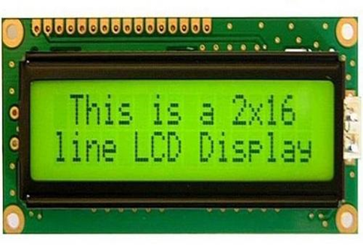
1-2*16 character LCD

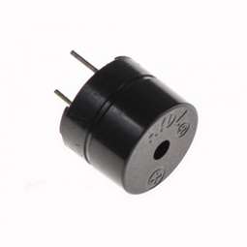
2- Push button 3- Buzzer

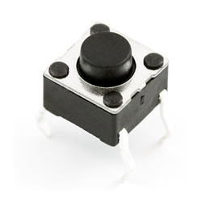

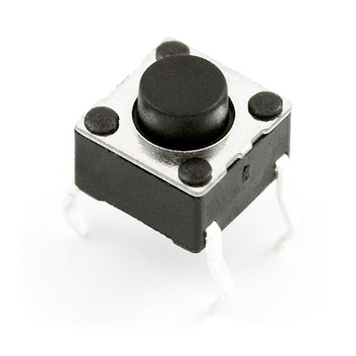

4-avr microcontroller
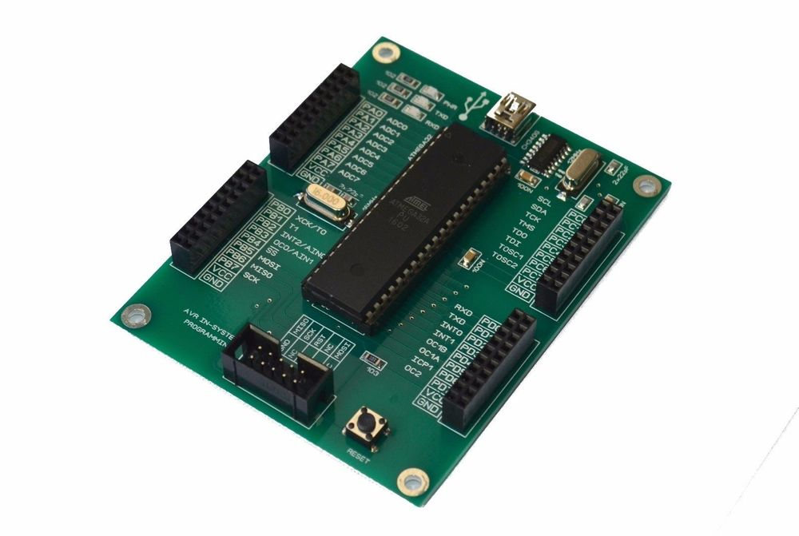

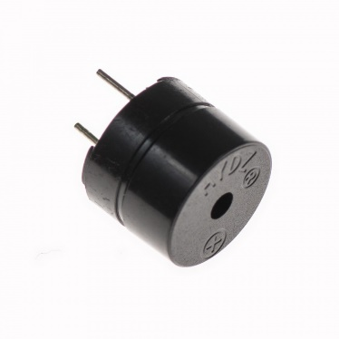

3.2 Software Interfaces
Eclipse IDE that runs on Microsoft windows and ubuntu platforms with minimum requirements, also preinstalled Java JDK, JRE API’s making an environmental variable path, and integrated commercial components. Identify you can use this IDE for C Programming methodologies, to connect Hardware platform with PC you have to install WinAvr tool that contain GCC cross tool compiler, then to make it ready install USBASP Hardware driver if you use Windows 8 and later

3.3 Communication Interfaces
Using USB UART communication protocol that copy .hex files into AVR processor ROM, verifying the code to be implemented correctly on the target

