<Project Name>
Configuration Management Plan
Version Number: 1.0
Version Date: <05/04/2018>

VERSION HISTORY
[Provide information on how the development and distribution of the Configuration Management Plan will be controlled and tracked. Use the table below to provide the version number, the author implementing the version, the date of the version, the name of the person approving the version, the date that particular version was approved, and a brief description of the reason for creating the revised version.]
Version  Number | Implemented  By | Revision  Date | Approval  Date | Description of  Change
1.0 | <Engy Zinhom> | <05/04/18> | <4/5/2018> | <implementation>
1.1 | <Dina Helmy> | <06/4/2018> | <4/6/2018> | <editing>
1.1 | <Enas Taher> | <06/4/2018> | <4/6/2018> | <update and review>

TABLE OF CONTENTS
1 Introduction 4
1.1 Purpose of The Configuration Management Plan 4
2 Configuration Management 4
2.1 Overview 4
3 Configuration Management Activities 4
3.1 Configuration Management Planning 4
3.1.1 Roles and Resbonsibiltes 4
3.1.2 Configuration Management Strategies 4
3.1.2.1 Configuration Management Tools 4
3.1.2.2 Folder Structure of ACS Project 4
3.2 Configuration Identification 4
3.3 Configuration Control 5
3.4 Configuration Auditing/Reporting 5

4 Configuration Management (CM) Resources………………………………4
4.1 Configuration Management (Cm) Support Environment 7

Introduction

This document describes the Configuration Management (CM) activities to be performed in support of Air Conditioner Screen (ACS) Project. Air Conditioner Screen is our product that aims to change the air conditioner temperature, change the air conditioner fan speed and display it on digital screen also switch on/off by push button. The system is planned as an LCD and up and down buttons to change the temperature degree, up and down buttons to change the fan speed and push button for switch on/off.
Our company is searching for simple Air Conditioner Screen. So, there are no specific target users. Users can be uneducated and have no technical expertise at all. Product is simple and can suit all user segments.
Our product has three major features "milestones", the first one is Changing Temperature degree, and the second one is Changing Fan speed, and the last one Display all modes on an LCD screen.

1.1 Purpose of The Configuration Management Plan
The overall objective of a Configuration Management (CM) Plan is to document and inform project stakeholders about CM with the project, what CM tools will be used, and how they will be applied by the project to promote success. The <DACS> CM Plan defines the project’s structure and methods for
- Identifying, defining, and baselining configuration items (CI)
- Controlling modifications and releases of CIs
- Reporting and recording status of CIs and any requested modifications
- Ensuring completeness, consistency, and correctness of CIs
- Controlling storage, handling, and delivery of the CIs

The intended audience of the CM Plan is the project manager, project team, project sponsor and any senior leaders whose support is needed to carry out communication plans.

Configuration Management

OVERVIEW
Configuration management determines clearly about the items that make up the software or system ,These items include source code, test scripts, hardware, data and both development and test documentation.
Configuration management is also about making sure that these items are managed carefully, thoroughly and attentively during the entire project and product life cycle.

Configuration Management Activities

3.1 CONFIGURATION MANAGEMENT PLANNING

3.1.1 Roles and Resbonsibiltes
Role | Team Name | Resbonsibiltes
Configuration controller | Enje Zinhom | Have full authority on Repository (READ – WRITE – DELETE – REVIEW – ADD) and Make team members access on Remote Repo.
Members | Abdallah Fathy | Full Access on Repository
Members | Esmail Samy | Full Access on Repository
Members | Hager Mohammed | Full Access on Repository
Members | Saber Osman | Full Access on Repository
Members | Sara Rashwan | Full Access on Repository
Members | Youssef Medhat | Full Access on Repository
Members | Enas Taher | Full Access on Repository
Members | Dina Helmy | Full Access on Repository
Members | Hadeel Yamni | Full Access on Repository
Members | Engy zenhom | Full Access on Repository
 | Yasmine Yehia

3.1.2 Configuartion Management stargeie

3.1.2.1 Configuration management tools
This section describes configuration Management tool that used in our project to make our communication easily as teams to deal with versions of Code and establish remote Repository.

We used GitHub and Tortoise Git to push and pull everything belong to our project
GitHub is a distributed revision control system with an emphasis on speed, data integrity and support for distributed workflows.

Tortoise Git is a free open-source client for the Git version control system. That is, Tortoise Git manages files over time. Files are stored in a local repository.

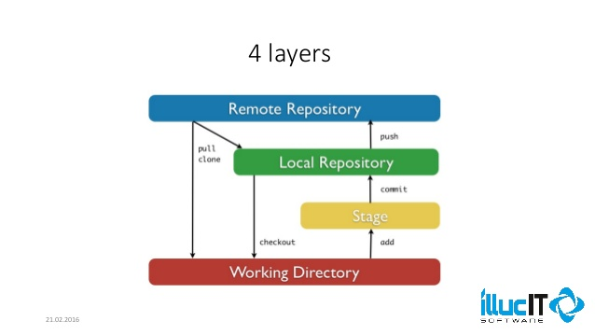

3.1.2.2 Folder Struture of ACS project
this section describe folder structure of ACS Project that help us in our configuration management to provide control of the deliverables and avoiding mistakes and misunderstandings. It is an integral part of quality management.
So we start with building our Repository
First start with Master that have two main folders and every folder contain sub folders:
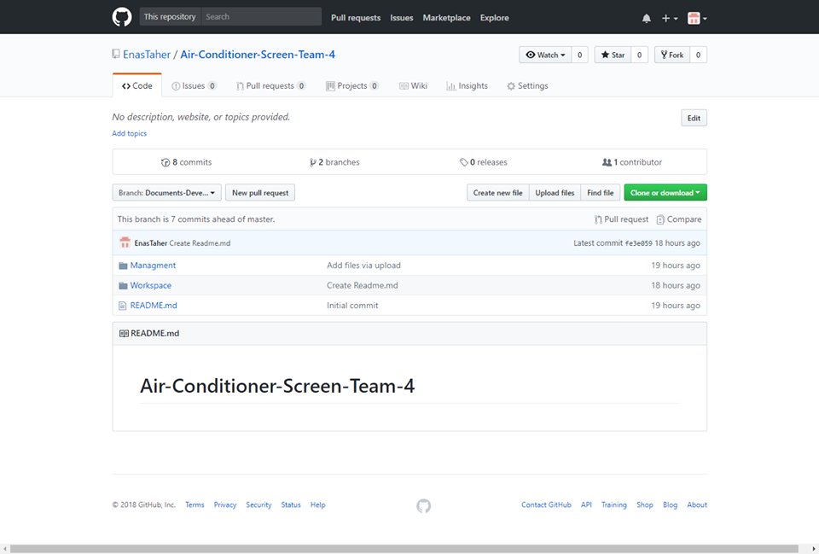
Figure 3.1.2.2 Describe Folders on our Repository on GITHub
- Work space
Its Sub Folders:
- Code
- Design
- Testing that contains documents (Test Cases – Bug Reports).
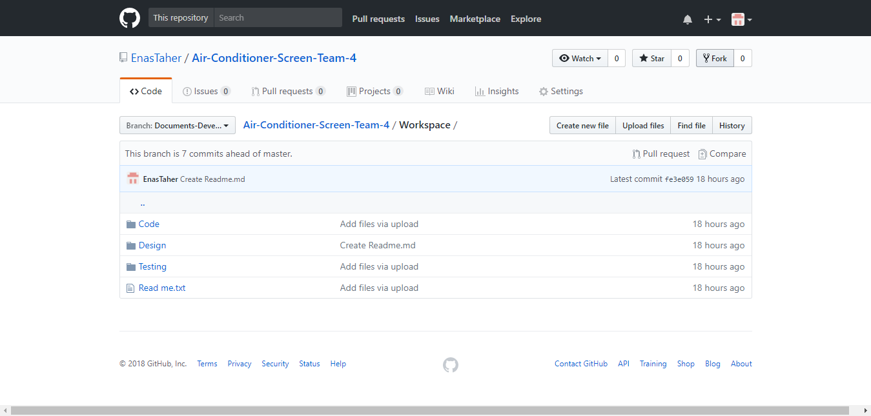
- Management
Its Sub Folders:
- Plan that contain documents (Project Planning – Test Plan – CM Plan).
- Requirements that contain documents (SRS – CRS – SIQ – Review log).
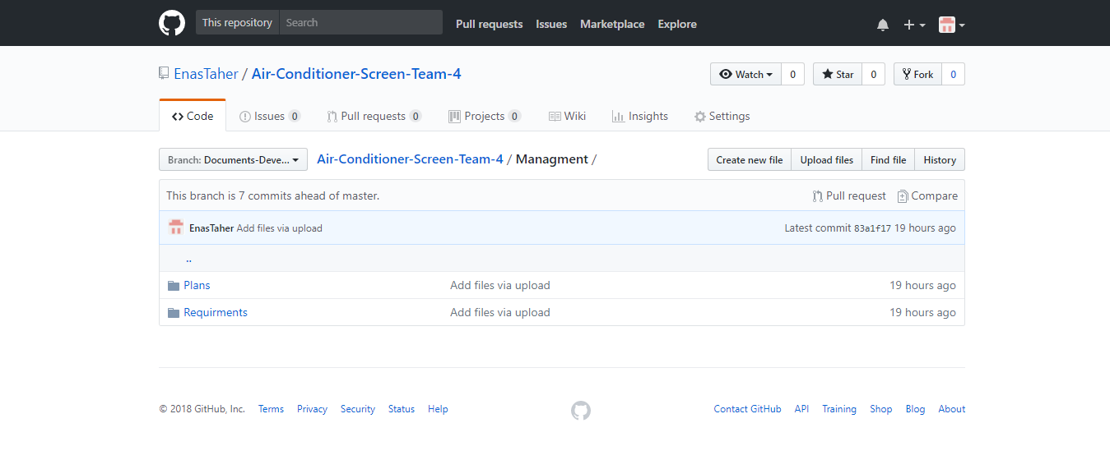

Configuration Identification
Configuration identification forms the cornerstone upon which all CM activities are based. Configuration identification is an element of CM that is concerned with selecting the CIs for a system or product, assigning unique identifiers and naming conventions, and recording their functional and physical characteristics in technical documentation. A CI is defined as an aggregation of hardware, software, or both that is designated for CM and treated as a single entity in the CM process (IEEE Std 610.12-1990). This section specifies the configuration identification activities to be performed during the ACS Lifecycle, including identifying CIs, naming CIs, and acquiring CIs.

3.2.1 Identifying ACS Baselines
A baseline is a logical grouping of Configuration items that constitute the system. Baselines provide a fixed reference to specify the Configuration items at a particular milestone event or point in time. A baseline establishes an approved standard upon which subsequent work can be made. After an initial baseline is established, changes to the baseline can only be performed through a formal change request process.
After Confirmation from all team members with our leaders, our baselines will be set Weekly.

The DACS CM establishes four (3) types of baselines as shown in Figure 3-1: DACS Project Milestones and Baselines.
• Documents baseline (SRS)
• Functional baseline (Source Code)
• Test Cases Baseline

Baseline in our project will be as shown in Figure 3-1

Baseline items | Who | When
Documents Baseline (SRS) | Abduallah, Ismail, Sara, Saber, Yossef,  Hager | After gathering requirements  ,Establish SRS and finish it.
Functional baseline (Source Code) | Abduallah, Ismail, Sara, Saber, Yossef,  Hager | After Finishing development and made unit testing.
Test Cases Baseline | Yasmin, Enas, Dina, Sara, Hadeel | After Finishing preparation of test cases and reviewing it.

Figure 3.2.1 : DACS Project Milestones and Baselines

Configuration Control
This Section that all changes to configuration items are documented. An important aspect is the ability to identify the interrelationships between configuration items. This is essential information for the ‘review’ and ‘assessment’ steps in the change control process;

Configuration Auditing/Reporting
This is used to determine whether a deliverable conforms to its requirements and configuration information. Typically, an audit is undertaken at the end of a phase, stage by review log.
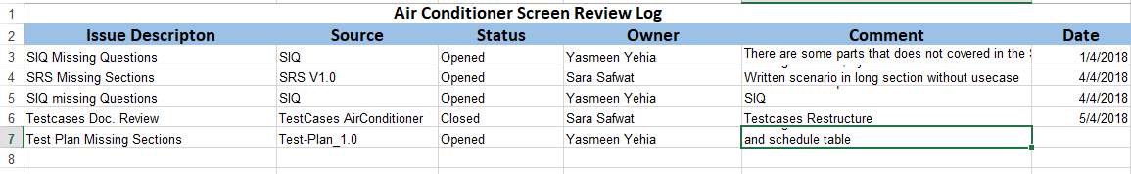

Configuration Management (CM) Resources

Configuration Management (CM) Support Environment
Currently, the CM support environment is maintained within the GitHub server as illustrated in Figure 4-1, ERA Configuration Management (CM) Support, below. The GitHub server has a partitioned area that is reserved for the ACS project. Currently security, maintenance (including backup and recovery of data), and access control for CM databases is maintained by the ACS staff. Access control is applied to each of the CM databases and managed by the ACS staff. CM is applied to the database to ensure that the configuration of the tool is documented and controlled.

