Cover Page
Table of Contents

Introduction

Problem Statement and Proposed Solution
This section describes the problem and how you intend to solve it.

System Description and Block Diagram

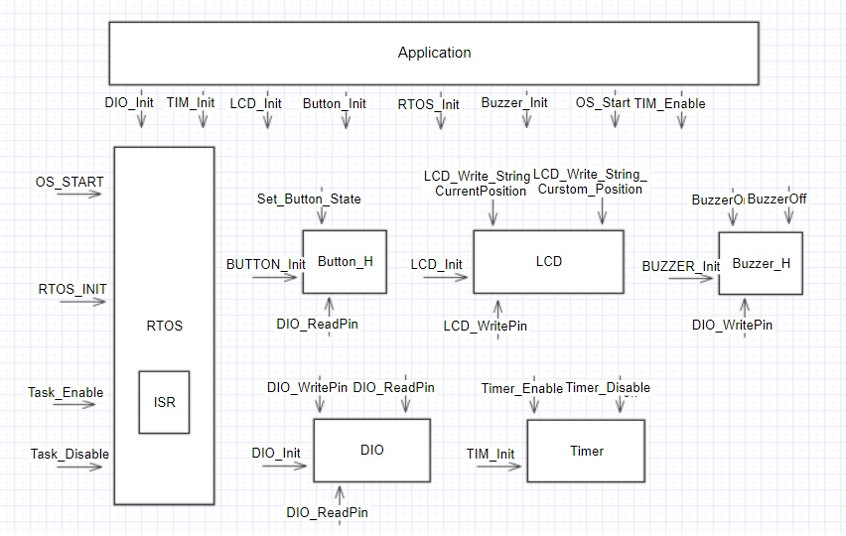

System Requirements

Overall System:
Give the overall system requirements. These requirements should describe what your system does (and what will be demonstrated in May.) There are detailed subsystem descriptions in the subsequent section.

Subsystem Requirements:
The requirements of each subsystem or major interface are described here by subsystem. These lower level requirements support the overall system requirements. Note that major interfaces (such as a wireless interface) should be described like any other subsystem. Don’t forget that there will be software as well has hardware in many of the subsystems, and that software will have requirements.

Future Enhancement Requirements
There may be a number of features that aren’t going to be part of the initial release of your product, but that you would like to add in the future. These are listed here so that the design does not preclude adding these features.

High Level Design Decisions
Broken down by subsystem and major interface, this section presents your high level design of each subsystem or interface.

For each subsystem or major interface, you should describe the function or interface and the appropriate technologies that will go into the subsystem. The decision level here is not necessarily to the specific part, but rather to a technology.

For example, if your system is using a wireless interface, your design should include the choices you considered for the wireless interface, the technology you chose to use, and why that technology choice was made (requirement such as size, cost, speed, power, etc. might all be issues for a wireless technology.) The specific part that you will be using can be left to the low level design.

In like fashion, if a subsystem contains embedded intelligence, it is not necessary to specify the specific microcontroller that you will be using. The requirements listed earlier should allow you to specify a class of microcontrollers (based again on requirements like cost, power (electrical), power (processing power), I/O and interface requirements, etc.)

Major Component Costs
Specify the costs of your major system components. This should allow you to have a rough cost estimate of your system.

Conclusions
References

