**Step 1**   
Go To this path First

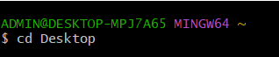

**Step 2**

Run this command

ssh -i eric.pem ubuntu@15.207.62.79



**Step 3**

If you run step 2

command you got this type view  
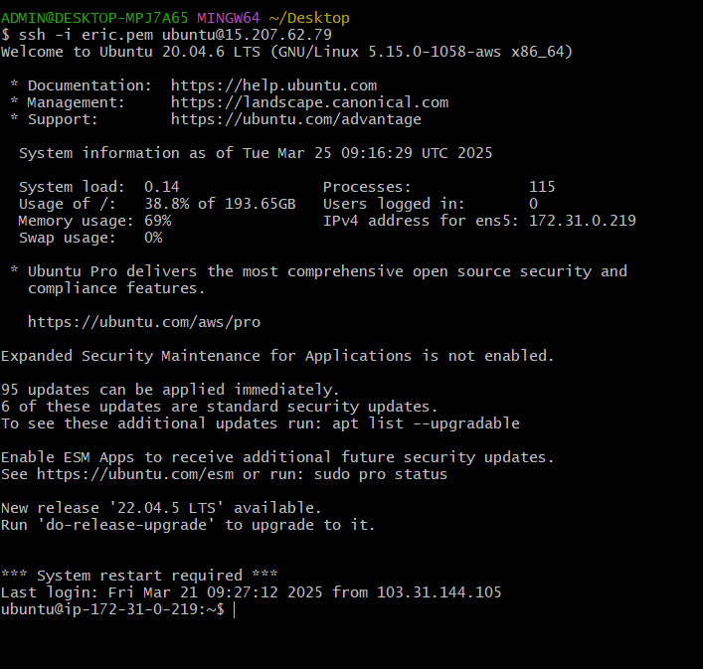

**In last line add this path**

**\*And click enter  
*IMP* = > /var/www/html/larssie/service/snippets**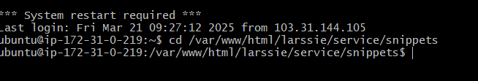

**Step 4  
  
in last line add this command**php report_mail_script.php  
  
  
  
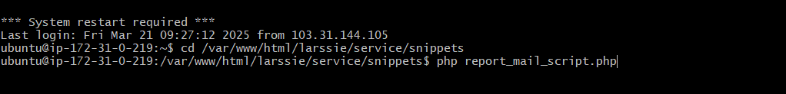

If script is stop  
  
**Check the Last Edit Time:**

Go to the filzila directory and check the last edit time of the script file.

If the edit time is more than **15 minutes old**, proceed with the following steps.

1. **Modify report_mail_script.php:**
   * Open report_mail_script.php.
   * Go to **line 72** and ensure this line is present:
   * $this->getdbandimport();
   * Go to **line 281** and do the following:
     + **Uncomment** this query:
     + $rd_datas = $this->db_query("SELECT * FROM `oc_manufacturer` WHERE `manufacturer_id` IN (" . $manufacturer_string . ") AND `manufacturer_id` > 82 ORDER BY `manufacturer_id` ", $this->link);
     + **Comment out** this query:
     + $rd_datas = $this->db_query("SELECT * FROM `oc_manufacturer` WHERE 1=1 AND `manufacturer_id` IN (" . $manufacturer_string . ") ORDER BY `manufacturer_id` ", $this->link);
     + Retrieve the **last manufacturer_id** from service.txt and add it in line 281.