
NED University of Engineering & Technology
Karachi
Department of Software Engineering

COMPLEX ENGINEERING ACTIVITY (CEA)

Technical Report
Design, Deployment, and Cloud-Native Enhancement of a Three-Tier Web Application
Project: BidBazaar – Online Auction Platform on AWS
Course | Cloud Computing
Course Code | SE-490
Section | [Section]
Instructor | Miss Amna

Group Members
Name | Roll No.
Ammar | [Roll No.]
[Member 2] | [Roll No.]
[Member 3] | [Roll No.]
[Member 4] | [Roll No.]

Source code: https://github.com/Enayat-Ur-Rehman/BidBazaar

1. Chosen Cloud Provider and Justification
BidBazaar is an online auction website. People can look at auctions, sign up, place bids and pay a deposit when they win. Auctioneers can create auctions, and an admin checks the payments. In this project we put the app into containers, put it on the cloud, and made a pipeline that builds, tests and updates the live site.
We chose Amazon Web Services (AWS) because:
- It has every service the project needs (network, load balancer, auto scaling, image storage, logs).
- We had a free account with credits, so it cost very little.
- GitHub can log in to AWS without saving any password or key.
- There is a lot of help and guides online.
We used the us-east-1 region because it is one of the cheapest and has all the services we needed.

2. Overall Architecture and Design Decisions
Figure 1 shows how the system is set up. Everything is written as code with Terraform, so the whole setup can be made or deleted with one command.
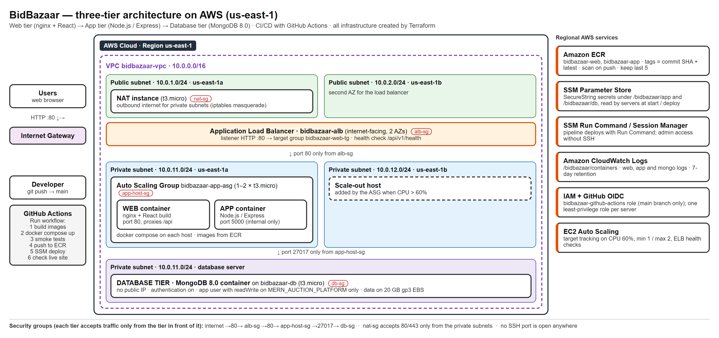
Figure 1: BidBazaar architecture on AWS
A user opens the website and the request goes to the load balancer. The load balancer sends it to a server in a private network. On that server, one container shows the website (Nginx) and another runs the backend (Node.js). Only the website container can talk to the backend. The backend saves data in MongoDB, which runs on its own private server.
The network is split into public and private parts in two zones (Table 1).
Subnet | Address range | Internet route | What is inside
Public | 10.0.1.0/24, 10.0.2.0/24 | Internet Gateway | Load balancer, NAT server
Private | 10.0.11.0/24, 10.0.12.0/24 | NAT server (outgoing only) | App servers and database
Table 1: Network layout

The private servers can go out to the internet (for updates and images) through the NAT server, but nobody from the internet can come in.
Main decisions:
- Two zones, so the site keeps working if one zone has a problem.
- The website and backend containers run together on each server. This is cheaper and still keeps the backend private.
- MongoDB runs in a container on its own server, because the managed version is too expensive.
- Any server can handle any user, so we can add more servers easily.
- A small NAT server instead of AWS NAT Gateway, to save about $25 a month.

3. Services Used and Their Role in Each Tier
Part | AWS service | What it does
Network | VPC, subnets, Internet Gateway, NAT server | Keeps public and private parts separate
Web tier | Load balancer, Auto Scaling, Nginx container | Receives users and shows the website
App tier | Node.js container | Handles auctions, bids, users and payments
Database | Server with MongoDB | Stores all data; password protected; private
Images | Amazon ECR | Stores the container images
Scaling | Auto Scaling | Adds a second server when busy (CPU over 60%)
Security | Security groups, IAM, Parameter Store | Firewalls, permissions and secret storage
Monitoring | CloudWatch Logs, Run Command | Keeps logs and updates servers without logging in
Table 2: AWS services used

Extra features. We also used Terraform (setup as code), CloudWatch (central logs) and made a cost estimate. The setup costs about $53 per month. Details are in Appendix A.9.
To save money we used a small NAT server, put both containers on the same server, used small t3.micro servers, and stop the servers when not in use.

4. Containerization and CI/CD Pipeline Design
We made two container images. The website image builds the React app and serves it with Nginx. The backend image runs the Node.js server. A docker-compose file starts the website, backend and database together, so the same setup works on a laptop, in GitHub and on AWS.
On AWS, each server runs a small script that gets the secrets, downloads the newest images and starts the containers. New servers run the same script, so they always have the latest version.
The pipeline runs when we click Actions → CI/CD - Build, Test, Deploy → Run workflow in GitHub (Table 3).
Step | What happens
1. Build | Builds the website and backend images
2. Start | Starts all three parts on GitHub's machine
3. Test | Checks the website and backend are working
4. Upload | Uploads the images to AWS (ECR)
5. Deploy | Tells the AWS servers to download and run the new images
6. Check | Opens the live site to make sure it works
Table 3: Pipeline steps

If a test fails, nothing is deployed. Each image is labeled with its commit, so we know which version is live.

5. Security Considerations
Measure | What we did
Firewalls | Each part only accepts traffic from the part before it (internet → load balancer → app → database)
Private network | Only the load balancer and NAT server are public. App and database are hidden.
Limited permissions | Each server and GitHub only get the permissions they really need
Secrets | Passwords and keys are kept in AWS Parameter Store, not in the code
Database | MongoDB needs a username and password (Appendix A.5)
No SSH | No open login port; we use AWS tools to manage servers
App | Passwords are encrypted and users can only open pages for their role
Table 4: Security measures

6. Testing Results and Automated Deployment
Test | What we checked | Result
Pipeline tests | Website, backend and database work together | 4 / 4 passed
Browser tests (Playwright) | Login, sign up, auctions, bids and payments in 3 browsers | 54 / 54 passed
Error tests | Pages don't crash when the server fails | 6 / 6 passed
API tests | Create, read, update and delete data | 4 / 4 passed
Database security | Database refuses access without a password | Passed (Figure 23)
Pipeline | Build, test, upload and deploy | Passed (Appendix A.8)
Live site | Site opens through the load balancer | Passed (Appendix A.10)
Table 5: Test results

The tests helped us find and fix some bugs, like a missing page route and forms that failed without showing an error. On AWS we also fixed a few setup problems, such as the database not starting on a new Linux version and a hard-coded localhost address.
To test the pipeline, we changed the home page footer from dark gray to white, pushed the change and ran the workflow. It finished in under 2 minutes and the change showed up on the live site (Figure 2).
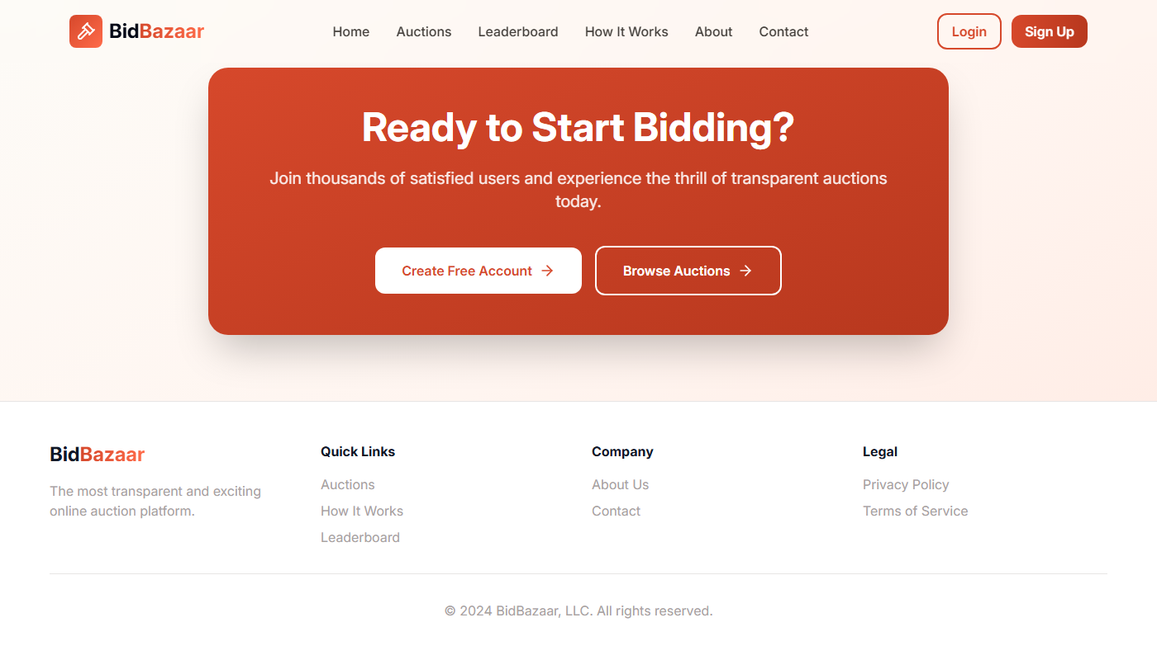
Figure 2: Live site after the update: the footer is now white

7. Non-Functional Requirements Justification
Requirement | How we met it | What can be improved
Scalability | A second server is added automatically when busy | Use more than one database server
Availability | Two zones; broken servers are replaced automatically | Run 2 servers all the time
Elasticity | Servers are added and removed based on load | Allow more than 2 servers
Security | Private network, firewalls, stored secrets, no SSH | Add HTTPS with a domain name
Maintainability | One click updates the live site | Update without any downtime
Performance | Nginx serves the website quickly | Add a CDN for faster loading
Cost | About $53 per month with small servers | Savings reduce availability
Portability | Containers can run on any cloud | Add Kubernetes support
Table 6: Non-functional requirements

Two requirements are not fully met: availability (only one database and one NAT server) and security (no HTTPS because we have no domain name). We did this to save cost, and both can be fixed later.

Appendix A: Deployment Evidence
These screenshots are from our live AWS setup, GitHub and the browser. “CLI output” means real command output.

A.1 Network / VPC configuration and subnets
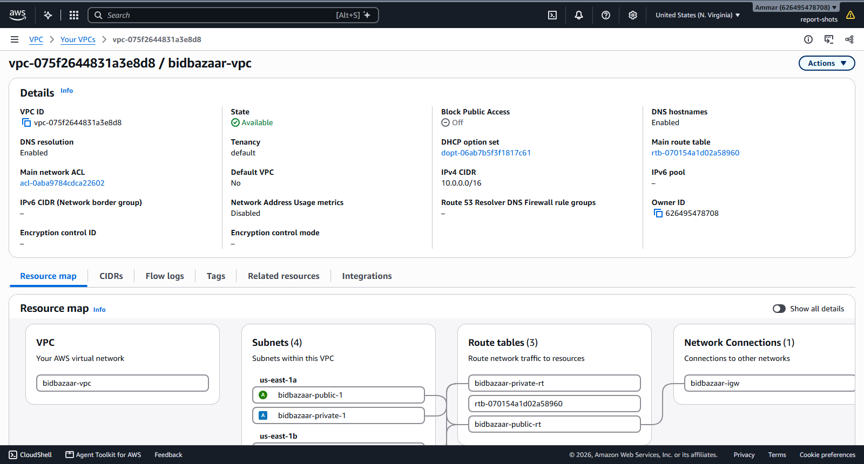
Figure 3: VPC bidbazaar-vpc (10.0.0.0/16)
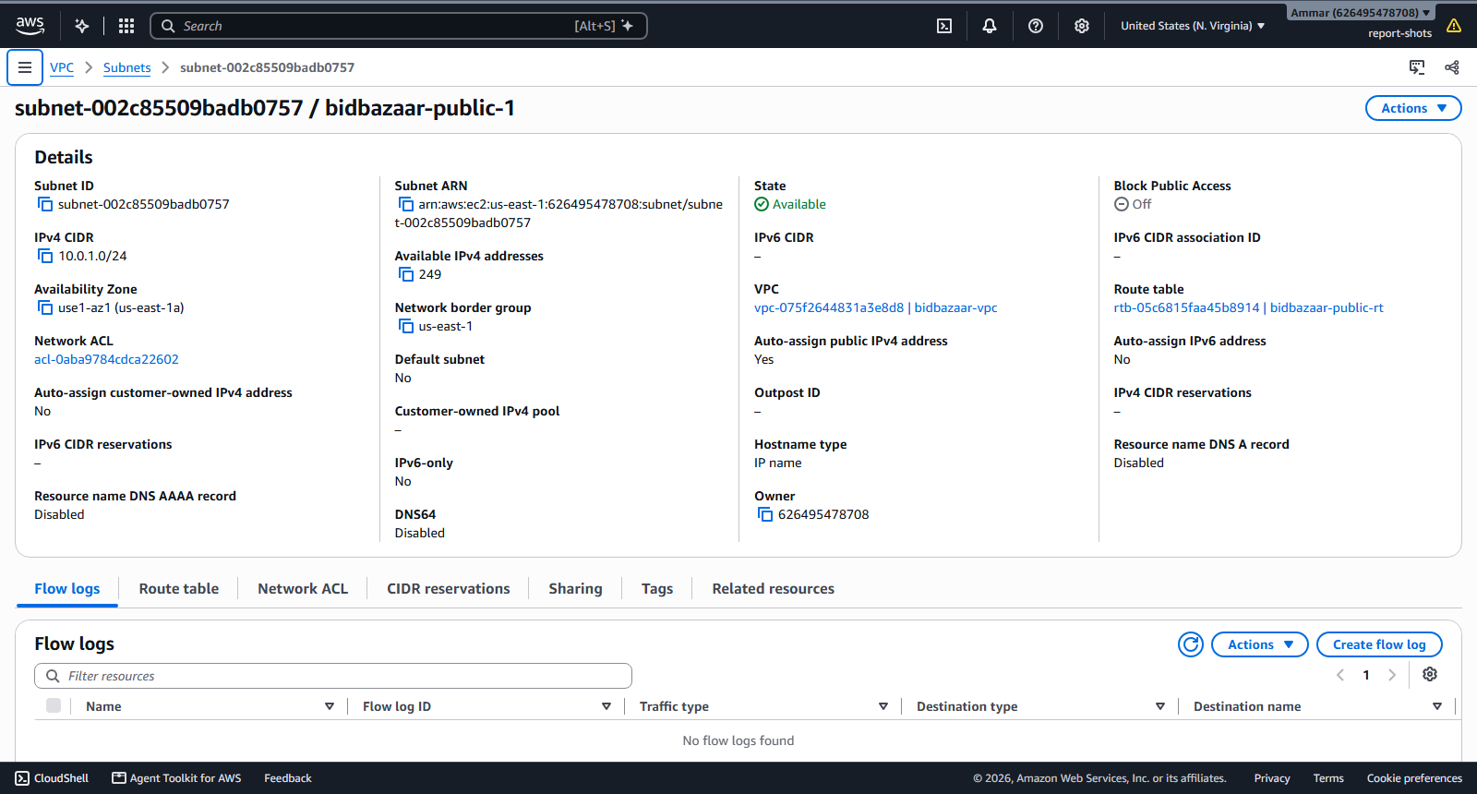 | 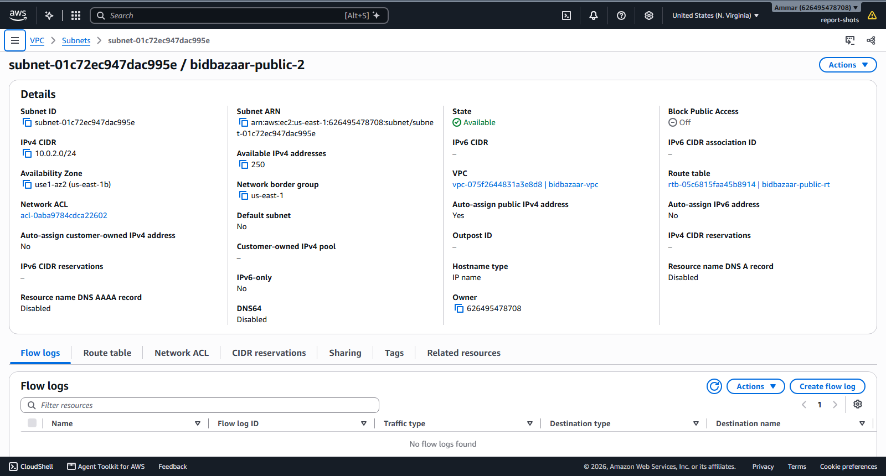
Figure 4: Public subnet, us-east-1a (10.0.1.0/24) | Figure 5: Public subnet, us-east-1b (10.0.2.0/24)

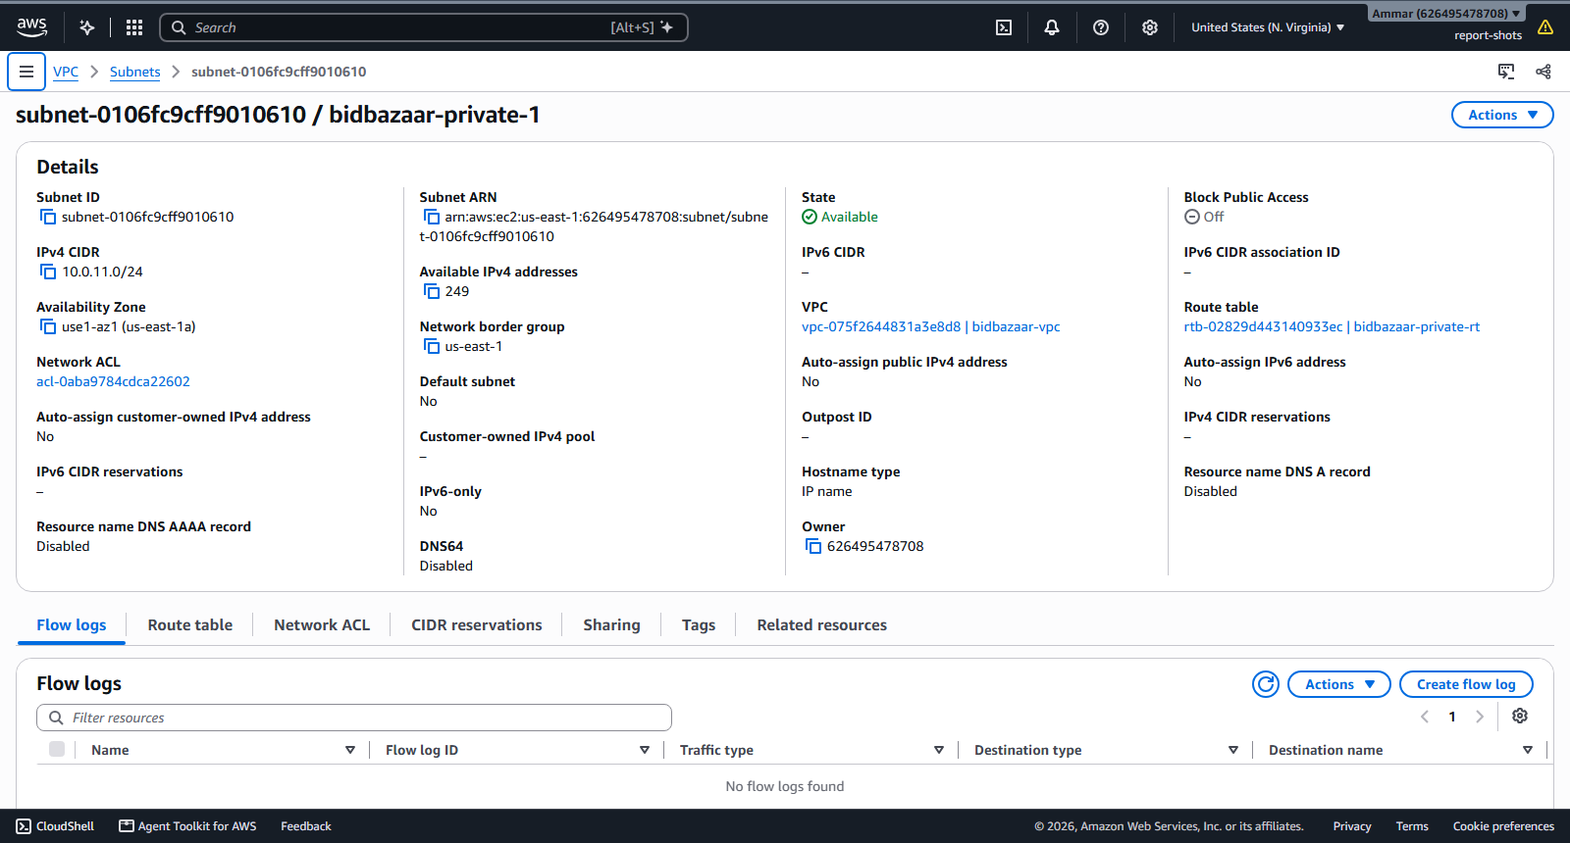 | 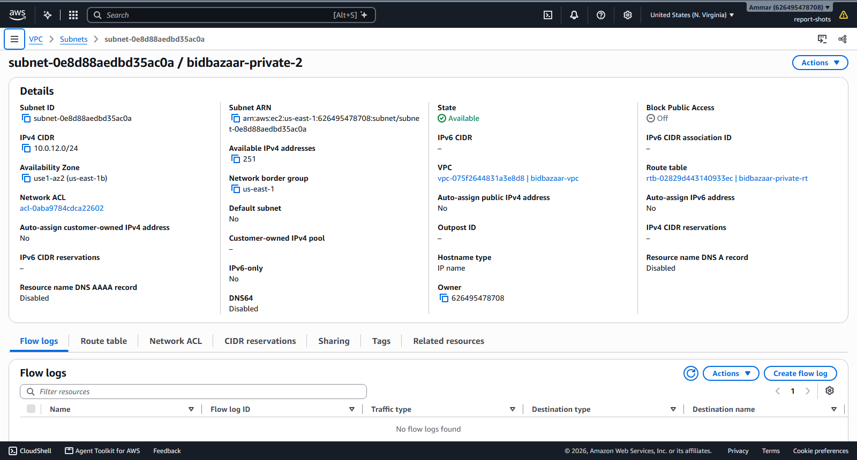
Figure 6: Private subnet, us-east-1a (10.0.11.0/24) | Figure 7: Private subnet, us-east-1b (10.0.12.0/24)

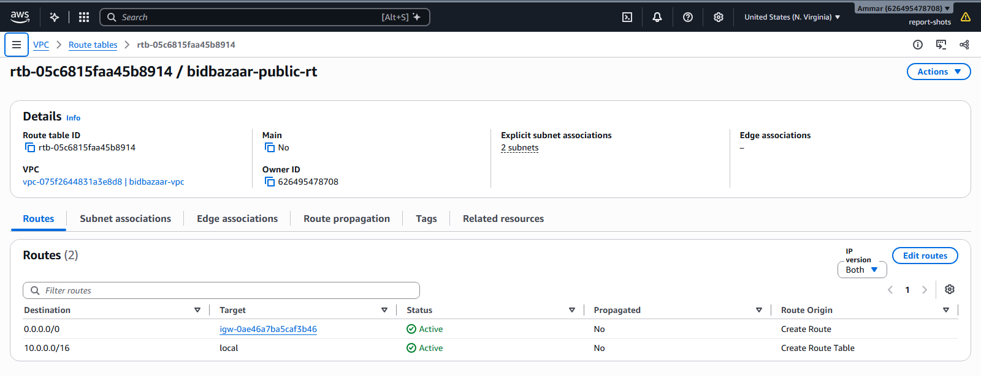 | 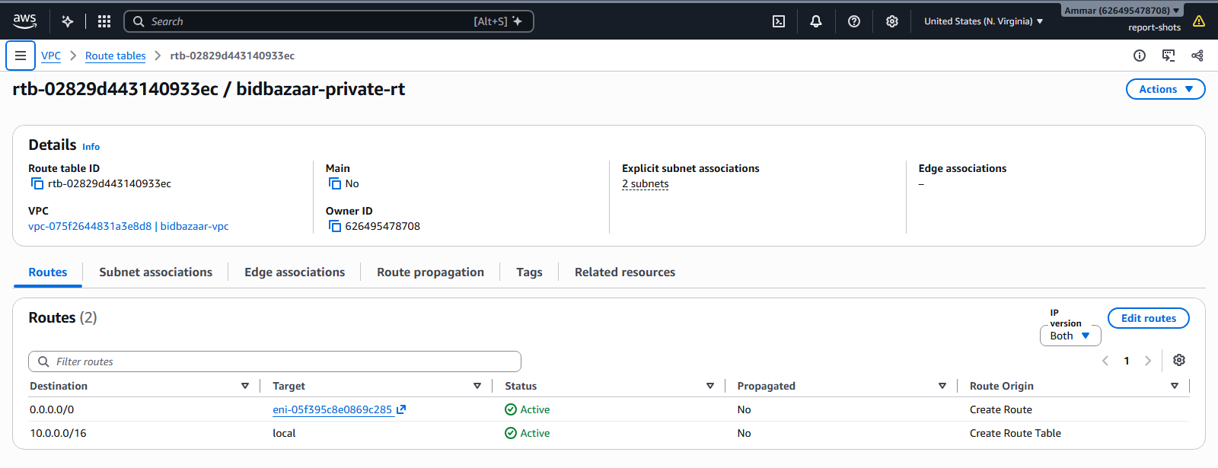
Figure 8: Public route table: 0.0.0.0/0 to Internet Gateway | Figure 9: Private route table: 0.0.0.0/0 to the NAT instance

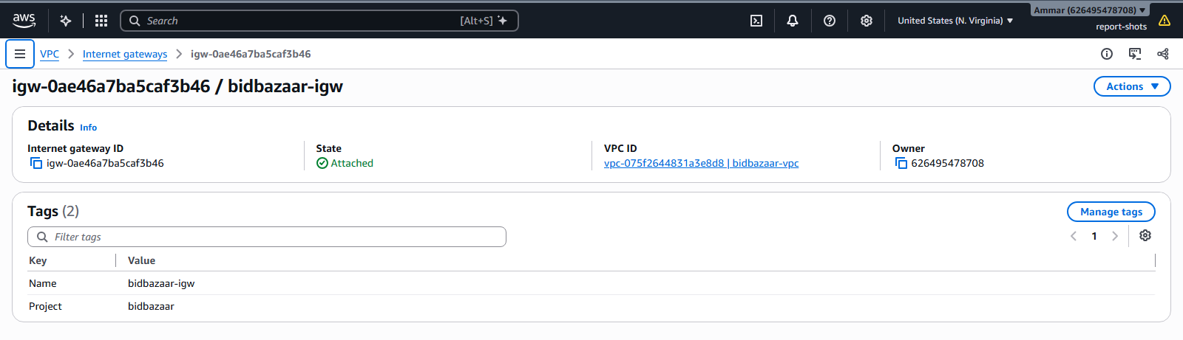 | 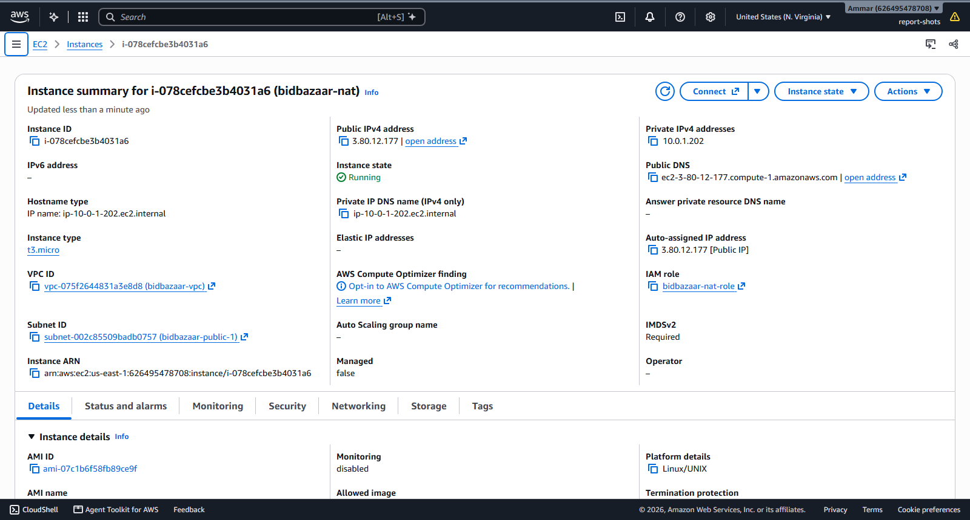
Figure 10: Internet Gateway attached to the VPC | Figure 11: NAT instance (t3.micro) in the public subnet

A.2 Compute instances / container hosts
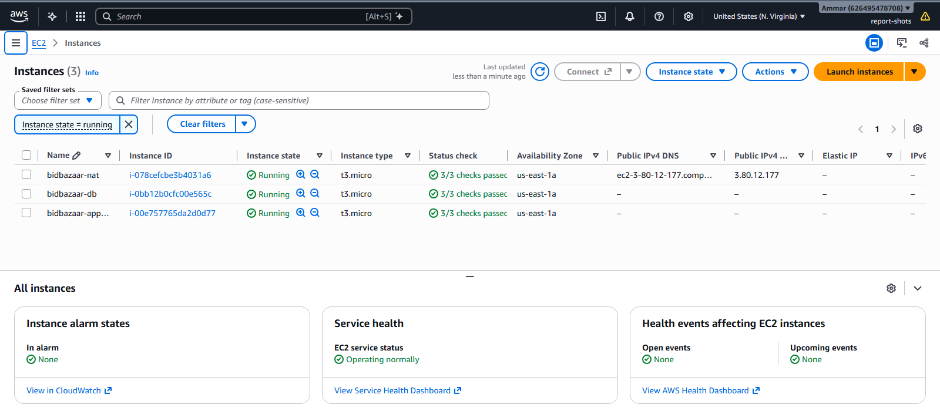
Figure 12: EC2 instances: NAT, database server and app host, all running
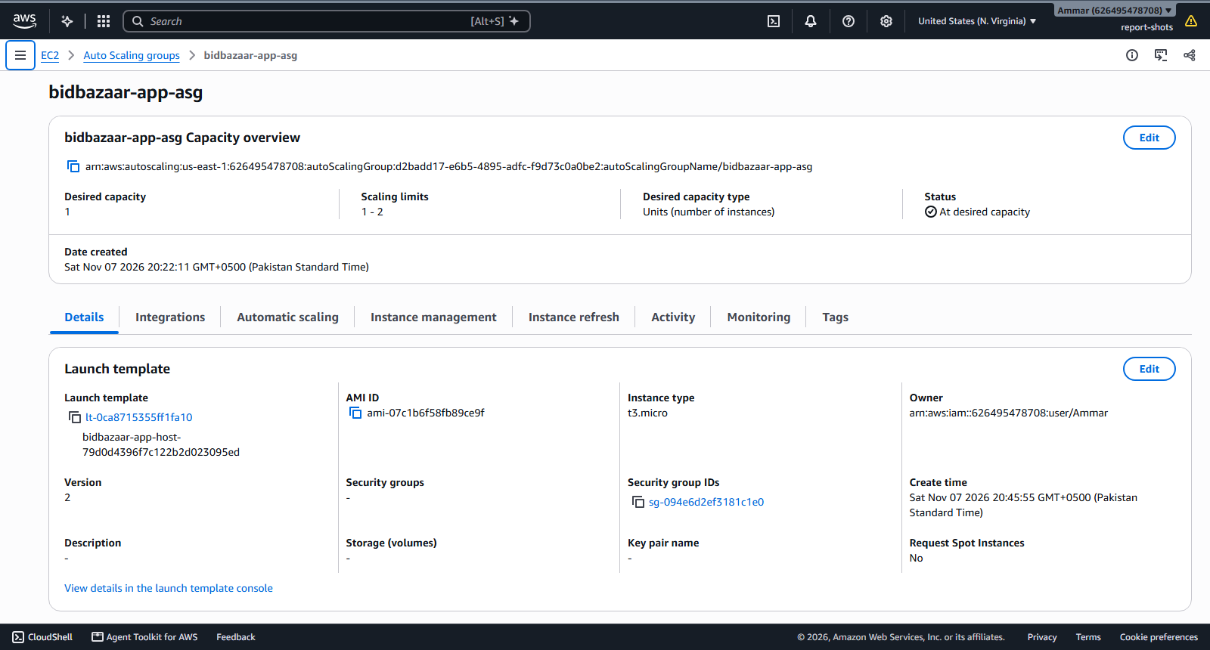
Figure 13: Auto Scaling Group bidbazaar-app-asg (1 to 2 hosts) with its launch template
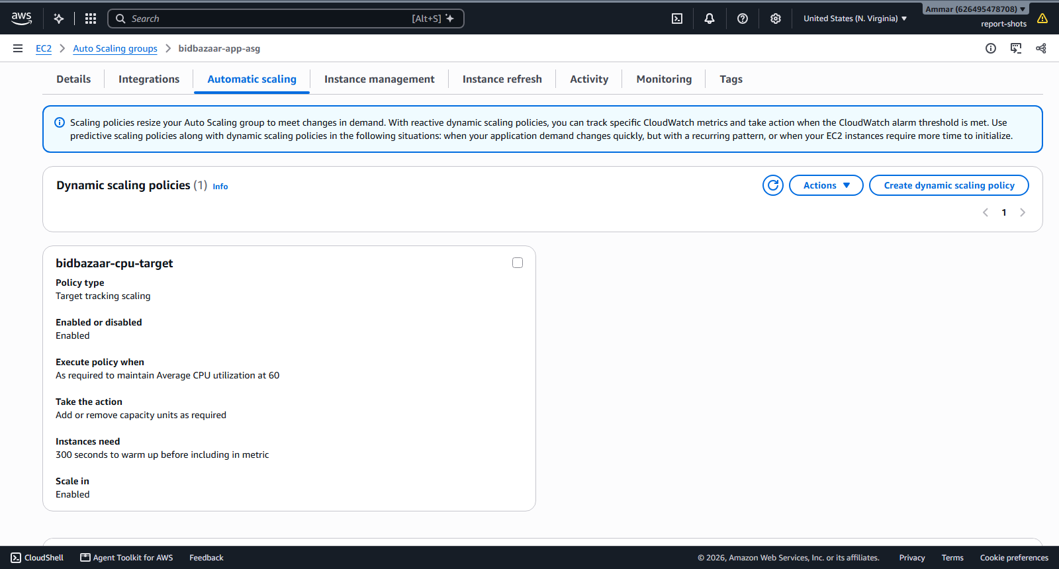
Figure 14: Scaling rule: add a server when CPU is over 60%
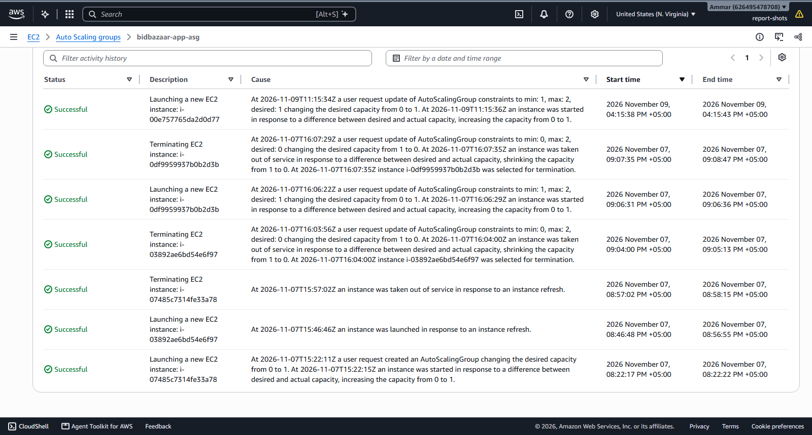
Figure 15: Servers started and replaced automatically

A.3 Security groups
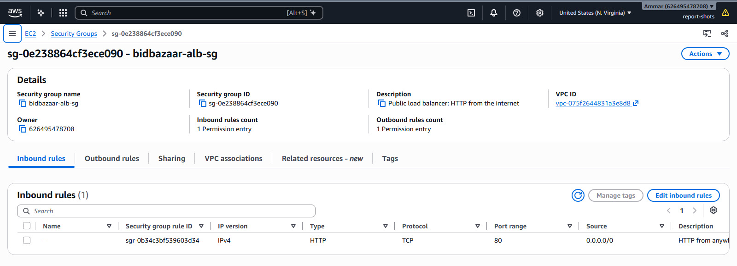 | 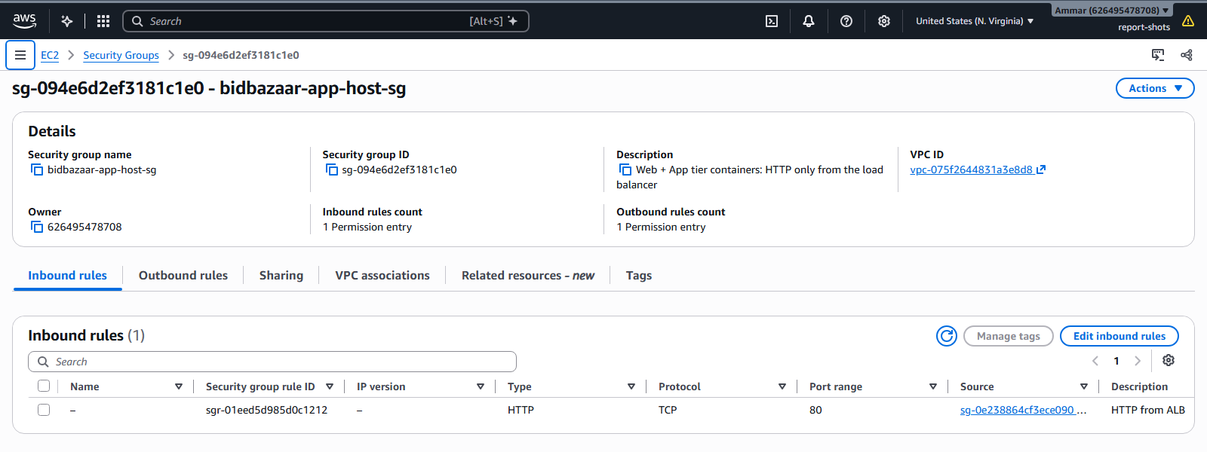
Figure 16: alb-sg inbound: HTTP 80 from the internet | Figure 17: app-host-sg inbound: 80 from alb-sg only

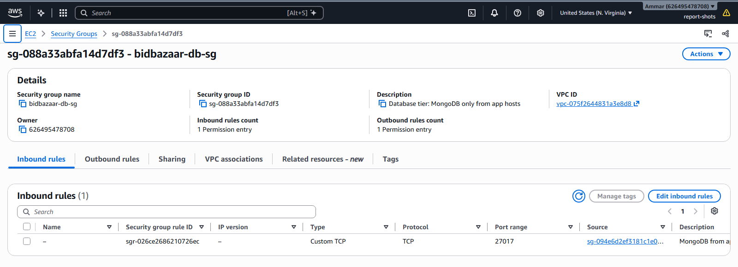 | 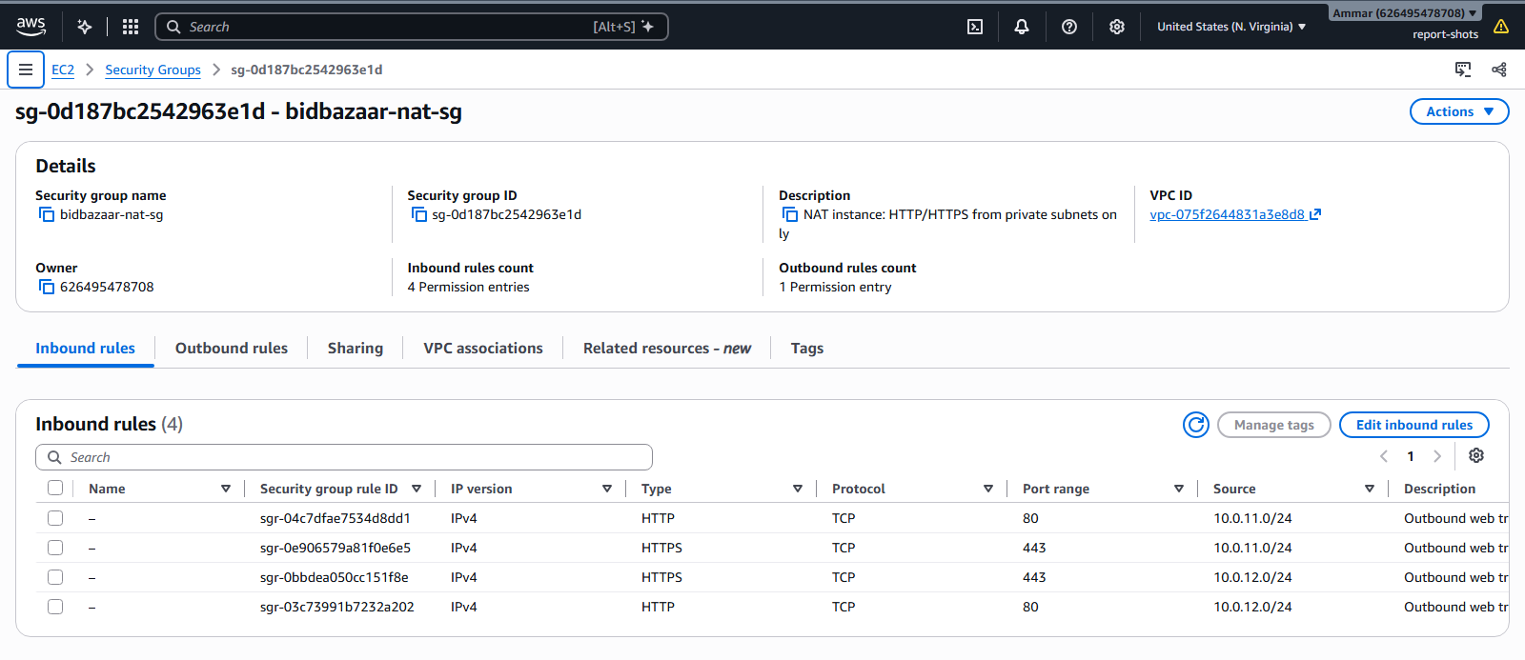
Figure 18: db-sg inbound: 27017 from app-host-sg only | Figure 19: nat-sg inbound: 80/443 from the private subnets only

A.4 Load balancer configuration
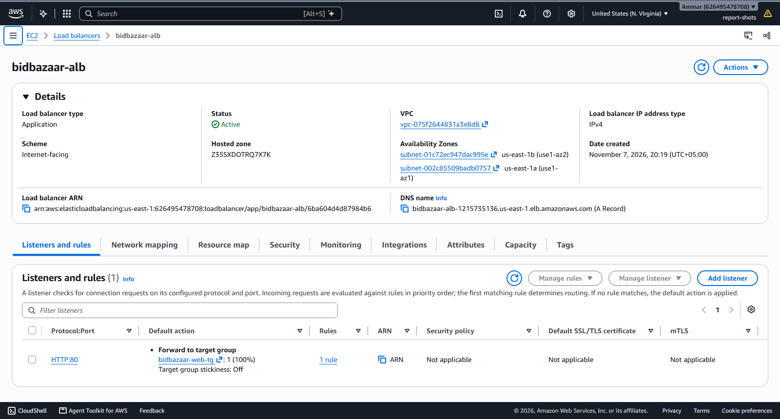
Figure 20: Load balancer in two zones, sending traffic to the web servers
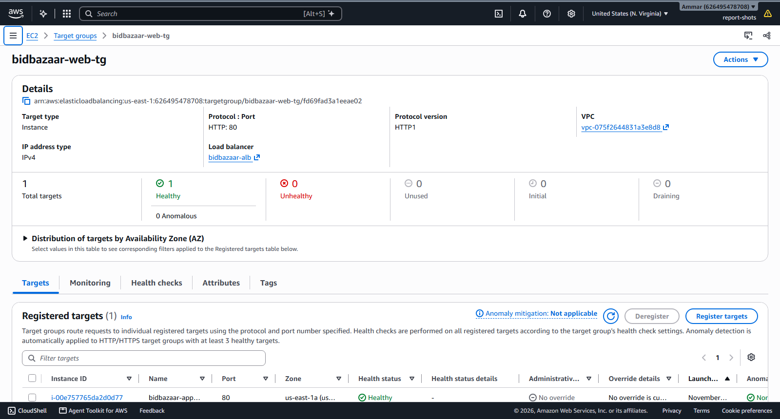
Figure 21: Target group showing a healthy app server

A.5 Database instance
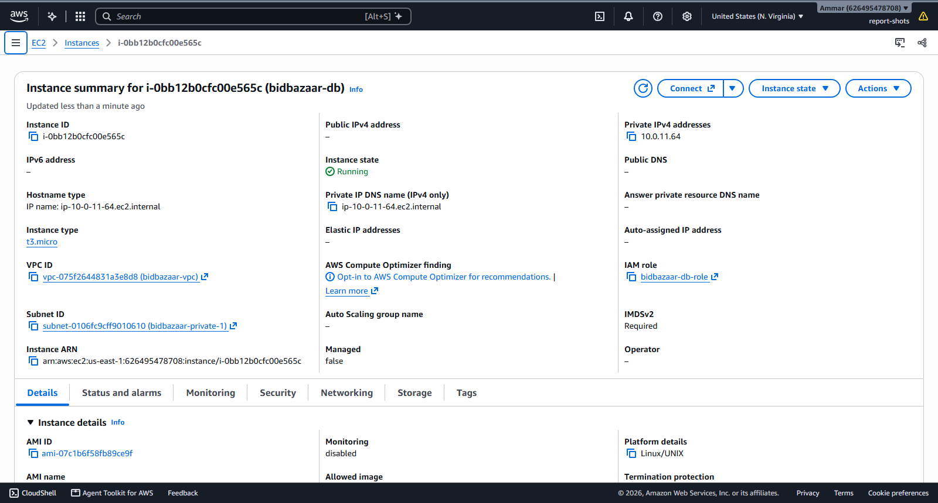
Figure 22: Database server bidbazaar-db: private IP only, no public IP
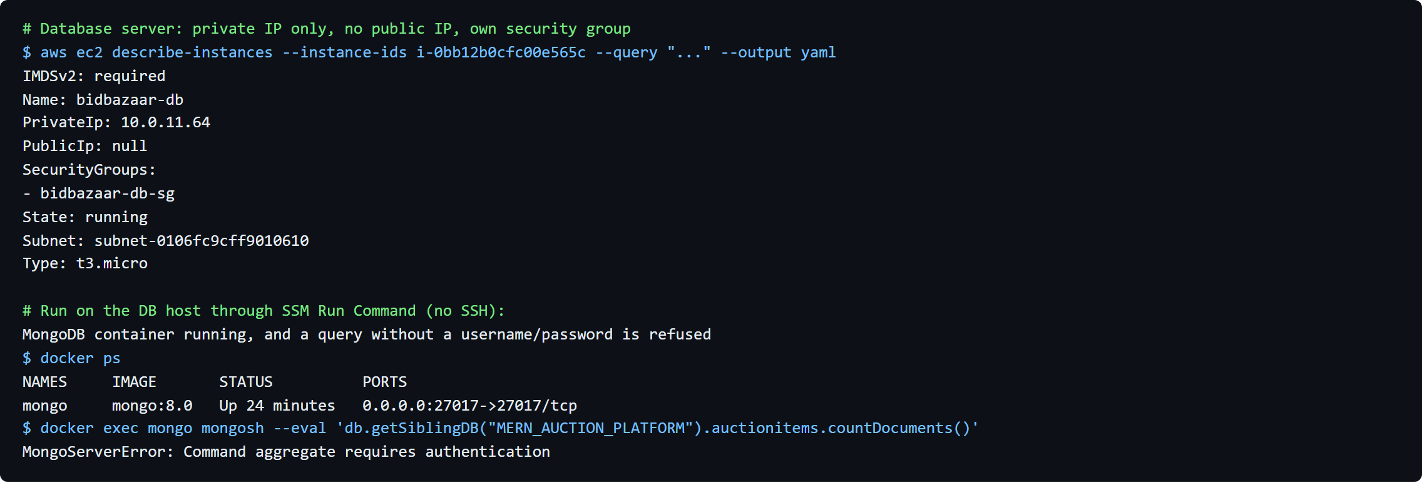
Figure 23: Database server details and MongoDB refusing access without a password (CLI output)

A.6 Docker image build and registry listing
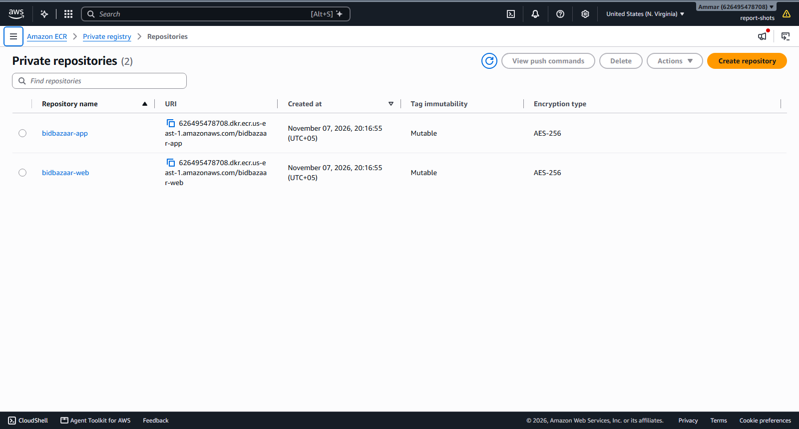
Figure 24: ECR repositories bidbazaar-app and bidbazaar-web
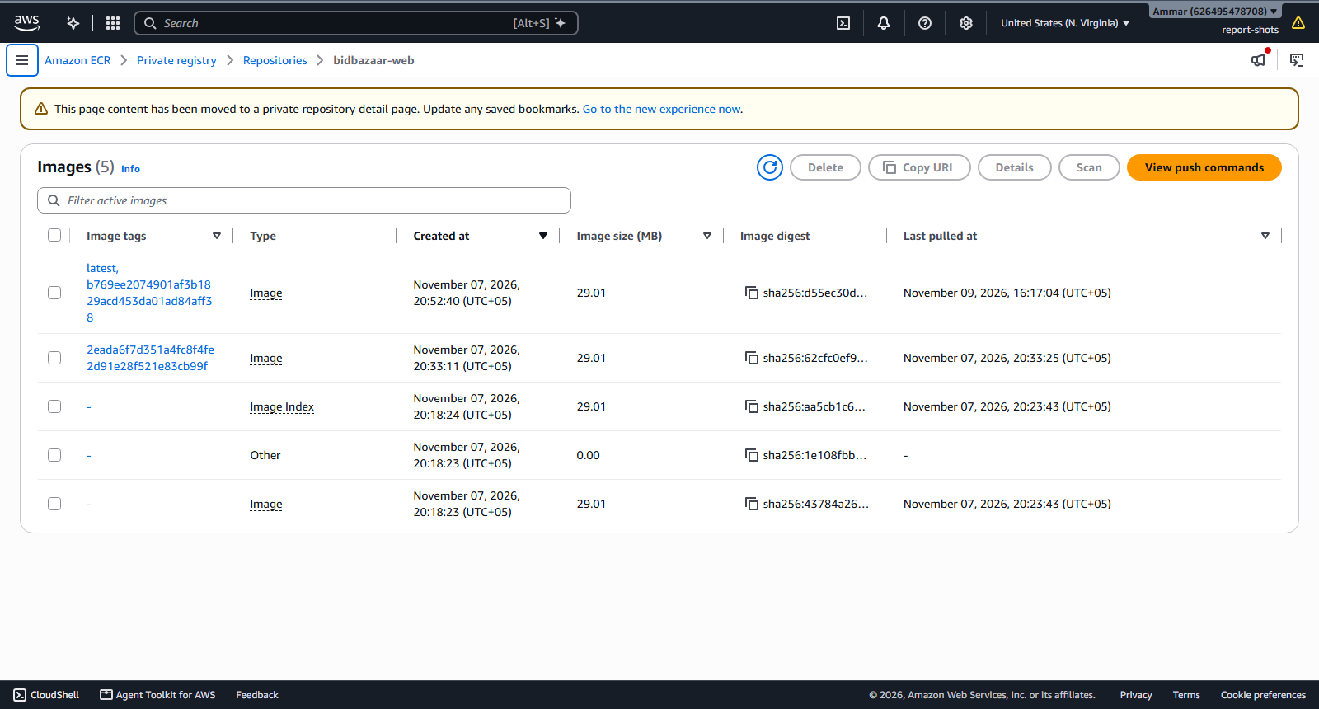
Figure 25: bidbazaar-web images tagged with commit SHA and latest
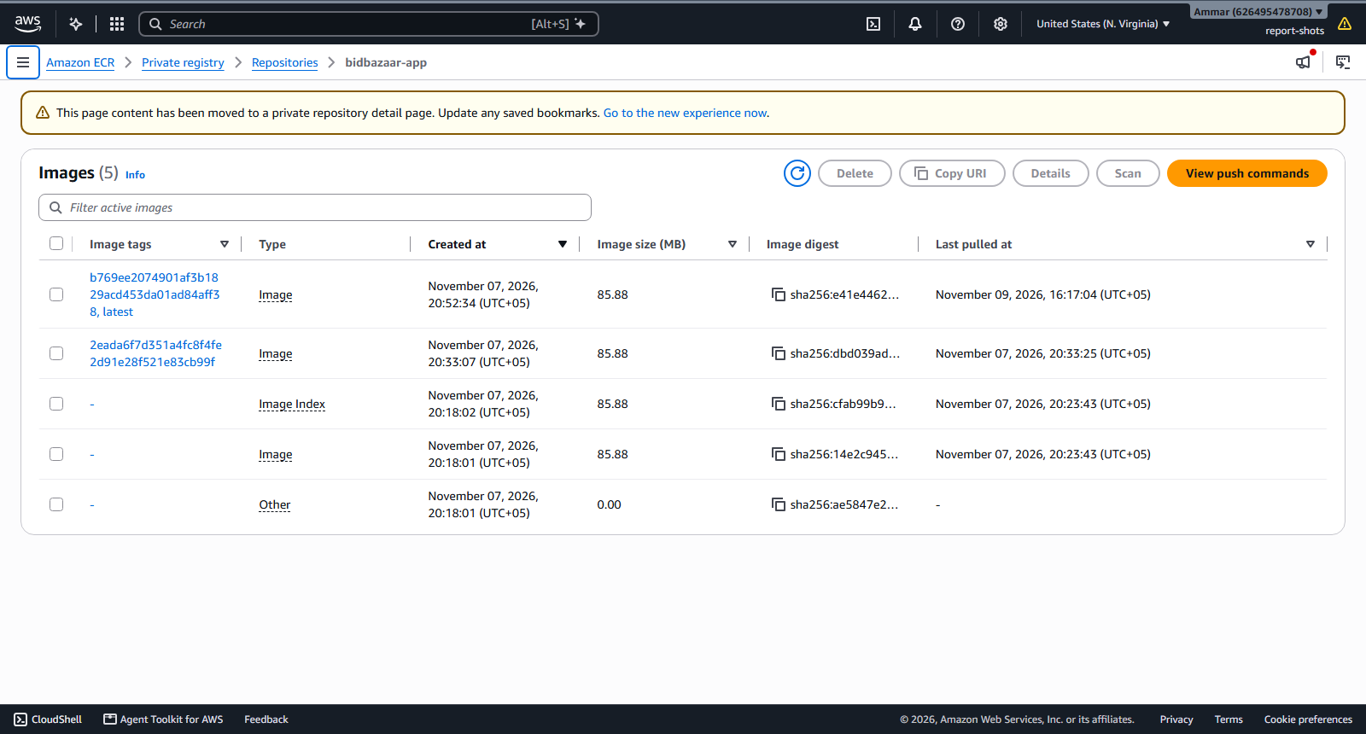
Figure 26: bidbazaar-app images tagged with commit SHA and latest

A.7 Secrets, IAM and monitoring
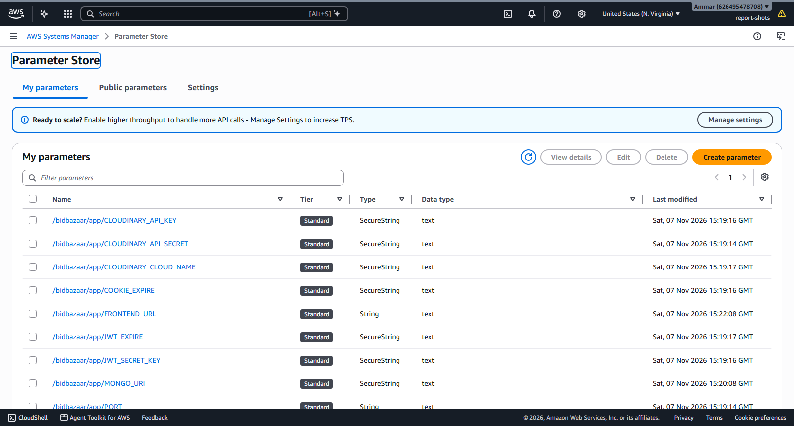
Figure 27: Secrets stored safely in Parameter Store (values hidden)
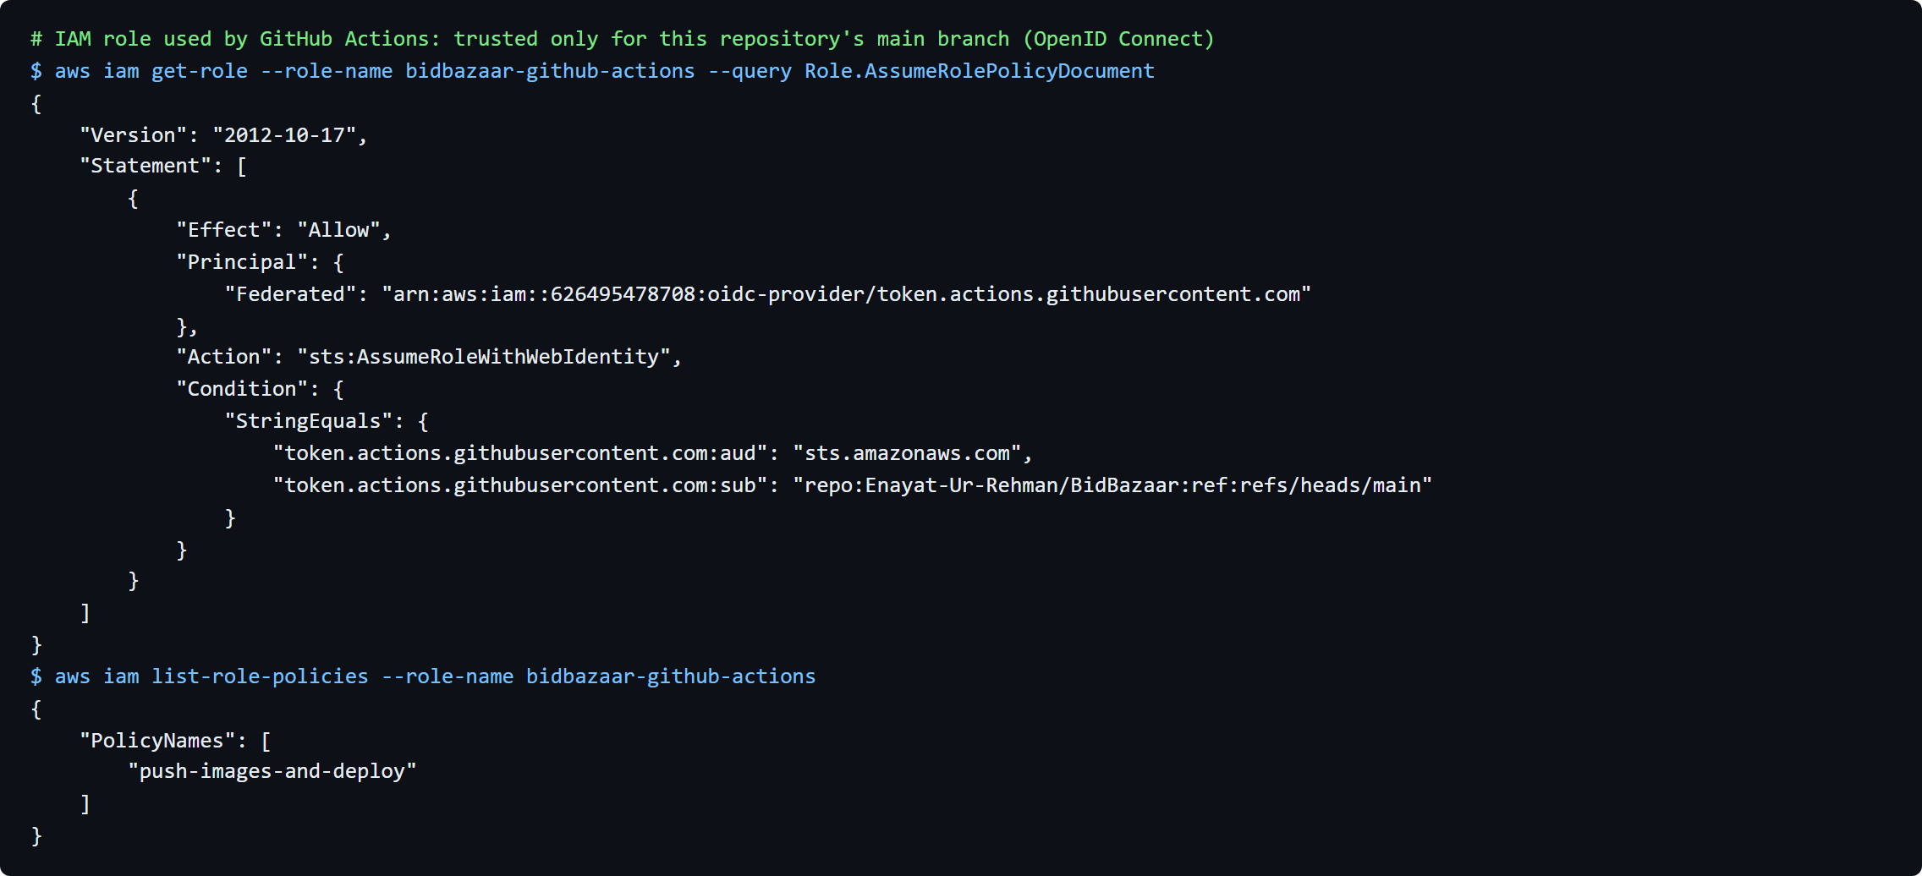
Figure 28: GitHub deploy role, allowed only for this repository (CLI output)
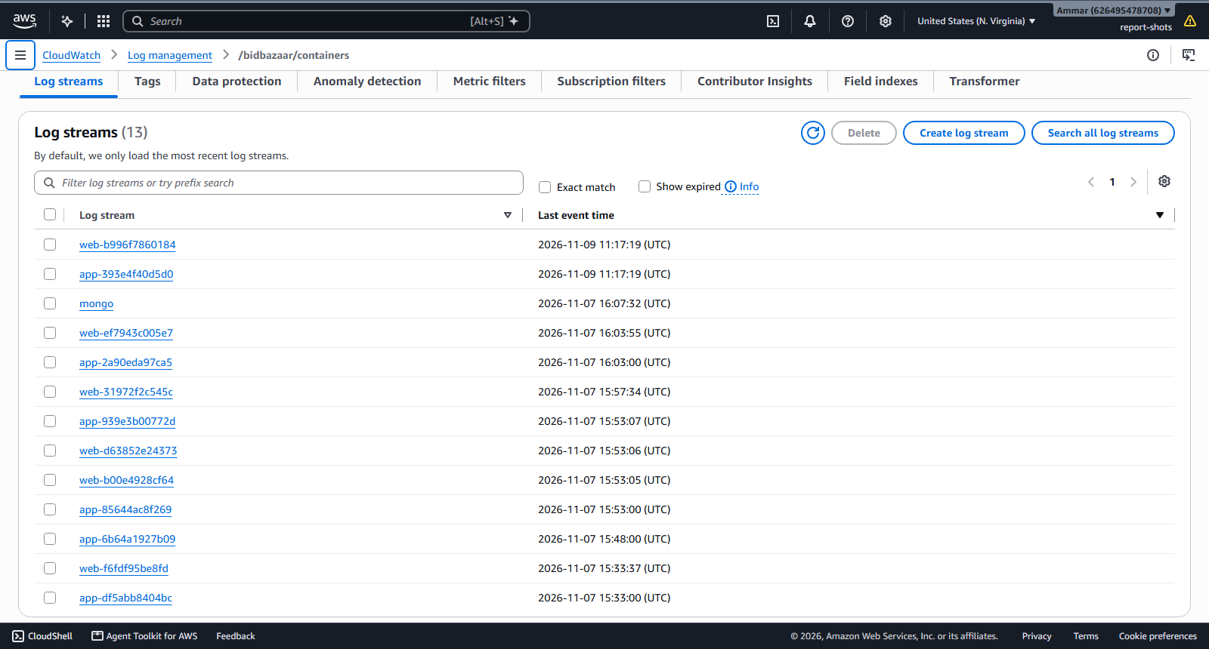
Figure 29: Container logs in CloudWatch
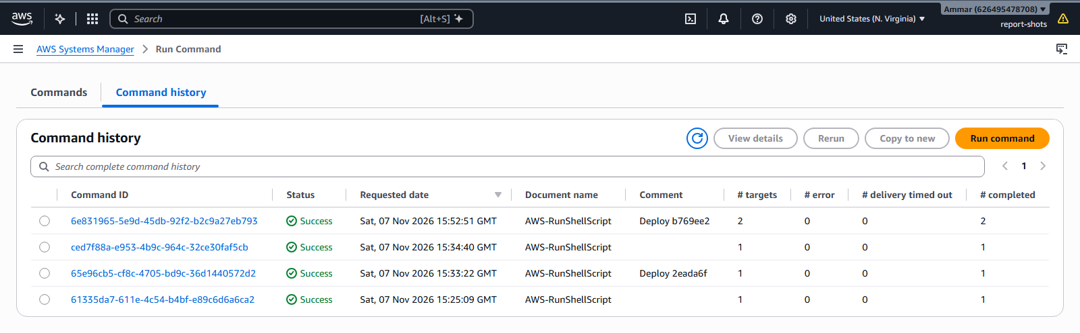
Figure 30: Deployments sent by the pipeline

A.8 CI/CD pipeline run
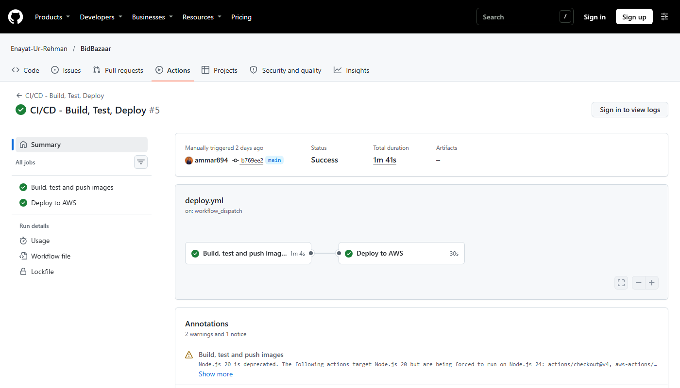
Figure 31: GitHub Actions run with both jobs passed
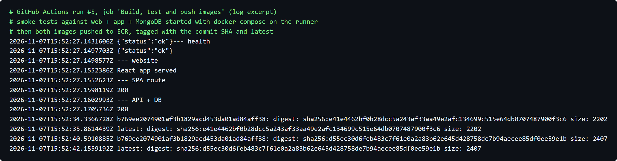
Figure 32: Build job: tests passed and images uploaded (CLI output)
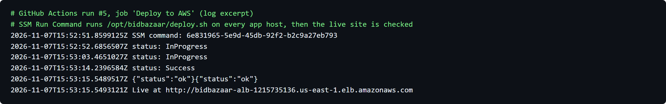
Figure 33: Deploy job: update done and live site working (CLI output)

A.9 Cost estimate
Item | Calculation | Approx. monthly cost
Application Load Balancer | $0.0225 per hour × 730 h | $16.40
3 small servers (NAT, app, database) | 3 × $0.0104 per hour × 730 h | $22.80
3 public IP addresses | 3 × $0.005 per hour × 730 h | $10.95
Disk storage (36 GB) | 36 GB × $0.08 per GB-month | $2.90
Images, logs, secrets | Free tier | ≈ $0
Total | ≈ $0.07 per hour ≈ $1.70 per day | ≈ $53
Table 7: Monthly cost estimate

A.10 Running application in the browser

Figure 34: Live site opened in a browser using the load balancer address
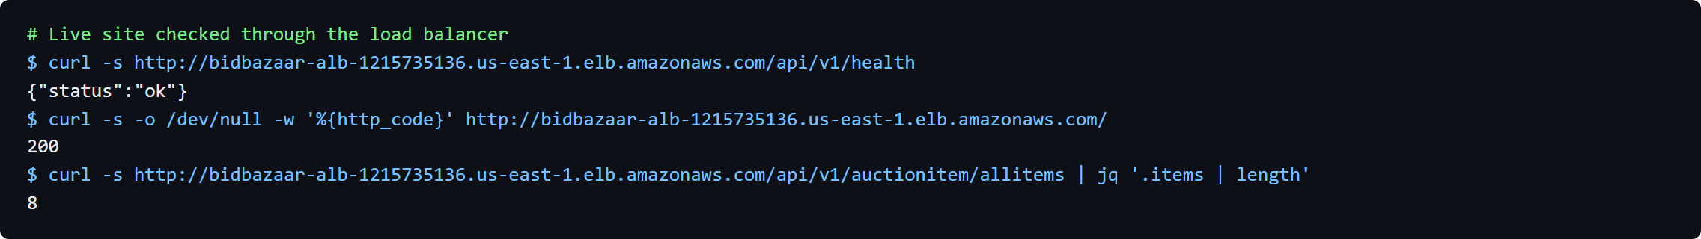
Figure 35: Checking the live site from the command line (CLI output)
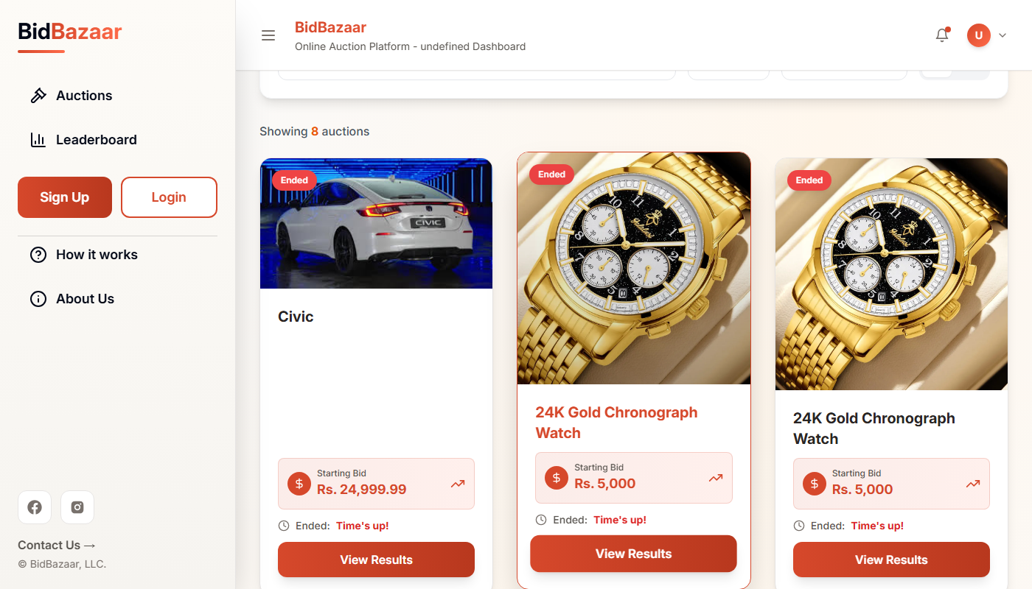
Figure 36: Auctions page loading data from the database
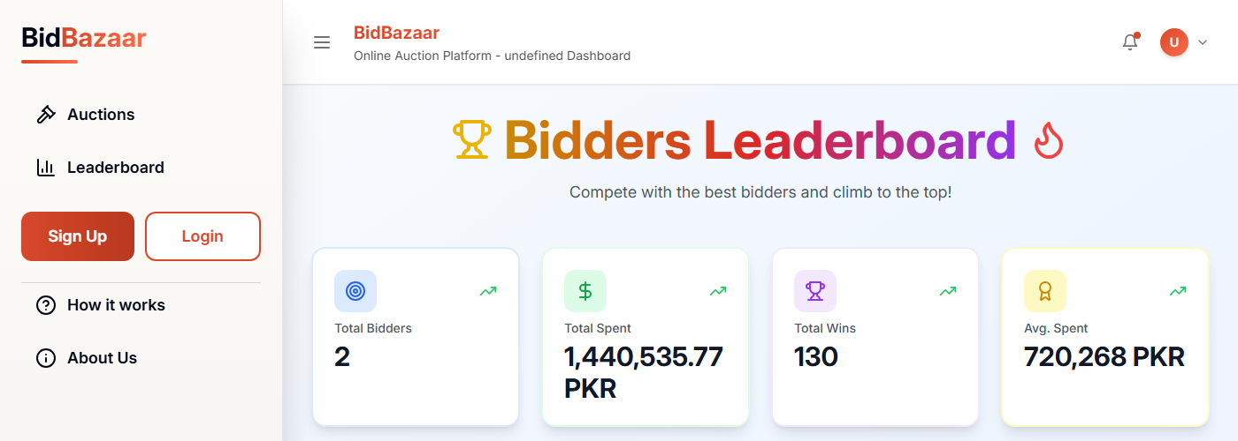
Figure 37: Bidders leaderboard with statistics
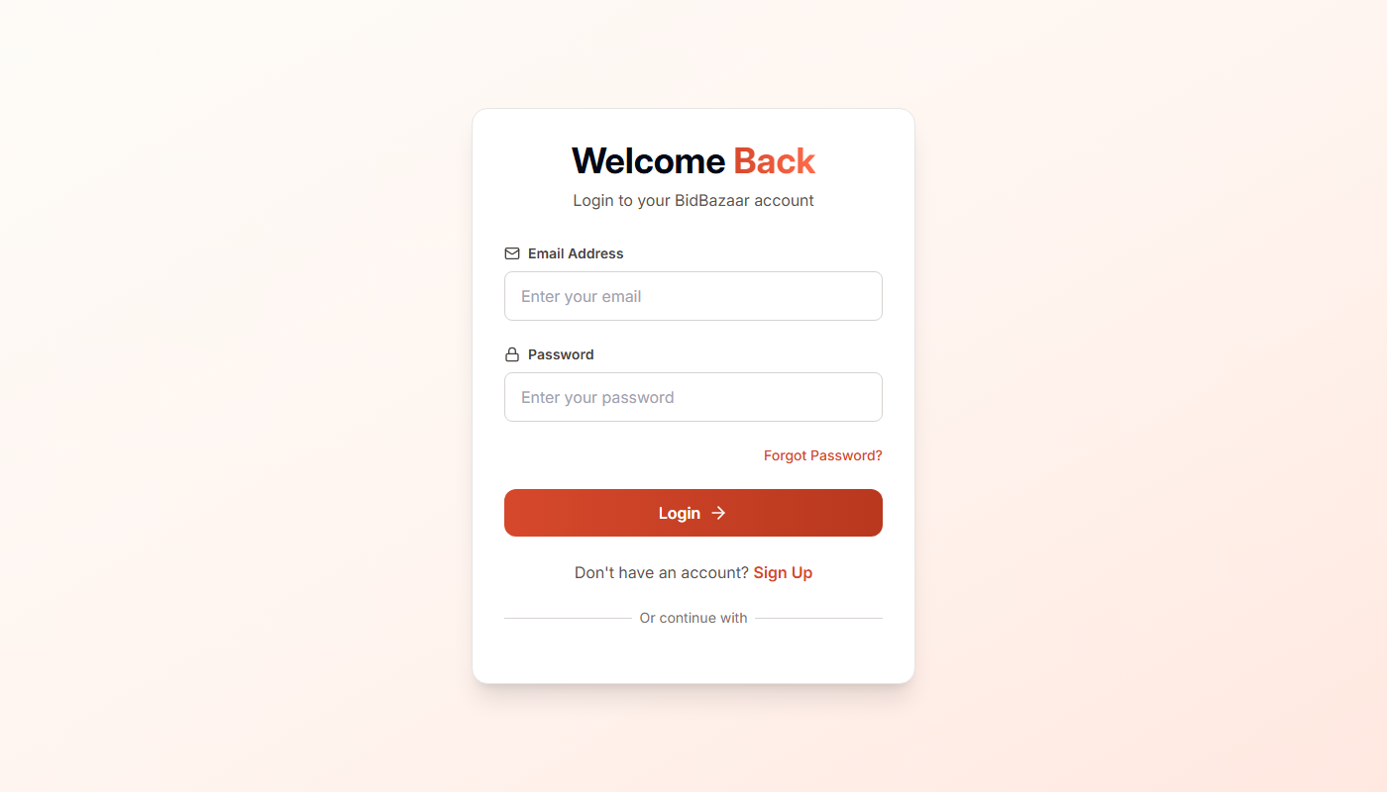
Figure 38: Login page

Appendix B: Source Files
File | Purpose
frontend/Dockerfile, frontend/nginx.conf.template | Website container and Nginx settings
backend/Dockerfile | Backend container
docker-compose.yml | Starts all three parts together
.github/workflows/deploy.yml | The CI/CD pipeline
infra/*.tf | Terraform code for the whole AWS setup
infra/templates/* | Startup scripts for the servers
DEPLOYMENT_GUIDE.md | Step-by-step deployment guide
Repository | https://github.com/Enayat-Ur-Rehman/BidBazaar

