BidBazaar — Automated Test Report
Playwright (Python) + pytest + pytest-html | Browser: Chromium | 28 October 2026
BidBazaar is a MERN online-auction platform (React/Vite frontend, Express API, MongoDB). This report covers 18 end-to-end tests (6 features × 3), 4 API CRUD tests and 2 network-mocking tests, plus one deliberately inserted bug. Every test was run on Chromium; each test file has its own HTML report and every success / error message on screen was captured as a screenshot.

1. Results summary
Test file | Type | Tests | Result | Time | HTML report
e2e/login.py | E2E | 3 | 3 PASSED | 9.3 s | reports/login.html
e2e/register.py | E2E | 3 | 3 PASSED | 10.7 s | reports/register.html
e2e/create_auction.py | E2E | 3 | 3 PASSED | 14.8 s | reports/create_auction.html
e2e/place_bid.py | E2E | 3 | 3 PASSED | 22.3 s | reports/place_bid.html
e2e/payment.py | E2E | 3 | 3 PASSED | 39.0 s | reports/payment.html
e2e/commission_review.py | E2E | 3 | 3 PASSED | 27.7 s | reports/commission_review.html
api/create.py | API | 1 | 1 PASSED | 2.4 s | reports/create.html
api/read.py | API | 1 | 1 PASSED | 1.5 s | reports/read.html
api/update.py | API | 1 | 1 PASSED | 1.4 s | reports/update.html
api/delete.py | API | 1 | 1 PASSED | 1.5 s | reports/delete.html
mocking/empty_data.py | Mocking | 1 | 1 PASSED | 3.6 s | reports/empty_data.html
mocking/server_error.py | Mocking | 1 | 1 PASSED | 3.5 s | reports/server_error.html
Total |  | 24 | 24 PASSED, 0 FAILED | ≈ 2.5 min

The same suite was also run on all three engines (Chromium, Firefox, WebKit): 64 / 64 passed (18 E2E + 2 mocking per browser, plus the 4 browser-independent API tests).

2. Features tested and left out

Features tested
# | Feature | Why it was chosen
1 | Login | Gate to every other feature; role-based redirect
2 | Registration | Entry point for new users; Auctioneers have extra mandatory payout fields
3 | Create Auction | Core Auctioneer flow with business rules (one active auction, unpaid commission)
4 | Place Bid | Core Bidder flow; minimum-bid boundary and re-bid behaviour
5 | Stripe Payment | Real money flow (20% win deposit) through Stripe test mode
6 | Commission Proof Review | Admin side of the money flow (approve / reject / over-payment)

Features left out
Feature | Reason
Leaderboard, Home, About, Contact, How-it-works | Read-only / static pages, low risk; page loads are covered indirectly
Auction search / filter | Pure client-side filtering, lower risk than the money and bidding flows
Republish auction | Needs an ended auction; depends on cron timing, slow to set up reliably
Auction-end cron & fallback to 2nd bidder | Time-driven background job, better suited to backend unit tests
Email notifications | External SMTP service; not observable from the browser

3. Test case table
ID | Feature | Type | Input / steps | Expected result | Result
TC-L1 | Login | Positive | Bidder, valid credentials | Redirect to /auctions | PASS
TC-L2 | Login | Negative | Valid email, wrong password | "Incorrect password." | PASS
TC-L3 | Login | Negative | Unregistered email | "No account found with this email." | PASS
TC-R1 | Registration | Positive | New Bidder, all fields | Redirect home, user saved in DB | PASS
TC-R2 | Registration | Negative | Email already used | Toast "User already registered." | PASS
TC-R3 | Registration | Negative | Auctioneer, no bank details | Toast "Please provide your full bank details." | PASS
TC-C1 | Create Auction | Positive | All fields + image | Toast "Auction item created" | PASS
TC-C2 | Create Auction | Negative | Already has an active auction | Toast "already have one active auction" | PASS
TC-C3 | Create Auction | Negative | Owes Rs. 750 commission | "Unpaid Commission", button disabled | PASS
TC-B1 | Place Bid | Negative (boundary) | Bid 999 (minimum 1000) | "Minimum bid is Rs. 1,000", Bid disabled | PASS
TC-B2 | Place Bid | Positive | Bid 1100 | Shown as Current Bid | PASS
TC-B3 | Place Bid | Positive (state) | Bid 1200, then 1300 | Current bid updates, only 1 bid record | PASS
TC-P1 | Payment | Positive | Card 4242 4242 4242 4242 | Success page, DB status Paid | PASS
TC-P2 | Payment | Negative | Card 4000 0000 0000 0002 | "Card declined", status stays Pending | PASS
TC-P3 | Payment | Negative | Deadline already passed | "Payment Deadline Expired", pay disabled | PASS
TC-M1 | Commission | Positive | Proof submitted, admin approves | Status Approved | PASS
TC-M2 | Commission | Negative | Proof submitted, admin rejects | Status Rejected | PASS
TC-M3 | Commission | Negative | Amount larger than owed | "exceeds your unpaid commission balance" | PASS
TC-A1 | API Create | Pos + Neg | POST /auctionitem/create (valid / no image) | 201 / 400 | PASS
TC-A2 | API Read | Pos + Neg | GET /auctionitem/auction/:id (real / missing) | 200 / 404 | PASS
TC-A3 | API Update | Pos + Neg | PUT proof status (real / missing) | 200 / 404 | PASS
TC-A4 | API Delete | Pos + Neg | DELETE auction, then again | 200 / 404 | PASS
TC-N1 | Mocking | Empty data | allitems → 200, items: [] | "No auctions found" | PASS
TC-N2 | Mocking | Server error | allitems → HTTP 500 | Page still works, no JS errors | PASS

4. End-to-end tests (with screenshots)

4.1 Login (e2e/login.py)

TC-L1 Valid login (positive)
The test opens the login page, enters a registered Bidder's email and password and clicks Login. The app shows a "Login successfully" toast and redirects the Bidder to the Live Auctions page, which is the correct landing page for this role.
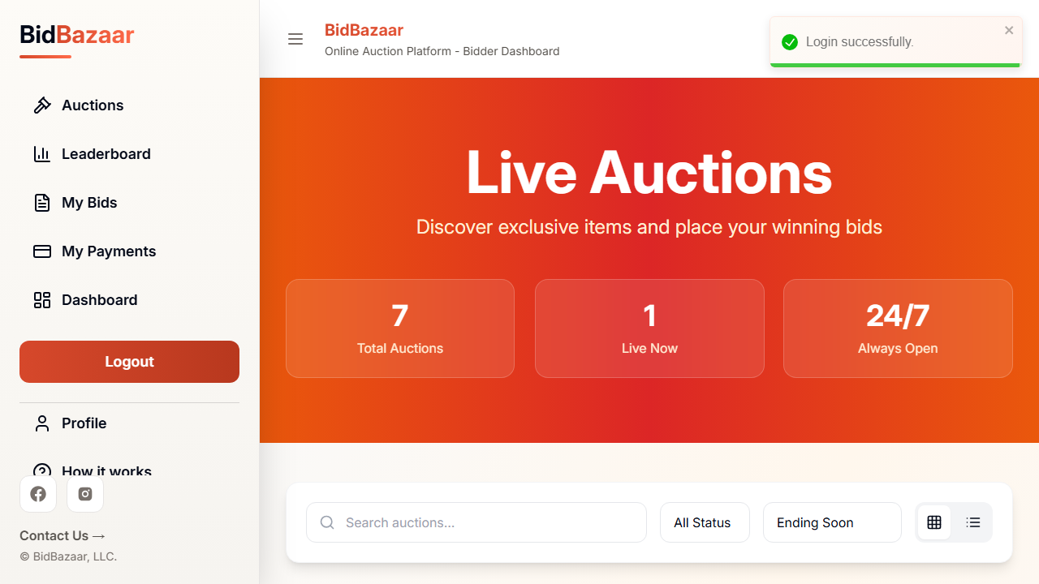
TC-L1 — logged in, auctions page
Result: PASSED

TC-L2 Wrong password (negative)
A registered email is entered with a wrong password. The backend rejects it and the site shows the red "Incorrect password." pop-up and inline message; the user stays on /login.
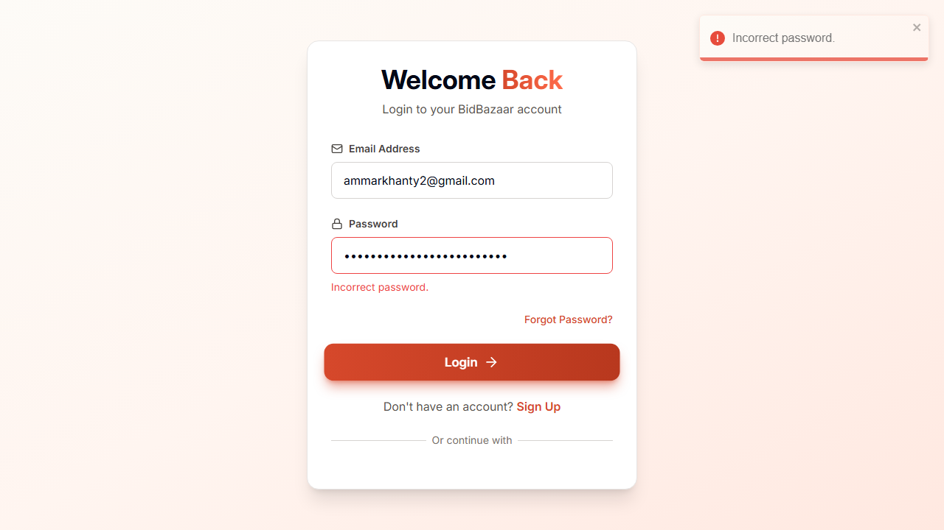
TC-L2 — incorrect password error
Result: PASSED

TC-L3 Unregistered email (negative)
An email that has no account is used. The site shows "No account found with this email." and the user is not logged in.
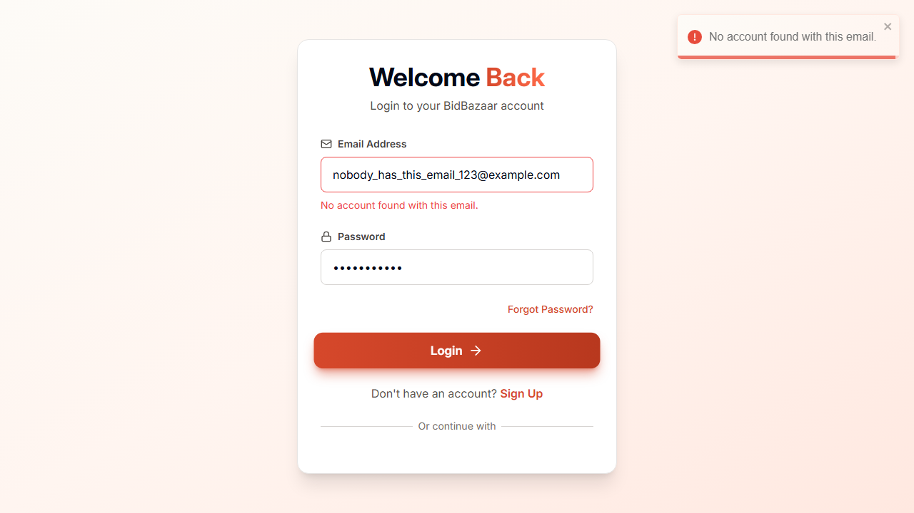
TC-L3 — no account error
Result: PASSED

4.2 Registration (e2e/register.py)

TC-R1 New Bidder registers (positive)
All personal fields are filled with a fresh email and role Bidder. The "User Registered" toast appears, the user is redirected to the home page, and the test confirms the user exists in MongoDB with role Bidder.

TC-R1 — registered, home page
Result: PASSED

TC-R2 Duplicate email (negative)
The form is submitted with an email that is already registered. The backend refuses it and the "User already registered." pop-up is shown; the page stays on /sign-up.
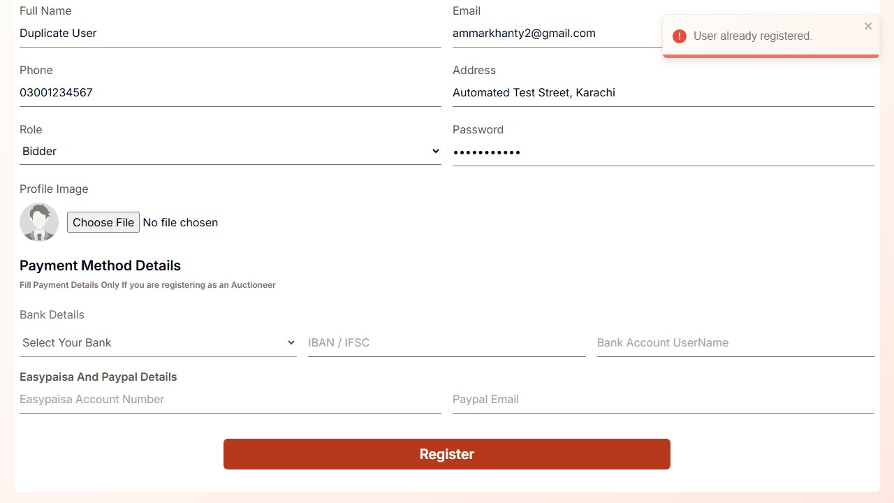
TC-R2 — already registered error
Result: PASSED

TC-R3 Auctioneer without bank details (negative)
Role Auctioneer is chosen but the mandatory bank / Easypaisa / PayPal fields are left empty. The form shows "Please provide your full bank details." and no account is created in the database.
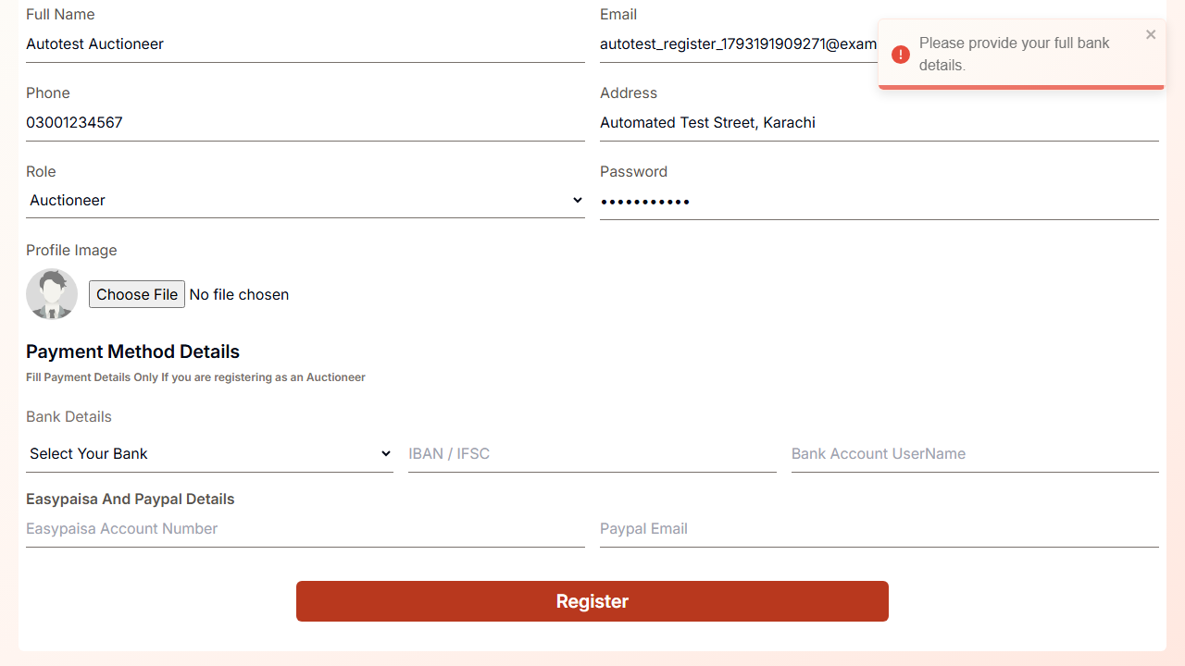
TC-R3 — bank details error
Result: PASSED

4.3 Create Auction (e2e/create_auction.py)

TC-C1 Valid auction (positive)
An Auctioneer fills in title, category, condition, starting bid, dates and uploads an image. The toast "Auction item created and will be listed on auction page at …" confirms success.
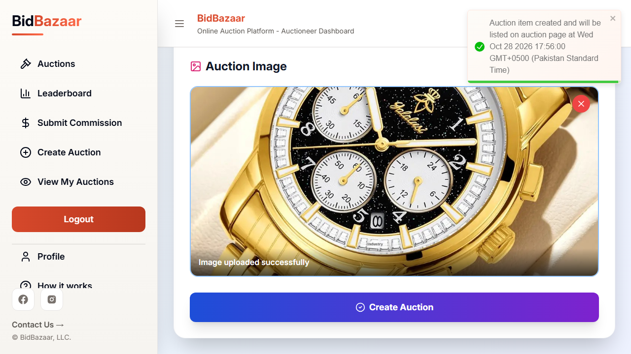
TC-C1 — auction created
Result: PASSED

TC-C2 Second active auction (negative)
The Auctioneer already has one active auction (created through the API). Trying to create another shows "You already have one active auction." — the one-auction business rule is enforced.
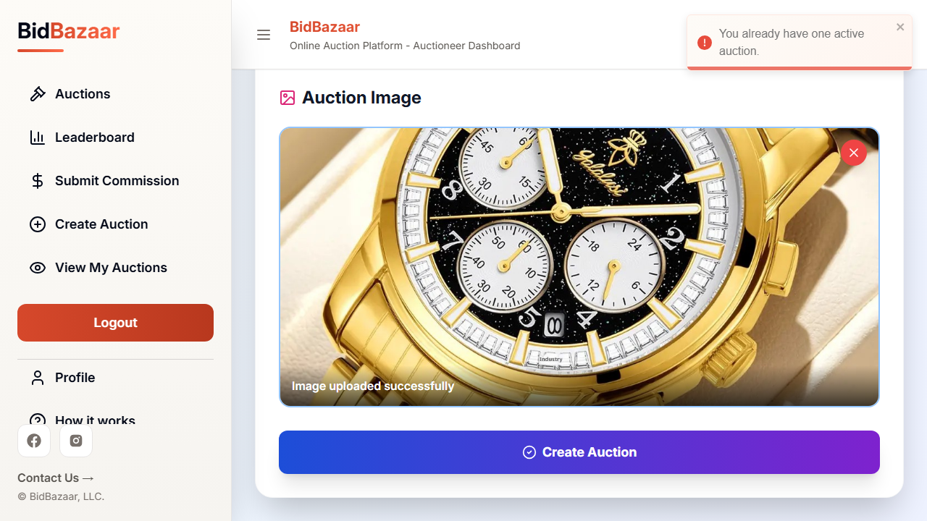
TC-C2 — one active auction error
Result: PASSED

TC-C3 Unpaid commission (negative)
The Auctioneer owes Rs. 750 commission. The Create Auction page shows the "Unpaid Commission" warning with the amount, and the Create Auction button is disabled.
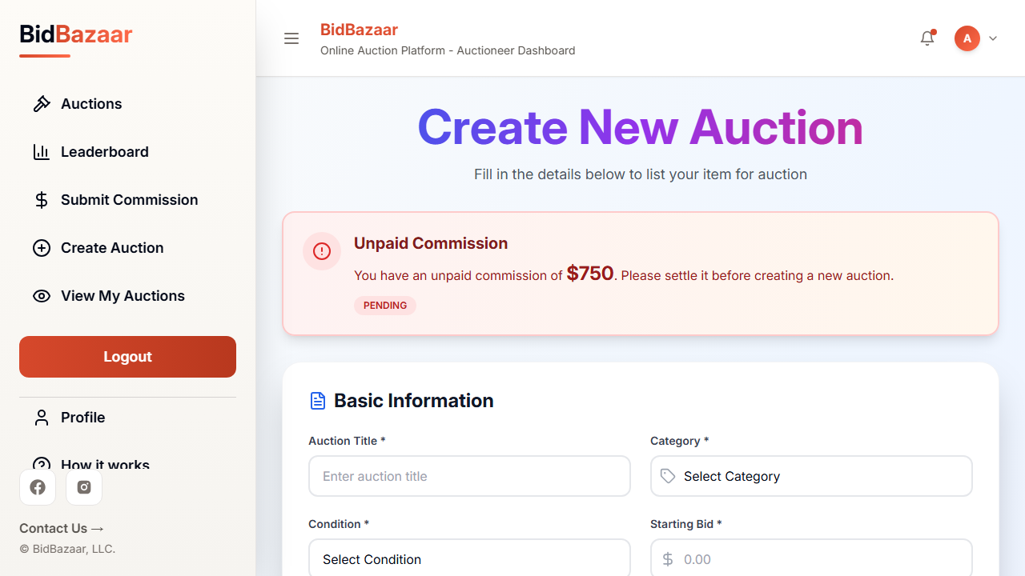
TC-C3 — unpaid commission warning
Result: PASSED

4.4 Place Bid (e2e/place_bid.py)

TC-B1 Bid below minimum (negative, boundary)
The starting bid is Rs. 1,000 and the Bidder types 999 (one rupee under). The page shows "Minimum bid is Rs. 1,000" inline and as a pop-up, and the Bid button is disabled.
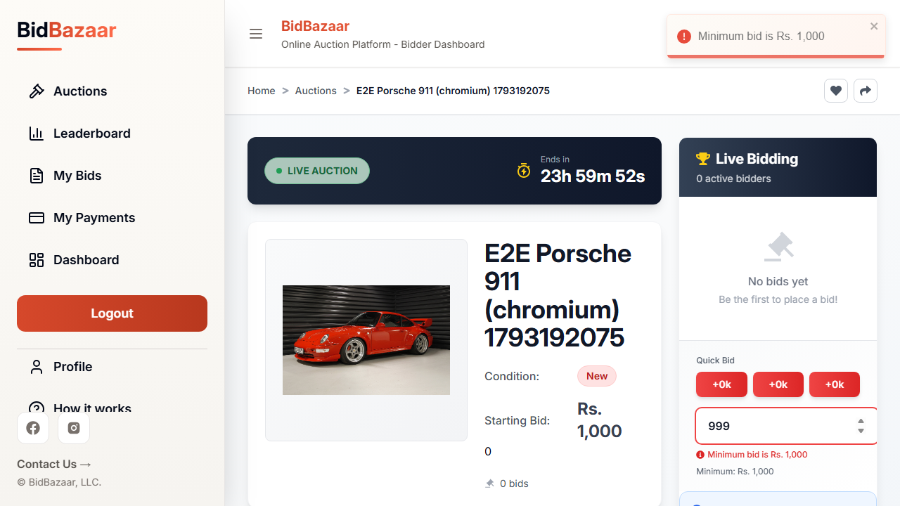
TC-B1 — minimum bid error
Result: PASSED

TC-B2 Valid bid (positive)
The Bidder places Rs. 1,100. The "Bid placed successfully" toast appears and Rs. 1,100 is shown as the Current Bid in the Live Bidding panel.
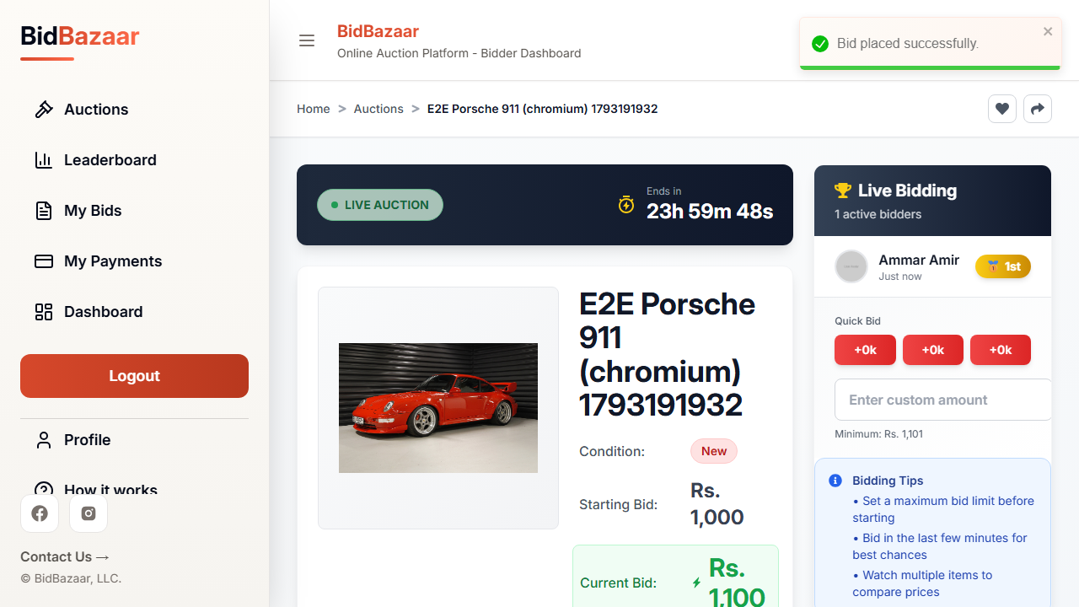
TC-B2 — bid accepted
Result: PASSED

TC-B3 Re-bid by same bidder (positive, state)
The same Bidder bids Rs. 1,200 and then Rs. 1,300. The current bid updates each time, and the test checks the API to confirm the bidder still has only one bid record (it was updated, not duplicated).
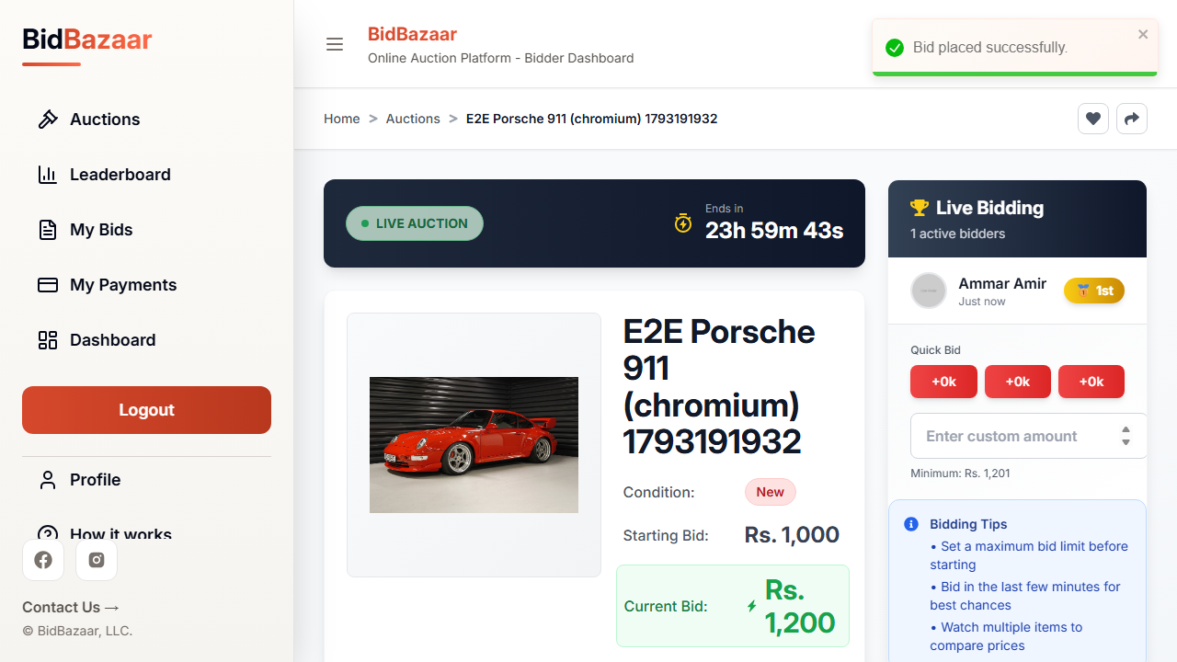
TC-B3 — first bid 1200
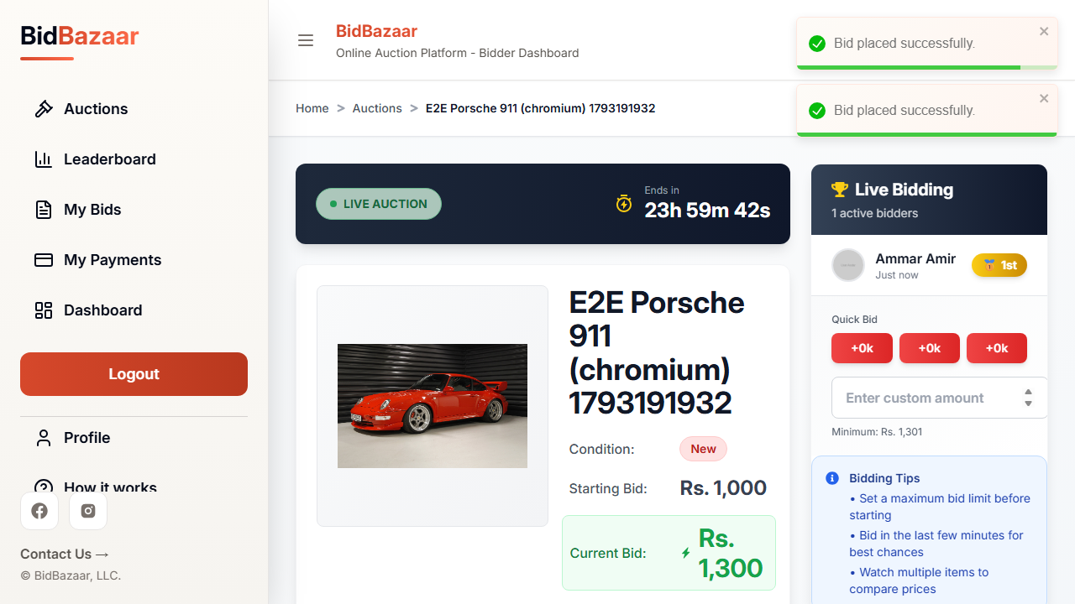
TC-B3 — rebid 1300
Result: PASSED

4.5 Stripe Payment (e2e/payment.py)

TC-P1 Valid card (positive)
The auction winner pays the 20% deposit on Stripe Checkout with test card 4242 4242 4242 4242. Stripe redirects back to the "Success! Your payment has been confirmed" page and the DB status becomes Paid.
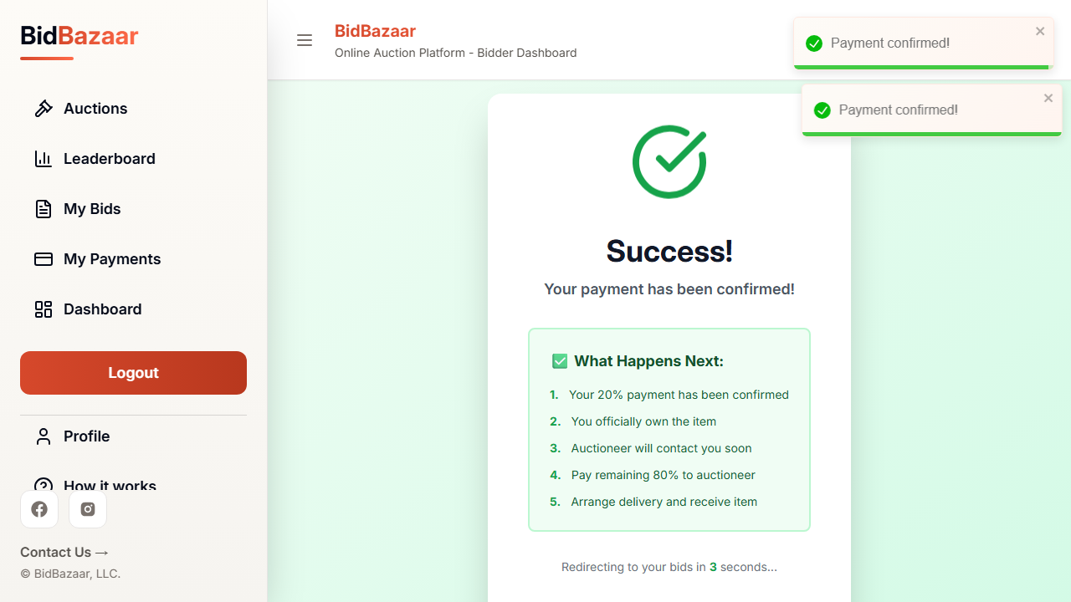
TC-P1 — payment success
Result: PASSED

TC-P2 Declined card (negative)
The test card 4000 0000 0000 0002 is used. Stripe shows "Your credit card was declined", the user stays on the Stripe page and the payment status in the DB stays Pending.
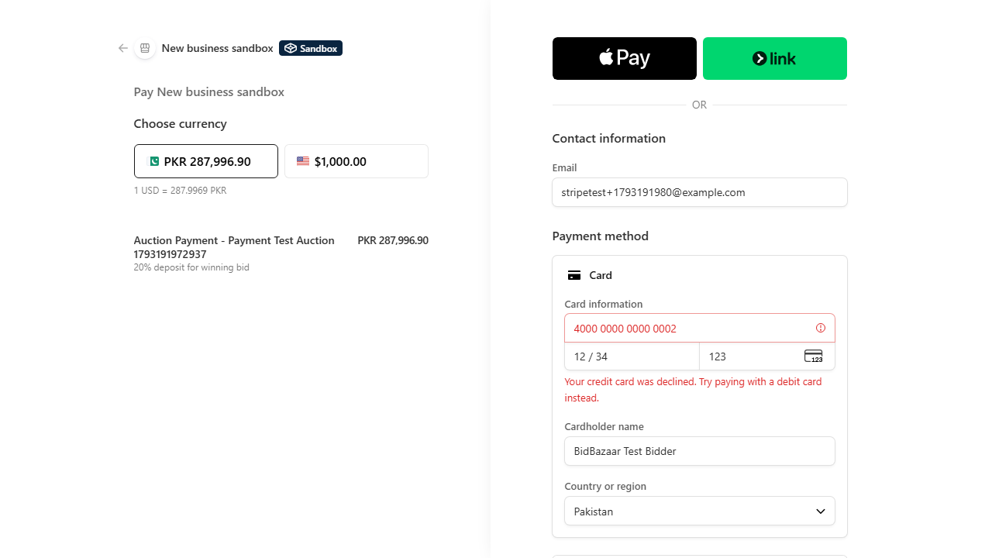
TC-P2 — card declined
Result: PASSED

TC-P3 Expired deadline (negative)
A payment whose deadline passed one hour ago is opened. The page shows "Payment Deadline Expired — your offer has been cancelled" and the pay button is disabled.
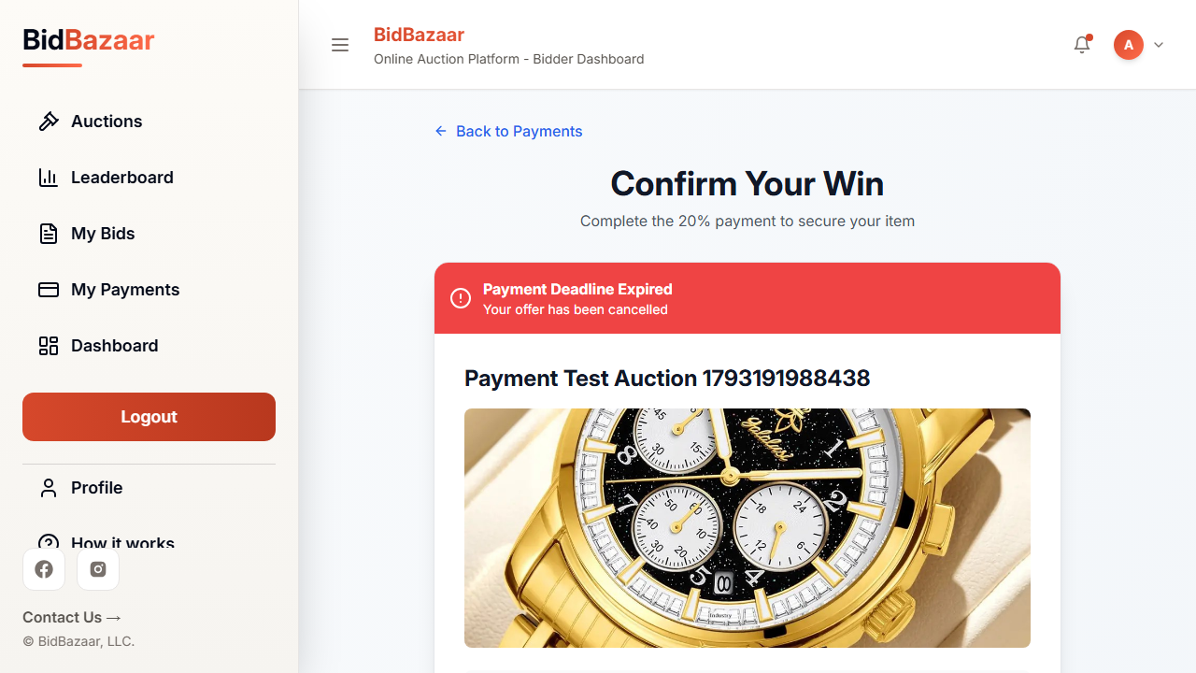
TC-P3 — deadline expired
Result: PASSED

4.6 Commission Proof Review (e2e/commission_review.py)

TC-M1 Admin approves proof (positive)
The Auctioneer uploads a commission payment proof (toast: "Your proof has been submitted successfully"). The Super Admin opens it, sets status to Approved and saves; the toast "Payment proof amount and status updated" appears and the proof's status is Approved.
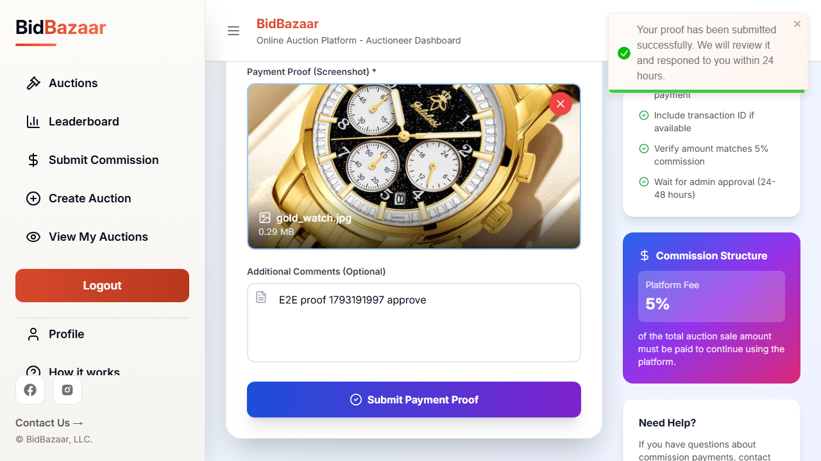
TC-M1 — proof submitted
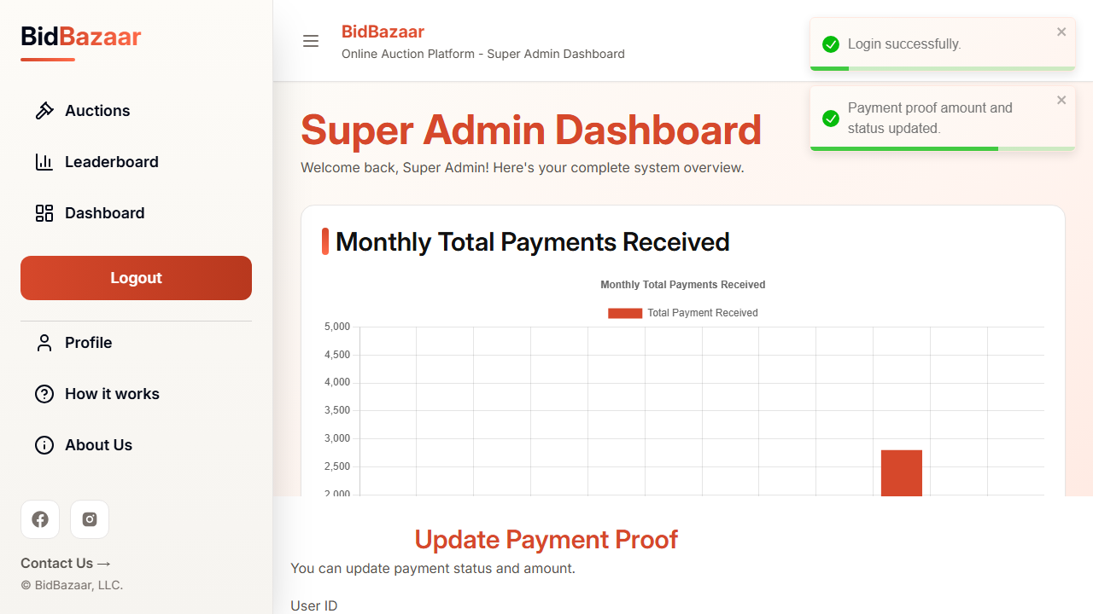
TC-M1 — status updated to Approved
Result: PASSED

TC-M2 Admin rejects proof (negative)
Same flow, but the Super Admin sets the status to Rejected. The update toast appears and the proof is stored as Rejected.
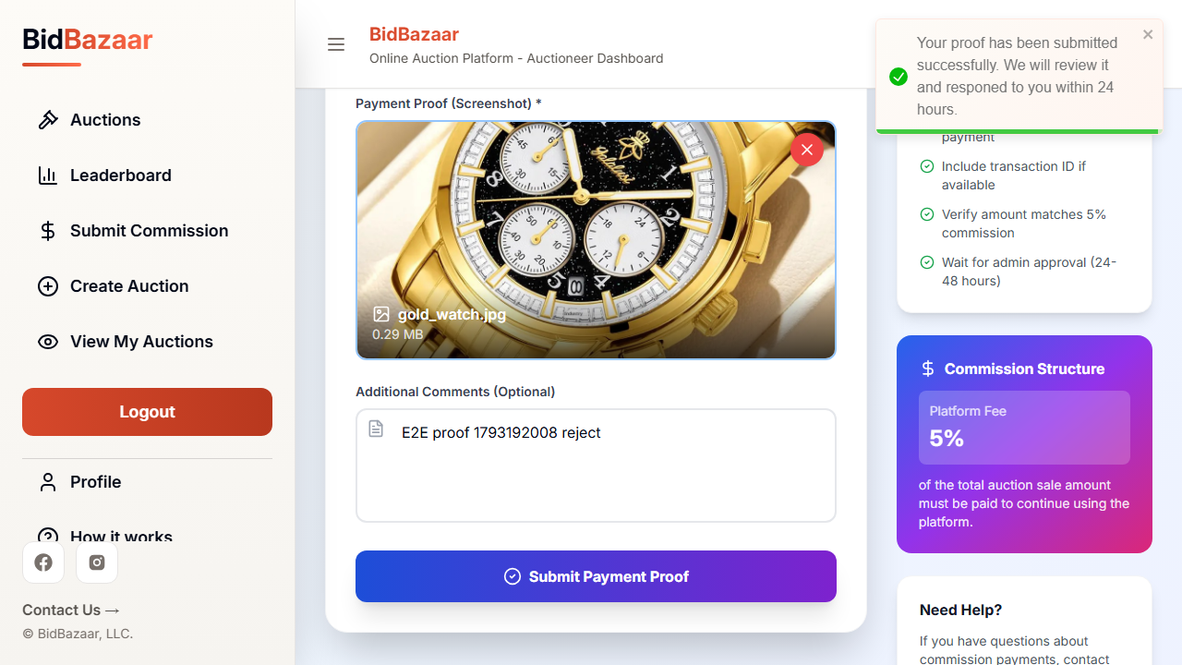
TC-M2 — proof submitted
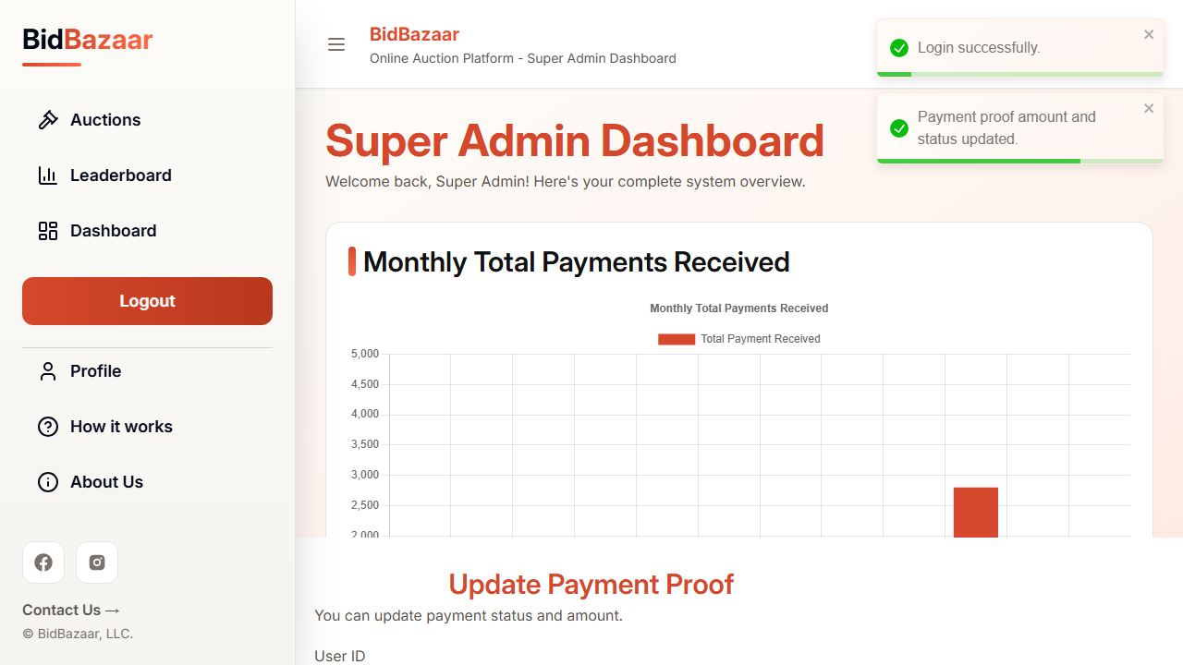
TC-M2 — status updated to Rejected
Result: PASSED

TC-M3 Amount more than owed (negative)
The Auctioneer owes Rs. 1,000 but submits a proof for Rs. 6,000. The site shows "The amount exceeds your unpaid commission balance" and the test confirms no proof was saved.
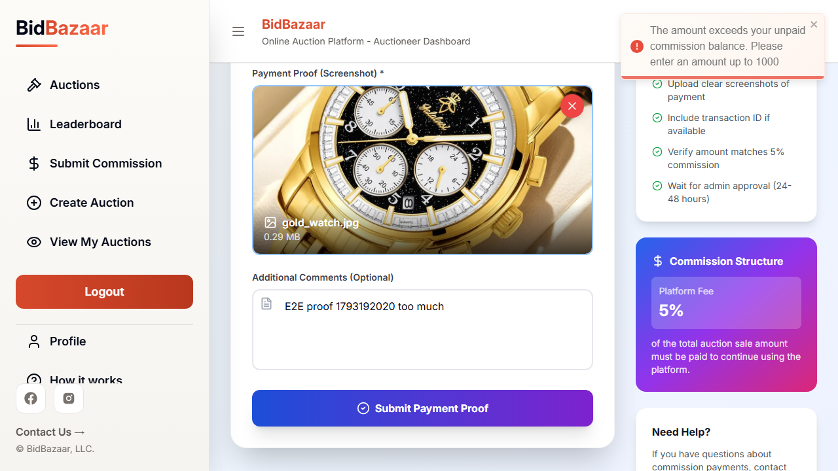
TC-M3 — exceeds balance error
Result: PASSED

5. API tests (CRUD)
Each API file uses Playwright's APIRequestContext to call the real Express backend and prints every request with its status code. The screenshots below are the terminal output of each file.

TC-A1 CREATE — POST /auctionitem/create (api/create.py)
A logged-in Auctioneer posts a complete auction with an image and gets 201 Created. The same request without an image is rejected with 400 "Auction item image required."
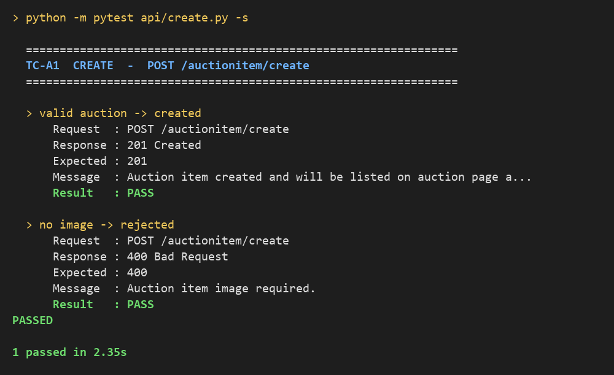
Terminal output of api/create.py
Result: PASSED

TC-A2 READ — GET /auctionitem/auction/:id (api/read.py)
An auction is created and then fetched by its id: 200 OK. Fetching an id that does not exist returns 404 "Auction not found."
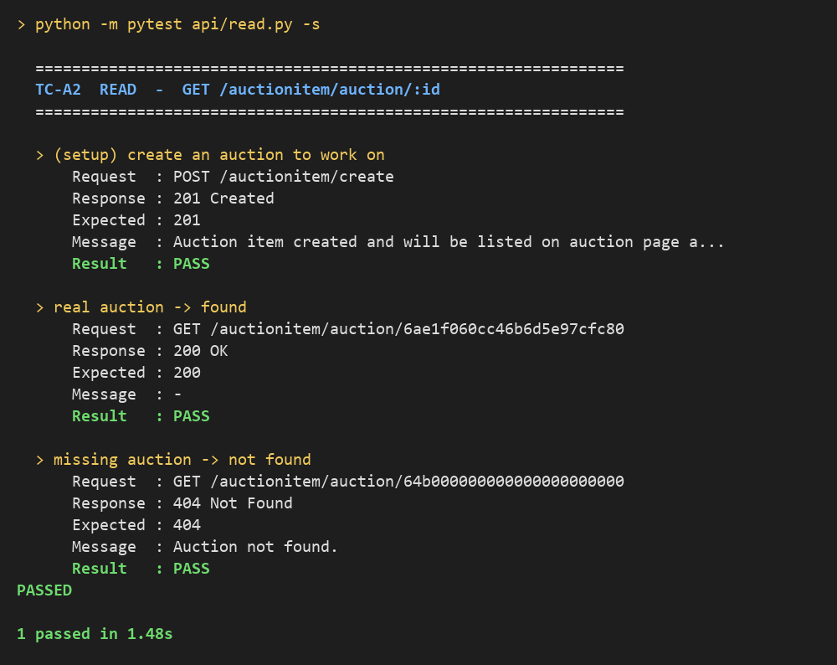
Terminal output of api/read.py
Result: PASSED

TC-A3 UPDATE — PUT /superadmin/paymentproof/status/update/:id (api/update.py)
A commission proof is submitted, then the Super Admin updates its status to Rejected: 200 OK. Updating an id that matches no proof returns 404 "Payment proof not found."
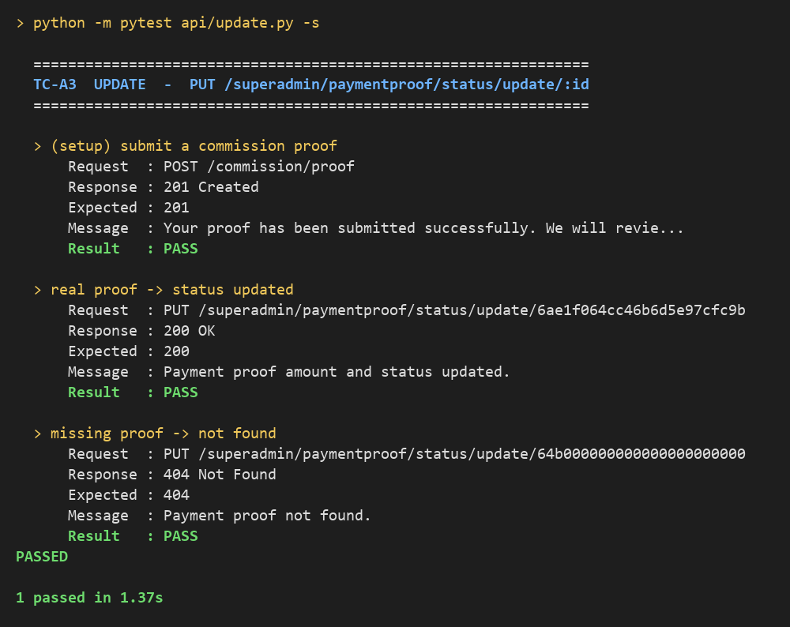
Terminal output of api/update.py
Result: PASSED

TC-A4 DELETE — DELETE /auctionitem/delete/:id (api/delete.py)
An auction is created and deleted: 200 OK. Deleting the same auction again returns 404 "Auction not found.", proving it is really gone.
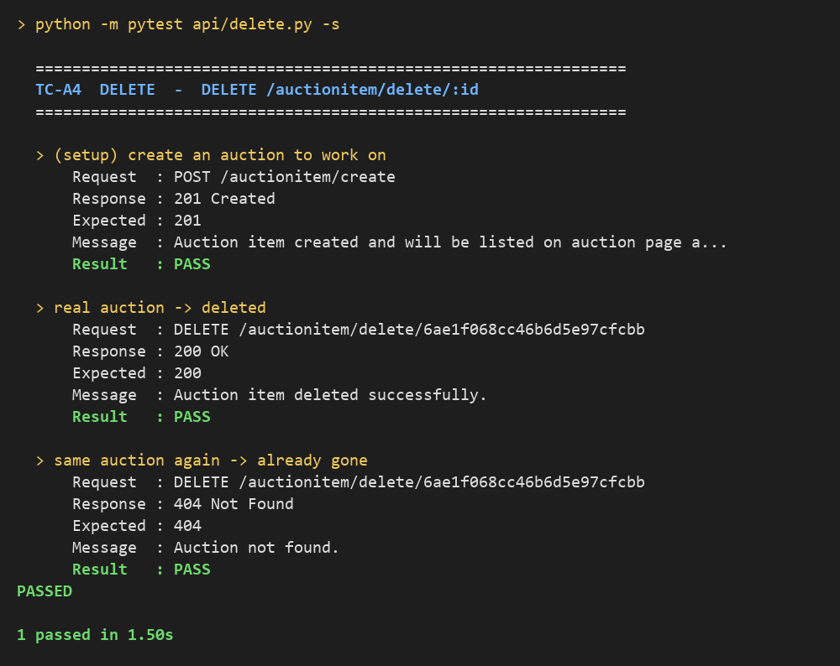
Terminal output of api/delete.py
Result: PASSED

6. Network mocking tests
page.route() intercepts the browser's request to GET /api/v1/auctionitem/allitems and answers it with a fake response, so the real backend is never contacted.

TC-N1 Empty data (mocking/empty_data.py)
The mocked response is 200 OK with an empty items list, even though the real database contains auctions. The Auctions page correctly shows its empty state: "No auctions found — Try adjusting your filters or search query" and 0 total auctions.
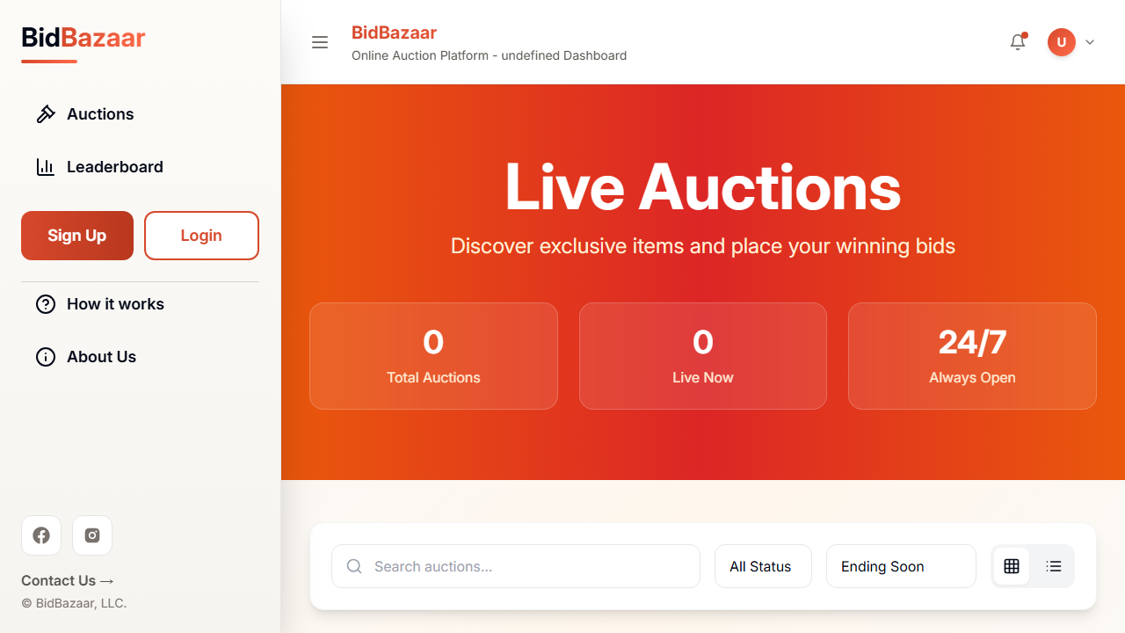
TC-N1 — empty state shown for an empty list
Result: PASSED

TC-N2 Server error (mocking/server_error.py)
The mocked response is HTTP 500 Internal Server Error, as if the backend crashed. The page does not break: the Live Auctions heading and the empty state are still rendered and no JavaScript errors are thrown.
TC-N2 — page still works after a 500 error
Result: PASSED

7. Deliberate bug (fail → pass)
An off-by-one bug was inserted on purpose into the minimum-bid check in frontend/src/pages/AuctionItem.jsx:
correct: if (numAmount < minBid) { // 999 is rejected (minimum 1000)
buggy: if (numAmount < minBid - 1) { // 999 is accepted, no error shown
The script bug_demo.py inserts the bug, runs TC-B1, removes the bug and runs TC-B1 again.

With the bug — TC-B1 FAILED
The Bidder types 999 but no "Minimum bid" error appears and the Bid button stays enabled. The test fails with "Locator expected to be visible" — the bug is caught. (Report: reports/report_with_bug.html)
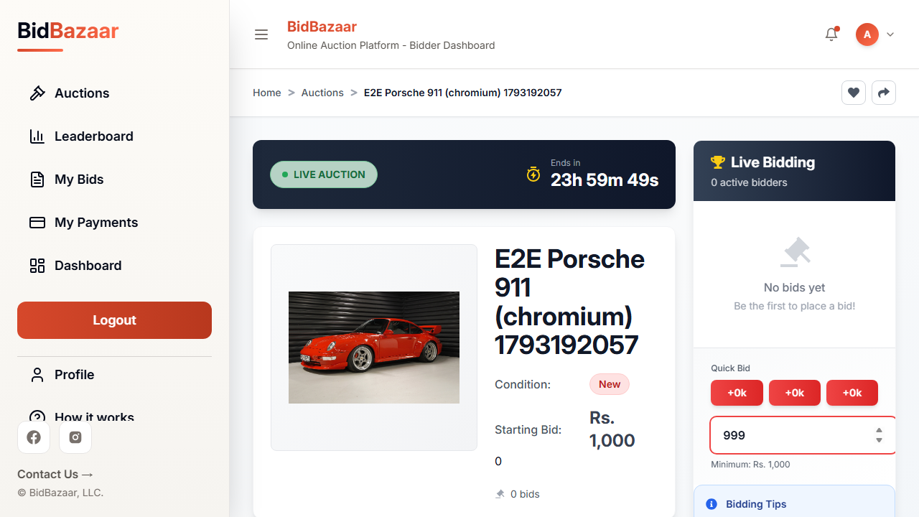
With the bug: 999 accepted, no error message
Result: FAILED (expected — bug detected)

Bug removed — TC-B1 PASSED
After restoring the original line the same test passes: the error "Minimum bid is Rs. 1,000" is shown and the Bid button is disabled. (Report: reports/report_bug_fixed.html)
Bug removed: error shown, Bid disabled
Result: PASSED

8. Real bugs found by the tests
# | Bug | Where | Found by | Status
1 | Create Auction calls GET /user/unpaid-commission but the route did not exist (404), so the warning never showed and the button stayed enabled | CreateAuction.jsx, userRoutes.js | TC-C3 | Fixed
2 | Payments were created with field status instead of paymentStatus; Mongoose silently dropped it | paymentFlowService.js | TC-P1 | Fixed
3 | Payment history used status instead of the schema field Status (dropped silently) | paymentFlowService.js | TC-P1 | Fixed
4 | Admin "Update proof" drawer showed the amount of the previously opened proof (stale state) | PaymentProofs.jsx | TC-M1 / M2 | Fixed
5 | Commission cron called sendEmail without await → unhandled promise rejection | verifyCommissionCron.js | Commission tests | Fixed
6 | Typo throw errorl in the email error handler → ReferenceError on any email failure | sendEmail.js | Commission tests | Fixed
7 | Invalid input was blocked silently with no error pop-up (sign-up missing fields / bank details, too-low bid, proof without file) | SignUp.jsx, AuctionItem.jsx, SubmitCommission.jsx | TC-R3, TC-B1 | Fixed
8 | Quick Bid buttons show "+0k" on an auction with no bids yet | AuctionItem.jsx | TC-B1 / B2 (observed) | Open (cosmetic)

9. Deliverables
- Test files: e2e/, api/, mocking/, helpers.py, conftest.py, shared_config.py, pytest.ini, bug_demo.py
- HTML reports: one per test file in reports/ (login.html … server_error.html), plus report_with_bug.html and report_bug_fixed.html
- Screenshots: reports/screenshots/ (one folder per test file) and reports/test-results/
- Logs: reports/logs/ (terminal output of every run)

