|  |  |  |  |
| --- | --- | --- | --- |
|  |  |  |  |



**CAN THO UNIVERSITY**

CANTHO UNIVERSITY SOFTWARE CENTER

ESSAY PROJECT

**DTH WEBSITE**

**Class:** CP1396C1 **Supervisor:**

**Group:** 01Lê Thị Minh Loan

**Members:**

Hoàng Nguyễn Trường Nam – 864407

Nguyễn Thành Danh – 864457

Trương Thị Thùy Trân – 869192

Can Tho, 01/2014

**Form No. 1** / eProjects

**III.1. Problem Definition**

**R-DTH**, one of the fastest growing DTH service providers in the country, having garnered 10+ millions subscribers since its inception in December 2007, aims to become one of the leading players in the DTH space. R-DTH transmits digital satellite television signals across the length and breadth of India. **R-DTH** is the first to have adopted the advanced MPEG-4 technology that offers better compression and signal quality. It is also the first to have offered High Definition (HD) content, for a whole new television viewing experience. Today, **R-DTH** has spread rapidly all over the country and offers the best entertainment value in regional content coupled with advanced yet affordable products like set top boxes with USB recordings.

With customer numbers crowded as today, the archival customer data management, orders details and information television services are important issues that the company wants to solve. improve the website is  the company's critical issues to better meet the data management and create a friendly  website .Home page designing must be accomplished with all the necessary links and description of the website .It must contain links such as packages, Recharge now, Contact us , Customer care , Login, Package details, locate Dealers List, Locate Distributors. To solve these problems we suggest:

Admin can login into the system to manage customer details, manage feedbacks, manage FAQs, manage package services and update the data of the website. Dealers and Distributor can login into the system to view the orders of the setup box in their location and also will place their payment accordingly. Customer can login into the system to view and update their profile, view list of package services, view list of dealer and distributors, booking movie. Customer can contact us directly via the information on page Contact Us to send feedback on for us on Feedback page.    Customers who are not registered as members can also view information about the company and our services.

**FormN.2**/eproject/CRS/Ver1.0

**III.2. Customer requirement specification (CRS)**

**Client:** R-DTH Company

**Business/Project Objective**:

Developed a website to increase the comfort level of the customer with the friendly interface . through this system , customer can view list of movie , view list of setup box, view list of package, view events, view news and request for them online.Customer can book movie, subscrice package and join events and evaluation services of the website.

**Modeling requirements of customer**

1. 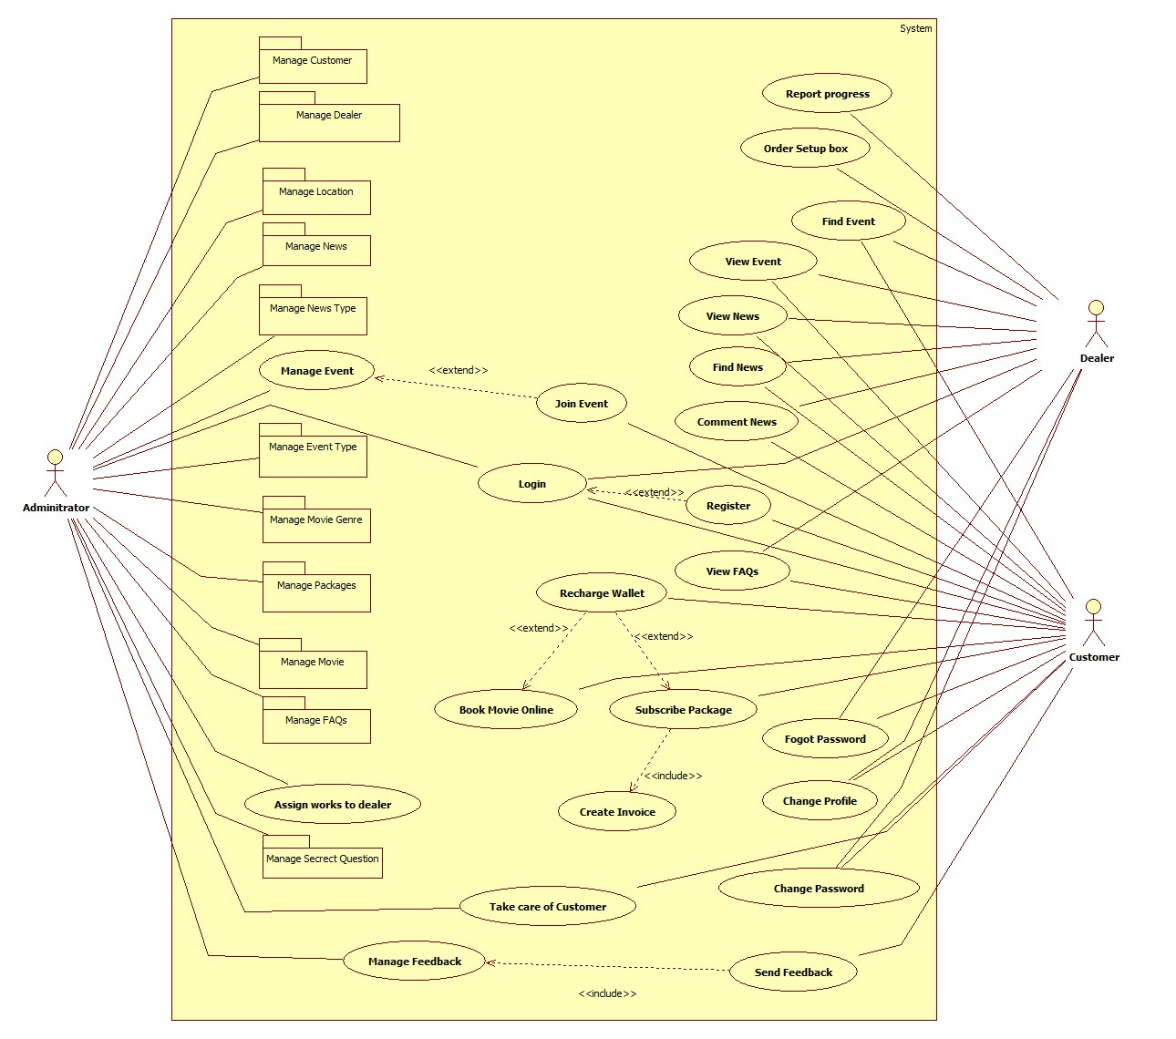**Use case Diagram**

* 1. **Actor Description**

|  |  |  |  |
| --- | --- | --- | --- |
| **No.** | **Actor** | **Use case** | **Description** |
| 1. | Administrator | Manage Customer | This module allow Admin to manage information of Customer consist of create new , edit , delete Customer |
| Mange Dealer | This module allow Admin to manage information of Customer consist of create new , edit , delete Dealer and Distributer |
| Manage Location | This module allow Admin to manage information of Customer consist of create new , edit , delete Location |
| Manage Package | This module allow Admin to manage information of Package consist of create new , edit , delete Package |
| Manage Movie | This module allow Admin to manage information of Movies consist of insert new, edit, delete Movie. |
| Manage Movie Genre | This module allow Admin to manage information of Movie genre consist of insert new, edit, delete Movie genre. |
| Manage Event | This module allow Admin to manage information of Event consist of insert new, edit, delete Event. |
| Manage Event Type | This module allow Admin to manage information of Event Type consist of insert new, edit, delete Event Type. |
| Manage News | This module allow Admin to manage information of News consist of insert new, edit, delete News. |
| Manage FAQs | This module allow Admin to manage information of FAQs consist of insert new, edit, delete FAQs. |
| Assign works for dealer | This module allow Admin to assign work for Dealer. |
| Login | This module allow Admin login to the system. |
| 2. | Customer | Find News | This module allow Customer to find News. |
| View News | This module allow Customer to views News. |
| Comment News | This module allow Customer to comments News. |
| Find Event | This module allow Customer to find Event. |
| View Event | This module allow Customer to views Event. |
| Join Event | This module allow Customer to join Event. |
| Subscribe Package | This module allow Customer to subscribe package. |
| Recharge Package | This module allow Customer to recharge the package. |
| Recharge Wallet | This module allow Customer to recharge the wallet. |
| Book Movie | This module allow Customer to booking movie online. |
| Change Profile | This module allow Customer to change their profile. |
| Change Password | This module allow Customer change their password. |
| Forgot Password | This module allow Customer to reset password. |
| View FAQs | This module allow Customer to view FAQs about our services. |
| Register | This module allow Customer register account. |
| Login | This module allow Customer login to the system. |
| 3. | Dealer | Find News | This module allow Dealer to views News. |
| View News | This module allow Dealer to views News. |
| Comment News | This module allow Dealer to comment News. |
| Find Event | This module allow Dealer to find Event. |
| View Event | This module allow Dealer to views Event. |
| Order Setup box | This module allow Dealer to order Setup box. |
| Report Process | This module allow Dealer to report their process. |
| Change Profile | This module allow Dealer to change their profile. |
| Change Password | This module allow Dealer change their password. |
| Forgot Password | This module allow Dealer to reset password. |
| Login | This module allow Dealer login to the system. |

1. **Use case Description**
   1. **Manage Customer :**

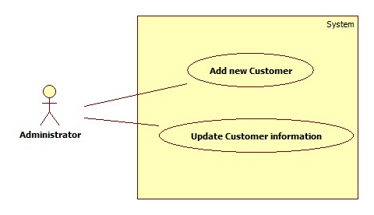

* + 1. **Add new Customer :**
* **Purpose :** This function allow admin add new Customer information
* **Input :**
  + Customer ID
  + Password
  + Customer name
  + Card number
  + Secret Question
  + Answer
  + Location
  + Address
  + Birthday
  + Phone number
  + Email
* **Output :** New customer information added to database
  + 1. **Update Customer :**
* **Purpose:** This function allow Admin to edit Customer information
* **Inputs:**
  + Customer ID
  + Customer information want to edit
* **Outputs:**  Customer information has been edit
  1. **Manage Dealer**

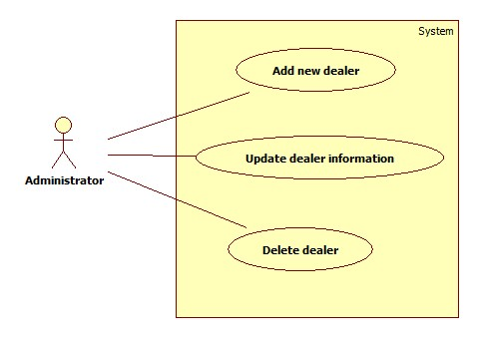

* + 1. **Add new Dealer:**
* **Purpose :** This function allow admin add new Dealer information
* **Input :**
  + Dealer ID
  + Password
  + Dealer name
  + Location
  + Address
  + Phone number
  + Email
* **Output :** New Dealer information added to database
  + 1. **Update Dealer:**
* **Purpose:** This function allow Admin to edit Dealer information
* **Inputs:**
  + Dealer ID
  + Dealer information want to edit
* **Outputs:**  Dealer information has been edit
  + 1. **Delete Dealer:**
* **Purpose :** This function allow Admin to delete Dealer
* **Inputs :**
  + Dealer ID
* **Outputs :** Dealer has been deleted from database
  1. **Manage Location**

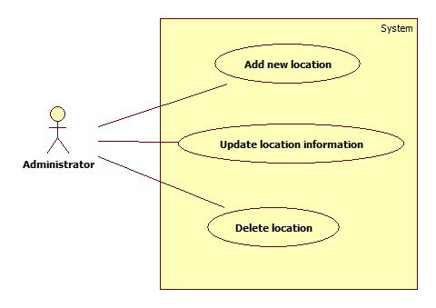

* + 1. **Add new Location:**
* **Purpose :** This function allow admin add new Location information
* **Input :**
  + Location ID
  + Location Name
* **Output :** New Location information added to database
  + 1. **Update Location:**
* **Purpose:** This function allow Admin to edit Location information
* **Inputs:**
  + Location ID
  + Location Name
* **Outputs:**  Location information has been edit
  + 1. **Delete Location:**
* **Purpose :** This function allow Admin to delete Location
* **Inputs :**
  + Location ID
* **Outputs :** Location has been deleted from database
  1. **Manage Package**

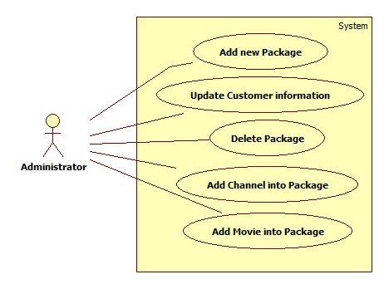

* + 1. **Add new Package:**
* **Purpose :** This function allow admin add new Package information
* **Input :**
  + Package ID
  + Package Name
  + Setup Box
  + Description
  + Price
  + Discount
* **Output :**New Package information added to database
  + 1. **Update Package:**
* **Purpose:** This function allow Admin to edit Package information
* **Inputs:**
  + Package ID
  + Package information want to edit
* **Outputs:**  Package information has been edit
  + 1. **Delete Package:**
* **Purpose :** This function allow Admin to delete Package
* **Inputs :**
  + Package ID
* **Outputs :** Package has been deleted from database
  + 1. **Add Channel for Package:**
* **Purpose :** This function allow Admin to add Channel for Package
* **Inputs :**
  + Package ID
  + Channel Number
* **Outputs :** Package has been deleted from database
  + 1. **Add Movie for Package:**
* **Purpose :** This function allow Admin to add Movie for Package
* **Inputs :**
  + Package ID
  + Movie ID
* **Outputs :** Package has been deleted from database
  1. **Register**
* **Purpose :** This function allow Customer create their account
* **Input :**
  + Customer ID
  + Password
  + Customer name
  + Card number
  + Location
  + Address
  + Birthday
  + Phone number
  + Email
* **Output :** New Customer information added to database
  1. **Login**
* **Purpose :** This function allow Customer/Dealer/Admin login into the system
* **Input :**
  + Customer ID / Dealer ID / Admin ID
  + Password
* **Output :** Authorization
  1. **Subscribe Package**
* **Purpose :** This function allow Customer to subscribe service package
* **Input :**
  + Customer ID
  + Card Number
* **Output :** Subscribe package successfully
  1. **Recharge Package**
* **Purpose :** This function allow Customer recharge expired Package
* **Input :**
  + Customer ID
  + Card Number
* **Output :** Recharge package successfully
  1. **Recharge Wallet**
* **Purpose :** This function allow Customer recharge their Digital Wallet
* **Input :**
  + Customer ID
  + Card Number
* **Output :** Recharge Wallet successfully
  1. **Assign works to dealer**
* **Purpose :** This function Admin assign works to dealer
* **Input :**
  + Package ID
  + Dealer ID
* **Output :** Authorization
  1. **Manage Channel**

**3.12.1 Add new Channel**

* **Purpose:** This function allow Admin add new Channel
* **Inputs:**
  + Channel Number
  + Channel Name
  + Channel Picture
* **Outputs:**  New Channel information added to database

**3.12.2 Update Channel**

* **Purpose:** This function allow Admin to edit Dealer information
* **Inputs:**
* **Outputs:**  Channel information has been edit

**3.12.3 Delete Channel**

* **Purpose:** This function allow Admin to delete Dealer information
* **Inputs:** Channel Number
* **Outputs:**  Channel information has been delete
  1. **Manage Movie**

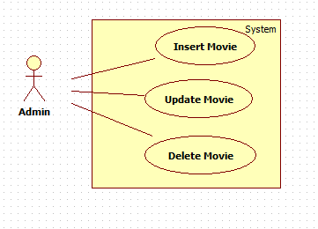

* + 1. **Insert Movie:**
* **Purpose :** This function allow Admin to insert movie
* **Inputs :**
  + Movie Name
  + Price Per Month
  + Discount
* **Outputs :** New movie has been insert into database
  + 1. **Update Movie:**
* **Purpose :** This function allow Admin to update movie information
* **Inputs :**
  + Movie Name
  + Price Per month
  + Discount
* **Outputs :** Movie information has been update in database
  + 1. **Delete Movie:**
* **Purpose :** This function allow Admin to delete Movie
* **Inputs :**
  + Movie ID
* **Outputs :** Movie has been deleted from database
  1. **Manage Movie genre**

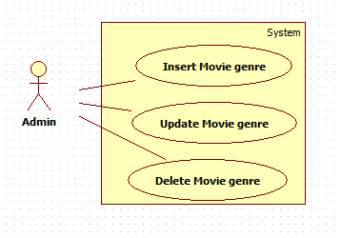

* + 1. **Insert Movie genre:**
* **Purpose :** This function allow Admin to insert new Movie genre into database
* **Inputs :**
  + Genre ID
  + Genre Name
* **Outputs :** New Movie genre has been insert into database
  + 1. **Update Movie Genre:**
* **Purpose :** This function allow Admin to update Movie genre information
* **Inputs :**
  + Genre Name
* **Outputs :** Movie genre information has been update into database
  + 1. **Delete Movie genre:**
* **Purpose :** This function allow Admin to delete Movie genre
* **Inputs :**
  + Genre ID
* **Outputs :** Movie genre has been deleted from database
  1. **Manage FAQs**

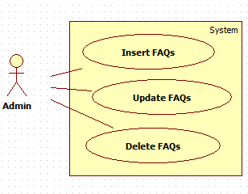

* + 1. **Insert FAQs:**
* **Purpose :** This function allow Admin to insert new FAQs into database
* **Inputs :**
  + FAQs ID
  + Question
  + Answers
* **Outputs :** New FAQs has been insert into database
  + 1. **Update FAQs:**
* **Purpose :** This function allow Admin to update FAQs information
* **Inputs :**
  + Question
  + Answer
* **Outputs :** FAQs information has been update into database
  + 1. **Delete FAQs:**
* **Purpose :** This function allow Admin to delete FAQs
* **Inputs :**
  + FAQs ID
* **Outputs :** FAQs has been deleted from database
  1. **Manage Feedbacks**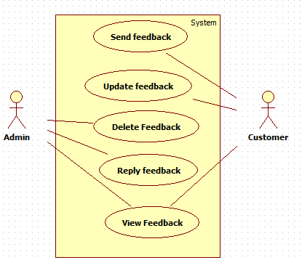
     1. **Update Feedbacks :**
* **Purpose :** This function allow Customer to update their feedbacks
* **Inputs :**
  + Customer ID
  + Title
  + Content
* **Outputs :** New Feedback has been update into database
  + 1. **Delete Feedbacks:**
* **Purpose :** This function allow Admin to delete Feedbacks
* **Inputs :**
  + Feedback ID
* **Outputs :** Feedback has been deleted from database.
  + 1. **Send Feedbacks:**
* **Purpose :** This function allow Customer to send their Feedbacks
* **Inputs :**
  + Customer ID
  + Title
  + Content
* **Outputs :** New Feedback has been insert into database.
  1. **Book Movie online**
* **Purpose :** This function allow Customer to booking movie online
* **Inputs :**
  + Customer ID
  + Movie ID
* **Outputs :** Booking movie successfully
  1. **Manage Event**

**3.18.1 Insert Event**

* **Purpose:** This function allow add Event into database
* **Inputs:**
* Event ID
* Event Name
* Description
* Date start
* Date End
* Image
* Reward
* **Outputs:**  New Event has been insert into database

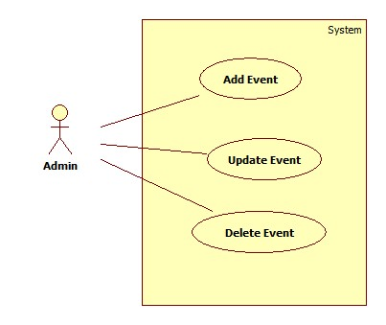**3.118.2 Update Event**

* **Purpose:** This function allow update Event into database
* **Inputs:**
* Event ID
* Event Name
* Description
* Date start
* Date End
* Image
* Reward
* **Outputs:** Event information has been update into database

**3.18.3 Delete Event**

* **Purpose:** This function allow delete Event into database
* **Inputs:**
* Event ID
* Event Name
* Description
* Date start
* Date End
* Image
* Reward
* **Outputs:**  Event information has been delete into database
  1. 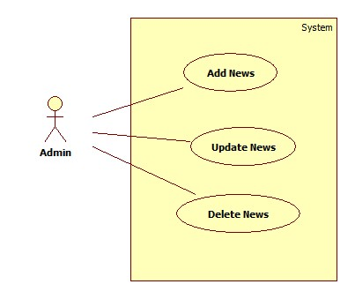**Manage News**

**3.20.1 Insert News**

* **Purpose:** This function allow add News into database
* **Inputs:**
* News ID
* Title
* Introduction
* Description 1
* Image 1
* Description 2
* Image 2
* Date post
* **Outputs:**  News has been add into database

**3.20.2 Update News**

* **Purpose:** This function allow update News into database
* **Inputs:**
* News ID
* Title
* Introduction
* Description 1
* Image 1
* Description 2
* Image 2
* Date post
* **Outputs:** News has been update into database

**3.20.3 Delete News**

* **Purpose:** This function allow delete News into database
* **Inputs:**
* News ID
* Title
* Introduction
* Description 1
* Image 1
* Description 2
* Image 2
* Date post
* **Outputs:**  News has been delete into database
* **Expected Delivery Dates**
* **List of Deliverable**

**Hardware and Software Requirements :**

1. **Hardware**

* **Server**

|  |  |
| --- | --- |
| Processor | Intel Core i3 or higher |
| Memory | 2GB RAM of greater |
| Modem/ADSL | Connecting |

* **Client**

|  |  |
| --- | --- |
| Processor | Pentium III or higher. |
| Memory | 64MB RAM or greater. |

1. **Software**

* **Server:**

|  |  |
| --- | --- |
| Operation System | Windows 2000/XP/2003/7/8/10 |
| Browser | Internet Explorer 6.0 or higher. |
| Database | Microsoft SQL Server 2012 |
| Software | J2EE  Java 8.0.2  GlassFish 3.1.2 |

* **Client:**

|  |  |
| --- | --- |
| Operation System | Windows XP or later. |
| Browser | Internet Explorer 6.0 or higher. |

* **Scope of the word (in brief) :**

1. Verification and validation of an administrator, dealer and customer.

2. A GUI should be created which displays a menu with various options depicted

on it.

3. The admin can login into the system to manage customer,delaler information, manage movie, manage feedback, manage event and update the data of the website.

4. Dealer can login into the system to view news, view events, order setup box and report the process.

5. Customer can login into the system to view list of movie, list of setup box, list of package,view news , view the events. They can subscribe package , booking movie online and join events.

7. Exit from the application if the user does not want to continue.

**Form No. 3** / eProjects / Design / Ver1.0

Architecture and Design of the Project



**Form No. 4** / eProjects / Flow Chart / Ver1.0

**Activity Diagram**

1. **Add new Customer**

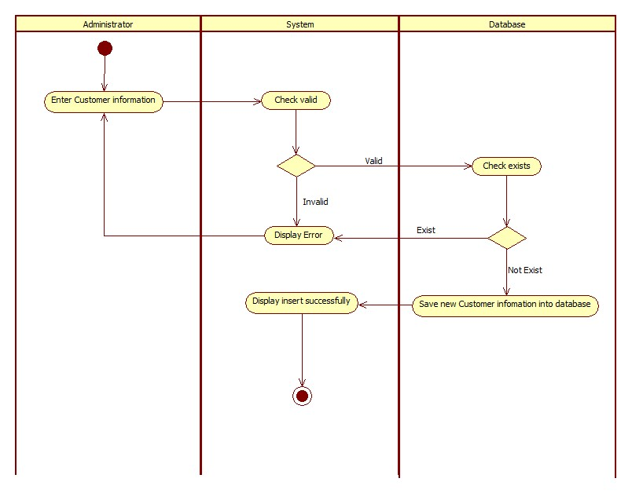

1. **Update Customer**

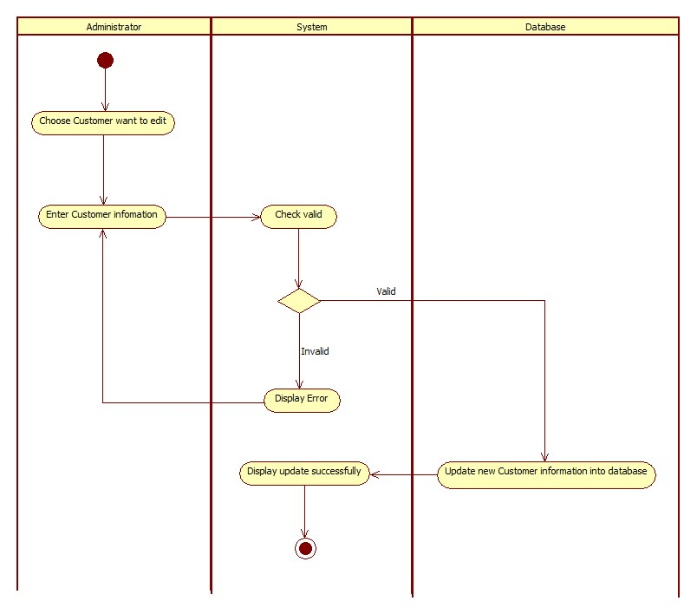

1. **Delete Customer**

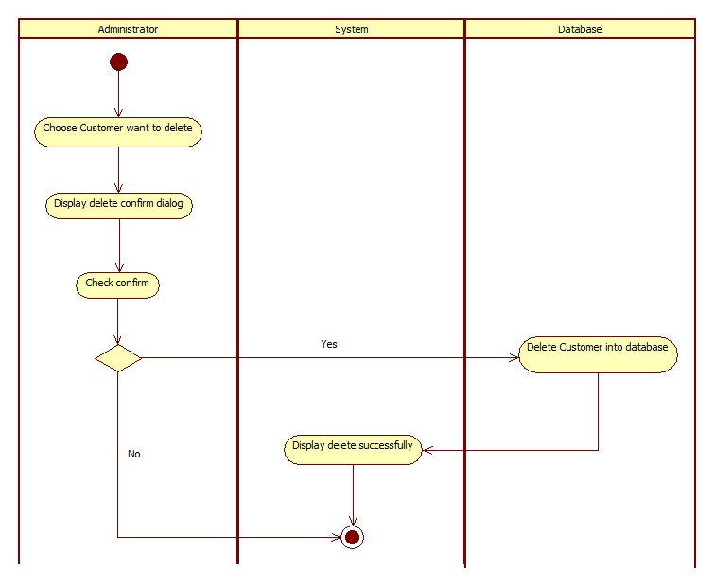

1. **Add new Dealer**

`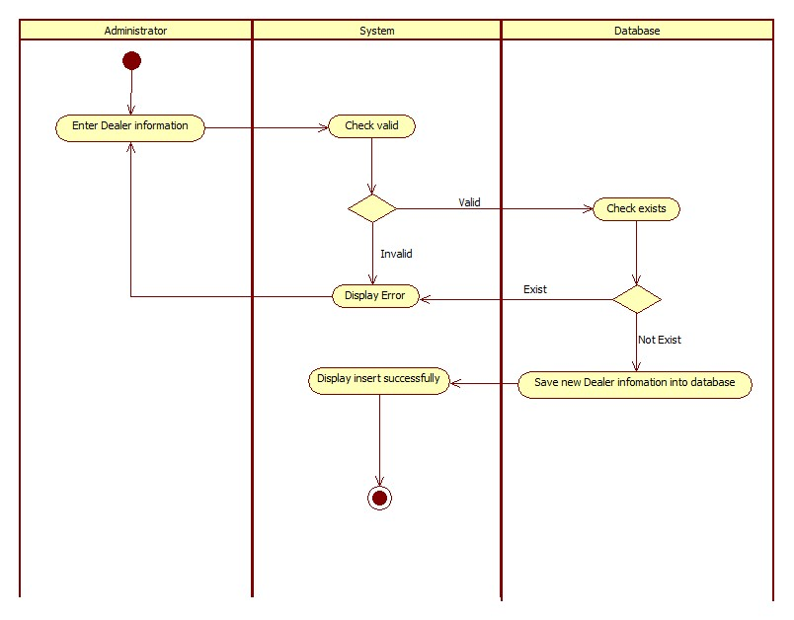

1. **Update Dealer**

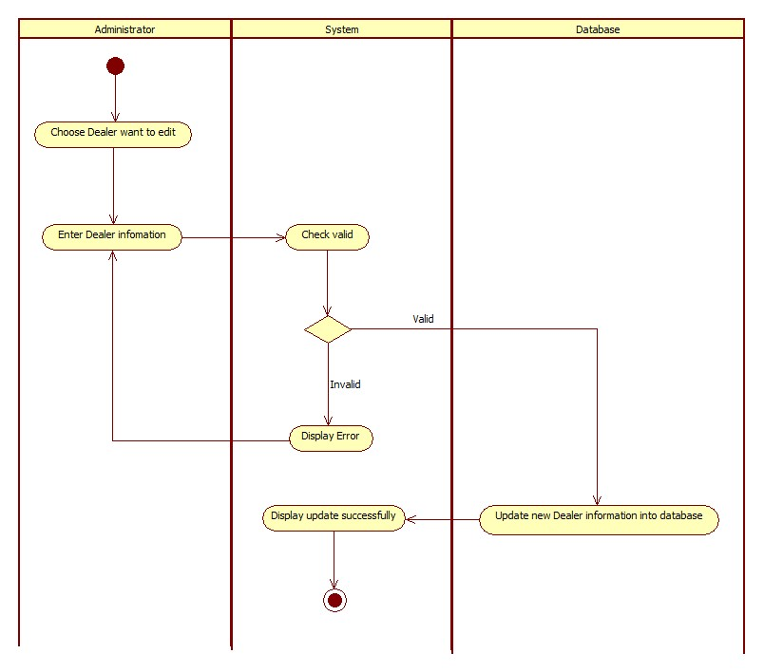

1. **Delete Dealer**

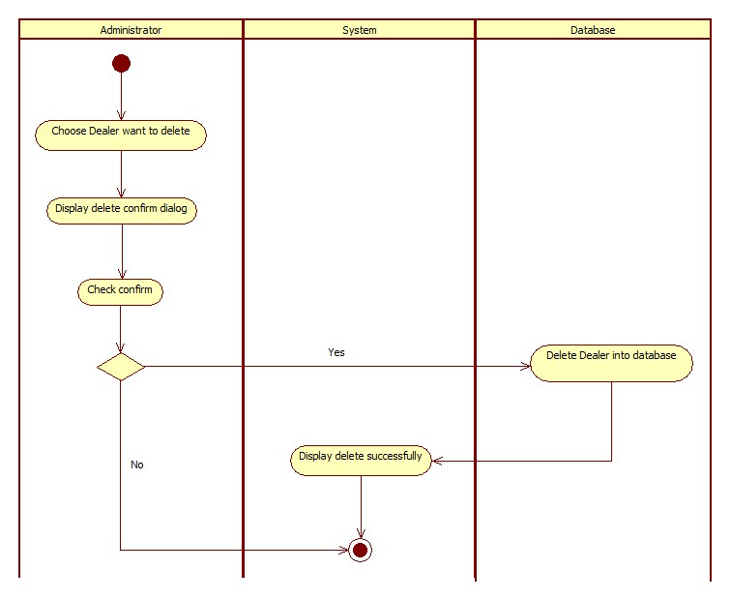

1. **Add new Location**

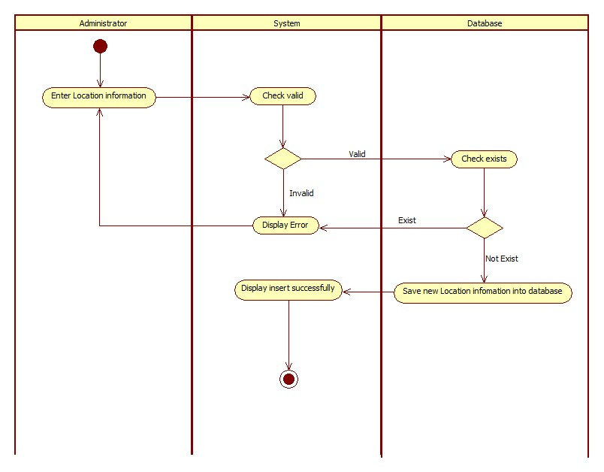

1. **Update Location**

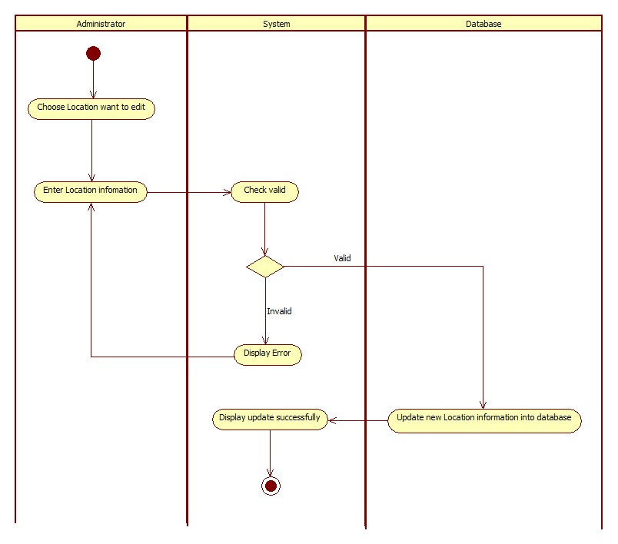

1. **Delete Location**

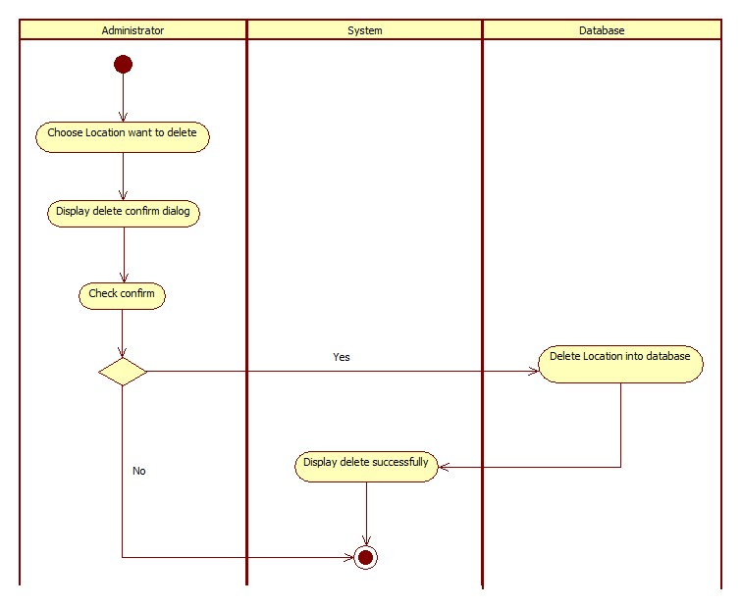

1. **Add new Package**

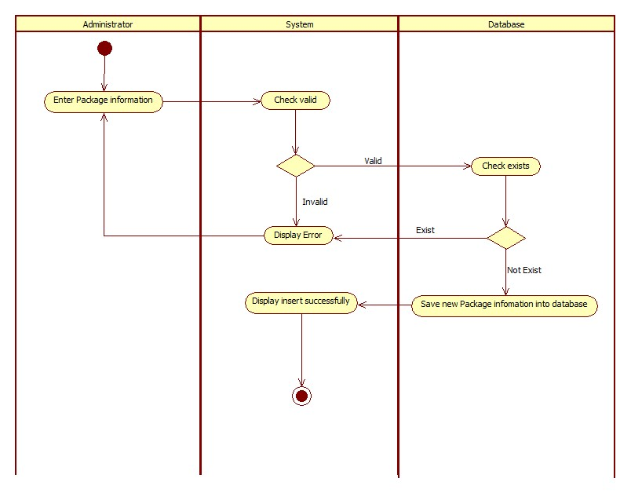

1. **Update Package**

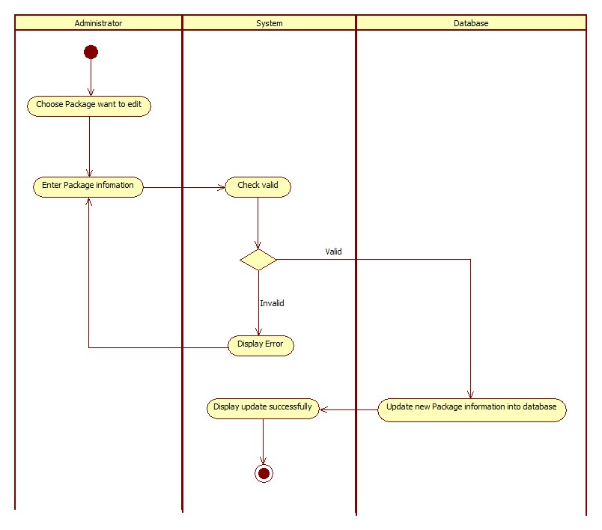

1. **Delete Package**

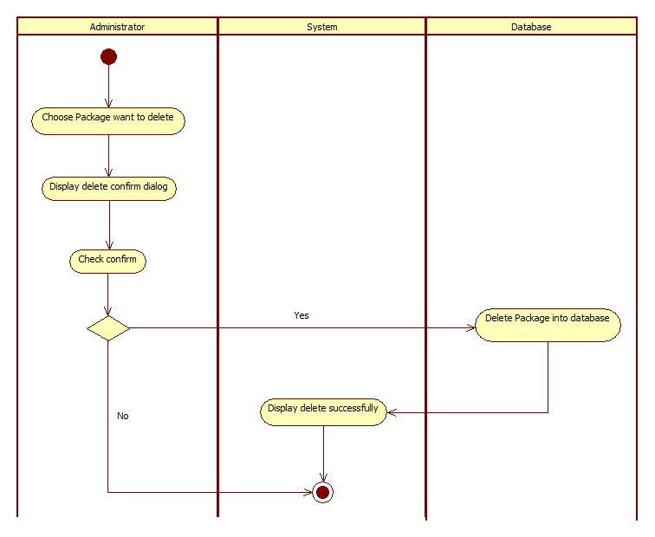

1. 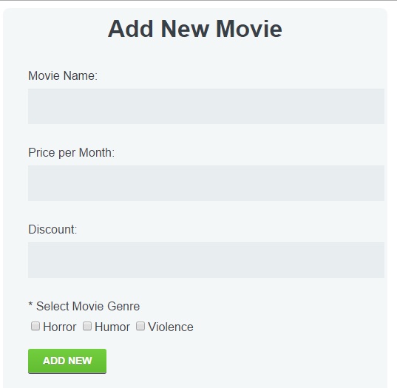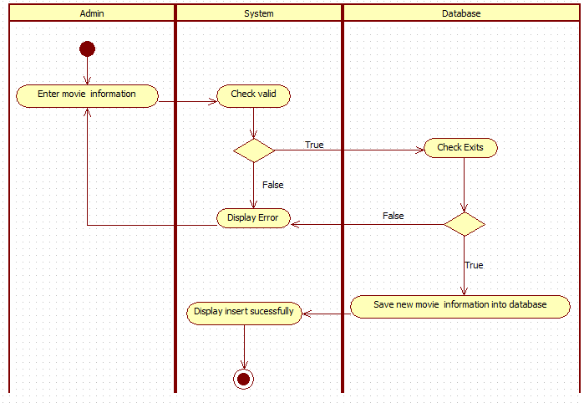**Add new Movie**
2. 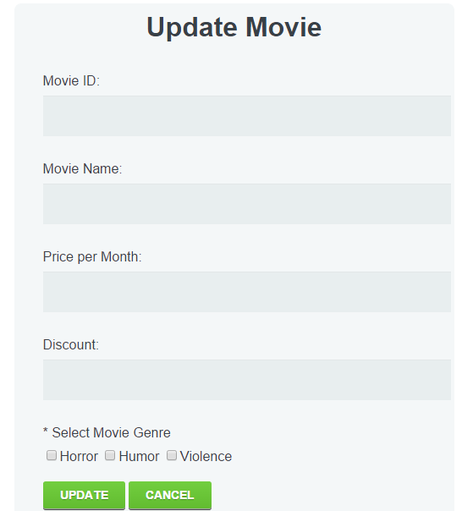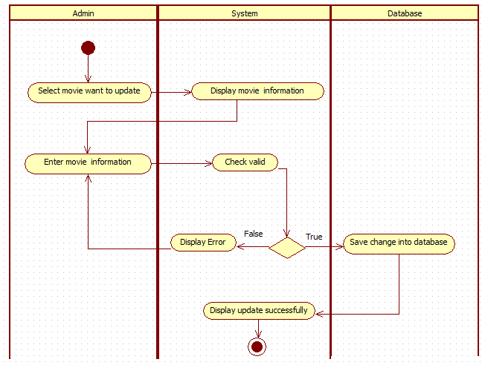**Update Movie**
3. **Delete Movie**

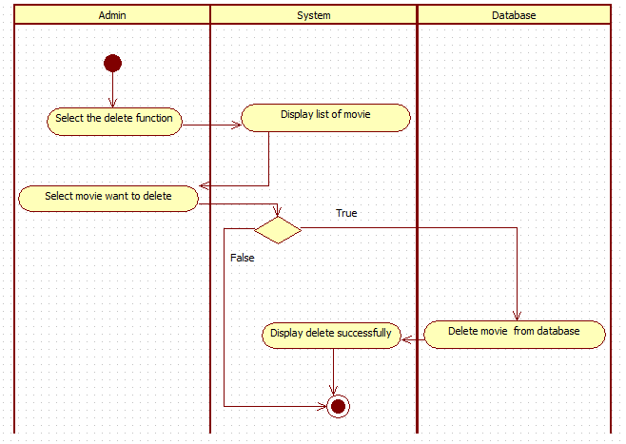

1. 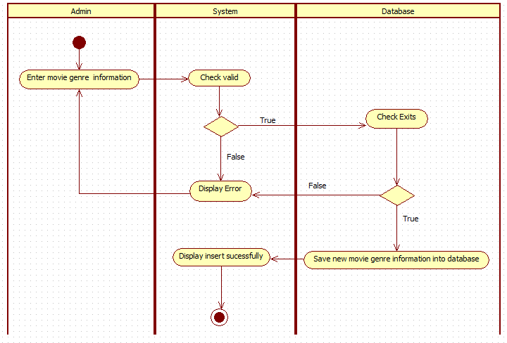**Insert Movie Genre**

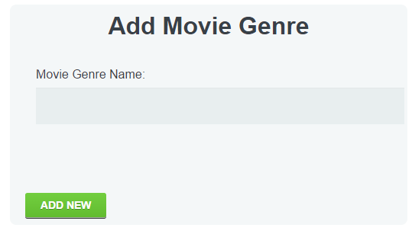

1. **Update Movie Genre**

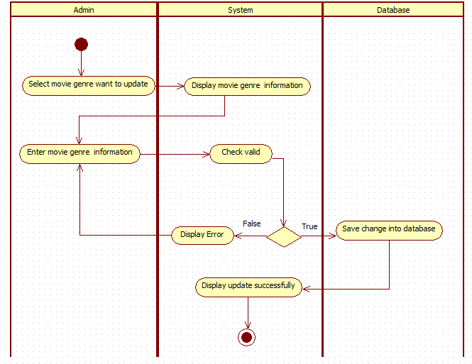

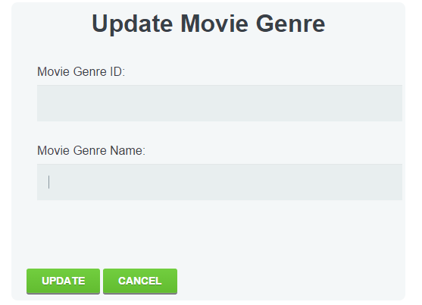

1. **Delete Movie Genre**

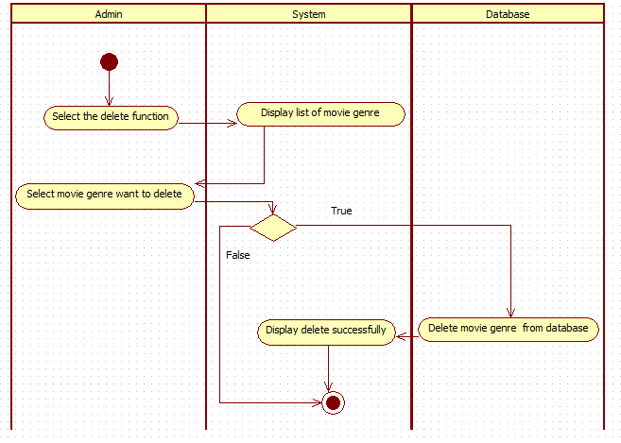

1. 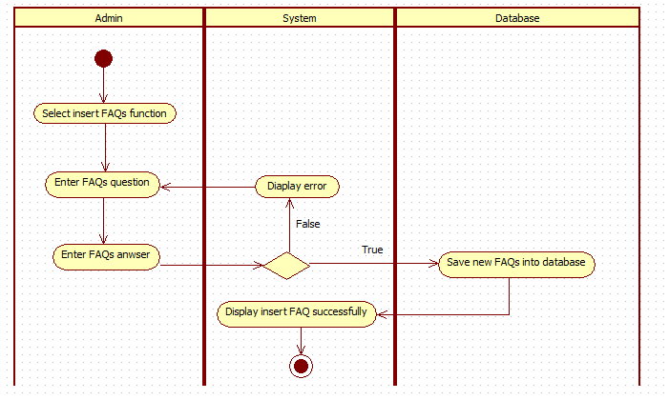**Add new FAQs**

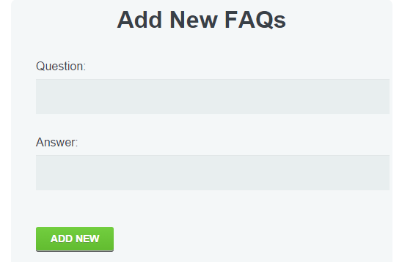

1. 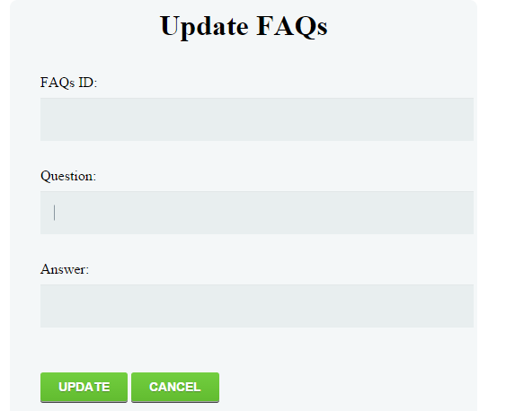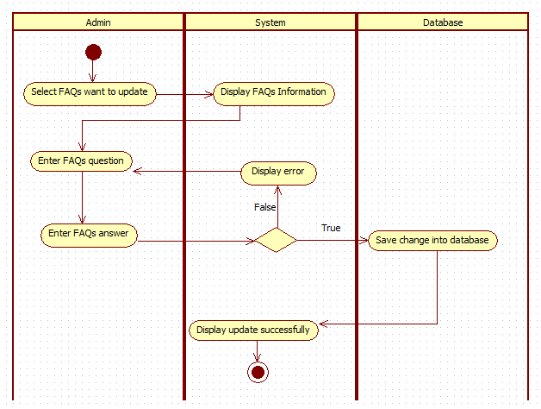**Update FAQs**
2. **Delete FAQs**

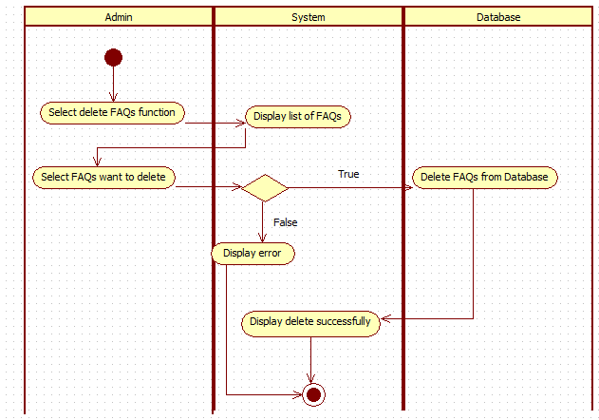

1. **Send Feedbacks**

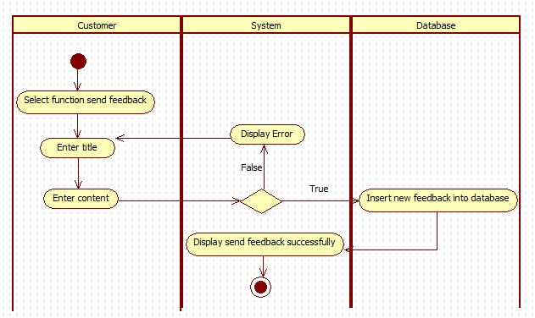

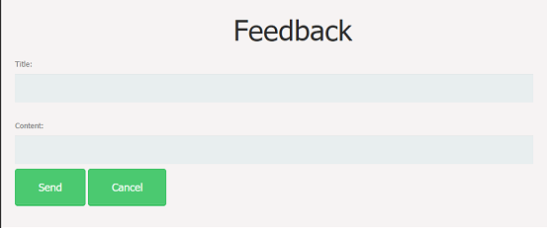

1. **Book Movie**

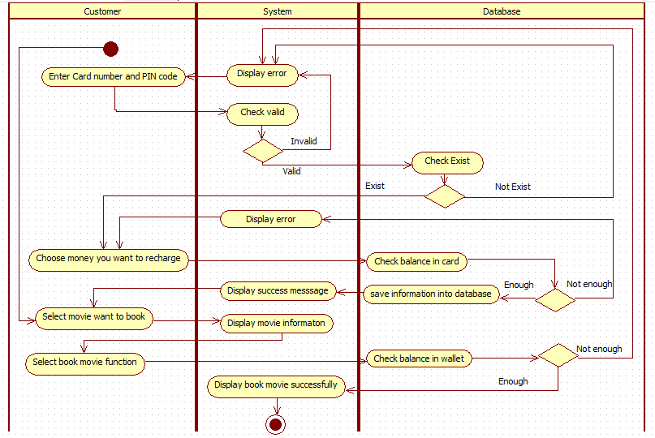

1. **Update Feedbacks**

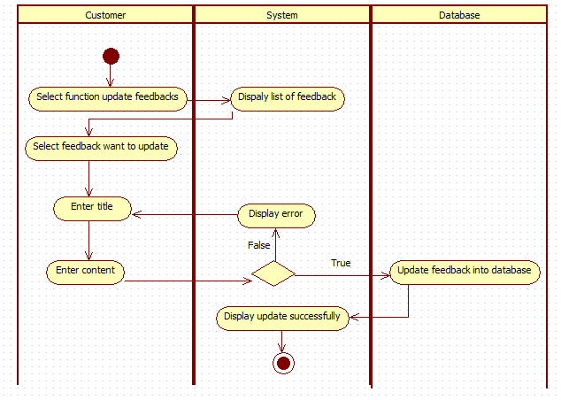

1. **Delete Feedbacks**

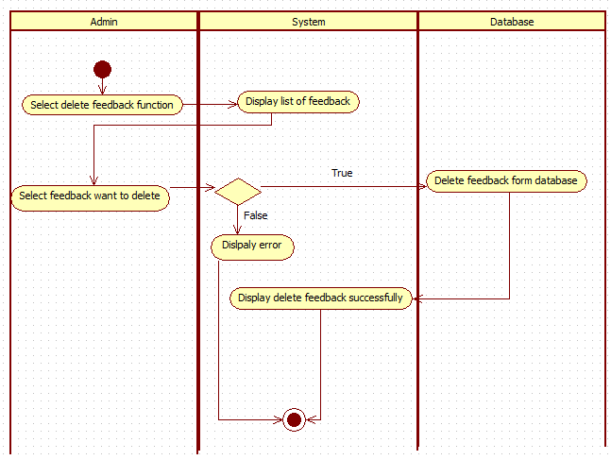

1. **Add event**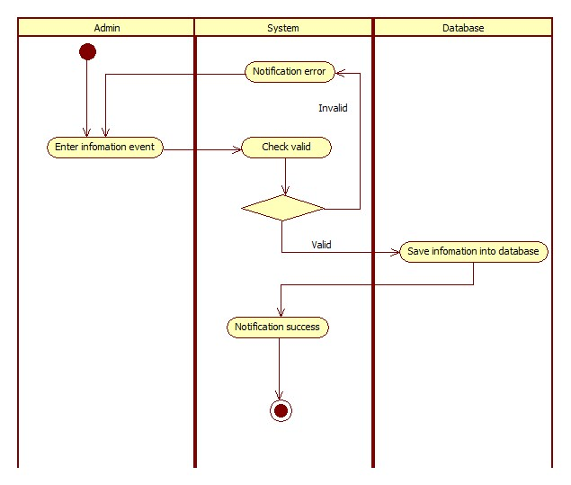

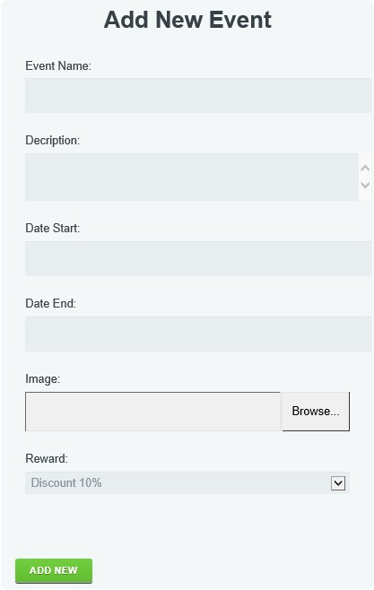

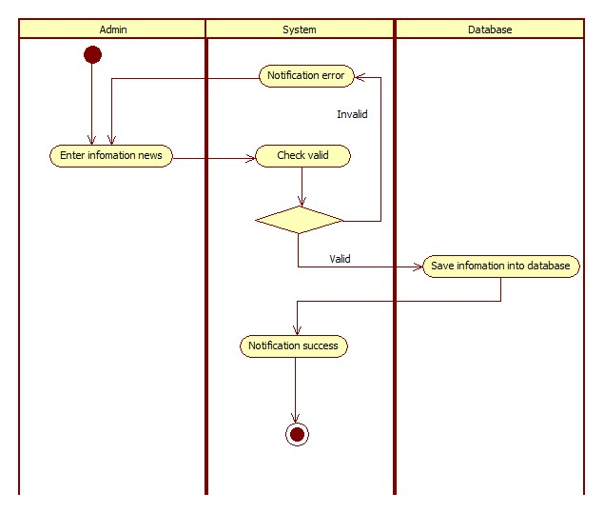**30.Add news**

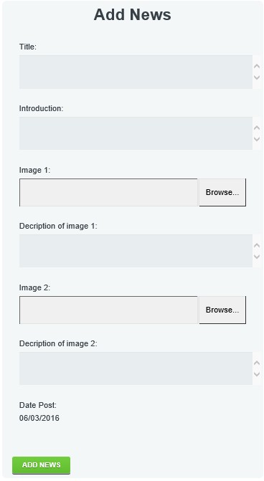

1. **Delete Event**

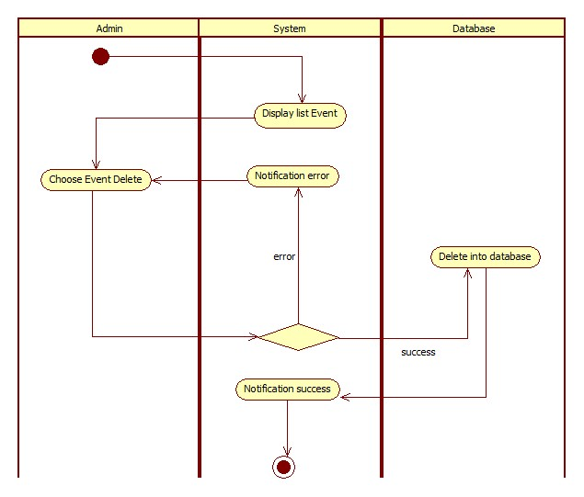

1. **Delete News**

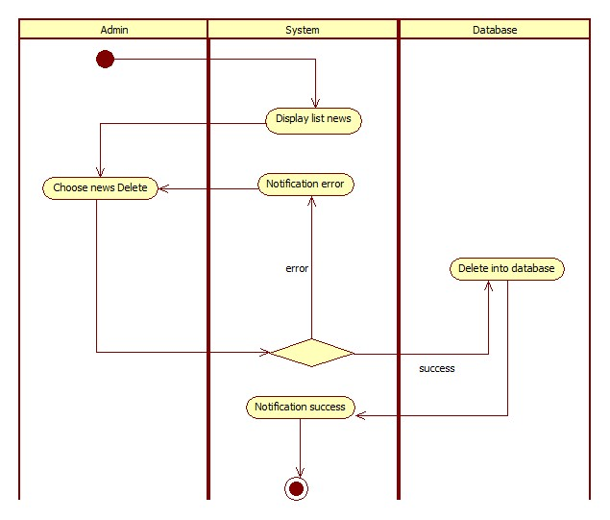

1. 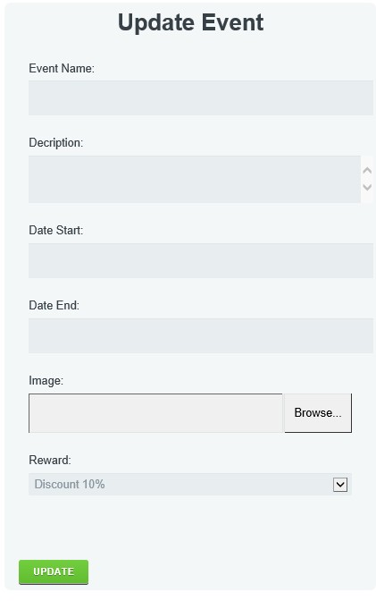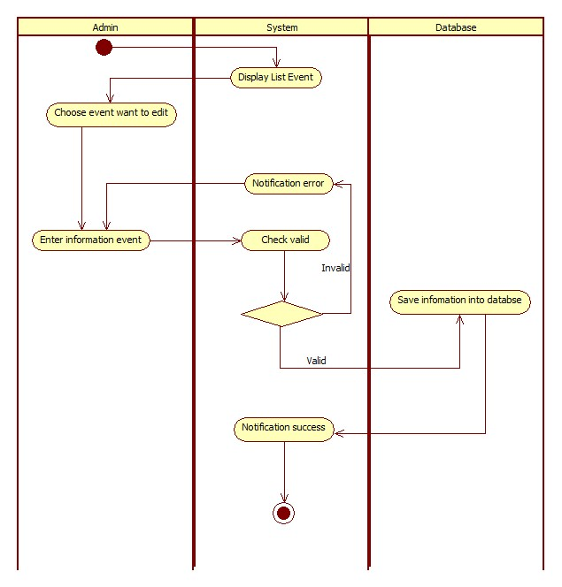**Edit Events**
2. 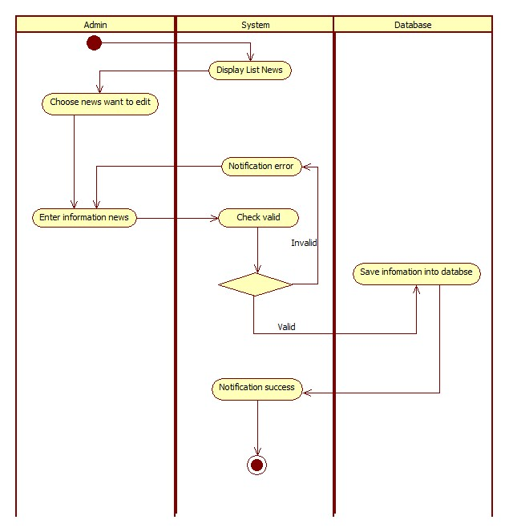**Edit News**

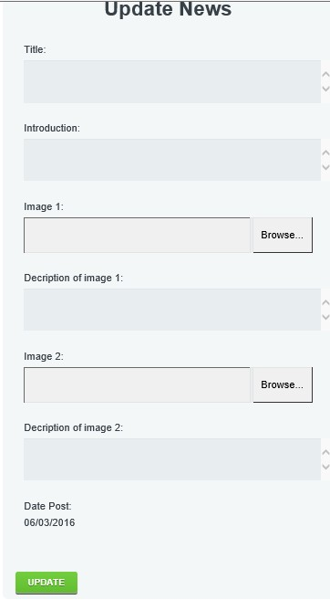

1. **Search**

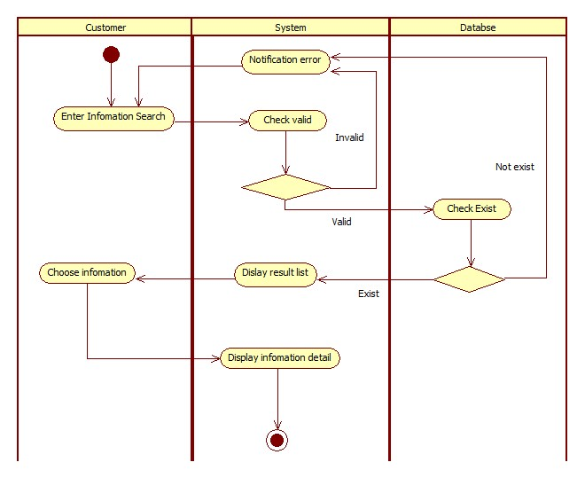

1. **Comment**

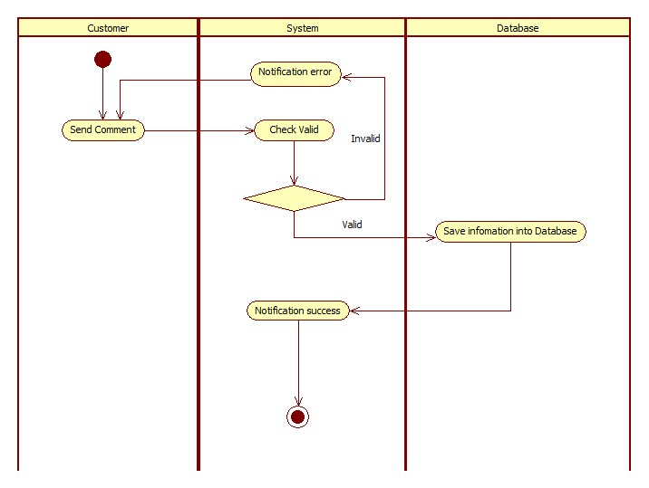

1. **Register**

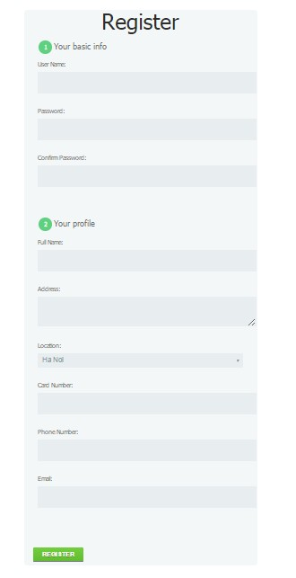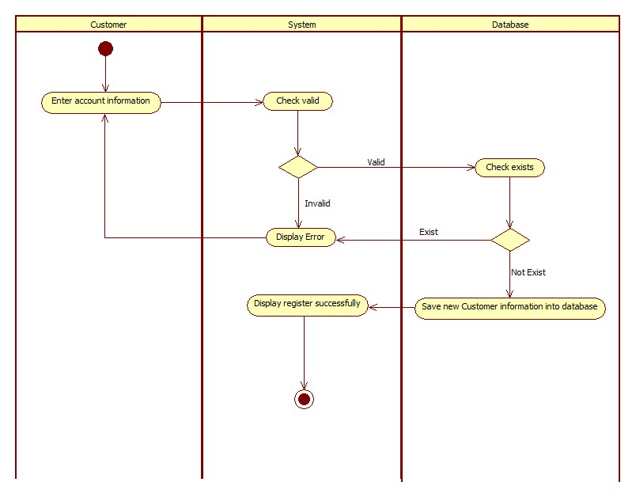

1. 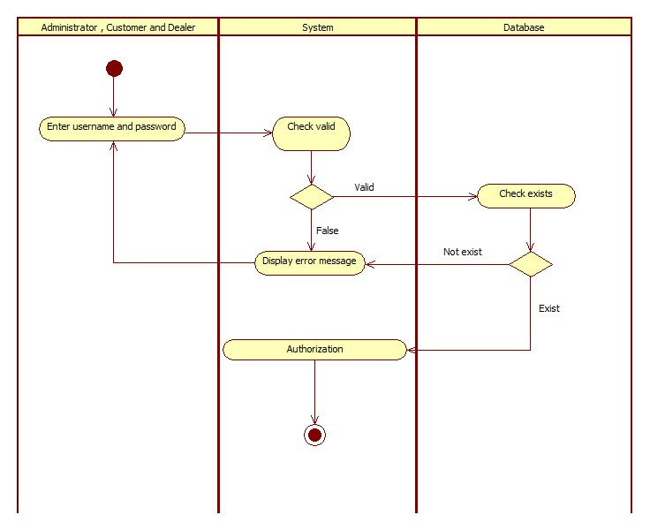**Login**

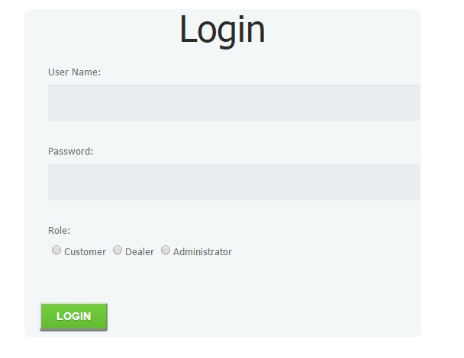

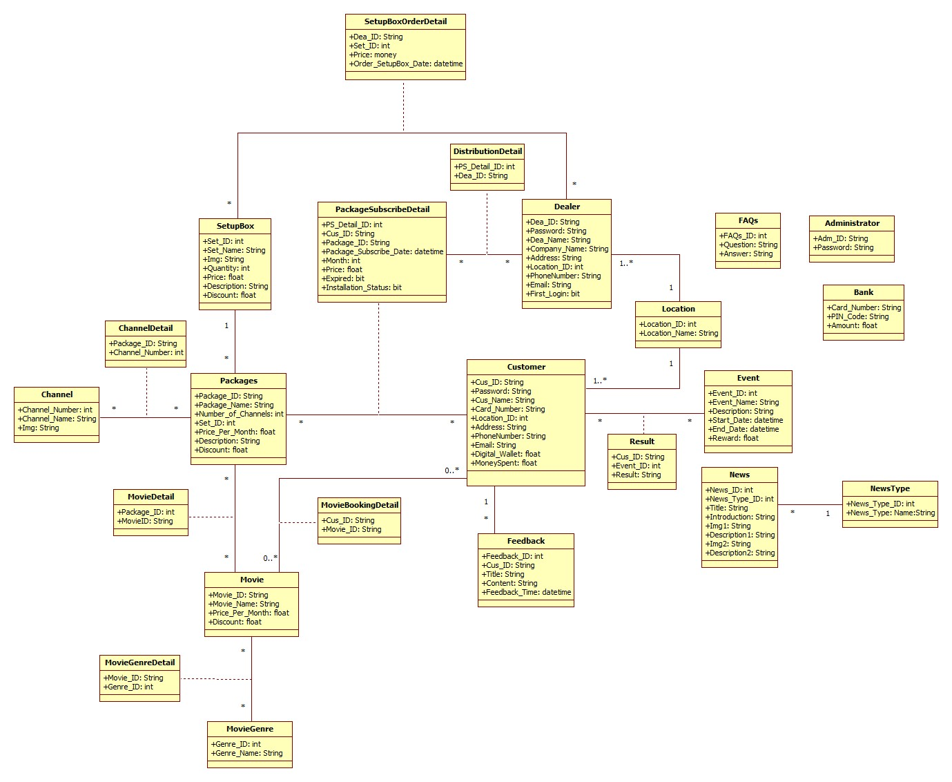Class Diagram

s

**Database Design**

|  |  |  |  |  |
| --- | --- | --- | --- | --- |
| Table : Location | | | | |
| **Field Name** | **Data Type** | **Constrain** | **Key** | **Description** |
| Location_ID | int | NOT NULL | PK | Location identification |
| Location_Name | Varchar(100) | NOT NULL |  | Location name |

|  |  |  |  |  |
| --- | --- | --- | --- | --- |
| Table : Customer | | | | |
| **Field Name** | **Data Type** | **Constrain** | **Key** | **Description** |
| Cus_ID | Varchar(50) | NOT NULL | PK | Customer identification |
| Password | Varchar(50) | NOT NULL |  | Password of customer |
| Cus_Name | Varchar(50) | NOT NULL |  | Customer name |
| Card_Number | Varchar(20) | NOT NULL |  | Bank card number |
| Location_ID | Int | NOT NULL |  | References from Location table |
| Address | Varchar(MAX) | NOT NULL |  | Address of customer |
| Phone_Number | Varchar(30) |  |  | Phone number of customer |
| Email | Varchar(30) |  |  | Email of customer |
| Digital_Wallet | Float | DEFAULT (0) |  | Money in digital wallet of customer |
| MoneySpent | Float | DEFAULT (0) |  | Customer’s money spent |

|  |  |  |  |  |
| --- | --- | --- | --- | --- |
| Table : Dealer | | | | |
| **Field Name** | **Data Type** | **Constrain** | **Key** | **Description** |
| Dea_ID | Varchar(50) | NOT NULL | PK | Dealer identification |
| Password | Varchar(50) | NOT NULL |  | Password of dealer |
| Dea_Name | Varchar(50) | NOT NULL |  | Dealer name |
| Company_Name | Varchar(50) | NOT NULL |  | Company name of dealer |
| Address | Varchar(200) | NOT NULL |  | Address of dealer |
| Location_ID | Int | NOT NULL | FK | References from Location table |
| Phone_Number | Varchar(30) | NOT NULL |  | Phone number of dealer |
| Email | Varchar(50) | NOT NULL |  | Email of dealer |
| First_Login | bit | DEFAULT (0) |  | Field to know Dealer got first login or not |

|  |  |  |  |  |
| --- | --- | --- | --- | --- |
| Table : SetupBox | | | | |
| **Field Name** | **Data Type** | **Constrain** | **Key** | **Description** |
| Set_ID | int | NOT NULL | PK | Setup box identification |
| Set_Name | Varchar(100) | NOT NULL |  | Setup box name |
| Img | Varchar(50) |  |  | Setup box picture |
| Quantity | Int | NOT NULL |  | Quantity of setup box |
| Price | Float | NOT NULL |  | Price of setup box |
| Description | Varchar(MAX) | NOT NULL |  | Description of setup box |
| Discount | Float | NOT NULL |  | Discount percent |

|  |  |  |  |  |
| --- | --- | --- | --- | --- |
| Table : SetupBoxOrderDetail | | | | |
| **Field Name** | **Data Type** | **Constrain** | **Key** | **Description** |
| Dea_ID | Varchar(50) | NOT NULL | FK | References from Dealer table |
| Set_ID | int | NOT NULL | FK | References from SetupBox table |
| Price | Float | NOT NULL |  | Price with discount |
| Order_SetupBox_Date | Datetime | NOT NULL |  | Order date |

|  |  |  |  |  |
| --- | --- | --- | --- | --- |
| Table : Package | | | | |
| **Field Name** | **Data Type** | **Constrain** | **Key** | **Description** |
| Package_ID | Varchar(50) | NOT NULL | PK | Package identification |
| Package_Name | Varchar(100) | NOT NULL |  | Package name |
| Number_of_Channels | int | NOT NULL |  | Number of channels |
| Set_ID | Int | NOT NULL | FK | References from SetupBox table |
| Price_Per_Month | Float | NOT NULL |  | Price per month |
| Discount | Float | NOT NULL |  | Discount percent |

|  |  |  |  |  |
| --- | --- | --- | --- | --- |
| Table : PackageSubscribeDetail | | | | |
| **Field Name** | **Data Type** | **Constrain** | **Key** | **Description** |
| PS_Detail_ID | int | NOT NULL | PK | Package Subscribe Detail identification |
| Cus_ID | Varchar(50) | NOT NULL | FK | References from Customer table |
| Package_ID | Varchar(50) | NOT NULL | FK | References from Package table |
| Package_Subscribe_Date | datetime | NOT NULL |  | Subscribe date of package |
| Month | int | NOT NULL |  | Number of month subscribe |
| Price | Money | NOT NULL |  | Total price |
| Expired | bit | DEFAULT (False) |  | Expired status of package |
| Installation_Status | bit | DEFAULT (False) |  | Installation status of package |

|  |  |  |  |  |
| --- | --- | --- | --- | --- |
| Table : Administrator | | | | |
| **Field Name** | **Data Type** | **Constrain** | **Key** | **Description** |
| Adm_ID | Varchar(50) | NOT NULL | PK | Administrator identification |
| Password | Varchar(50) | NOT NULL |  | Password of administrator |

|  |  |  |  |  |
| --- | --- | --- | --- | --- |
| Table : DistributionDetail | | | | |
| **Field Name** | **Data Type** | **Constrain** | **Key** | **Description** |
| PS_Detail_ID | int | NOT NULL | FK | References from PackageSubscribeDetail table |
| Dea_ID | Varchar(50) | NOT NULL | FK | References from Dealer table |

|  |  |  |  |  |
| --- | --- | --- | --- | --- |
| Table : Channel | | | | |
| **Field Name** | **Data Type** | **Constrain** | **Key** | **Description** |
| Channel_Number | int | NOT NULL | PK | Channel number |
| Channel_Name | Varchar(100) | NOT NULL |  | Channel name |
| Img | Varchar(50) | NOT NULL |  | Images of channel |

|  |  |  |  |  |
| --- | --- | --- | --- | --- |
| Table : ChannelDetail | | | | |
| **Field Name** | **Data Type** | **Constrain** | **Key** | **Description** |
| Package_ID | Varchar(50) | NOT NULL | FK | References from Package table |
| Channel_Number | int | NOT NULL | FK | References from Channel table |

|  |  |  |  |  |
| --- | --- | --- | --- | --- |
| Table : Movie | | | | |
| **Field Name** | **Data Type** | **Constrain** | **Key** | **Description** |
| Movie_ID | Varchar(50) | NOT NULL | PK | Movie identification |
| Movie_Name | Varchar(100) | NOT NULL |  | Movie name |
| Price_Per_Month | Float | NOT NULL |  | Price per month |
| Discount | Float | NOT NULL |  | Discount persent |

|  |  |  |  |  |
| --- | --- | --- | --- | --- |
| Table : MovieDetail | | | | |
| **Field Name** | **Data Type** | **Constrain** | **Key** | **Description** |
| Package_ID | int | NOT NULL | FK | References from Package table |
| Movie_ID | Varchar(50) | NOT NULL | FK | References from Movie table |

|  |  |  |  |  |
| --- | --- | --- | --- | --- |
| Table : MovieGenre | | | | |
| **Field Name** | **Data Type** | **Constrain** | **Key** | **Description** |
| Genre_ID | int | NOT NULL | PK | Movie genre identification |
| Genre_Name | Varchar(50) | NOT NULL |  | Movie genre name |

|  |  |  |  |  |
| --- | --- | --- | --- | --- |
| Table : MovieGenreDetail | | | | |
| **Field Name** | **Data Type** | **Constrain** | **Key** | **Description** |
| Movie_ID | Varchar(50) | NOT NULL | FK | References from Movie table |
| Genre_ID | int | NOT NULL | FK | References from MovieGenre table |

|  |  |  |  |  |
| --- | --- | --- | --- | --- |
| Table : MovieBookingDetail | | | | |
| **Field Name** | **Data Type** | **Constrain** | **Key** | **Description** |
| Cus_ID | Varchar(50) | NOT NULL | FK | References from Customer table |
| Movie_ID | Varchar(50) | NOT NULL | FK | References from Movie table |

|  |  |  |  |  |
| --- | --- | --- | --- | --- |
| Table : Feedback | | | | |
| **Field Name** | **Data Type** | **Constrain** | **Key** | **Description** |
| Feedback_ID | int | NOT NULL | PK | Feedback identification |
| Cus_ID | Varchar(50) | NOT NULL | FK | References from Customer table |
| Title | Varchar(100) | NOT NULL |  | Feedback title |
| Content | Varchar(MAX) | NOT NULL |  | Feedback content |
| Feedback_Time | datetime | NOT NULL |  | Feedback time |

|  |  |  |  |  |
| --- | --- | --- | --- | --- |
| Table : News | | | | |
| **Field Name** | **Data Type** | **Constrain** | **Key** | **Description** |
| News_ID | int | NOT NULL | PK | News identification |
| News_Type_ID | int | NOT NULL |  | References from NewsType table |
| Title | Varchar(50) | NOT NULL | FK | News title |
| Introduction | Varchar(200) | NOT NULL |  | News introduction |
| Img1 | Varchar(50) | NOT NULL |  | Picture 1 |
| Description1 | Varchar(MAX) | NOT NULL |  | Description of picture 1 |
| Img2 | Varchar(50) | NOT NULL |  | Picture 2 |
| Description2 | Varchar(MAX) | NOT NULL |  | Description of picture 2 |

|  |  |  |  |  |
| --- | --- | --- | --- | --- |
| Table : NewsType | | | | |
| **Field Name** | **Data Type** | **Constrain** | **Key** | **Description** |
| News_Type_ID | int | NOT NULL | PK | News type identification |
| News_Type_Name | Varchar(50) | NOT NULL | FK | News type name |

|  |  |  |  |  |
| --- | --- | --- | --- | --- |
| Table : Event | | | | |
| **Field Name** | **Data Type** | **Constrain** | **Key** | **Description** |
| Event_ID | int | NOT NULL | PK | Feedback identification |
| Event_Type_ID | Varchar(50) | NOT NULL | FK | References from EventType table |
| Event_Name | Varchar(100) | NOT NULL |  | Event name |
| Content | Varchar(MAX) | NOT NULL |  | Event content |
| Start_Date | datetime | NOT NULL |  | Event start time |
| End_Date | datetime | NOT NULL |  | Event end time |
| Reward | Float | NOT NULL |  | Event reward |

|  |  |  |  |  |
| --- | --- | --- | --- | --- |
| Table : Result | | | | |
| **Field Name** | **Data Type** | **Constrain** | **Key** | **Description** |
| Cus_ID | Varchar(50) | NOT NULL | FK | References from Customer table |
| Event_ID | int | NOT NULL | FK | References from Event table |
| Result | String | NOT NULL |  | Event result |

|  |  |  |  |  |
| --- | --- | --- | --- | --- |
| Table : FAQs | | | | |
| **Field Name** | **Data Type** | **Constrain** | **Key** | **Description** |
| FAQs_ID | int | NOT NULL | PK | FAQs identification |
| Question | Varchar(50) | NOT NULL | FK | FAQs question |
| Answer |  | NOT NULL |  | FAQs answer |

|  |  |  |  |  |
| --- | --- | --- | --- | --- |
| Table : Bank | | | | |
| **Field Name** | **Data Type** | **Constrain** | **Key** | **Description** |
| Card_Number | Varchar(50) | NOT NULL | PK | Bank card number |
| PIN_Code | Varchar(50) | NOT NULL | FK | Card PIN code |
| Amount | float | NOT NULL |  | Money in card |

**Database Design**

Project Title : DTH Business Website

Activity Plan Prepared by : Hoang Nguyen Truong Nam

Project start date : 19/01/2016

Project end date : 10/03/2016

|  |  |  |  |  |  |  |
| --- | --- | --- | --- | --- | --- | --- |
| **No.** | **Task** | | **Actual Start Date** | **Actual Days** | **Teammate Name** | **Status** |
| 1. | Problem definition | | 20/01/2016 | 1 | Tran | 100% |
| 2. | Customer requirement specification | | 20/01/2016 | 1 | Danh |  |
| 3. | Architecture and design of the project | | 20/01/2016 | 1 | Nam | 100% |
| 4. | Usecase diagram | | 21/01/2016 | 3 | Group | 100% |
| 5. | Class Diagram | | 21/01/2016 | 3 | Group | 100% |
| 6. | Activity  Diagram | Add new customer | 24/01/2016 | 4 | Nam | 100% |
| 7 | Update customer | Nam | 100% |
| 8 | Add new dealer | Nam | 100% |
| 9 | Update dealer | Nam | 100% |
| 10 | Delete dealer | Nam | 100% |
| 11 | Add new package | Nam | 100% |
| 12 | Update package | Nam | 100% |
| 13 | Delete package | Nam | 100% |
| 14 | Add channel into package | Nam | 100% |
| 15 | Add movie into package | Nam | 100% |
| 16 | Add new setup box | Nam | 100% |
| 17 | Update setup box | Nam | 100% |
| 18 | Delete setup box | Nam | 100% |
| 19 | Add new channel | Nam | 100% |
| 20 | Update channel | Nam | 100% |
| 21 | Delete channel | Nam | 100% |
| 22 | Add new location | Nam | 100% |
| 23 | Update location | Nam | 100% |
| 24 | Delete location | Nam | 100% |
| 25 | Login | Nam | 100% |
| 26 | Register | Nam | 100% |
| 27 | Change password | Nam | 100% |
| 28 | Change profile | Nam | 100% |
| 29 | Subscribe package | Nam | 100% |
| 30 | Recharge package | Nam | 100% |
| 31 | Recharge digital wallet | Nam | 100% |
| 32 | Order setup box | Nam | 100% |
| 33 | Activity  Diagram | Insert Movie | 24/01/2016 | 3 | Tran | 100% |
| 34 | Update Movie | Tran | 100% |
| 35 | Delete Movie | Tran | 100% |
| 36 | Insert Movie Genre | Tran | 100% |
| 36 | Update Movie Genre | Tran | 100% |
| 37 | Delete Movie Genre | Tran | 100% |
| 39 | Insert FAQs | Tran | 100% |
| 40 | Update FAQs | Tran | 100% |
| 41 | Delete FAQs | Tran | 100% |
| 42 | Send Feedback | Tran | 100% |
| 43 | Delete Feedback | Tran | 100% |
| 44 | Book Movie online | Tran | 100% |
| 45 | Activity  Diagram | Insert Event | 24/01/2016 | 3 | Danh | 100% |
| 46 | Update Event | Danh | 100% |
| 47 | Delete Event | Danh | 100% |
| 48 | Insert News | Danh | 100% |
| 49 | Update News | Danh | 100% |
| 50 | Delete News | Danh | 100% |
| 51 | Comments | Danh | 100% |
| 53 | Search | Danh | 100% |
| 61 | Class Diagram | | 22/01/2016 | 1 | Group | 100% |
| 62 | Database design/structure | | 24/01/2016 | 2 | Nam | 100% |
| 63 | Design website interface | | 25/01/2016 | 1 | Nam | 100% |
| 64 | Coding login | | 03/02/2016 | 1 | Nam | 100% |
| 65 | Coding logout | | 04/02/2016 | 1 | Nam | 100% |
| 66 | Coding change password | | 05/02/2016 | 1 | Nam | 100% |
| 67 | Coding add new customer | | 07/02/2016 | 1 | Nam | 100% |
| 68 | Coding update customer information | | 08/02/2016 | 1 | Nam |  |
| 69 | Coding delete information | | 10/02/2016 | 1 | Nam | 100% |
| 70 | Coding add new channel | | 11/02/2016 | 1 | Nam | 100% |
| 71 | Coding update channel information | | 13/02/2016 | 1 | Nam | 100% |
| 72 | Coding delete channel | | 14/02/2016 | 1 | Nam | 100% |
| 73 | Coding add location | | 15/02/2016 | 1 | Nam | 100% |
| 74 | Coding update location | | 16/02/2016 | 1 | Nam | 100% |
| 75 | Coding delete location | | 18/02/2016 | 1 | Nam | 100% |
| 76 | Coding subscribe package | | 20/02/2016 | 2 | Nam | 100% |
| 77 | Coding update package | | 23/02/2016 | 2 | Nam | 100% |
| 78 | Coding recharge package | | 26/02/2016 | 3 | Nam | 100% |
| 79 | Coding recharge digital wallet | | 28/02/2016 | 2 | Nam | 100% |
| 80 | Coding insert package | | 01/03/2016 | 1 | Nam | 100% |
| 81 | Coding delete package | | 02/03/2016 | 1 | Nam | 100% |
| 82 | Coding insert new dealer | | 04/03/2016 | 1 | Nam | 100% |
| 83 | Coding delete dealer | | 05/03/2016 | 1 | Nam | 100% |
| 84 | Coding update dealer | | 06/03/2016 | 1 | Nam | 100% |
| 85 | Coding register | | 07/03/2016 | 1 | Nam | 100% |
| 86 | Coding order setup box | | 08/03/2016 | 1 | Nam | 100% |
| 87 | Coding insert movie | | 26/01/2016 | 2 | Tran | 100% |
| 88 | Coding update movie | | 28/01/2016 | 2 | Tran | 100% |
| 89 | Coding delete movie | | 30/01/2016 | 2 | Tran | 100% |
| 90 | Coding insert movie genre | | 02/02/2016 | 2 | Tran | 100% |
| 91 | Coding update movie genre | | 04/02/2016 | 2 | Tran | 100% |
| 92 | Coding delete movie genre | | 16/02/2016 | 2 | Tran | 100% |
| 93 | Coding delete feedback | | 18/02/2016 | 2 | Tran | 100% |
| 94 | Coding insert FAQs | | 28/02/2016 | 2 | Tran | 100% |
| 95 | Coding delete FAQs | | 01/03/2016 | 2 | Tran | 100% |
| 96 | Coding update FAQs | | 03/03/2016 | 2 | Tran | 100% |
| 97 | Coding send feedback | | 05/03/2016 | 2 | Tran | 100% |
| 98 | Coding booking movie online | | 07/03/2016 | 2 | Tran | 100% |
| 99 | Coding Insert Event | | 20/01/2016 | 2 | Danh | 100% |
| 100 | Coding Update Event | | 23/01/2016 | 2 | Danh | 100% |
| 101 | Coding Delete Event | | 24/01/2016 | 1 | Danh | 100% |
| 102 | Coding Insert News | | 28/01/2016 | 2 | Danh | 100% |
| 103 | Coding Update News | | 01/02/2016 | 2 | Danh | 100% |
| 104 | Coding Delete News | | 05/02/2016 | 3 | Danh | 100% |
| 105 | Coding Comments News | | 09/02/2016 | 2 | Danh | 100% |
| 106 | Coding Comment Event | | 15/02/2016 | 2 | Danh | 100% |
| 106 | Coding Delete Comment | | 18/02/2016 | 2 | Danh | 100% |
| 107 | Coding List News | | 21/02/2016 | 3 | Danh | 100% |
| 108 | Coding List Event | | 25/02/2016 | 2 | Danh | 100% |
| 109 | Coding View News Detail | | 29/02/2016 | 3 | Danh | 100% |
| 110 | Coding View Event Detail | | 28/02/2016 | 3 | Danh | 100% |
| 111 | Coding view information | | 05/03/2016 | 3 | Danh | 100% |
| 112 | Final check | | 05/03/2016 | 4 | Group | 100% |

**3.9**  **Checklist of Validations**

|  |  |
| --- | --- |
| **Option** | **Validated** |
| Do all numeric variables have a default value or zero? | Yes |
| Does the administrator have all the rights to create and delete the records? | Yes |
| Are all the records property fed into the appropriate database? | Yes |
| Have all the modules been property integrated and are completely functional? | Yes |
| Have all the Design and Coding Standards been followed and implemented? | Yes |
| Is the GUI design consistent all over? | Yes |
| Is the navigation sequence correct through all the forms/screens in the application? | Yes |
| Is exception handling mechanism implemented in all the screens? | Yes |
| Are all the program codes working? | Yes |

**3.10. Submission Checklist**

|  |  |  |  |  |  |
| --- | --- | --- | --- | --- | --- |
| **Sr.** **No** | **Particulars** | **Yes** | **No** | **NA** | **Comments** |
| 1 | Are all the users able to search for a particular item? | **Yes** |  |  |  |
| 2 | Are all the old auction records property saved and can be retrieved when required? | **Yes** |  |  |  |
| 3 | Have all the modules been property integrated and are completely functional? | **Yes** |  |  | All the modules are property tested |
| 4 | Are the GUI contents devoid of pelling mistakes? | **Yes** |  |  |  |
| 5 | Is the application user-friendly? | **Yes** |  |  |  |
| 6 | Is the project published property into a setup file? | **Yes** |  |  |  |