**Intallation Guide**

**SQL Server 2012**

**Step 1** : OpenMicrosoft SQL Sever Management Studio

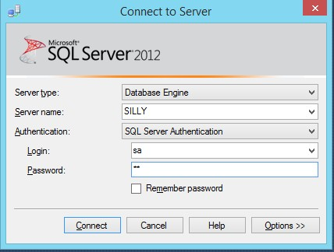

**Step 2** : Right click in **Databases** -> click **Attach…**

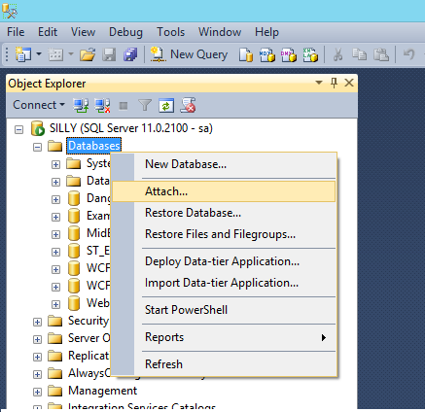

**Step 3** : Click **Add (1)** -> table **Locate Database Files – SILLY** display -> Click **OK (2)**

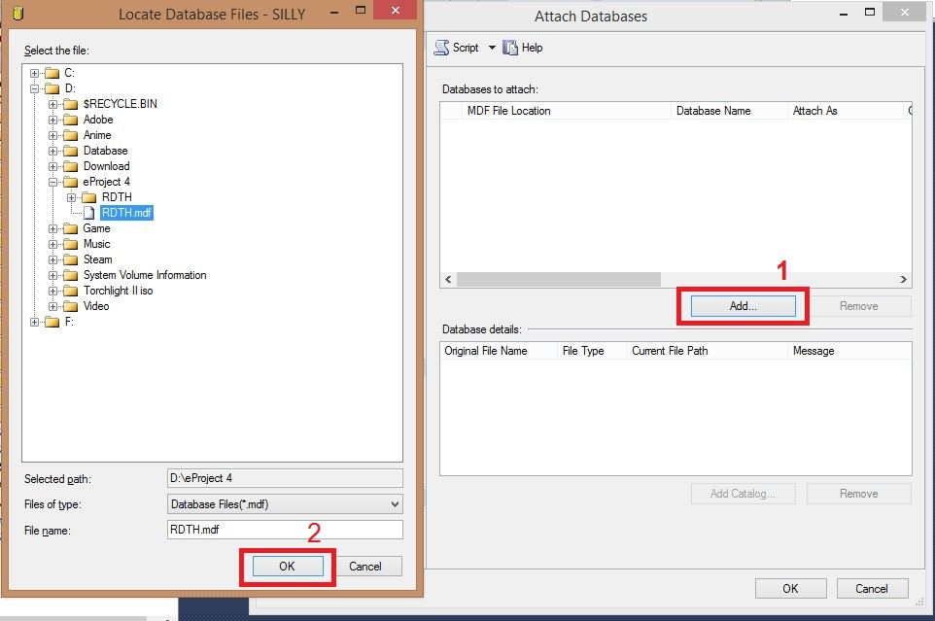

**Step 4** : Click OK

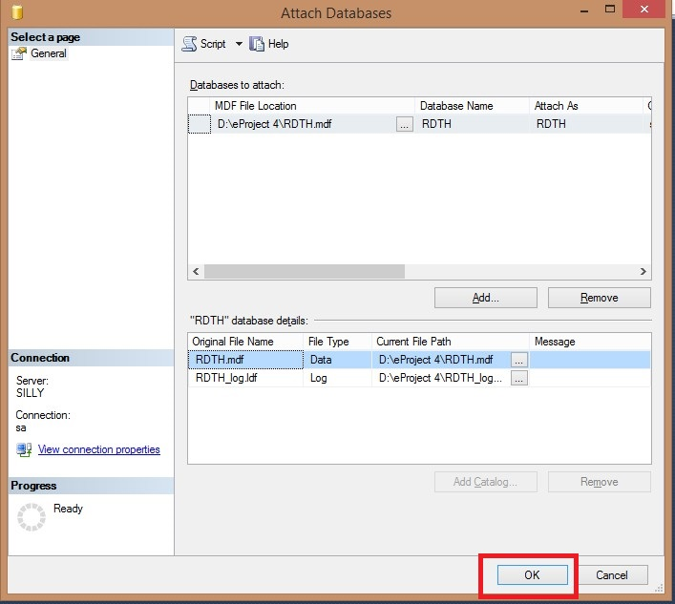

**Step 5** : Finish

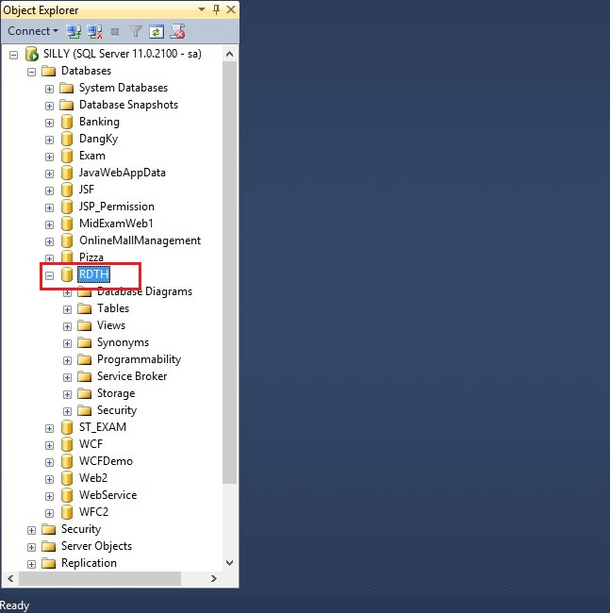

**Netbean 8.0.2**

Step 1: Open NetBeans IDE

Step 2: Click File and select Open Project:

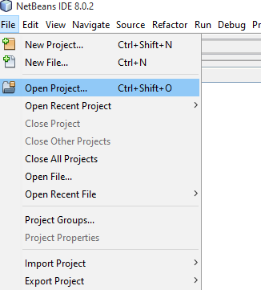

Step 2: Select project path then click Open Project

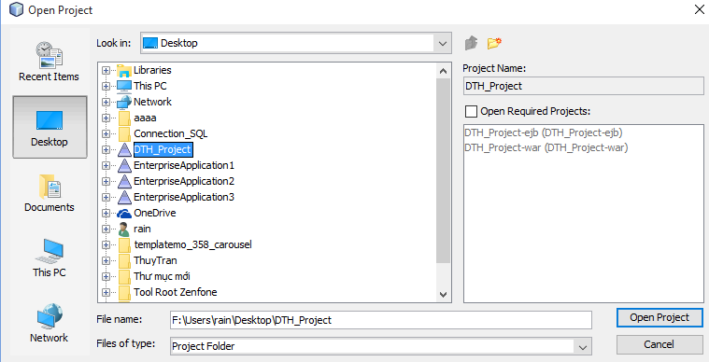

This will display as:

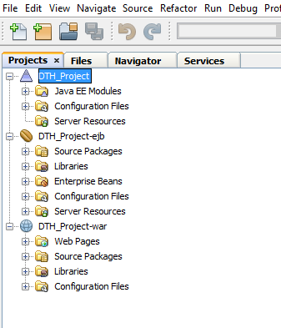

Step 3: Right click DTH-Project-ejb

Choose Resolve Data Source Problem

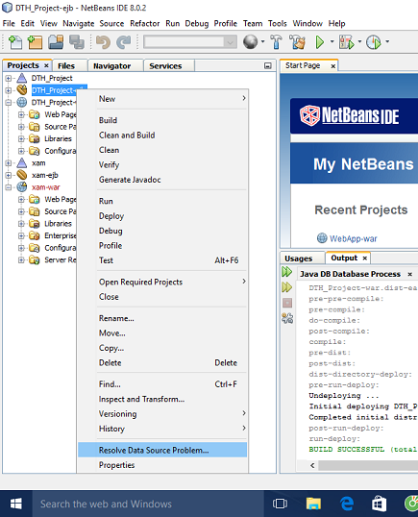

Step 4: Choose Add Connection

: 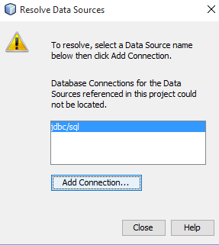

Step 5: Test Connection and then Click Next

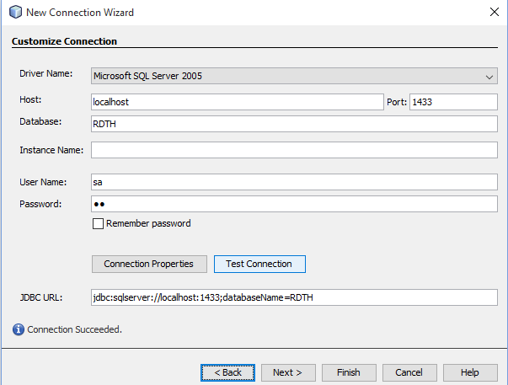

Step 6: Select dbo Schema and Click Next

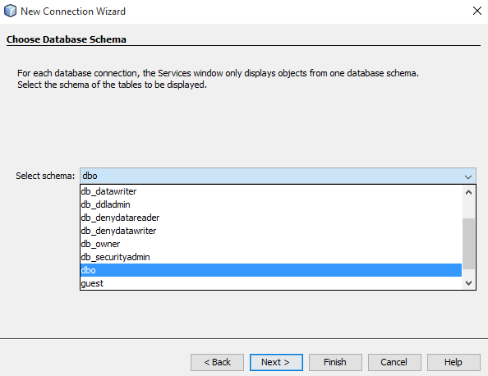

Step 7: Click Finish to create new connection.

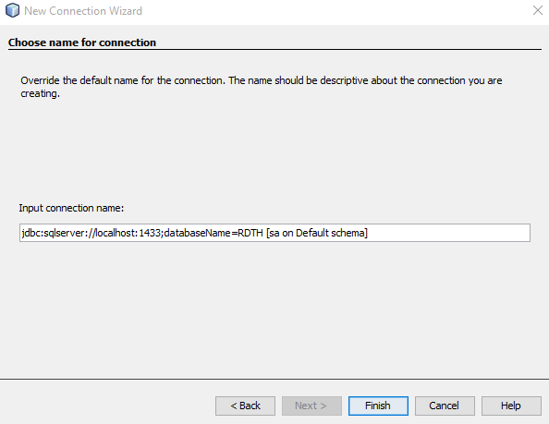

Step 8: In Service window select GlassFish Server

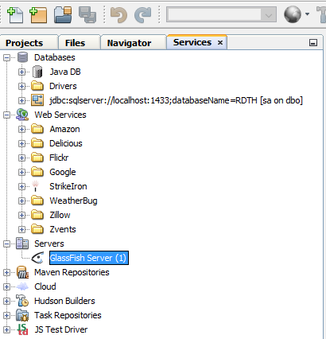

Step 9: Right click GlassFish Server and select Start

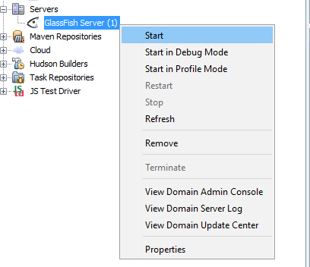

Step 10: Right click GlassFish Server and select View Domain Admin Console

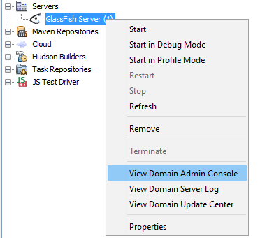

Browser will display

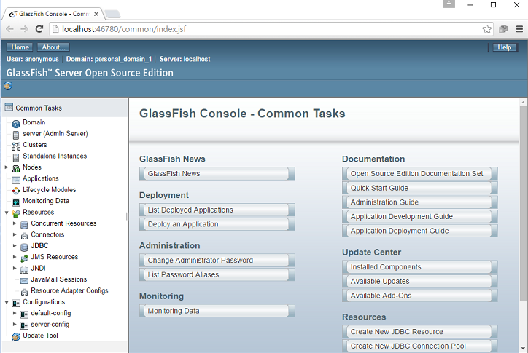

Step 11: Select JDBC Connection Pool 🡪 Click New to create new Connection Pool

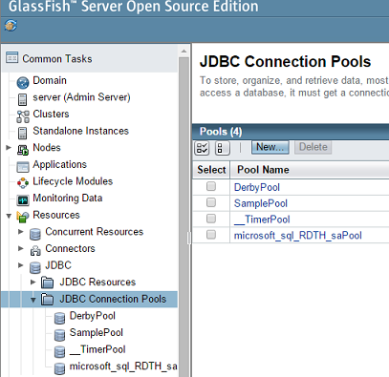

This will display: You must fill this field like this picture and click next

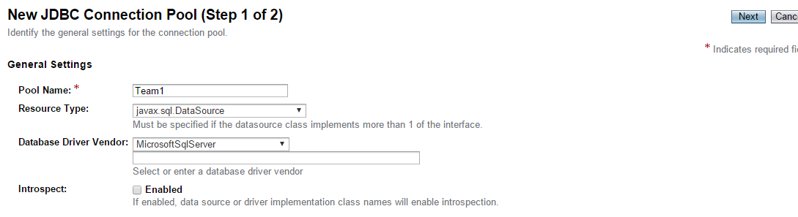

Step 12: Select JDBC Resource -> click New to create new Resource

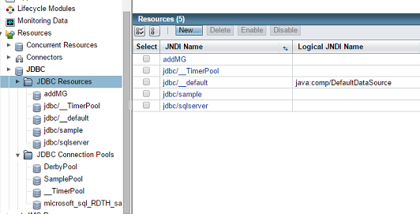

You must fill in this field and click OK. New JDBC Resource has been create

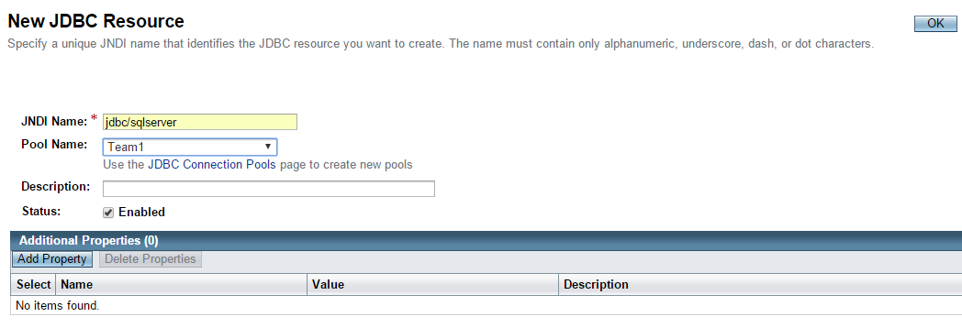

Step 13: Right click GlassFish Server and then select Restart

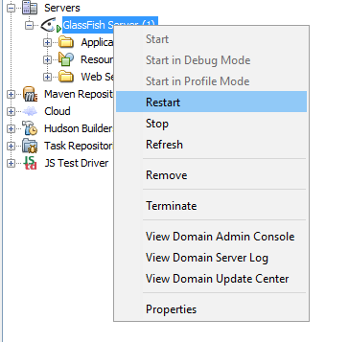

Step 14 : In Projects window, right click DTH_Project-ejb and then select Deploy

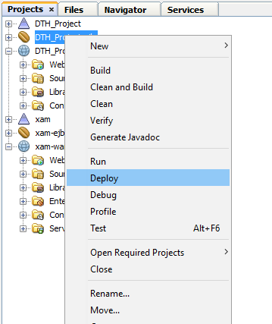

Step 15: Right click DTH_Project and select Run

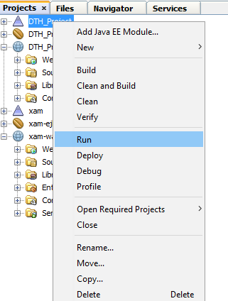

DTH_Project will be run as

