This is home page , if you want to use website service you must be login !

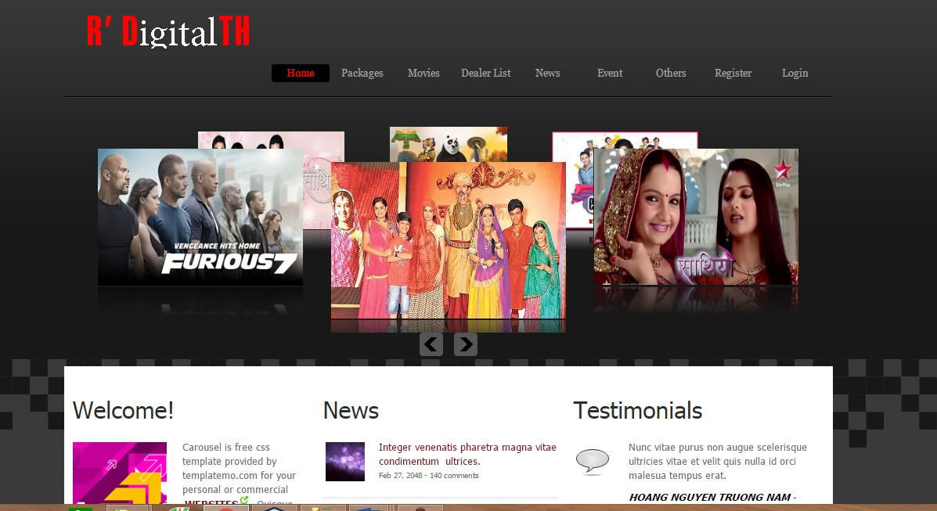

**Login**

If you has an account , you just enter your username and password and press login button to Login . Login got 3 check button Customer , Dealer and Administrator

You must be to click one of tree to Login and been authorization corresponding

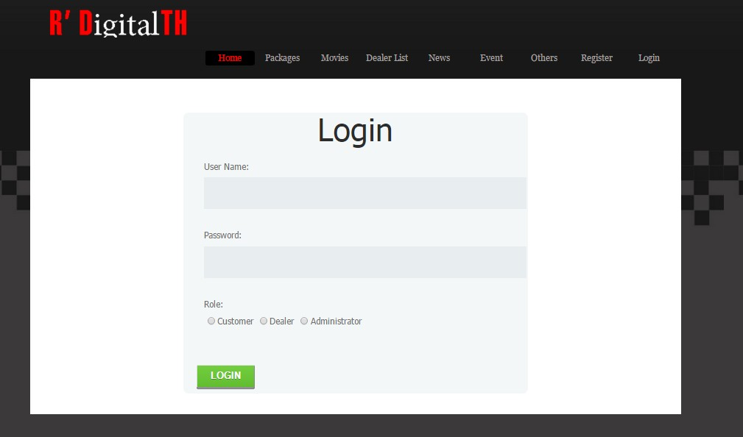

If you is Customer , you can Register new account here .

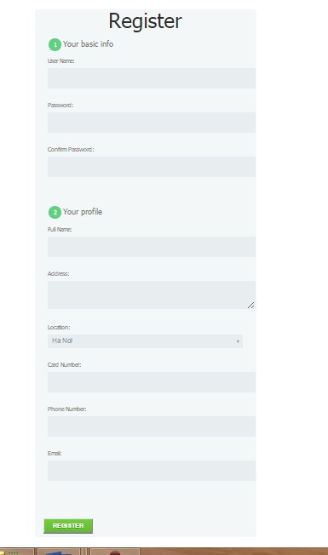**Register**

You just give us enough information, you will have a

Customer account , it’s easy . Like this ==>

When you logon .

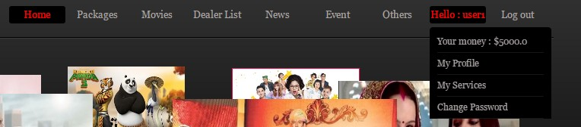

You can check you money in digital wallet .

1. **Customer Role**
   1. **Subscribe Package**

You need to click Subscribe Package in menu bar

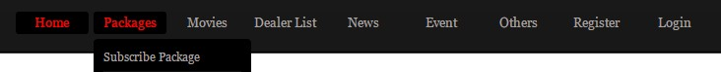

And now , all packages we have :

* + 1. **Package List**

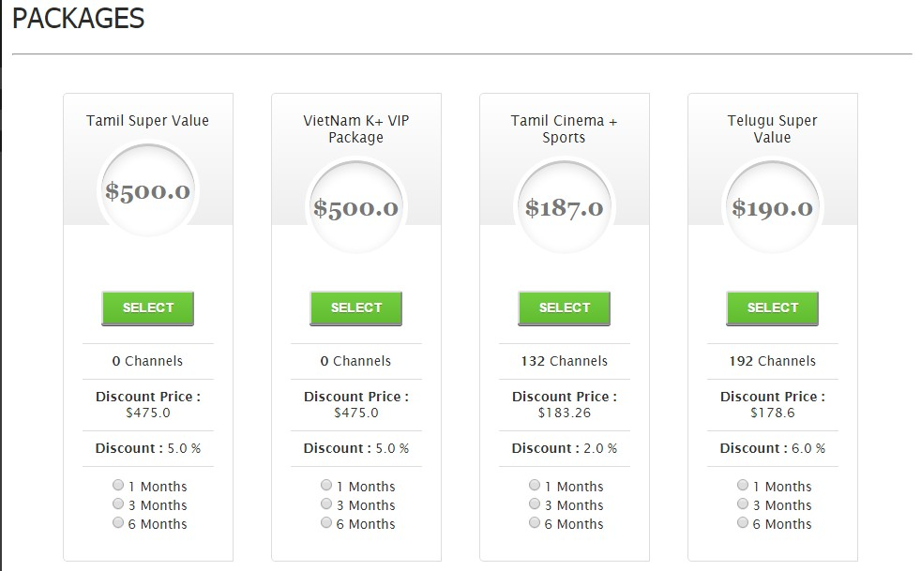

When you like any package and want to subscribe :

You just to choose use time : 1 months , 3 months , 6 months by click the button and click SELECT

* + 1. **Package Detai**

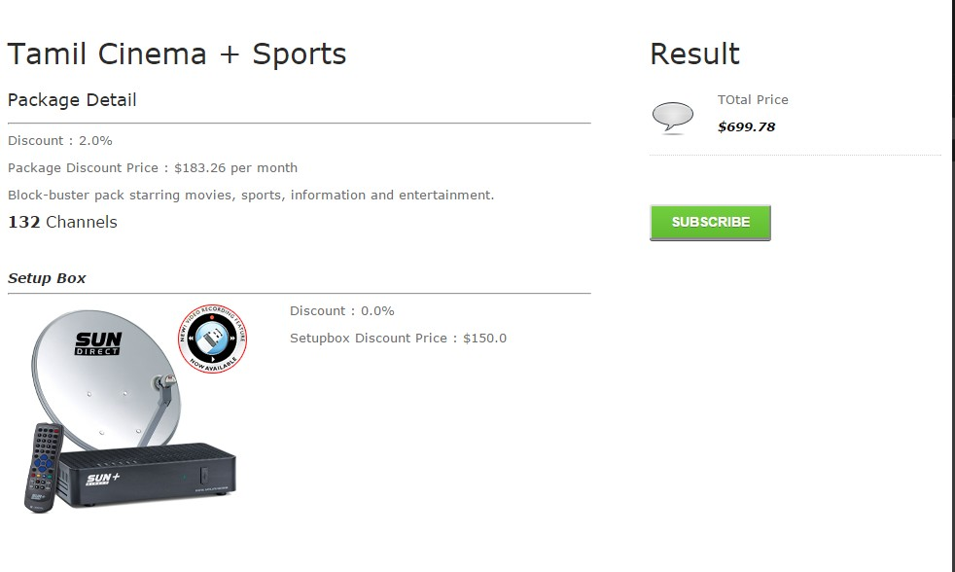

This page show all detail of package and include setup box . Show total price of package . Press SUBSCRIBE to subscribe package

* + 1. **Invoice Package**

**Successfully , you subscribe complete a package**

You can see all information of package invoice

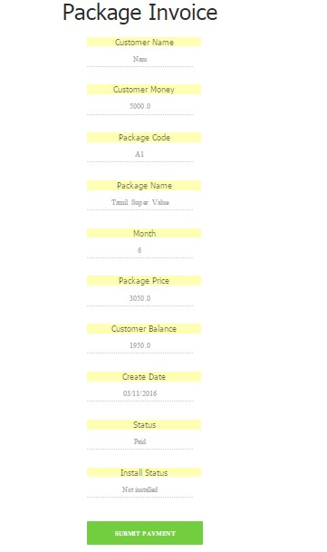

* 1. **View News and Event**
     1. ***News***



* + 1. **Event**

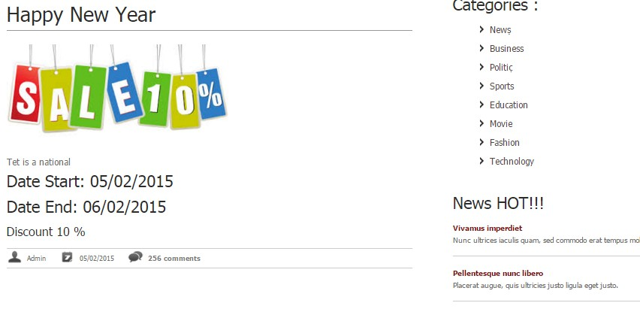

You can join events and bring some reward if you win

* + 1. **Comment**

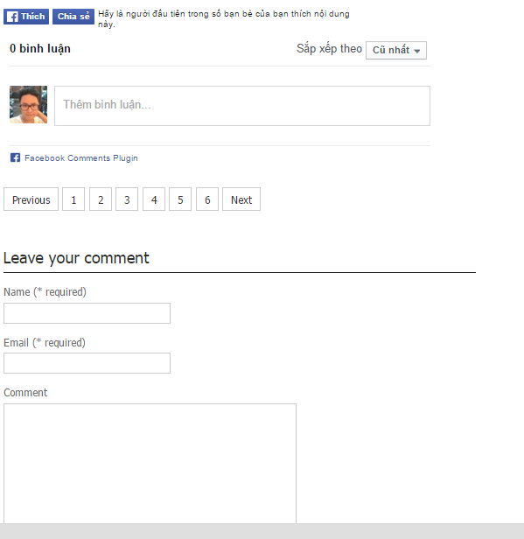

Comment have 2 type

1. Comment via Facebook
2. Comment of system
3. **Admin Role**

You must be login and click Administrator login in Login page



When you logon , you click Dashboard in menu bar to go to Manager page

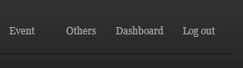

Administrator can Add , edit , delete all components of the page

Example : Package

* 1. Add new

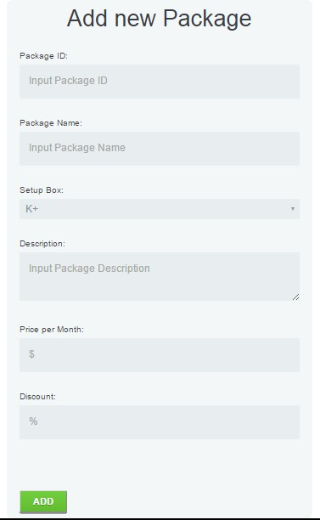

Enter Package information you want to add and click button “ADD” to save new package in database

* 1. List

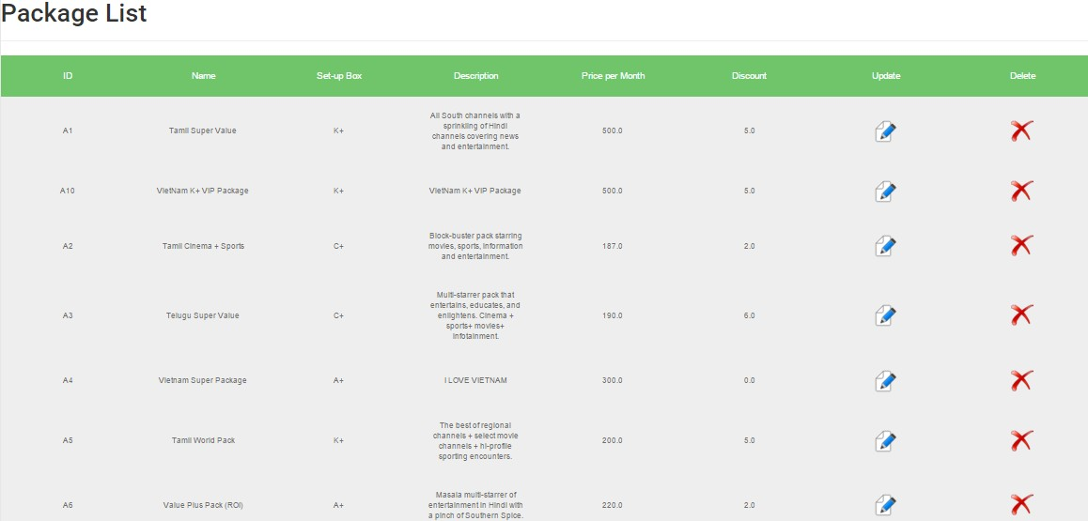

You can view all field of Package here and you can click  to delete Package or  to go to Update Package

* 1. Update

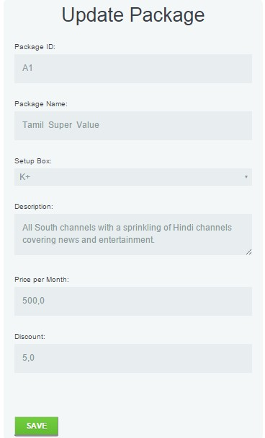

Enter all information you wan to edit and press SAVE button