阿米巴更新韌體

To update DAP firmware, please follow the steps:  
1. Press and hold the button next to CON2.  
2. Press the button next to CON1.  
3. Release the button you press and hold in step 1.

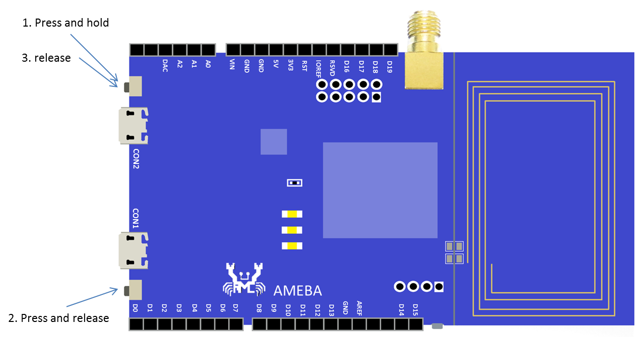

A removable storage appears with name “CRP DISABLED”:

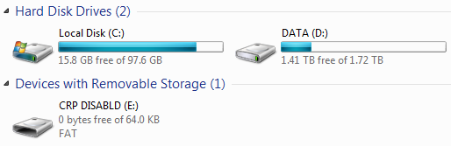

Click to open “CRP DISABLED”, you will find a file named “firmware.bin”, which is the DAP firmware currently used in Ameba:

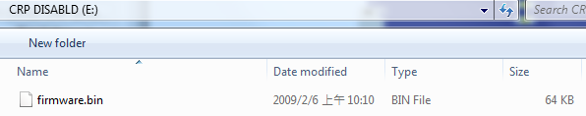

Please backup the original firmware file first, then replace it with new firmware file.

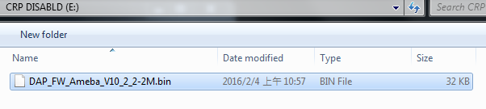

Replug the USB, and the new firmware should work normally.

Below is the list of DAP firmware versions currently available:

|  |  |  |
| --- | --- | --- |
| Version | Description | Link |
| DAP_FW_Ameba_V10_2_3-2M | 1. Improve upload speed. 2. Won’t restart DAP after upload finished. | [Download](https://github.com/Ameba8195/Arduino/raw/master/misc/dap_firmware/DAP_FW_Ameba_V10_2_3-2M.bin) |
| DAP_FW_Ameba_V10_2_3-2M_LED_Disable | 1. Improve upload speed 2. Won’t restart DAP after upload finished. 3. Turn off DAP LED. | [Download](https://github.com/Ameba8195/Arduino/blob/master/misc/dap_firmware/DAP_FW_Ameba_V10_2_3-2M_LED_Disable.bin) |
| DAP_FW_Ameba_V10_2_2-2M | 1. Won’t restart DAP after upload finished. | [Download](https://github.com/Ameba8195/Arduino/raw/master/misc/dap_firmware/DAP_FW_Ameba_V10_2_2-2M.bin) |
| DAP_FW_Ameba_V10_2_2-2M_LED_Disable | 1. Won’t restart DAP after upload finished. 2. Turn off DAP LED | [Download](https://github.com/Ameba8195/Arduino/raw/master/misc/dap_firmware/DAP_FW_Ameba_V10_2_2-2M_LED_Disable.bin) |
| 11u35_ameba_if_mbed_0_7_seperate | Original version | [Download](https://github.com/Ameba8195/Arduino/raw/master/misc/dap_firmware/11u35_ameba_if_mbed_0_7_seperate.bin) |