**上課3D零件清單**

**RobotWheel**

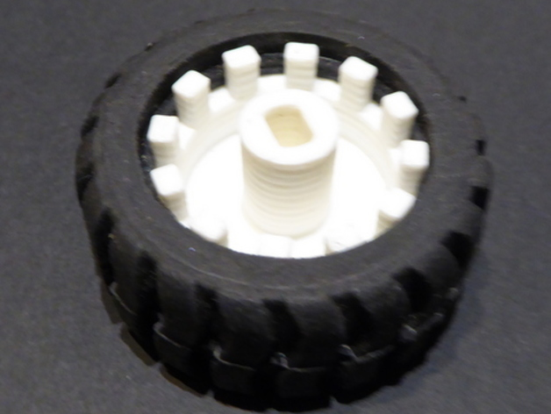

<http://www.thingiverse.com/thing:1878851>

**SlimWheel**

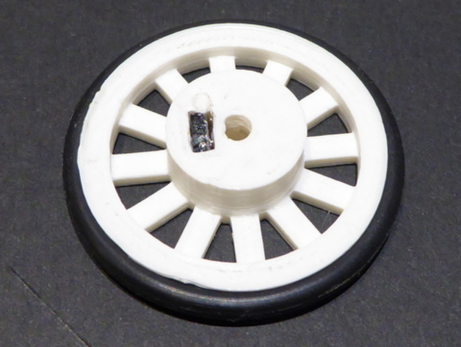

<http://www.thingiverse.com/thing:1878754>

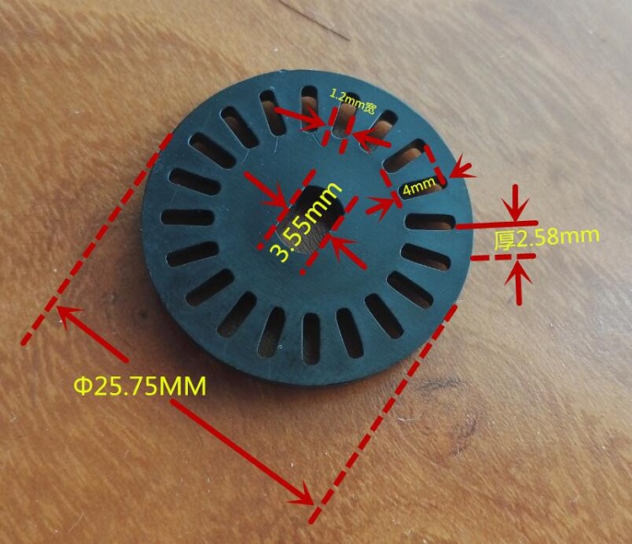测速码盘

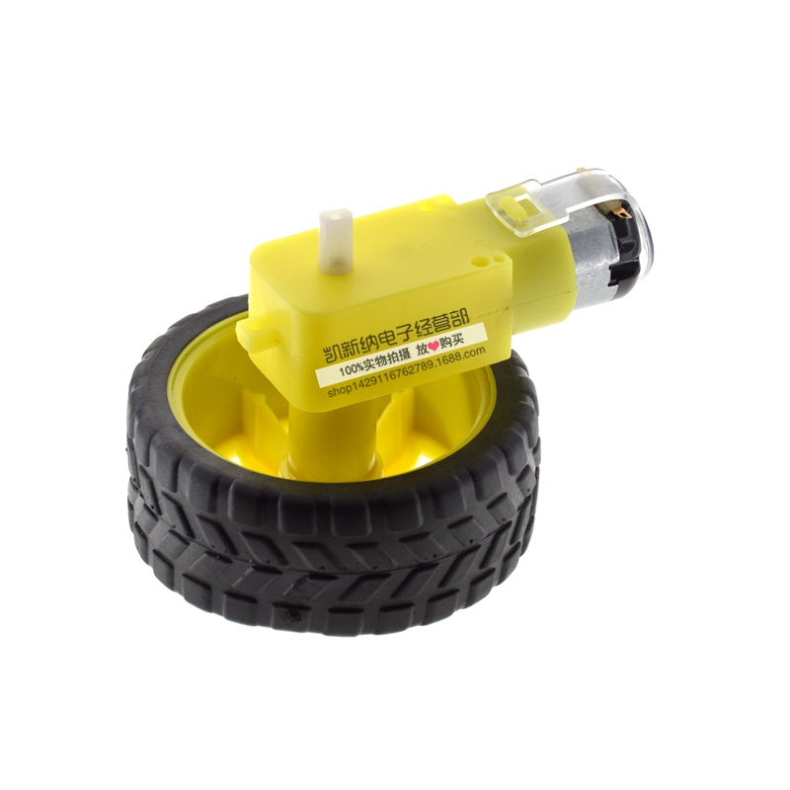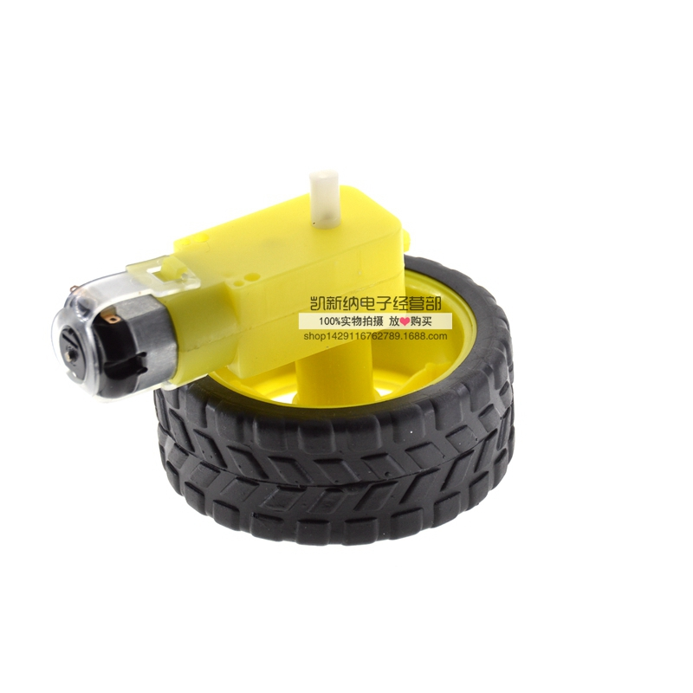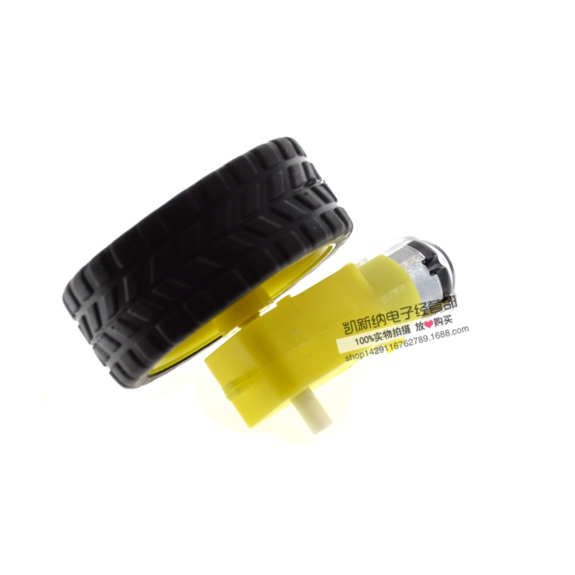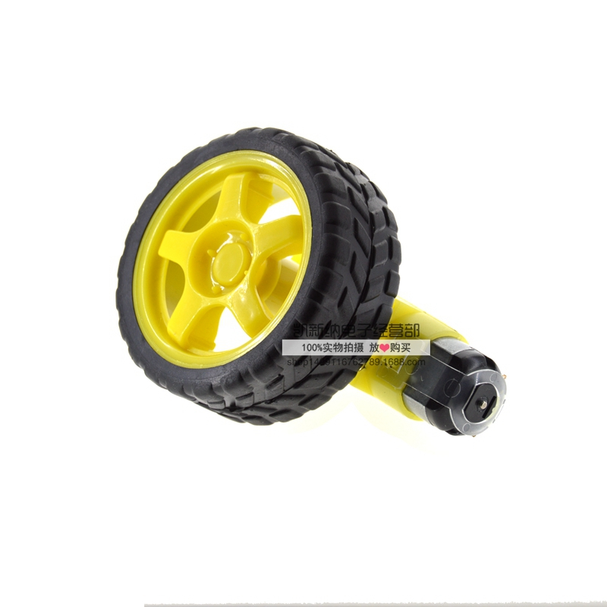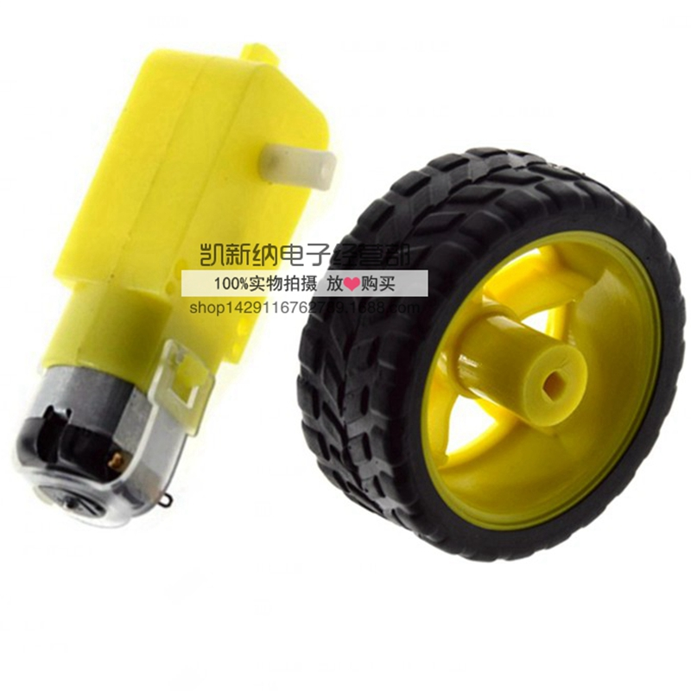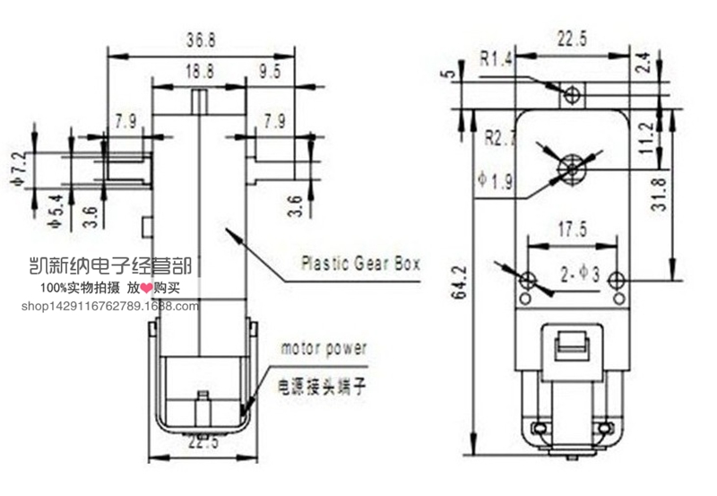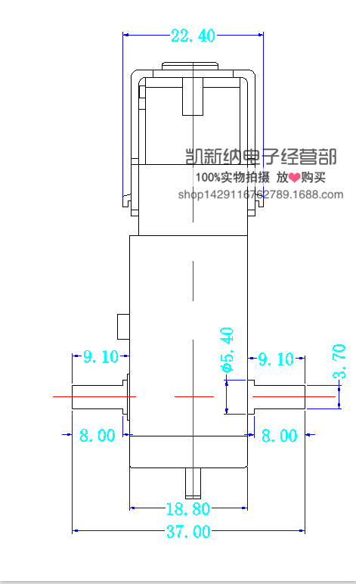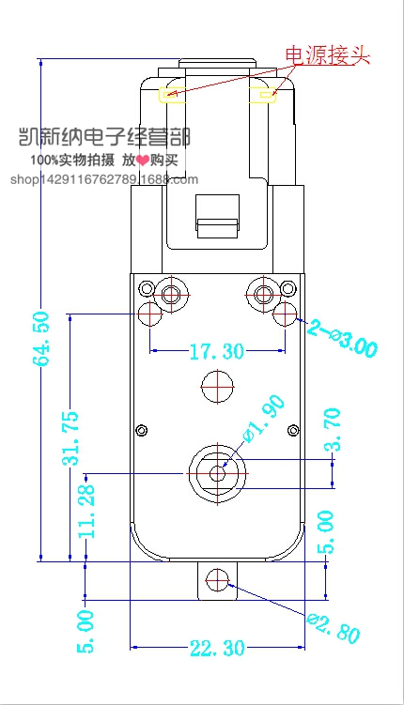

**和此**

**slotted wheel**

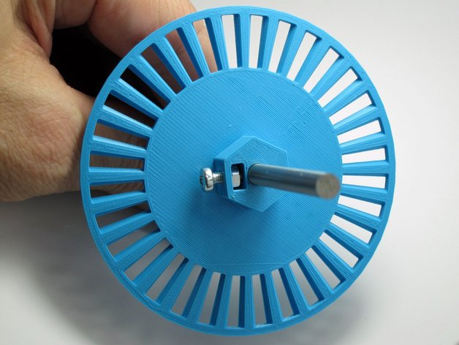

<http://www.thingiverse.com/thing:446143>

**Customizable Optical Encoder**

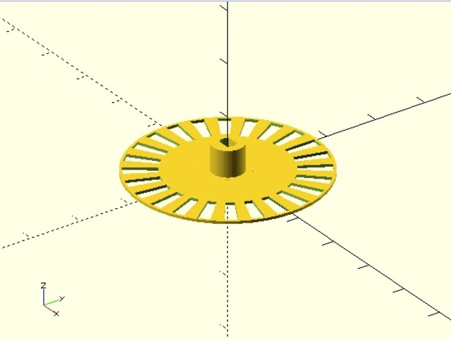

<http://www.thingiverse.com/thing:1679204>

**Parametric Encoder Wheel - Public Domain**

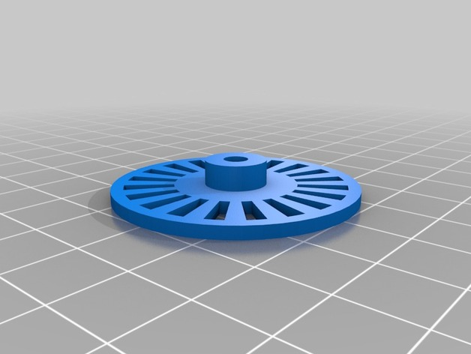

http://www.thingiverse.com/thing:1147656

**Scorbot ER Pittman Servo Motor Encoder Discs**

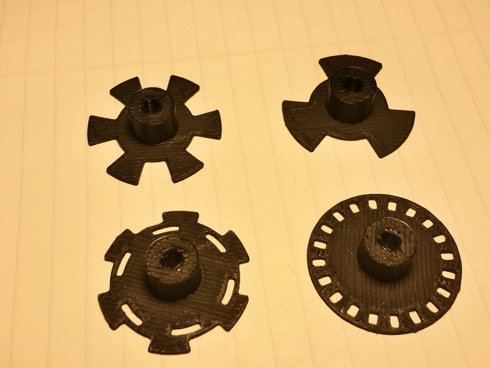

http://www.thingiverse.com/thing:1102883

**Rotory Encoder Knob**

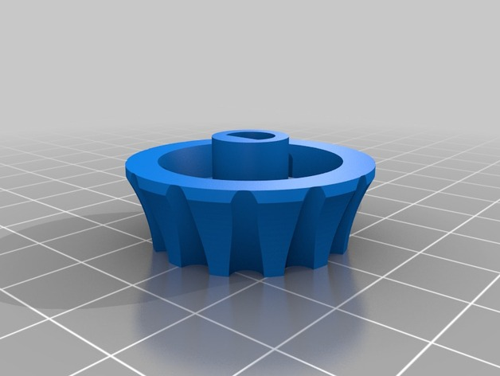

<http://www.thingiverse.com/thing:1340247>

**BottleCapWheel**

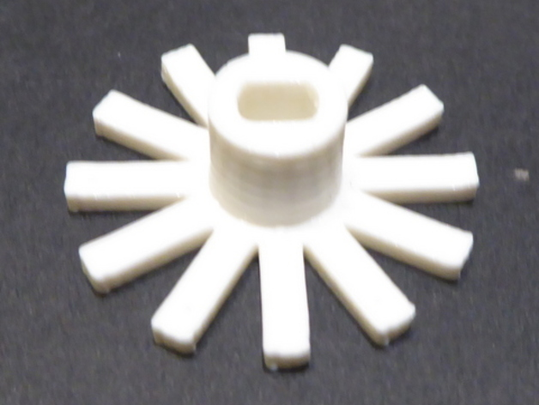

<http://www.thingiverse.com/thing:1878715>

<http://www.thingiverse.com/thing:1878715>

**encoder wheel for Dagu Multi chassis 4WD KIT**

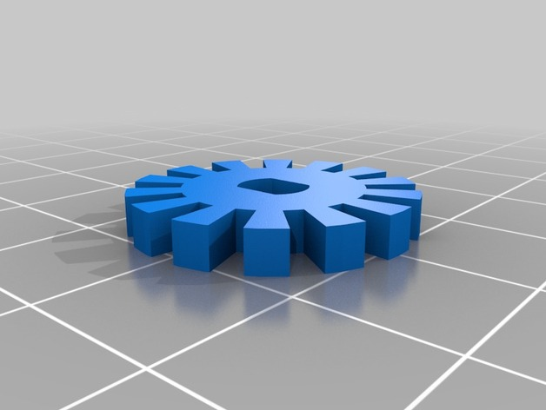

http://www.thingiverse.com/thing:690178

**Thor - Open Source, 3D printable robotic arm**

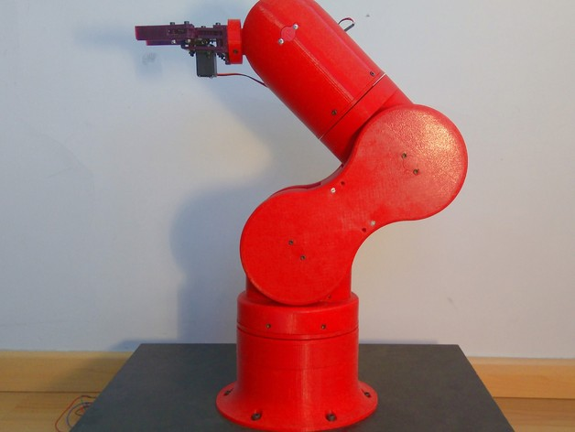

http://www.thingiverse.com/thing:1743075