Table of _{Contents}
Goal 1
Design 1
Thought 1
Plan 1
Tasks 1
Project structure 2
Vision 2
Environment 2
Tool stack 2
Dependencies 3
Modules 3
Project Interface 3
Program procedure 4
Core data structure 4
core algorithm 4
Project details 6
Knowledge 6
Style 6
Tricks 6
evaluation 6
advantage 6
disadvantage or risk 7
scenes 7

Goal

Find an approach to do this kind of things.

Design

Thought


Plan

Tasks

module | task | description | time | status
Project structure | Vision | Project vision | 0.5h | Done!
Project structure | Environment | Running environment | 0.5h | Done!
Project structure | Tool stack | Dev tool, test tool, deploy tool. | 0.5h | Done!
Project structure | Dependencies | Find all the dependents of the project, and know those dependencies’ functions. | 0.3 h | Done!
Project structure | Modules | Distinct modules and find the relationship of all modules. | 1h | Done!
Project structure | Project interface | Interfaces of project, like API, UI. | 1h | Done!
Program procedure | Core data structure | The core data structures used in the project. | 1h | Done!
Program procedure | Core algorithm | The core data algorithms used in the project. | 2h | Done!
Project details | Knowledge | The knowledge you do not know | 1h | Done!
Project details | Style | Style of project: comment, naming, lint, closure. Slips, law. | 1h | Done!
Project details | Tricks | Programing tricks. | 1h | Done!
Project details | Other
evaluation | Advantage | The advantages of this project | 0.5h | Done!
evaluation | Disadvantage | The disadvantage of this project | 0.5h | Done!
evaluation | Scenes | The scenes it suits and not suits | 0.5h | Done!

Project structure

Vision

Generator based control flow goodness for nodejs and the browser, using promises, letting you write non-blocking code in a nice-ish way.

https://github.com/tj/co

Environment

iojs >= 1.0.0 node >= 0.12.0 ES5

Tool stack

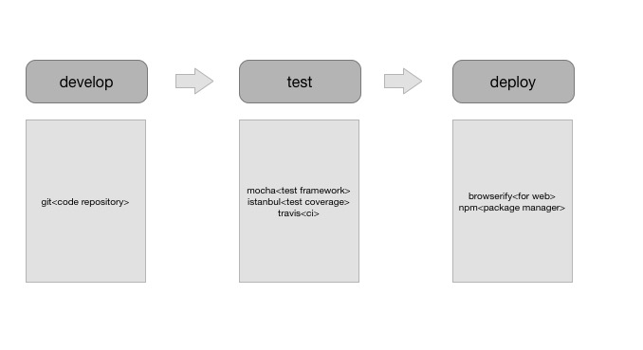

Dependencies

None

Modules

Too simple to just have one module.

Project Interface

https://github.com/tj/co

interface | description | invoke | parameters |  | result
co | Returns a promise that resolves a generator, generator function, or any function that returns a generator. | co(fn*) | 0 | generator |  generator function |  any function returns a generator | Promise
co.wrap | Convert a generator into a regular function that returns a promise | co.wrap(fn*) | 0 | generator | Promise generator

Program procedure

Core data structure

yieldable object
- promises
- thunks. https://github.com/thunks/thunks
- array(parallel)
- objects(parallel)
- generators
- generator functions

core algorithm

co function, execute the generator function or a generator

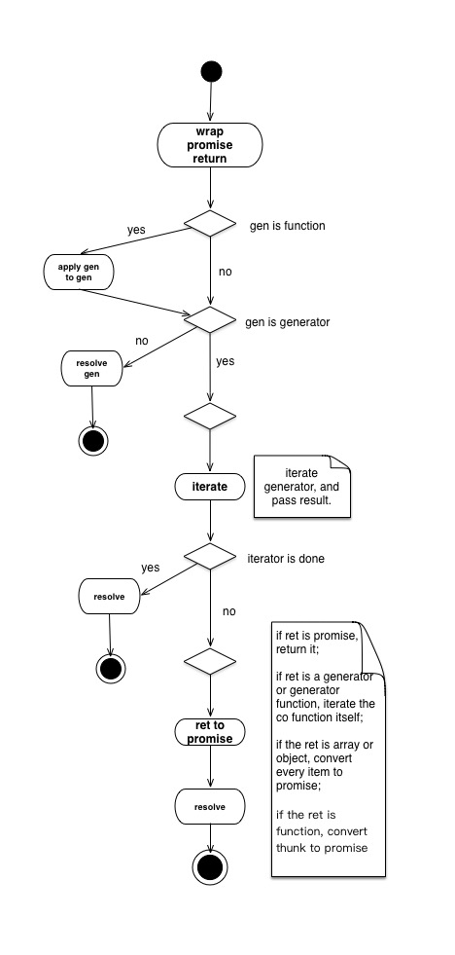

Project details

Knowledge

- thunk
- generator function
constructor.name
constructor.displayName
isGenerator(constructor.prototype)
- plain object
Object == val.constructor

Style

- comment
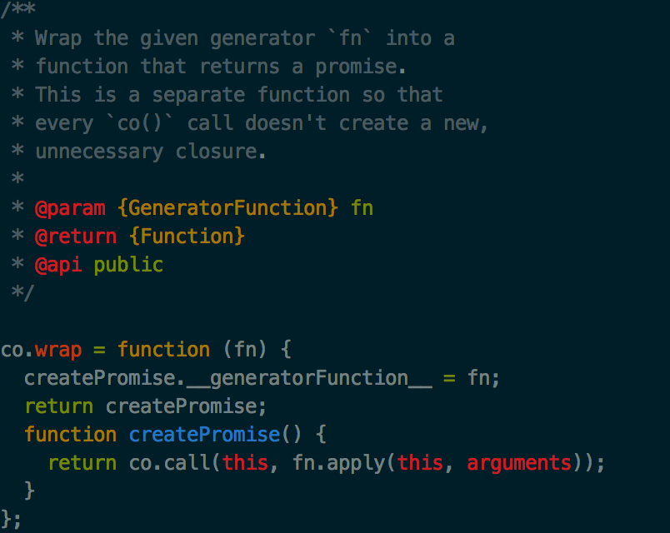

type: Function, Object, …, Mixed, …

Tricks
- try-catch hack

evaluation

advantage
- very simple interfaces, easy to use

disadvantage or risk
- ES7 async await

scenes
- generator or generator function

