Table of _{Contents}
Goal 1
Design 1
Thought 1
Plan 1
Tasks 1
Project structure 2
Vision 2
Environment 2
Tool stack 2
Dependencies 3
Modules 3
Project Interface 3
Program procedure 3
Core data structure 3
core algorithm 3
Project details 3
Knowledge 3
Style 3
Tricks 3
evaluation 3
advantage 3
disadvantage or risk 3
scenes 3

Goal

Understand the project node, from whole to part.

Design

Thought
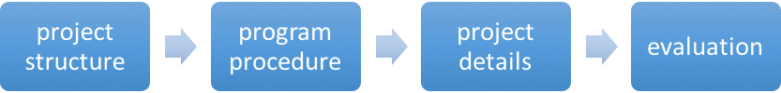

Plan

Tasks

module | task |  | description | time | status
Project structure | Vision |  | Project vision
Project structure | Environment |  | Running environment
Project structure | Tool stack |  | Dev tool, test tool, deploy tool.  (a tool stack flow and a function table)
Project structure | Dependencies |  | Find all the dependents of the project, and know those dependencies’ functions.  (dependency chart and a function table)
Project structure | Modules |  | Distinct modules and find the relationship of all modules.  (dependency chart and a function table)
Program procedure | ${module} | Module interface | Interfaces of module, like API, UI.  ( an interface table)
Program procedure | ${module} | Core data structure | The core data structures used in the project.
Program procedure | ${module} | Core algorithm | The core data algorithms used in the project.
Project details | ${module} | Knowledge | The knowledge you do not know
Project details | ${module} | Style | Style of project: comment, naming, lint, closure. Slips, law.
Project details | ${module} | Tricks | Programing tricks.
Project details | ${module} | Other
evaluation | Advantage |  | The advantages of this project
evaluation | Disadvantage |  | The disadvantage of this project
evaluation | Scenes |  | The scenes it suits and not suits

Project structure

Vision

Node.js is a JavaScript runtime built on Chrome's V8 JavaScript engine. Node.js uses an event-driven, non-blocking I/O model that makes it lightweight and efficient.

Environment

Unix
• gcc and g++ 4.8 or newer, or
• clang and clang++ 3.4 or newer
• Python 2.6 or 2.7
• GNU Make 3.81 or newer

https://github.com/nodejs/node/blob/master/BUILDING.md

Tool stack

Dependencies

Module name | Function description

Modules

Module name | Function description

Project Interface

interface | description | invoke | parameters |  | result

Program procedure

Core data structure

core algorithm

Project details

Knowledge

target | method

Style

Tricks

evaluation

advantage

disadvantage or risk

scenes

