Table of _{Contents}
Goal 1
Design 1
Thought 1
Plan 1
Tasks 1
Project structure 2
Vision 2
Environment 2
Tool stack 3
Dependencies 3
Modules 4
Project Interface 4
Program procedure 5
Core data structure 5
core algorithm 7
Project details 9
Knowledge 9
Style 10
Tricks 10
evaluation 10
advantage 10
disadvantage or risk 10
scenes 10

Goal

Understand the project koa, from from whole to part.

Design

Thought
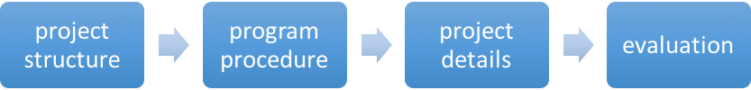

Plan

Tasks

module | task | description | time | status
Project structure | Vision | Project vision | 0.5h | Done!
Project structure | Environment | Running environment | 0.5h | Done!
Project structure | Tool stack | Dev tool, test tool, deploy tool.  (a tool stack flow and a function table) | 0.5h | Done!
Project structure | Dependencies | Find all the dependents of the project, and know those dependencies’ functions.  (dependency chart and a function table) | 3h | Done!
Project structure | Modules | Distinct modules and find the relationship of all modules.  (dependency chart and a function table) | 1h | Done!
Project structure | Project interface | Interfaces of project, like API, UI.  ( an interface table) | 1h | Done!
Program procedure | Core data structure | The core data structures used in the project. | 1h | Done!
Program procedure | Core algorithm | The core data algorithms used in the project. | 2h | Done!
Project details | Knowledge | The knowledge you do not know | 1h | Done!
Project details | Style | Style of project: comment, naming, lint, closure. Slips, law. | 1h | Done!
Project details | Tricks | Programing tricks. | 1h | Done!
Project details | Other
evaluation | Advantage | The advantages of this project | 0.5h | Done!
evaluation | Disadvantage | The disadvantage of this project | 0.5h | Done!
evaluation | Scenes | The scenes it suits and not suits | 0.5h | Done!

Project structure

Vision

Koa is a new web framework designed by the team behind Express, which aims to be a smaller, more expressive, and more robust foundation for web applications and APIs. Through leveraging generators Koa allows you to ditch callbacks and greatly increase error-handling. Koa does not bundle any middleware within core, and provides an elegant suite of methods that make writing servers fast and enjoyable.

http://koajs.com/

Environment

node V4+
node 0.12 with the --harmony-generators or –harmony flag.
iojs >= 1.0.0

Tool stack
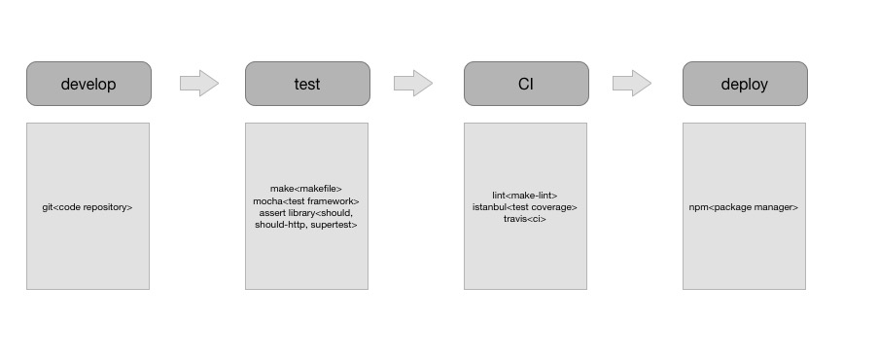

Dependencies

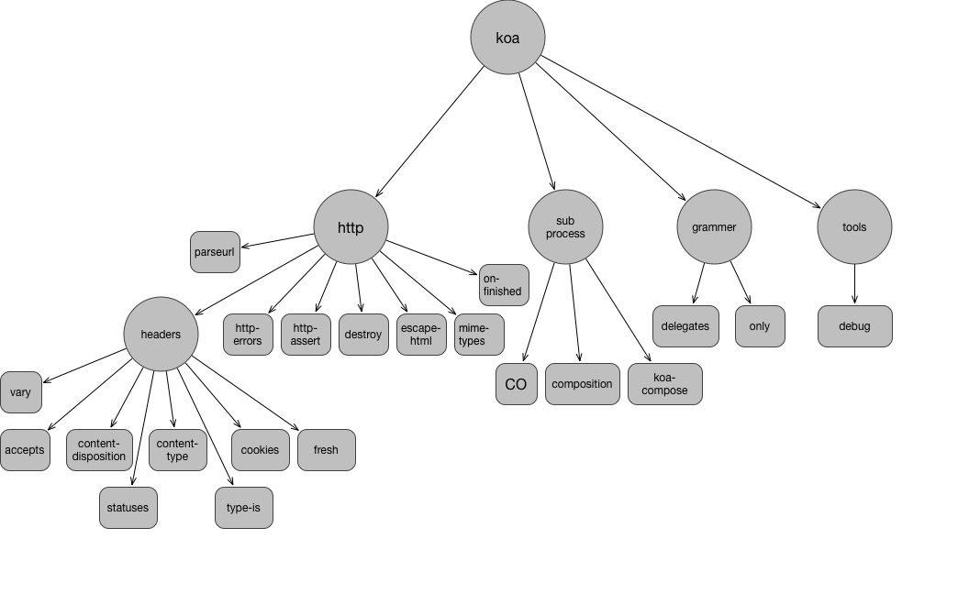
Module name | Function description
accetps | Extract accept type from request object
composition | Compose generator functions or async await functions to a function.
content-disposition | Create and parse HTTP Content-Disposition header  https://www.w3.org/Protocols/rfc2616/rfc2616-sec19.html
content-type | Create and parse HTTP Content-Type header
cookies | Getting and setting HTTP(s) cookies
delegates | Node method and accessor delegation utilty
destroy | Destroy a stream
escape-html | Escape string for use in HTML
fresh | HTTP response freshness testing
http-assert | Assert with status codes.
koa-compose | Compose a group of middleware to a middleware
mime-types | content-type
on-finished | Execute a callback when a HTTP request closes, finishes, or errors.
only | return whitelisted properties of an object
parseurl | Cache url.parse results
vary | Manipulate the HTTP Vary header  http://mark.koli.ch/understanding-the-http-vary-header-and-caching-proxies-squid-etc

Modules

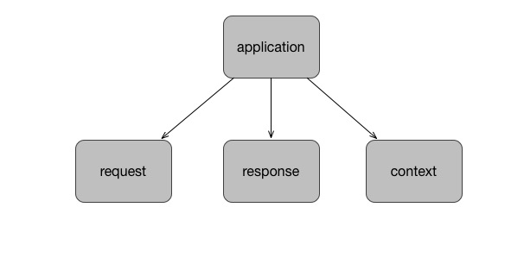
Module name | Function description
application | Entrance. App interfaces.
context | Export context interfaces, delegate request and response’s interfaces.
request | koa request object. Define koa request interfaces. Like headers, status, message, body, url, length, accept etc. It’s a wrapper to original request object.
response | koa response object. It’s a wrapper to original response object.

Project Interface

interface | description | invoke | parameters |  | result
app.use | add koa middleware | app.use(fn) | 0 | fn | app
app.callback | koa server handler genetator | app.callback() |  |  | server handler

Program procedure

Core data structure

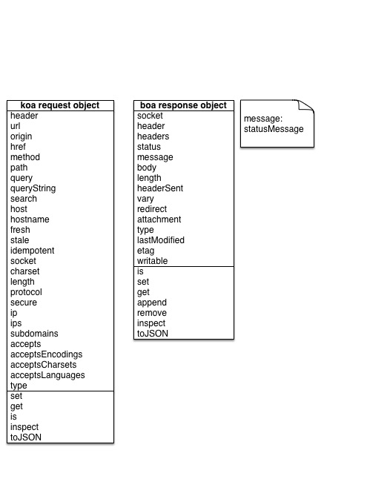

core algorithm

- Compose middleware
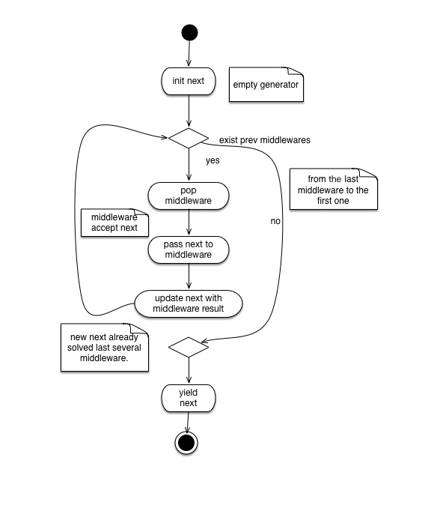
- Response algorithm
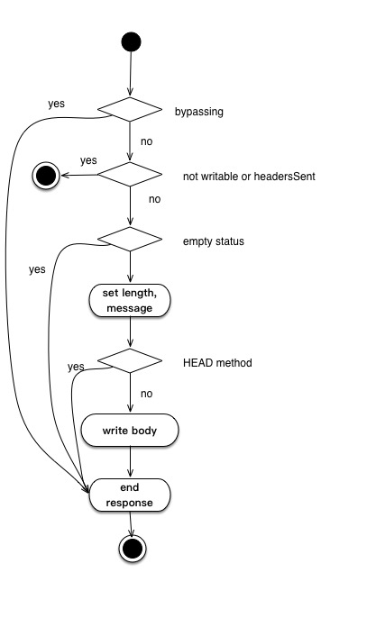
- Content length
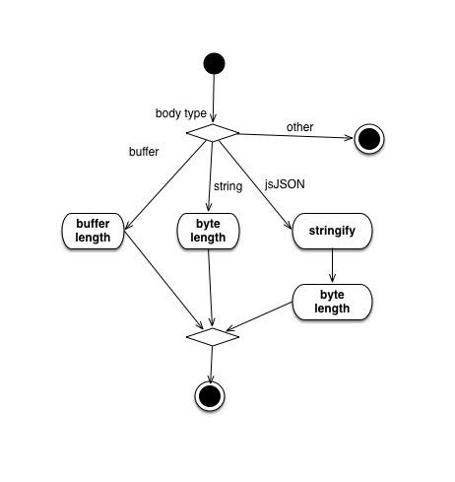

Project details

Knowledge

target | method
Calculate http host | When proxy is enable, get X-Forwarded-Host field of headers. Otherwise get Host. X-Forwarded-For: client, proxy1, proxy2
idempotent | GET HEAD PUT DELETE OPTIONS TRACE
protocol | If socket.encrypted, https; if not proxy, http; trust X-Forward-proto
ip | The first ip of X-Forwarded-For, or socket.remoteAddress
accept | Accept-Encoding: gzip, deflate  Accept-Charset: utf-8, iso-8859-1;q=0.2, utf-7;q=0.5  Accept-Language: en;q=0.8, es, pt
Content-Disposition | filename
Last-Modified | toUTCString
etag | "123456789" – A strong ETag validator  W/"123456789" – A weak ETag validator

Style

- ES5 setter, getter

Tricks

- cache queryString, query object for request object

evaluation

advantage

- generator as a hack solution
- simple and light

disadvantage or risk

- learning costs
- costs of converting express middleware to koa mid

scenes

- no babel, higher level node
- ecosystem

