Table of _{Contents}
Goal 1
Design 1
Thought 1
Plan 1
Tasks 1
Project structure 2
Vision 2
Environment 2
Tool stack 2
Dependencies 2
Modules 2
Project Interface 2
Program procedure 3
Core data structure 3
core algorithm 3
Project details 3
Knowledge 3
Style 3
Tricks 3
evaluation 3
advantage 3
disadvantage or risk 3
scenes 3

Goal

Understand the project koa, from from whole to part.

Design

Thought
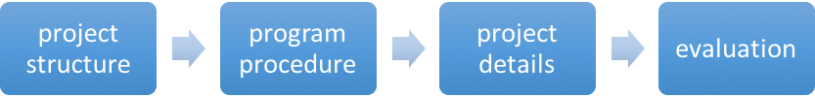

Plan

Tasks

module | task | description | time | status
Project structure | Vision | Project vision | 0.5h | Done!
Project structure | Environment | Running environment | 0.5h | Done!
Project structure | Tool stack | Dev tool, test tool, deploy tool.  (a tool stack flow and a function table) | 0.5h | Done!
Project structure | Dependencies | Find all the dependents of the project, and know those dependencies’ functions.  (dependency chart and a function table) | 3h | Done!
Project structure | Modules | Distinct modules and find the relationship of all modules.  (dependency chart and a function table) | 1h
Project structure | Project interface | Interfaces of project, like API, UI.  ( an interface table) | 1h
Program procedure | Core data structure | The core data structures used in the project. | 1h
Program procedure | Core algorithm | The core data algorithms used in the project. | 2h
Project details | Knowledge | The knowledge you do not know | 1h
Project details | Style | Style of project: comment, naming, lint, closure. Slips, law. | 1h
Project details | Tricks | Programing tricks. | 1h
Project details | Other
evaluation | Advantage | The advantages of this project | 0.5h
evaluation | Disadvantage | The disadvantage of this project | 0.5h
evaluation | Scenes | The scenes it suits and not suits | 0.5h

Project structure

Vision

Koa is a new web framework designed by the team behind Express, which aims to be a smaller, more expressive, and more robust foundation for web applications and APIs. Through leveraging generators Koa allows you to ditch callbacks and greatly increase error-handling. Koa does not bundle any middleware within core, and provides an elegant suite of methods that make writing servers fast and enjoyable.

http://koajs.com/

Environment

node V4+
node 0.12 with the --harmony-generators or –harmony flag.
iojs >= 1.0.0

Tool stack
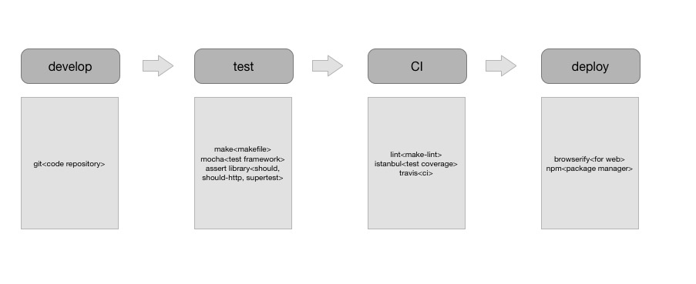

Dependencies

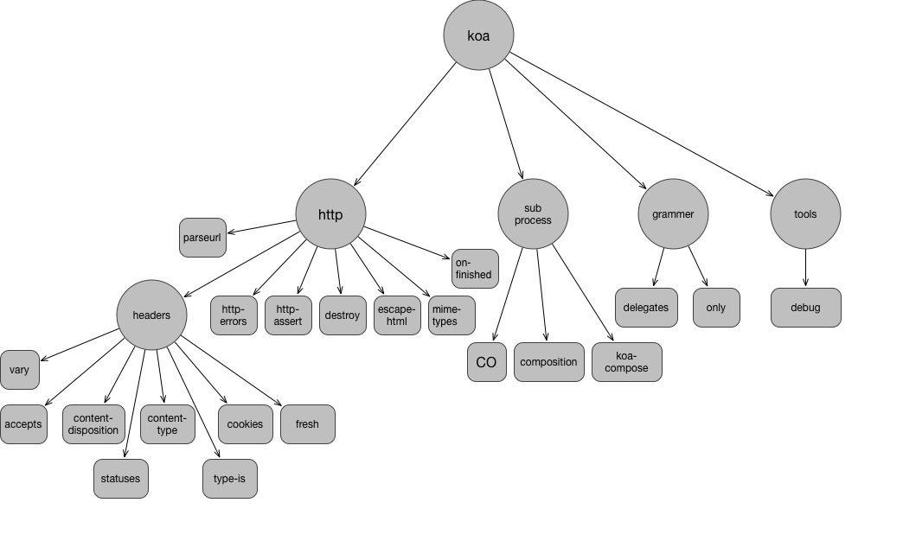
Module name | Function description
accetps | Extract accept type from request object
composition | Compose generator functions or async await functions to a function.
content-disposition | Create and parse HTTP Content-Disposition header  https://www.w3.org/Protocols/rfc2616/rfc2616-sec19.html
content-type | Create and parse HTTP Content-Type header
cookies | Getting and setting HTTP(s) cookies
delegates | Node method and accessor delegation utilty
destroy | Destroy a stream
escape-html | Escape string for use in HTML
fresh | HTTP response freshness testing
http-assert | Assert with status codes.
koa-compose | Compose a group of middleware to a middleware
mime-types | content-type
on-finished | Execute a callback when a HTTP request closes, finishes, or errors.
only | return whitelisted properties of an object
parseurl | Cache url.parse results
vary | Manipulate the HTTP Vary header  http://mark.koli.ch/understanding-the-http-vary-header-and-caching-proxies-squid-etc

Modules

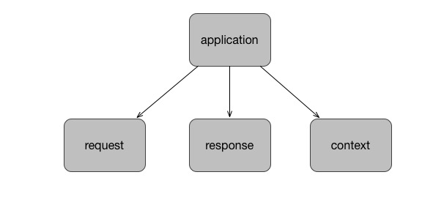
Module name | Function description
application
context
request | koa request object. Define koa request interfaces.
response | koa response object.

Project Interface

interface | description | invoke | parameters |  | result

Program procedure

Core data structure

core algorithm

Project details

Knowledge

Style

- comment

Tricks

evaluation

advantage

disadvantage or risk

scenes

