Table of Contents

Goal 1

Design 1

Thought 1

Plan 1

Tasks 1

Project structure 2

Vision 2

Environment 3

Tool stack 3

Dependencies 4

Modules 4

Program procedure 5

module: Core 5

module: Ajax 8

module: Event 12

Project details 14

Logic 14

Knowledge 15

Style 15

Tricks 15

evaluation 15

advantage 15

disadvantage or risk 15

scenes 15

## Goal

Understand the project jQuery, from whole to part.

## Design

### Thought

## Plan

### Tasks

|  |  |  |  |  |  |
| --- | --- | --- | --- | --- | --- |
| **module** | **task** | | **description** | **time** | **status** |
| **Project structure** | Vision | | Project vision | 1h | Done! |
| Environment | | Running environment | Done! |
| Tool stack | | Dev tool, test tool, deploy tool.  (a tool stack flow and a function table) | Done! |
| Dependencies | | Find all the dependents of the project, and know those dependencies’ functions.  (dependency chart and a function table) | 0h | Done! |
| Modules | | Distinct modules and find the relationship of all modules.  (dependency chart and a function table) | 2h | Done! |
| **Program procedure** | ${module} | Module exports data structure | The module exports data structure. Using **class diagram**.   * Find module export parts * Draw class diagram for exports object (function signature, comment) | 15 * 1h |  |
|  |
| Other data structure | (append later) Other data structures used in the module. Using **class diagram**. | 15 * 1h |  |
| Module interface logic | The main logic for module interfaces.   * Find module export parts * Analysis function logic (simply describe sub procedure) | 15 * 1h |  |
| Core sub procedures | The logic for sub procedures. | 15 * 1h |  |
| **Project details** | ${module} | Logic |  |  |  |
| Knowledge | The knowledge you do not know |  |  |
| Style | Style of project: comment, naming, lint, closure. Slips, law. |  |  |
| Tricks | Programing tricks. |  |  |
| Other |  |  |  |
| **evaluation** | Advantage | | The advantages of this project | 1h |  |
| Disadvantage | | The disadvantage of this project |
| Scenes | | The scenes it suits and not suits |

## Project structure

### Vision

jQuery is a fast, small, and feature-rich JavaScript library. It makes things like HTML document traversal and manipulation, event handling, animation, and Ajax much simpler with an easy-to-use API that works across a multitude of browsers. With a combination of versatility and extensibility, jQuery has changed the way that millions of people write JavaScript.

### Environment

* Browser Support

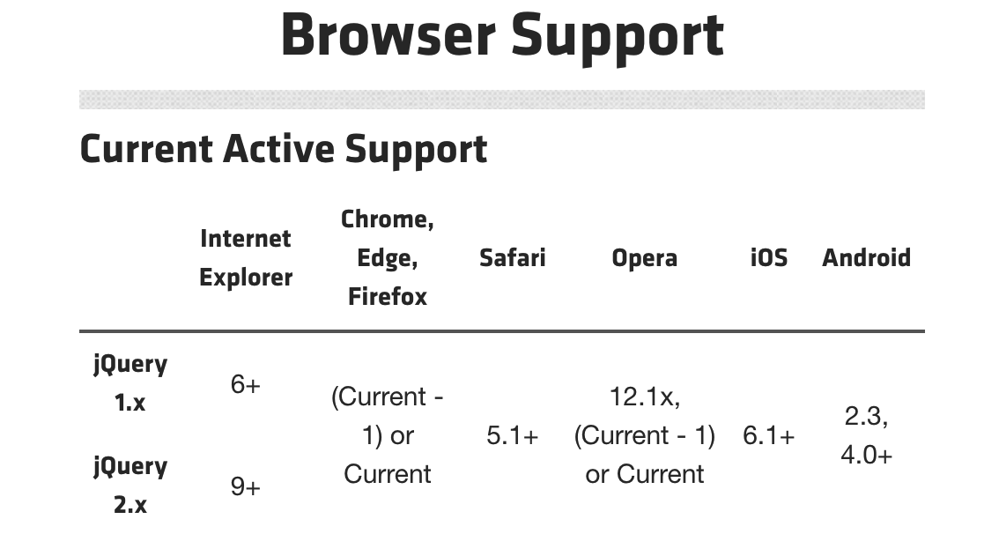

* jQuery also supports Node, browser extensions and other non-browser environments.

### Tool stack

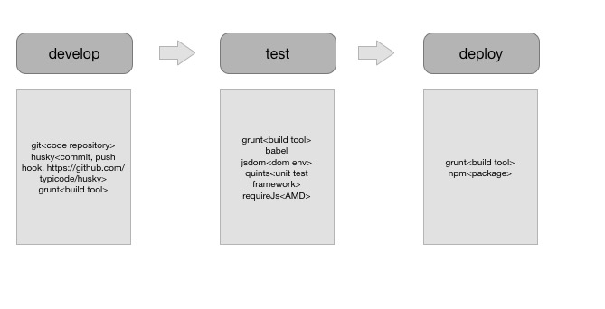

### Dependencies

|  |  |
| --- | --- |
| **Module name** | **Function description** |
|  |  |

### Modules

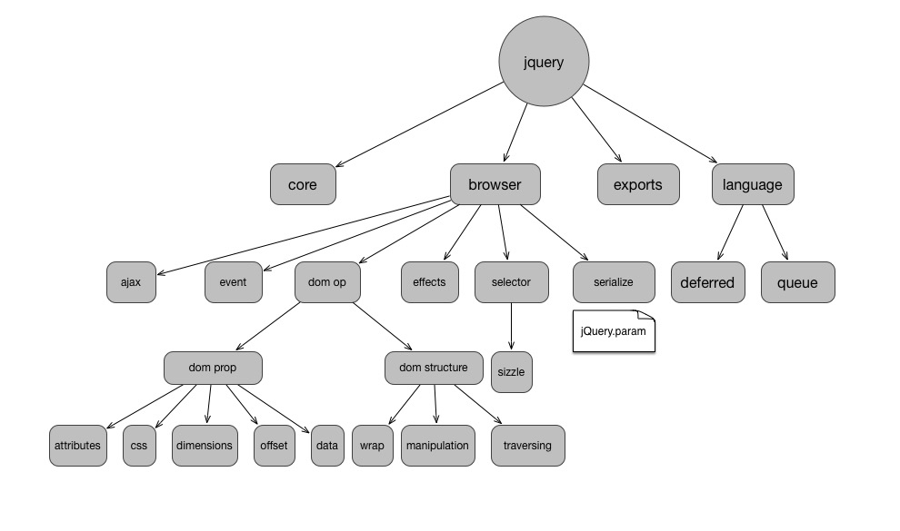

|  |  |
| --- | --- |
| **Module name** | **Function description** |
| **core** | jQuery constructor. jQuery.fn. Some array-like operations. jQuery.extend. Basic tool functions. |
| **ajax** | ajax request, ajax settings. |
| **event** | event model. on, off, dispatch, event object, etc. |
| **effects** | animation, fadeTo, stop, animate, finish |
| **selector** | Sizzle. Css selector engine. |
| **serialize** | jQuery.param. Serialize an array of form elements or a set of key/values into a query string. |
| **deferred** | promise |
| **attributes** | dom attr, prop, classes, val |
| **css** | css, style |
| **dimensions** | innerHeight, innerWidth, height, width, outerHeight, outerWidth |
| **offset** | offset, position, scrollLeft, scrollTop, top, left |
| **data** | data-* attribute |
| **wrap** | wrapAll, wrapInner, wrap, unwrap |
| **manipulation** | Basic dom writing operation. text, remove, detach, append, prepend … |
| **traversing** | Some dom nearby reading operation. parent, parents, next, prev, sibling, children… |

## Program procedure

### module: Core

#### data structure

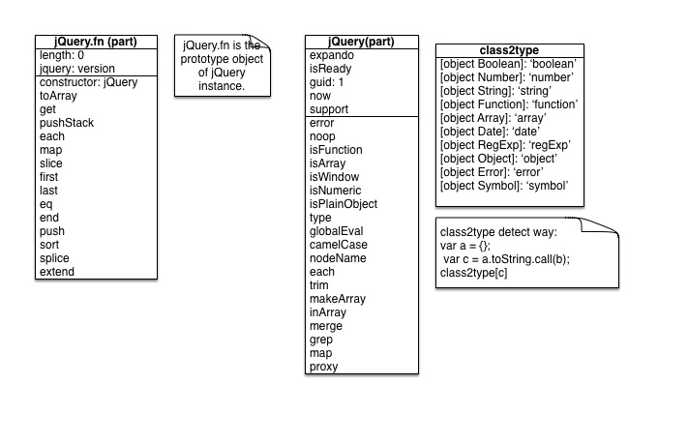

#### algorithm

* isPlainObject

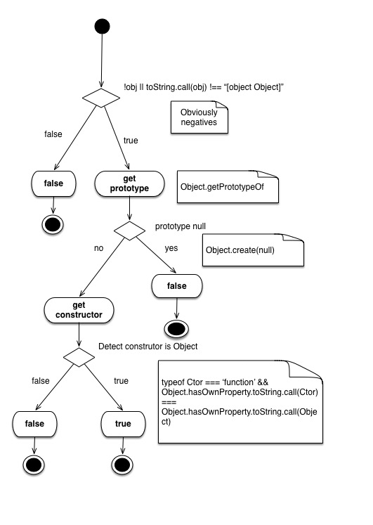

### module: Ajax

#### data structure

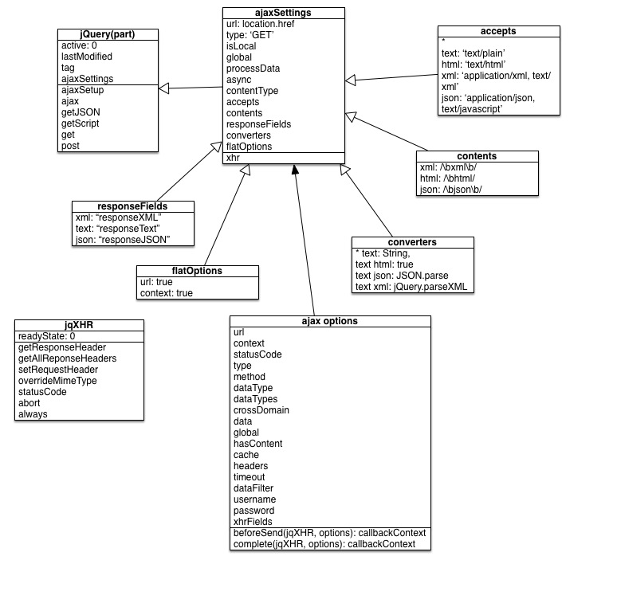

* dataTypeExpression

*datatypes* = *datatype* | *datatype* *whitespaces* *datatypes*

*datatype* ::= word | +word | * | +

*whitespaces* ::= whitespace | whitespace *whitespaces*

#### algorithm

* core procedure
* ajax request process

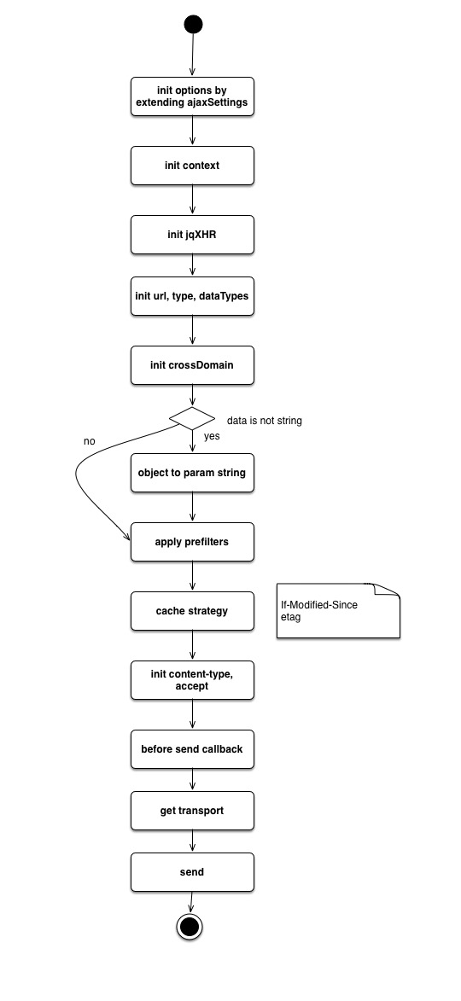

* ajax response process

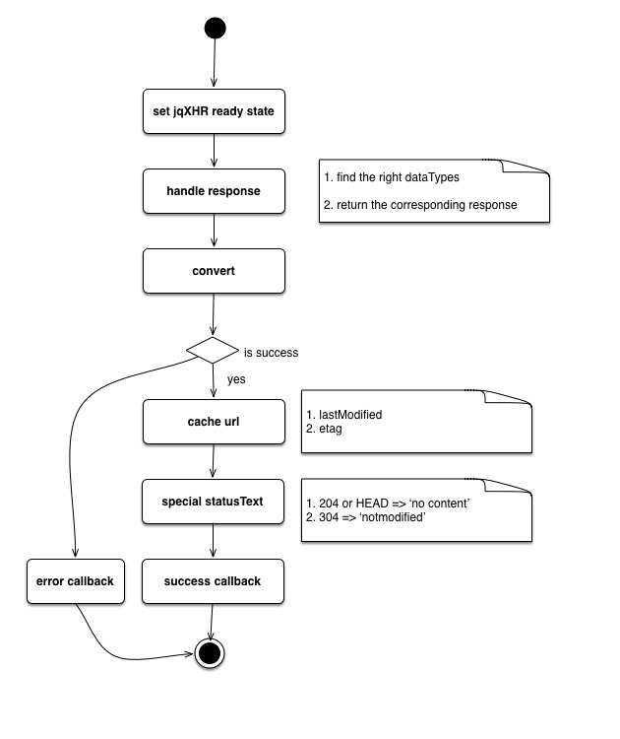

* inspect transports

1. execute every transport function by dataType
2. if result is string, inspect result as a dataType

### module: Event

#### Module exports data structure

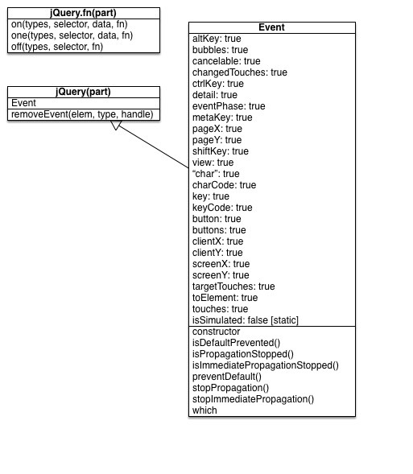

#### Other data structure

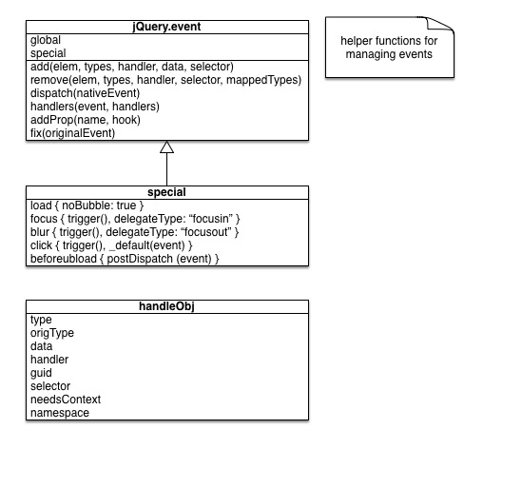

#### Module interface logic

* on(elem, types, selector, data, fn, one)

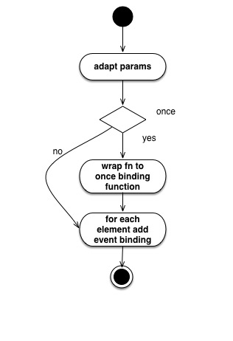

* add(elem, types, handler, data, selector)

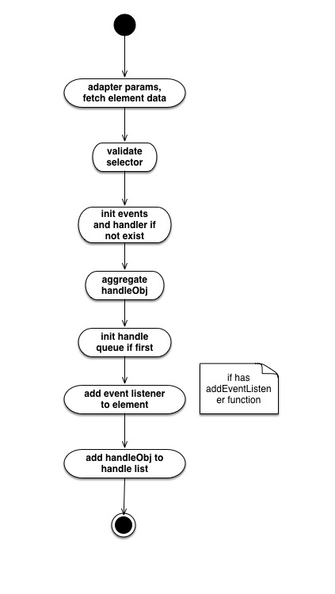

#### Core sub procedures

## Project details

### Logic

|  |  |  |
| --- | --- | --- |
| **module** | **name** | **description** |
| **core** | **jQuery.fn.get(num)** | num is null, return slice.call(this); if num < 0, return this.[num+this.length];if num > 0, return this.[num] |
| **jQuery.extend=jQuery.fn.extend(deep, target, copy)** | * default deep is false. deep is optional. * if only one argument if not count deep, target is this * ignore null/undefined values |
| **ajax** | **Success status code** | status >=200 && status < 300 || status === 304 |
| **prefilters: {}** | * key is the datatype * the catchall symbol * can be used * execution will start with transport datatype and THEN go to * if needed |
| **transports: {}** | * key is the datatype * the catchall symbol * can be used * execution will start with transport datatype and THEN go to * if needed |

### Knowledge

|  |  |  |
| --- | --- | --- |
| **module** | **name** | **description** |
| **core** | **DOMEval** | dynamic add and remove script node. |
| **BOM** |  |
| **NBSP** |  |
| **rtrim** | /^[\s\uFEFE\xA0]+|[\s\uFEFE\xA0]+$/g |
| **Object.create(null)** | Prototype is null |
| **ajax** | **detect type** | var a = {}; a.toString.call(true) === ‘[object Boolean]’ |
|  |  |  |

### Style

### Tricks

|  |  |  |
| --- | --- | --- |
| **module** | **target** | **method** |
| **core** |  |  |

## evaluation

### advantage

### disadvantage or risk

### scenes