NAME : CHINTAN UDANI

ROLL NO: 20BCP301D

BRANCH: Computer Science and Engineering

PROBLEM STATEMENT: E-Portal for filing complaints regarding po holes, electricity failure etc.

SOLUTION: Creation of a dashboard with modern UI, interactable and customizable sorted with categories so that user can also track down filed complaints.

DESCRIPTION: The user will be able to view all the filed complaints as well as he/she will also be able to chat with government officials of different departments regarding filed complaints. The problem is that after filing a complaint official do not take a proper track of all the filed complaints. Hence this solution works like an arrow hitting two targets.

1. User will be easily able to file complaints regarding any social problem.
2. User will also be able to track down old complaints, i.e. which were filed earlier

NOTE: PLEASE DO VIEW THE SOLUTION ON LIVE SERVER – SIMPLY OPENING HTML FILE WILL NOT RENDER ELEMENTS PROPERLY ON WEBPAGE

EXPECTED OUTPUT ON VIEWER’S BROWSER:

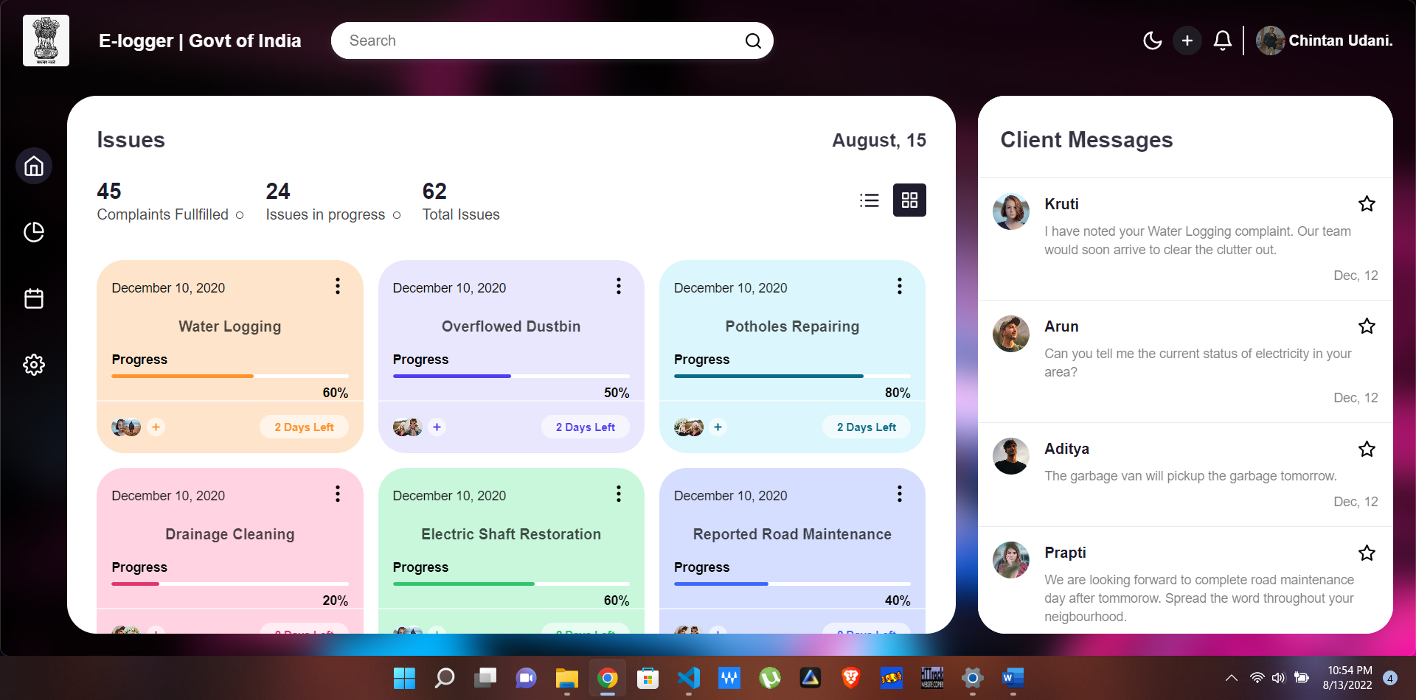

Click on the button below the home button to open complaint form:

