Advanced Web Programming Project 1:

Mobile Website Profile External Documentation

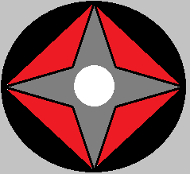

Written By: Kevin Kan

Student Number: 200213257

Date: November 4, 2013

Updated: November 16, 2013

Table of Contents

Site Description: 1

Navigation Bar: 1

Colours (Mobile): 3

Typography: 4

Wire Frame: 5

Branding: 7

# Site Description:

This site is a portfolio for showcasing work done and I as a person professionally. This website contains a navigation side bar that contains a link to my GitHub account, a Home page, About Me page, Services page, Contact page and Projects page. The Home page is the landing page that has a slider showing some featured projects, a button to link to more work and a stay connected area that are links to my social media pages. The About Me page contains a short biography and Kevin’s current CV. Services page contains information about services that I can offer. Projects page contains images of Kevin’s old work with each image linked to the respective code repository.

Additionally this update includes mobile site designs. This new design uses jquery mobile and theme roller. There is also mobile detection as well as mobile device overrides.

NOTE: the slider on the index (home) page is a prepackaged from dev7studios called nivo-slider. It contains base jquery and css file.

# Navigation Bar:

The desktop navigation bar is displayed as a sidebar. The ‘active’ tab (the page currently displayed) will have a white background while the others will have a blue one. The entire navigation bar will have a black background. Each tab in the navigation bar is stacked on top of one another and the entire navigation is located just under the company logo on the left of the page. Clicking on Home, About Me, Projects, Services, Contact Me will redirect the user to the appropriate page of my website. The Stay connected and GitHub tab areas will redirect the user to their respective websites.

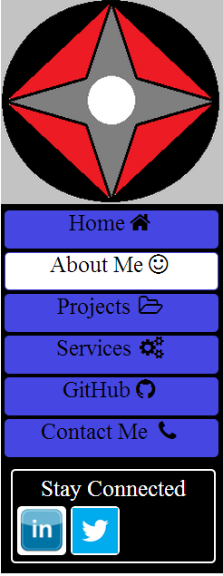

The mobile navigation is hidden initially and displays when Show/Hide Navbar button at the top of the page is clicked. The navigation bar in mobile is similar to the desktop version with some differences. The first difference is the back button. The back button uses jquery mobile built in functions to use the browser’s history to go back. The other differences are the Services and projects buttons. These buttons have been replaced with half-sized image buttons. The open folder is the projects tab and the cogs are the services tab.

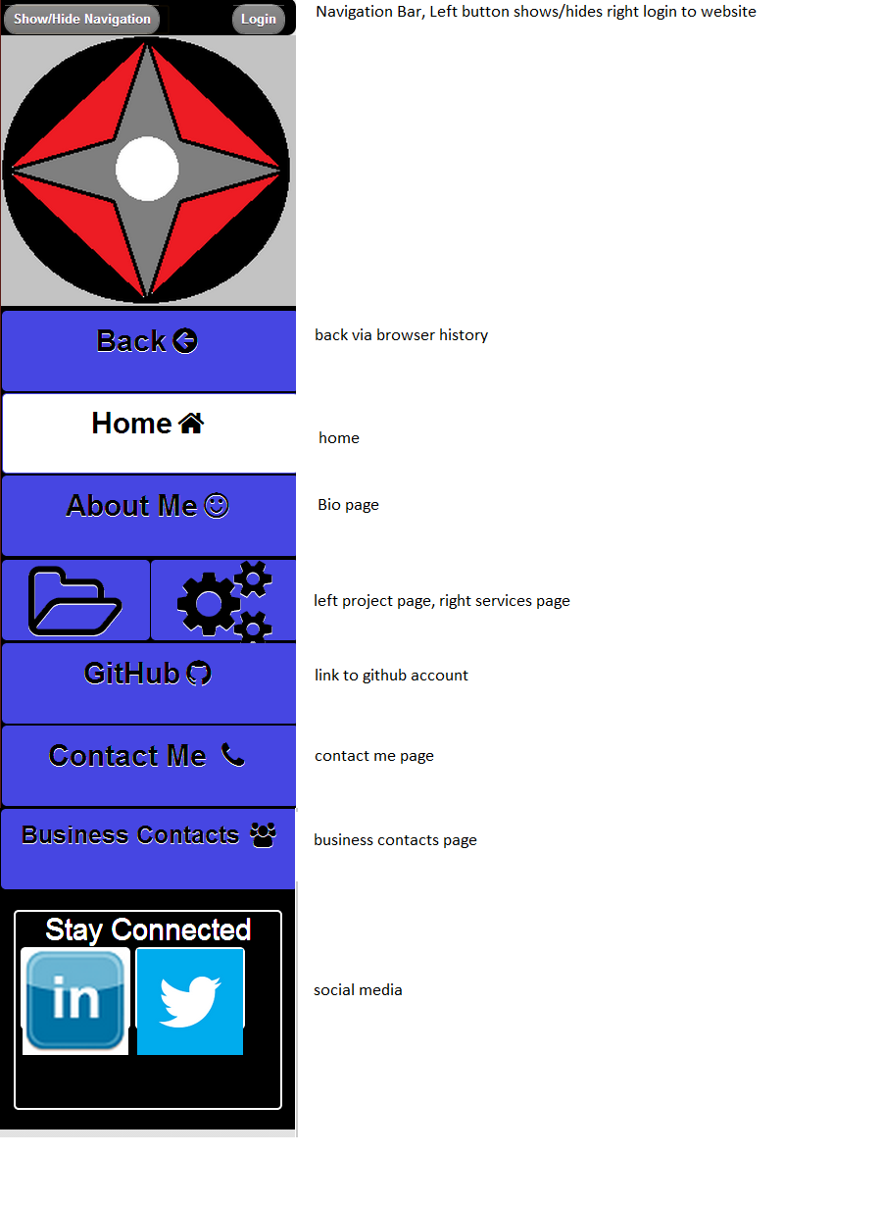

# Colours (Mobile):

|  |  |
| --- | --- |
| **Element** | **Colour** |
| Buttons : not active and active nav tab |  |
| Html background |  |
| Links not in nav |  |
| Nav tabs not active |  |
|  |  |
|  |  |
|  |  |

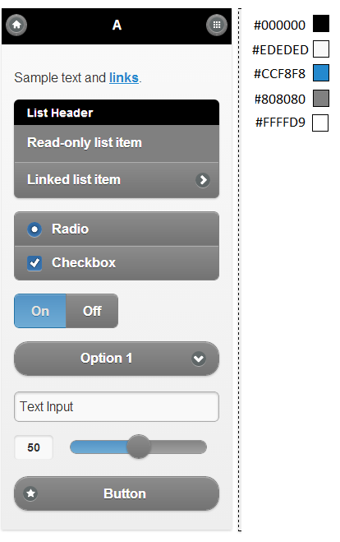

# Typography:

|  |  |  |  |
| --- | --- | --- | --- |
| **Element** | **Font** | **Colour** | **Size** |
| Html | 'Times New Roman', sans-serif (standard web) | default | default |
| footer | Same as above | Black | 0.75em |
| nav | Same As above | Black | 25px |
| *#socialMediaLinks* | Same As above | White(#FFFFFF) |  |
|  |  |  |  |
|  |  |  |  |
|  |  |  |  |
|  |  |  |  |
|  |  |  |  |

# Wire Frame:

Above: About Me

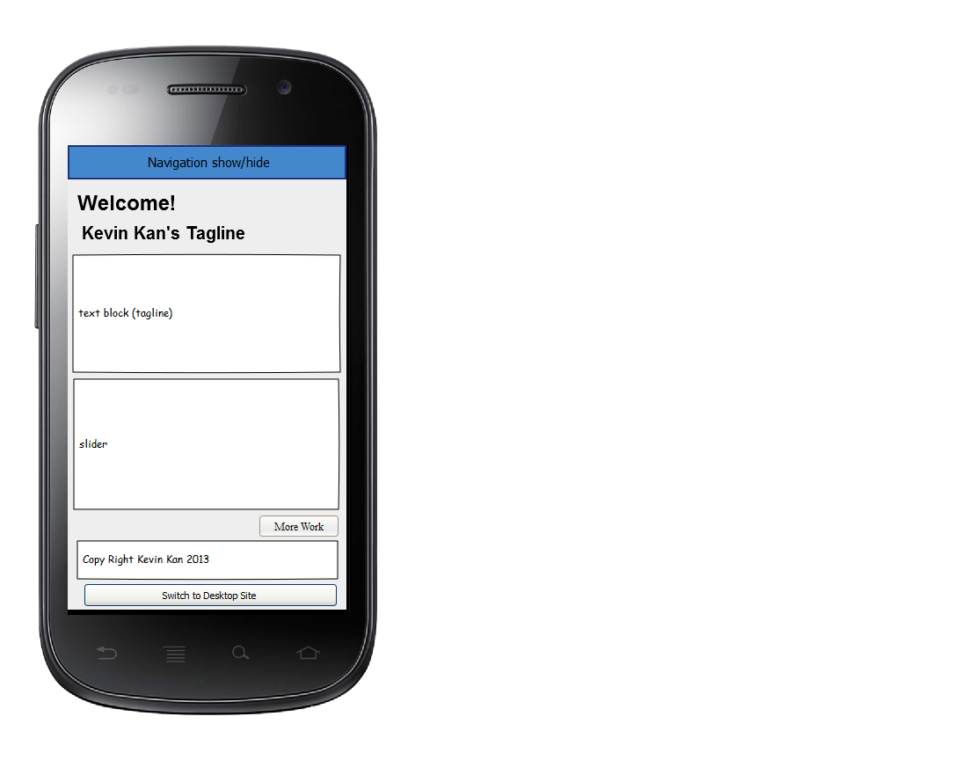

Above: Home Page WireFrame

# 

Above: Services WireFrame

Above: Projects Wire Frame

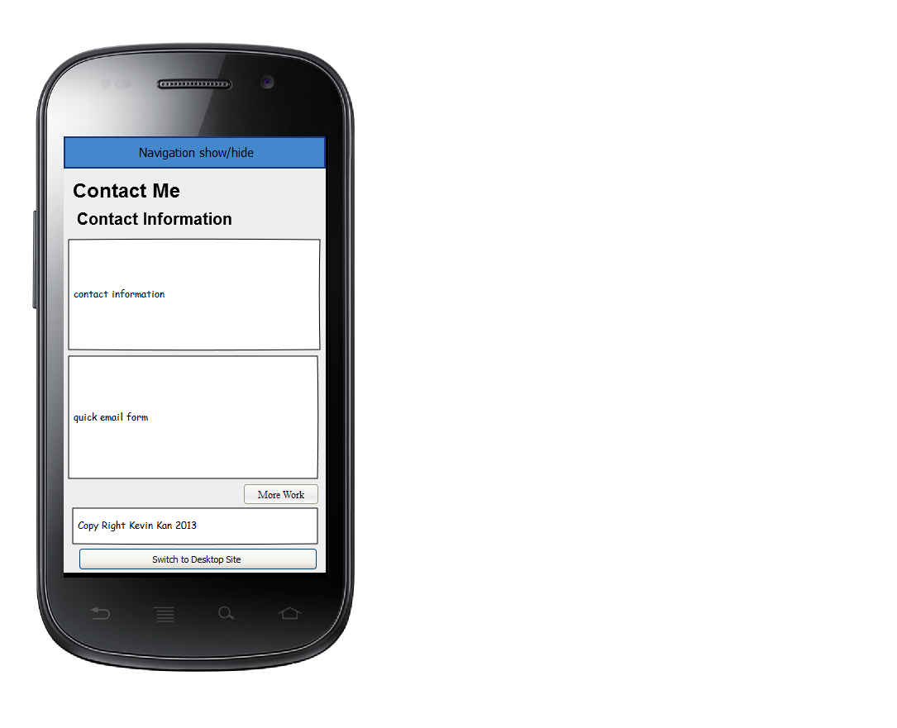

Above: Contact Me Wire Fame

# Branding:

