Advanced Web Programming Assignment 1:

Website Profile External Documentation



Written By: Kevin Kan

Student Number: 200213257

Date: Sept. 30, 2013

Table of Contents

Site Description: 1

Navigation Bar: 1

Colours: 1

Typography: 1

Wire Frame: 1

Branding: 1

# Site Description:

This site is a portfolio for showcasing work done and I as a person professionally. This website contains a navigation side bar that contains a link to my GitHub account, a Home page, About Me page, Services page, Contact page and Projects page. The Home page is the landing page that has a slider showing some featured projects, a button to link to more work and a stay connected area that are links to my social media pages. The About Me page contains a short biography and Kevin’s current CV. Services page contains information about services that I can offer. Projects page contains images of Kevin’s old work with each image linked to the respective code repository.

NOTE: the slider on the index (home) page is a prepackaged from dev7studios called nivo-slider. It contains base jquery and css file.

# Navigation Bar:

The navigation bar is displayed as a sidebar. The ‘active’ tab (the page currently displayed) will have a white background while the others will have a blue one. The entire navigation bar will have a red background. Each tab in the navigation bar is stacked on top of one another and the entire navigation is located just under the company logo on the left of the page.

# Colours:

# Typography:

|  |  |  |  |
| --- | --- | --- | --- |
| **Element** | **Font** | **Colour** | **Size** |
|  |  |  |  |
|  |  |  |  |
|  |  |  |  |
|  |  |  |  |
|  |  |  |  |
|  |  |  |  |
|  |  |  |  |
|  |  |  |  |
|  |  |  |  |

# Wire Frame:

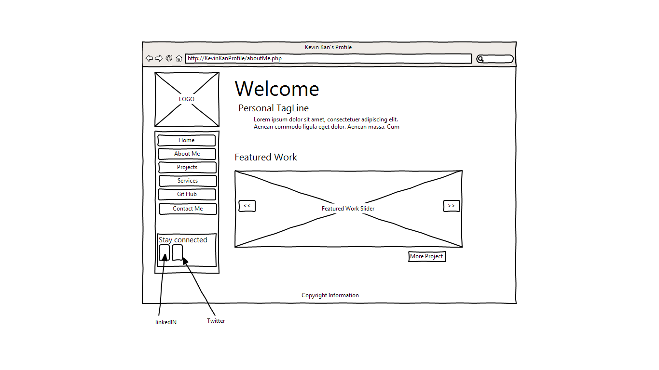

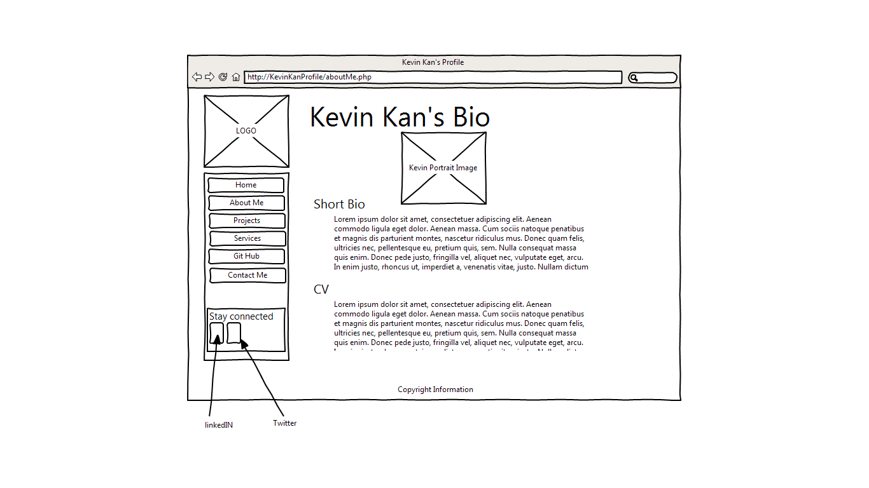

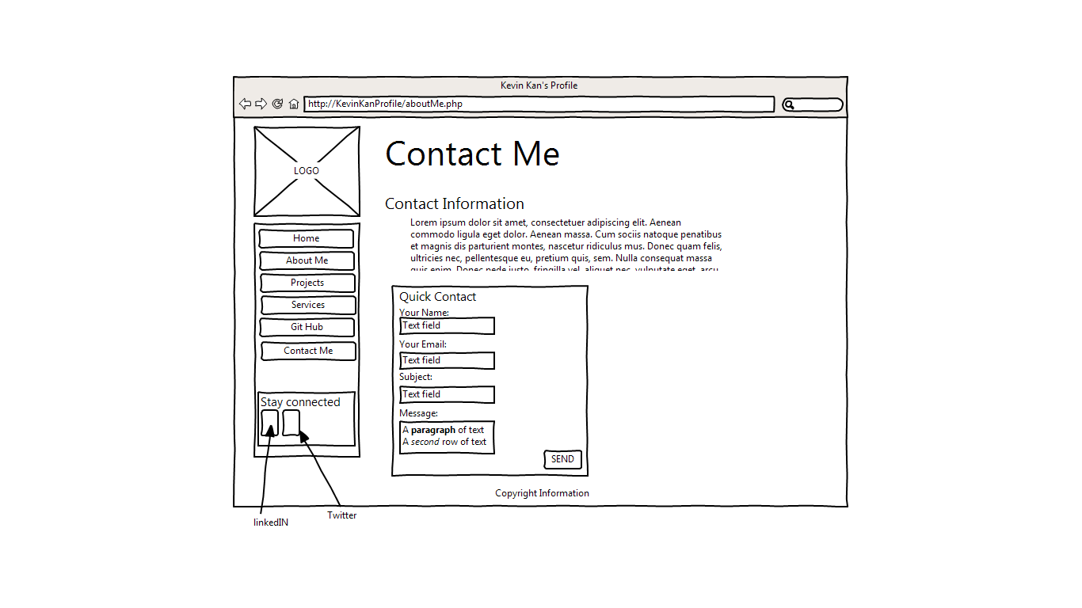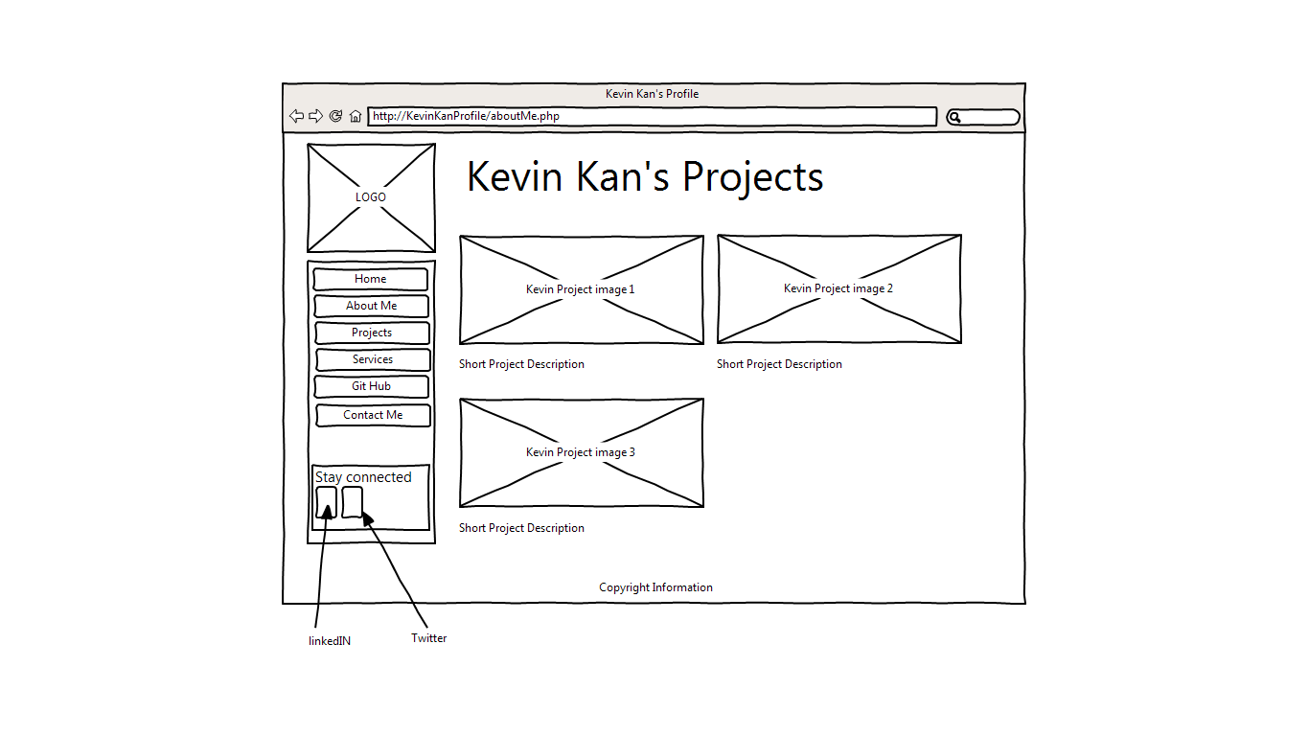

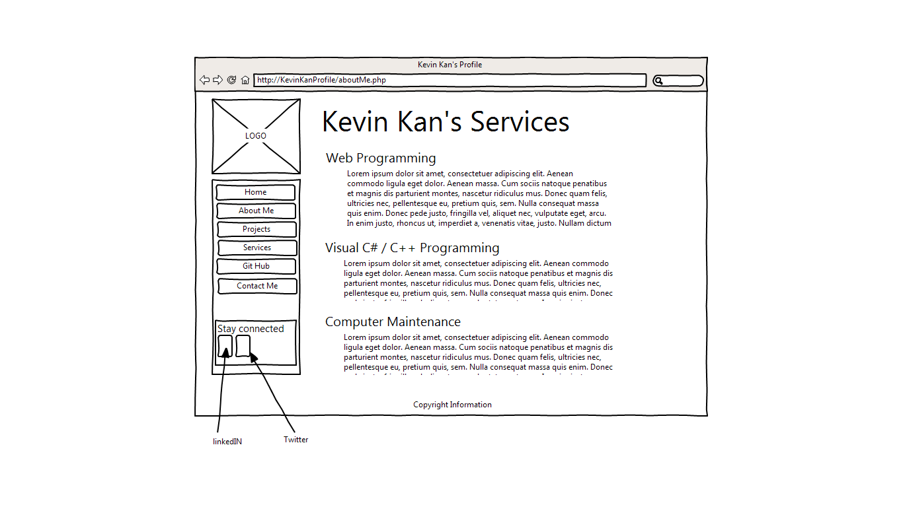

# Branding:

