COMP3025-Mobile and Pervasive Computing Final Project:

Utility App: Swift Alarms



By: Jean-Luc De and Kevin Kan

Written: April 2, 2015

Table of Contents

[App Description: 1](#_Toc416794041)

[Wireframes: 2](#_Toc416794042)

[App Images: 6](#_Toc416794046)

# App Description:

This application is a simple alarm clock. On load there is a programmatic 3 second delay as required by the given request. The app is a standard two tabbed application that uses Core Data library for memory usage.

Users can set one time into memory as an Alarm time. From there, the app will make a noise to alert the user when the current time is the same as the set alarm time. Once the time for the alarm and the local phone time match up then a screen will pop up and an alarm will sound. The alarm will also pull up a new view where it asks the user to “snooze” or “turn off”. Snooze will pause the alarm for a few minutes while turn off will shut off the alarm until the next cycle. There is only one setting in the setting tab. This setting is the clock type setting. It will toggle the clock between 24 hour display and 12 hour display.

# C:\Users\k\AppData\Local\Microsoft\Windows\INetCache\Content.Word\splash_screen.pngWireframes:

# C:\Users\k\AppData\Local\Microsoft\Windows\INetCache\Content.Word\alarms_page.png

# C:\Users\k\AppData\Local\Microsoft\Windows\INetCache\Content.Word\options_page.png

# C:\Users\k\AppData\Local\Microsoft\Windows\INetCache\Content.Word\ringingscreen.png

# App Images:

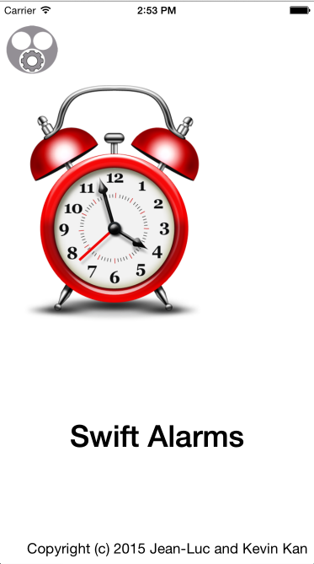

Loading Screen

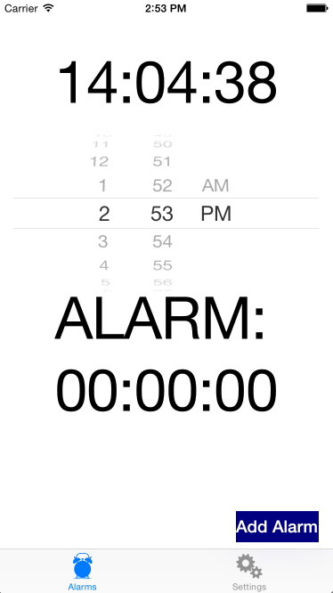

First Screen

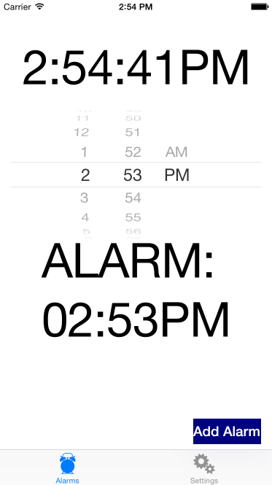

First Screen 12 hour clock

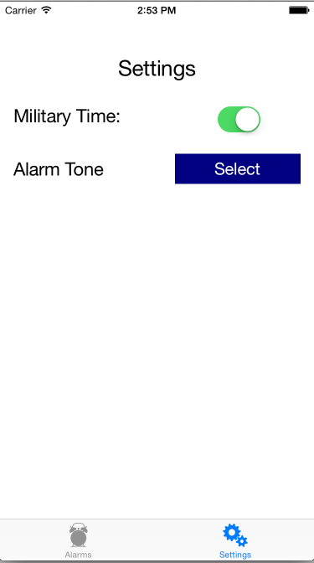

Settings Page

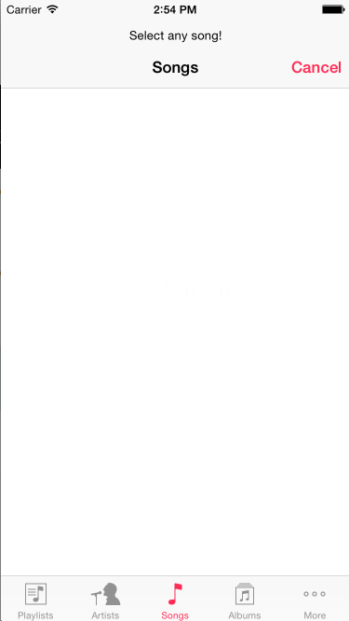

Ring Tone Selection Page.