**COMP1004 – Rapid Application Development Assignment 2: Sharp Auto Center External Documentation**



By Kevin Kan

By: Kevin Kan

Date: Sept. 26 2013

Table of Contents

Application Description: 1

Wire Frame: 1

Code Planning: 1

MultiMedia: 2

# 

# Application Description:

This application calculates the car new purchase value with several additional accessories. It also allows menu access with shortcut keys that can control and affect the form to access the form’s main functions. There are three buttons Calculate, Clear and Exit. The menu includes a ‘File’, ‘Edit’ and ‘Help’ sections. The ‘File’ section contains an option to exit the form. The ‘Edit’ section holds; the ‘Calculate’ option which calculates the value for the purchase vehicle, the ‘Clear’ option clears all optional data (form is totally empty), the Font and Colour option will open a new dialog that allows the user to change the font and colour respectively of the AmountDueTextBox and BasePriceTextBox. The ‘Help’ section has an ‘About’ option which opens up a message box describing the application’s purpose. When the calculation function is activated by either the ‘File’ section of the menu or ‘Calculate’ button, it calculates the total cost of the car with its options minus the trade-in value. Exit will close the program and Clear will clear all selected options and results. All data in the ‘Additional Options’ is pulled from the actual Honda website and the vehicle name is copyright to Honda. The ‘Exterior Finish’ values are all made up for demonstrative purposes.

# Wire Frame:

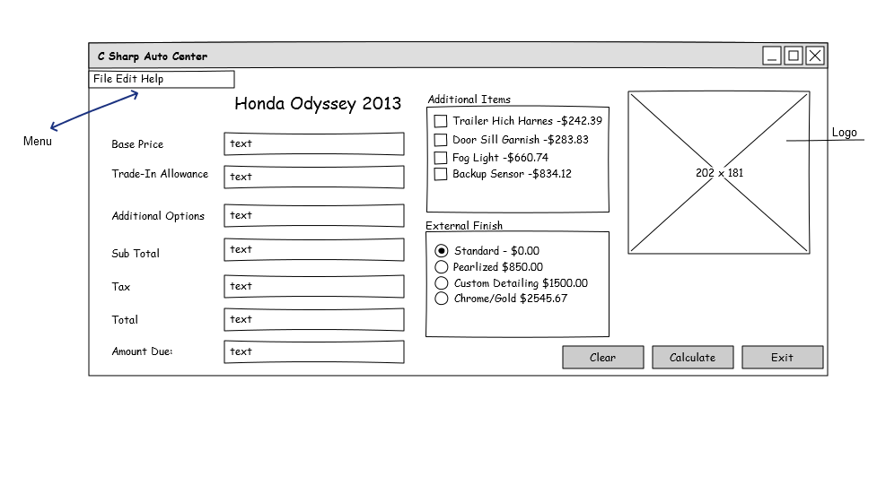

|  |  |  |
| --- | --- | --- |
| **Object** | **Property** | **Setting** |
| CSharpAutoCenterForm | Font | MicroSoft Sans-Serif Size 12 |
|  | StartPosition | CenterScreen |
|  | Size | 1027, 471 |
|  | Text | C Sharp Auto Center |
| MenuStrip | Items | FileStripMenuItem  EditStripMenuItem  HelpStripMenuItem |
| FileStripMenuItem | DropDownItems | ExitToolStripMenuItem |
|  | Text | &File |
| ExitToolStripMenuItem | ShortcutKeys | ALT+Shift+X |
|  | Text | E&xit |
| EditStripMenuItem | DropDownItems | CalculateToolSripMenuItem  ClearToolStripMenuItem  FontToolStripMenuItem  ColourTooStripMenuItem |
|  | Text | &Edit |
| CalculateToolSripMenuItem | ShortcutKeys | ALT+Shift+A |
|  | Text | C&alculate |
| ClearToolStripMenuItem | ShortcutKeys | ALT+Shift+C |
|  | Text | &Clear |
| FontToolStripMenuItem | ShortcutKeys | ALT+Shift+O |
|  | Text | F&ont |
| ColourTooStripMenuItem | ShortcutKeys | ALT+Shift+L |
|  | Text | Co&lour |
| BasePriceLabel | Text | Base Price: |
| BasePriceTextBox | Size | 231, 30 |
| TradeInValueLabel | Text | Trade-In Allowance: |
| TradeInValueTextBox | Size | 231, 30 |
| AdditionalItemsLabel | Text | Additional Items: |
| AdditionalItemsTextBox | Size | 231, 30 |
|  | ReadOnly | True |
| SubTotalLabel | Text | Sub Total: |
| SubTotalTextBox | Size | 231, 30 |
|  | ReadOnly | True |
| TaxLabel | Text | Tax: |
| TaxTextBox | Size | 231, 30 |
|  | ReadOnly | True |
| TotalLabel | Text | Total: |
| TotalTextBox | Size | 231, 30 |
|  | ReadOnly | True |
| AmountDueLabel | Text | Amount Due: |
| AmountDueTextBox | Size | 231, 30 |
|  | ReadOnly | True |
| LogoPictureBox | BackgroundImg | CSharpAutoCenter.Properties.Resources.Yin_Yang_Symbol |
| CarNameLabel | Text | Honda Odyssey 2013 |
| AdditionalOptionGroupBox | Text | Additional Options |
| TrailerHitchCheckBox | Text | Trailer Hitch Harness - $242.39 |
| DoorSillCheckBox | Text | Door Sill Garnish -$283.83 |
| FogLightCheckBox | Text | Fog Lights - $660.79 |
| BackupSensorCheckBox | Text | Backup Sensor - $834.12 |
| ExternalFinishOptionGroupBox | Text | External Finish |
| StandardFinishRadioButton | Text | Standard -$0.00 |
|  | Checked | True |
| PearledFinishRadioButton | Text | Pearled - $850.00 |
| CustomDetailingFinishRadioButton | Text | Custom Detailing -$1500.00 |
| ChromeGoldFinishRadioButton | Text | Chrome/Gold-$2545.67 |
| ClearButton | Text | Clear |
| CalculateButton | Text | Calculate |
| ExitButton | Text | Exit |

# Code Planning:

**Menu File Options Click:**

**Option Exit:** When the exit option is chosen close the form.

**Menu Edit Options Click:**

**Option Calculate:** Get the Additional Options text value, parse it to decimal and add to base cost as given by user (this too must be parsed) save in a variable SubTotalDecimal. Then display SubTotalDecimal in SubTotalTextBox. Take this value and multiply by 0.13 (13% sales tax), save the result in a variable TaxDecimal and display in the TaxTextBox. Take the TaxDecimal value and add to the SubTotalDecimal value and set the text of TotalTextbox to the result. This value then is subtracted by the trade-in value (parsed from TradeInValueTextBox). The end result is displayed into AmountDueTextBox.

**Option Clear:** Reset the form to defaults. Clear all TextBoxes , unselect all checkboxes and reset radio button selected to standard.

**Option Font:** Set the FontDialog.Font to the the AmountDueTextBox and BasePriceTextBox Font property. Open FontDialog in modal form. Then change the AmountDueTextBox and BasePriceTextBox Font Property to the user’s selected font.

**Option Colour:** Set the ColorDialog.Font to the the AmountDueTextBox and BasePriceTextBox BackColor property. Open ColorDialog in modal form. Then change the AmountDueTextBox and BasePriceTextBox BackColor Property to the user’s selected color.

**Menu Help Options Click:**

**Option Help:** Open the AboutMessageBox to display a summary of the program.

**Click on Button ‘Exit’:** Access the File Exit click function.

**Click on Button ‘Calculate’:** Access the Edit Calculate click function.

**Click on Button ‘Clear’:** Access the Edit Clear click function.

**On change of Additional Items/External Finish:** Check which options are chosen and add the appropriate values then display the result in

AdditionalItemsTotalDecimal=0;

For each checkbox in AdditionalOptionsGroupBox

If checkbox is checked

AdditionalItemsTotalDecimal+= checkbox value;

End if

End for each

ExternalFinishDecimal= Radio button selected value from ExternalFinishGroupBox

AdditionalItemsTextBox.Text= AdditionalItemsTotalDecimal + ExternalFinishDecimal

# MultiMedia:

Screen Shot:

Logo: Yin Yang Symbol.jpg