**COMP1004 – Rapid Application Development Assignment 3: Movie Bonanza - External Documentation**



By: Kevin Kan

Date: Nov, 14 2013

Table of Contents

Application Description: 1

Wire Frame: 1

Code Planning: 2

MultiMedia: 3

# 

# Application Description:

This program is a multiform program that simulates a streaming movie program where the user selects a movie from the drop down list. When a movie is selected the appropriate preview will display. The preview will display a movie poster and the cost to “stream” the video. The cost is determined by the movie’s category.

The user may select to go on to the next form only if they made a movie selection (Order Form) which will summarize the previous form’s information and will tabulate a cost for the streaming including tax. The form will also offer a purchase DVD that will add $10 prior to tax calculations. At this point this form will have a cancel button and menu that will cancel the transaction and close the application. This form will also have a menu that prints the summary as well as a stream button and menu item that starts streaming the video. The final menu item is a help -> about option that opens an about box.

If the user decides to proceed with streaming the video, the final form displays and thanks the user for choosing this service. It also says the user will be charged whatever final total was displayed and that the movie (by name) the user selected will begin streaming shortly.

# Wire Frame:

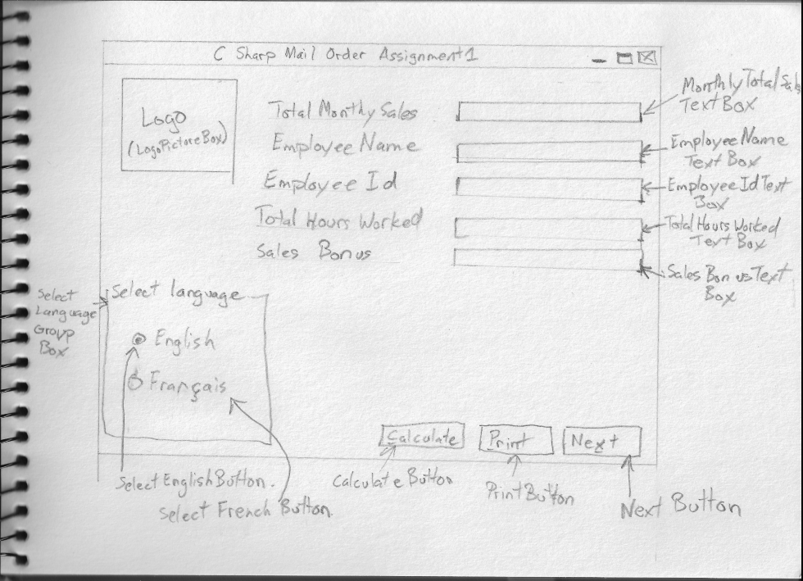

|  |  |  |
| --- | --- | --- |
| **Object** | **Property** | **Setting** |
| Assignmnet1Form | StartPosition | CenterScreen |
|  | Text | C Sharp Mail Order Assignment1 |
| SelectLanguageGroupBox | Text | Select Language |
| SelectEnglishButton | Text | English |
|  | Checked | True |
| SelectFrancaisButton | Text | Francais |
| MonthlyTotalSalesLabel | Text | Total Monthly Sales |
| EmployeeNameLabel | Text | Employee Name |
| EmployeeIdLabel | Text | Employee Id |
| TotalHoursWorkedLabel | Text | Total Hours Worked |
| SalesBonusLabel | Text | Sales Bonus |
| SalesBonusTextBox | BorderStyle | None |
|  | Cursor | Default |
|  | ReadOnly | True |
| CalculateButton | Text | &Calculate |
| PrintButton | Text | &Print |
| NextButton | Text | Ne&xt |

# Code Planning:

*TotalMonthlySalesTextBox_Leave:*

When leave check if data type is valid. If not valid display error warning message that this textbox has invalid data and clear data. Else format the data to currency display.

*TotalHoursWorkedTextBox_Leave:*

When leave check if data type is valid. If not valid display error warning message that this textbox has invalid data and clear data.

*CalculateButton_Click:*

On click check if the total hours worked and monthly sales is correct data type. If it is then,{ perform the calculation of monthly sales times 2% multiplied hours worked divided by 160. Now display the results in the SalesBonusTextBox }

Otherwise set ErrorLable.Text = some appropriate error message

*PrintButton_Click:*

Display print preview.

*NextButton_Click:*

Set EmployeeNameTextBox.Text, EmployeeIdTextBox.Text, TotalHoursWorkedTextBox.Text and SalesBonusTextBox.Text equal to””

*SelectEnglishButton:*

Change all labels and buttons text to English.

*SelectFrancaisButton:*

Change all labels and buttons text to French.

# 

# Multi-Media:

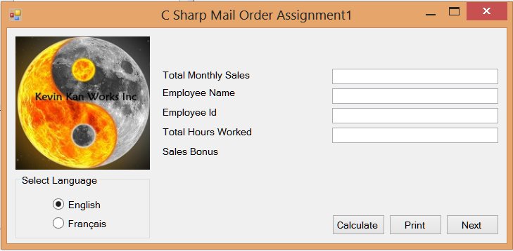Screen Shot:

Logo: Yin Yang Symbol.jpg