**COMP1004 – Rapid Application Development Assignment 4: Movie Bonanza - External Documentation**



By: Kevin Kan

Date: Nov, 28 2013

Table of Contents

Application Description: 1

Wire Frame: 1

Code Planning: 4

MultiMedia: 4

# 

# Application Description:

This program simulates the use of a computer ordering system. The key features of this program include the connection to a database (local file as I can’t use access on the school server so had to add file in as a resource) and the ability to save/load user selections on the product.

Note that in this case there are two pre-existing save files included in the project. They are named after the product id that was chosen in those files. The collection of all data despite none use in the display was intentional as this allows for future expansion.

# Wire Frame:

Splash Page:

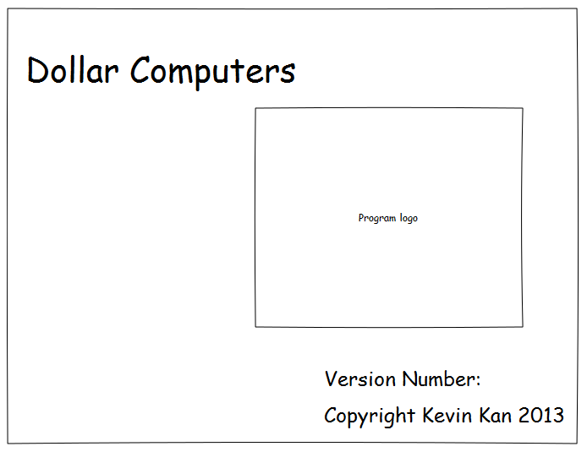

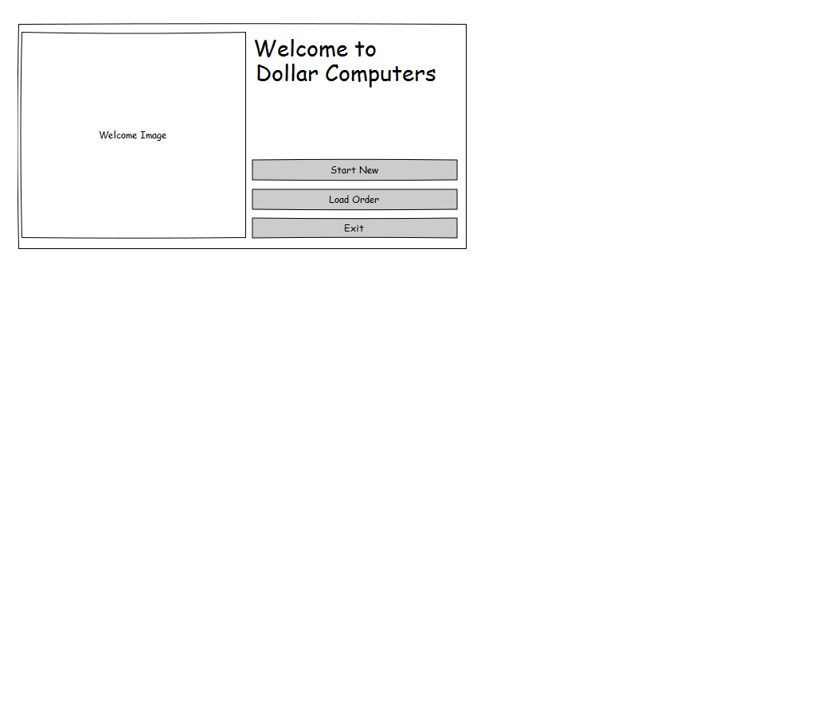Start Form:

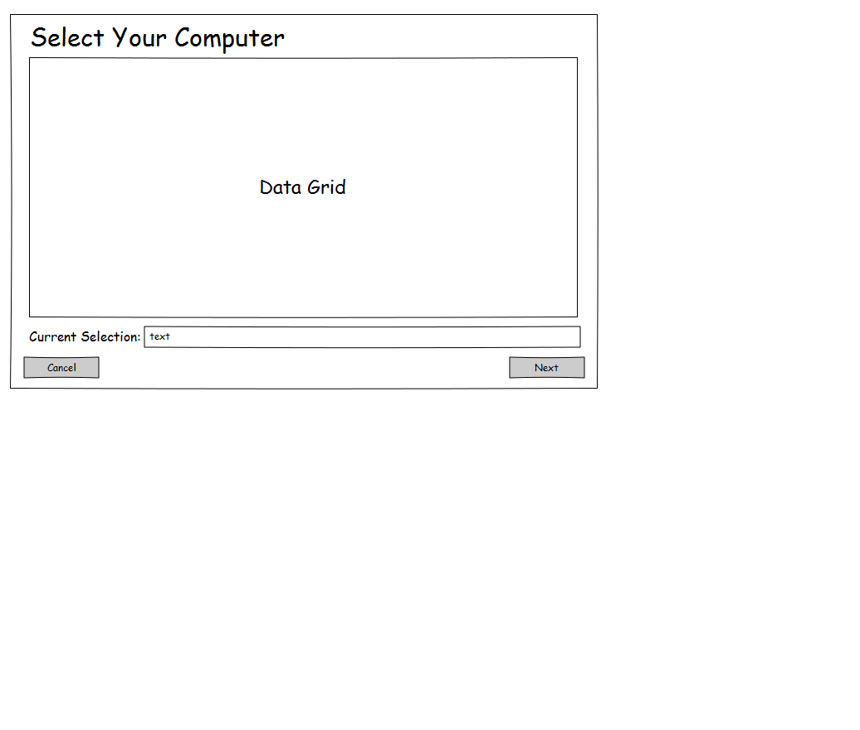Selection Form:

Product Info Form

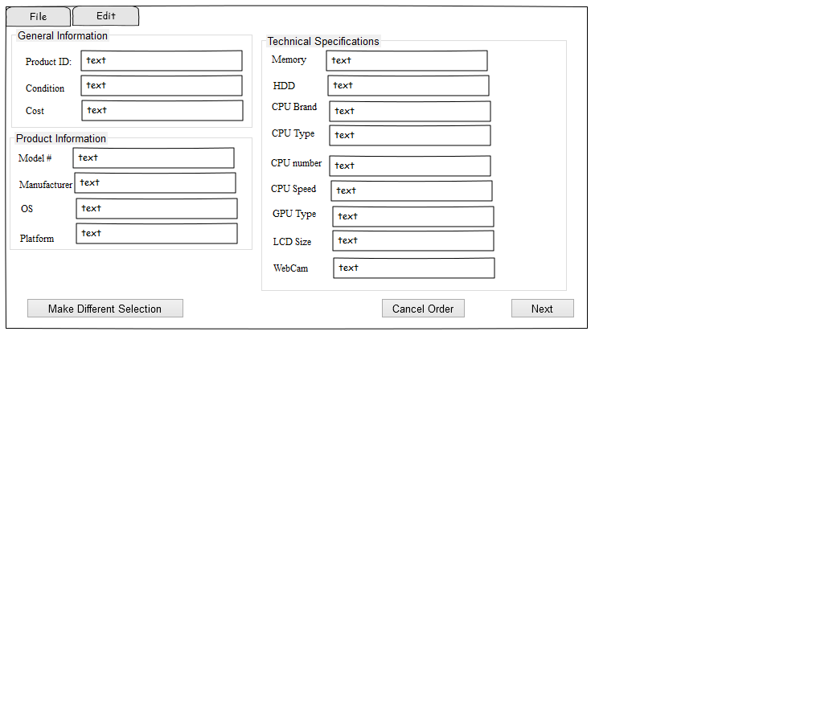

Order Form:

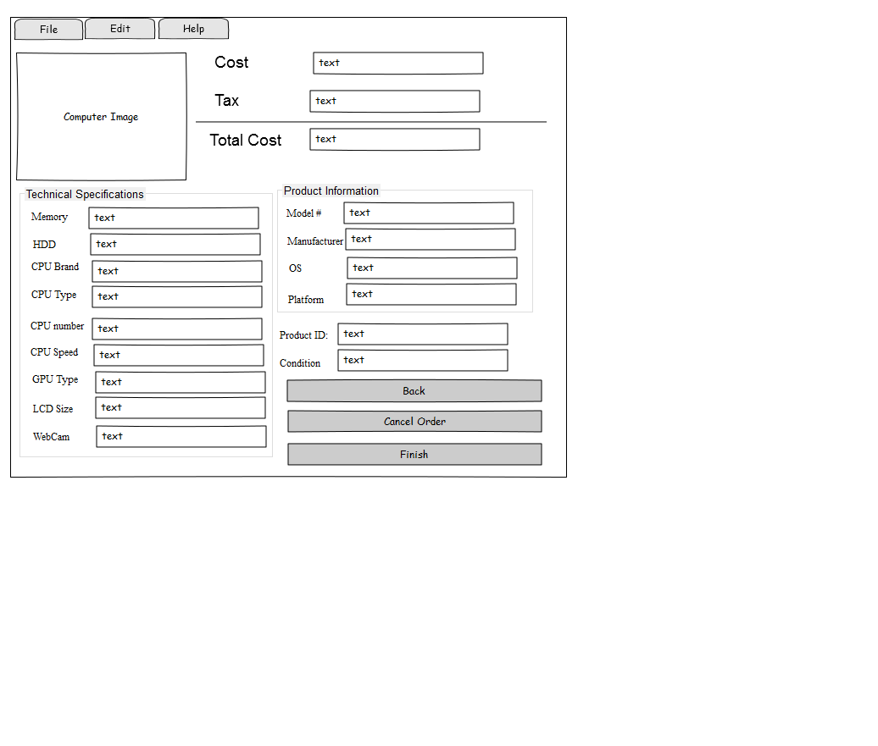

|  |  |  |
| --- | --- | --- |
| **Object** | **Property** | **Setting** |
| All Forms | ControlBox | False |
|  | StartPosition | Center |
| Start Form |  |  |
| WelcomeImagePictureBox | backgroundimage | DollarComputers.Properties.Resources.StartLogo |
| WelcomeLabel | Text | Welcome To |
|  | Font | Microsoft Sans Serif, 16.2pt |
| CompanyLabel | Text | Dollar Computers |
|  | Font | Microsoft Sans Serif, 16.2pt |
| LoadOrderButton | Text | Load Order |
| NewOrderButton | Text | New Order |
| ExitButton | Text | Exit |
|  |  |  |
| SelectForm |  |  |
| HardwarSelectLabel | Text | Please Choose a Model From Below |
|  | Font | Microsoft Sans Serif, 16.2pt |
| SelectionDataGridView | ReadOnly | True |
|  | SelectionMode | FullRowSelect |
| ModelChoosenLabel |  |  |
|  | Text | Please Choose a Model From Below |
|  | Font | Microsoft Sans Serif, 16.2pt |
|  |  |  |
| ModelChoosenTextBox | Text | Please Choose a Model From Below |
|  | Font | Microsoft Sans Serif, 16.2pt |
|  | ReadOnly | True |
|  |  |  |
| NextButton | Text | &Next |
|  | Font | Microsoft Sans Serif, 16.2pt |
| CancelButton | Text | &Cancel |
|  | Font | Microsoft Sans Serif, 16.2pt |
|  |  |  |
| ProductInfoForm |  |  |
| All TextBoxes | Font | Microsoft Sans Serif, 16.2pt |
|  | ReadOnly | True |
| ALL Labels/GroupBoxes | Font | Microsoft Sans Serif, 16.2pt |
| OrderForm |  |  |
| All TextBoxes | Font | Microsoft Sans Serif, 16.2pt |
|  | ReadOnly | True |
| ALL Labels/GroupBoxes | Font | Microsoft Sans Serif, 16.2pt |
|  |  |  |
|  |  |  |

# Code Planning:

*Form passing data*

Start form will instantiate both SelectForm and ProductInfoForm and pass these locations to the opposite form. (ProductInfoForm will be passed SelectForm and vice versa). Both SelectForm and ProductInfoForm will pass selected data back and forth.

*SelectForm DataGridView MouseClick*

When anything is clicked on the data grid view, save the row clicked parse it into an array to send to later forms.

*ProductForm Activated Form*

When the form is activated place respective data to correct text boxes

*OrderForm ActivatedForm*

Simular to ProductForm

# Multi-Media:

Screen Shots:

Splash Page

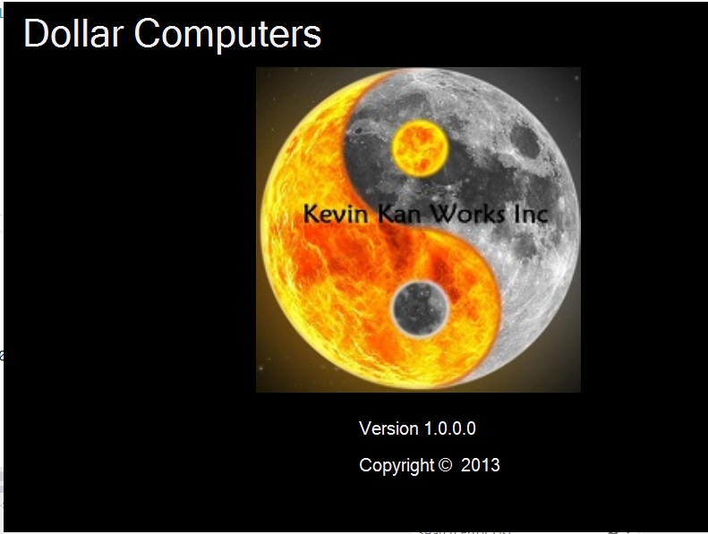

Start Form

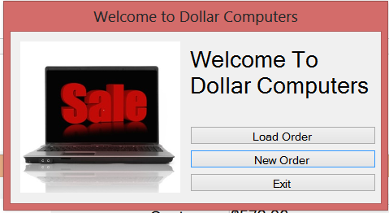

SelectForm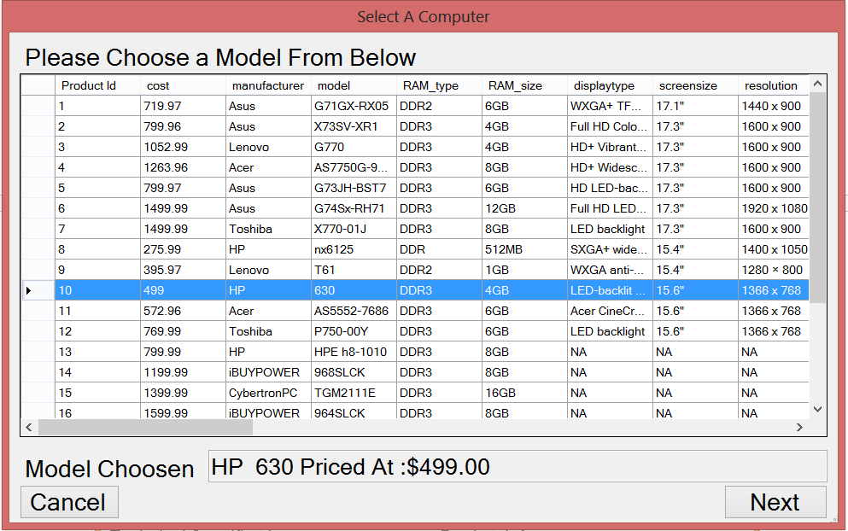

ProductForm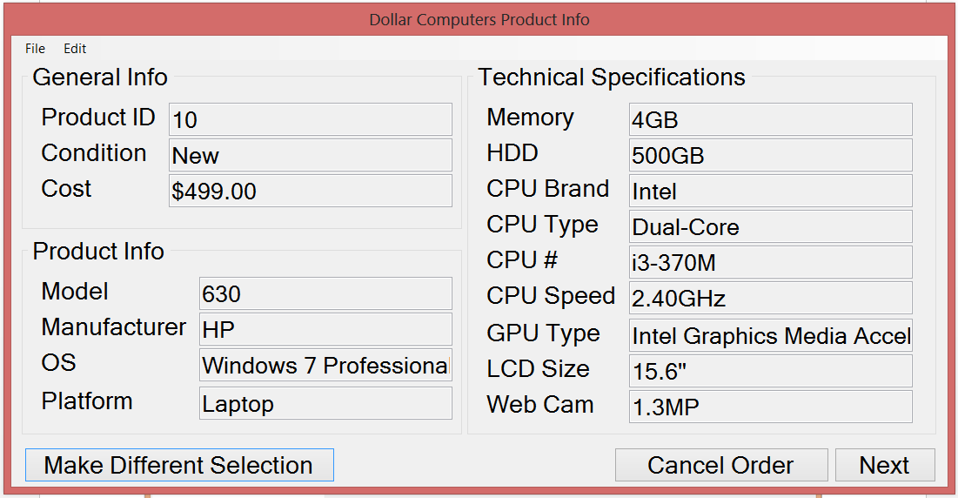

OrderForm

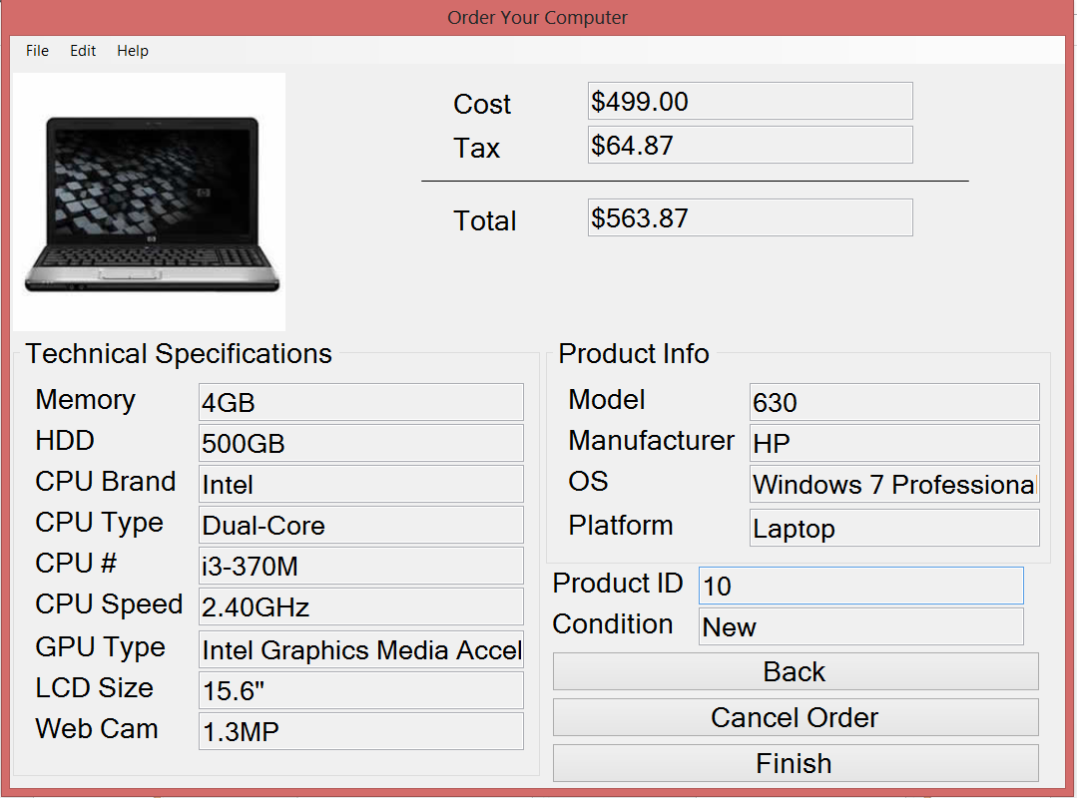

Logo: Yin Yang Symbol.jpg

Project Icon:

Other Media used was supplied by Instructor.