Encorb Website Content & UX Review

Increase the font size and visual prominence of the Encorb wordmark and the primary navigation labels in the main header. This will strengthen brand visibility and improve the header's typographic hierarchy.

Add a continuous horizontal ticker animation so the index bar behaves like a live market-data feed, similar to stock-price tickers used on financial exchanges. A smooth, looping motion would reinforce the concept of a dynamic commodity marketplace.

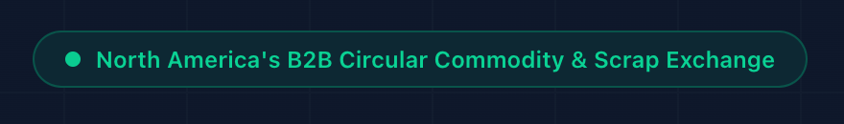
Increase the font size and visual emphasis of this positioning statement. I also recommend testing several alternative taglines. The term 'scrap' can carry a low-value or negative connotation; because this is the first section that positions Encorb as an 'exchange,' the language should communicate a professional, technology-enabled circular commodities marketplace. Consider alternatives such as 'Circular Materials Exchange,' 'Industrial Materials Exchange,' or 'B2B Circular Commodity Exchange.' The current typography and color treatment do not give this important message sufficient impact. A subtle entrance or text animation could further strengthen the hero-section value proposition.


If feasible, add a subtle text or reveal animation to this headline. We should also consider replacing 'scrap' with terminology such as 'industrial materials,' 'recoverable materials,' 'secondary materials,' or 'circular commodities' to better reflect the platform's value proposition and maintain a more professional tone.

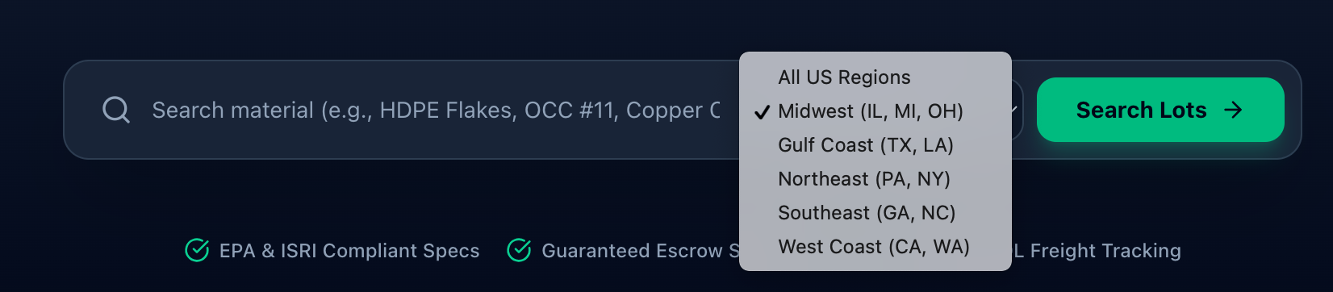

In addition to the regional filter, add a dedicated State filter. The current regional dropdown lists only two or three example states in parentheses, which may unintentionally imply that Encorb operates only in those states. Providing separate Region and State filters would improve search granularity and make the geographic coverage clearer. Users should be able to filter by either region or individual state, depending on their search requirements.

Change the text to white or another high-contrast treatment to improve legibility against the dark background and maintain visual consistency. Also consider replacing the abbreviation 'BOL' with 'Bill of Lading (BOL)' on first use, or with a more user-friendly logistics descriptor, so users who are unfamiliar with industry terminology can understand the feature immediately.

- 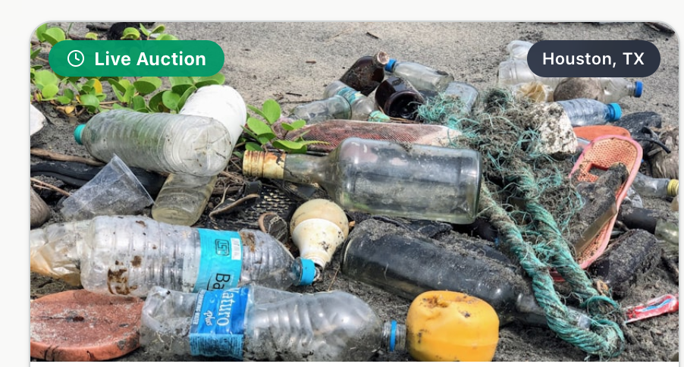
Replace this image with a cleaner, higher-quality visual that is more consistent with the site's overall industrial and professional design language. The current image appears visually cluttered and does not align well with the aesthetic of the surrounding marketplace imagery.

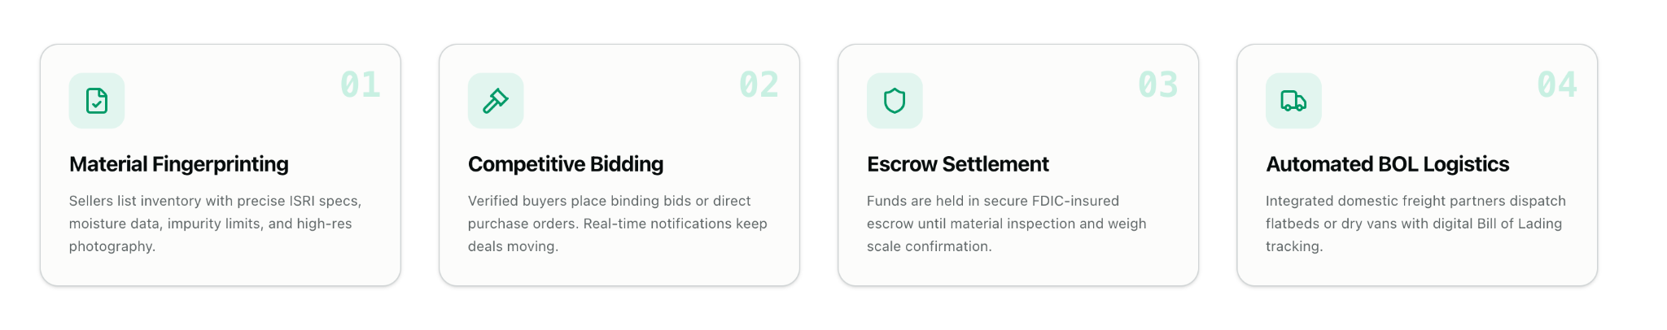
Add subtle micro-animations to each workflow step and introduce slightly stronger visual differentiation across the cards while maintaining the existing design system. Consider using consistent, colored representative icons or small illustrations in the upper-left area of each card. This would improve scanability, reinforce the meaning of each step, and make the four-stage workflow feel more interactive without creating unnecessary visual complexity.


This is a strong section title and represents an important differentiating capability of the platform. Increase its font size, weight, and visual prominence so that 'Environmental & Economic Intelligence' reads as a major product feature rather than a secondary label.


Center-align this text block within the section to improve visual balance and maintain consistency with the alignment and composition used elsewhere on the page.

Rephrase this sentence to make the value proposition more concise and technically precise. Suggested copy: 'Quantify the economic value recovered and verified Scope 3 emissions reductions generated by your industrial material streams through Encorb.'

12.
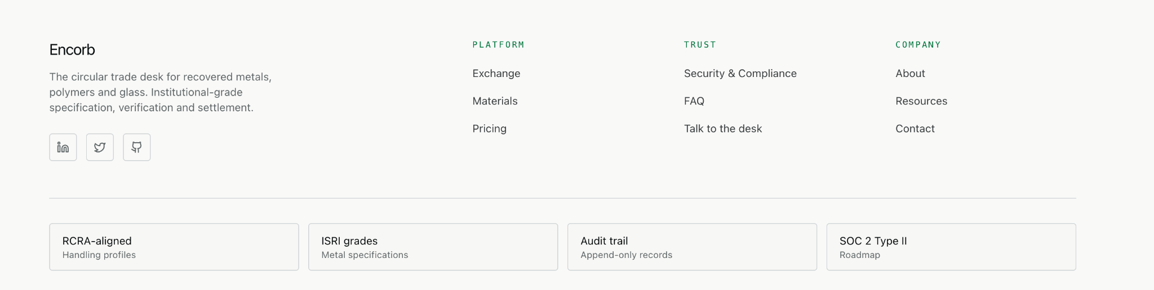
The footer currently feels visually understated relative to the rest of the site. Introduce a stronger footer treatment using the established brand palette, subtle background contrast, clearer section separation, and improved typographic hierarchy. This would create a more intentional visual endpoint to the page while preserving readability.

13. Marketplace page: Overall, the page is strong. Consider adding a State filter in addition to the existing Region filter to provide more granular geographic search and avoid ambiguity regarding Encorb's market coverage.

14. Materials, About, and FAQ pages: The overall content is strong, but the visual presentation is relatively minimal compared with the main marketplace experience. Consider introducing additional branded section containers, subtle color accents, stronger content hierarchy, and varied but consistent background treatments to improve visual engagement while maintaining a cohesive design system across the site.

