**Packet Tracer - Designing and Implementing a VLSM Addressing Scheme**

**Addressing Table**

|  |  |  |  |  |
| --- | --- | --- | --- | --- |
| **Device** | **Interface** | **IP Address** | **Subnet Mask** | **Default Gateway** |
| Remote-Site1 | G0/0 | 10.11.48.97 | 255.255.255.240 | N/A |
| G0/1 | 10.11.48.65 | 255.255.255.224 | N/A |
| S0/0/0 | 10.11.48.121 | 255.255.255.252 | N/A |
| Remote-Site2 | G0/0 | 10.11.48.113 | 255.255.255.248 | N/A |
| G0/1 | 10.11.48.1 | 255.255.255.192 | N/A |
| S0/0/0 | 10.11.48.122 | 255.255.255.252 | N/A |
| Sw1 | VLAN 1 | 10.11.48.98 | 255.255.255.240 | 10.11.48.97 |
| Sw2 | VLAN 1 | 10.11.48.66 | 255.255.255.224 | 10.11.48.65 |
| Sw3 | VLAN 1 | 10.11.48.114 | 255.255.255.248 | 10.11.48.113 |
| Sw4 | VLAN 1 | 10.11.48.2 | 255.255.255.192 | 10.11.48.1 |
| User-1 | NIC | 10.11.48.110 | 255.255.255.240 | 10.11.48.97 |
| User-2 | NIC | 10.11.48.94 | 255.255.255.224 | 10.11.48.65 |
| User-3 | NIC | 10.11.48.118 | 255.255.255.248 | 10.11.48.113 |
| User-4 | NIC | 10.11.48.62 | 255.255.255.192 | 10.11.48.1 |

**Objectives**

**Part 1: Examine the Network Requirements**

**Part 2: Design the VLSM Addressing Scheme**

**Part 3: Assign IP Addresses to Devices and Verify Connectivity**

**Background**

In this activity, you are given a /24 network address to use to design a VLSM addressing scheme. Based on a set of requirements, you will assign subnets and addressing, configure devices and verify connectivity.

**Part 1:**   **Examine the Network Requirements**

**Step 1:**     **Determine the number of subnets needed. Ans: 5**

You will subnet the network address 10.11.48.0/24. The network has the following requirements:

•         **Sw1** LAN will require **14** host IP addresses

•         **Sw2** LAN will require **30** host IP addresses

•         **Sw3** LAN will require **6** host IP addresses

•         **Sw4** LAN will require **60** host IP addresses

How many subnets are needed in the network topology?

**Step 2:**     **Determine the subnet mask information for each subnet.**

1. Which subnet mask will accommodate the number of IP addresses required for **Sw1**?

Ans: 255.255.255.240

How many usable host addresses will this subnet support?

Ans: 14

1. Which subnet mask will accommodate the number of IP addresses required for **Sw2**?

Ans: 255.255.255.224

How many usable host addresses will this subnet support?

Ans: 30

1. Which subnet mask will accommodate the number of IP addresses required for **Sw3**?

Ans: 255.255.255.248

How many usable host addresses will this subnet support?

Ans: 6

1. Which subnet mask will accommodate the number of IP addresses required for **Sw4**?

Ans: 255.255.255.192

How many usable host addresses will this subnet support?

60

1. Which subnet mask will accommodate the number of IP addresses required for the connection between **Remote-Site1** and **Remote-Site2**?

Ans: 255.255.255.252

**Part 2:**   **Design the VLSM Addressing Scheme**

**Step 1:**     **Divide the 10.11.48.0/24 network based on the number of hosts per subnet.**

a.     Use the first subnet to accommodate the largest LAN.

b.    Use the second subnet to accommodate the second largest LAN.

c.     Use the third subnet to accommodate the third largestLAN.

d.    Use the fourth subnet to accommodate the fourth largestLAN.

e.     Use the fifth subnet to accommodate the connection between **Remote-Site1**and**Remote-Site2**.

**Step 2:**     **Document the VLSM subnets.**

Complete the **Subnet Table**,listing the subnet descriptions (e.g. Sw1 LAN), number of hosts needed, then network address for the subnet, the first usable host address, and the broadcast address. Repeat until all addresses are listed.

**Subnet Table**

|  |  |  |  |  |
| --- | --- | --- | --- | --- |
| **Subnet Description** | **Number of Hosts Needed** | **Network Address/CIDR** | **First Usable Host Address** | **Broadcast Address** |
| Sw4 | 60 | 10.11.48.0/26 | 10.11.48.1/26 | 10.11.48.63/26 |
| Sw2 | 30 | 10.11.48.64/27 | 10.11.48.65/27 | 10.11.48.95/27 |
| Sw1 | 14 | 10.11.48.96/28 | 10.11.48.97/28 | 10.11.48.111/28 |
| Sw3 | 6 | 10.11.48.112/29 | 10.11.48.113/29 | 10.11.48.119/29 |
| Remote Site1-Remote Site2 | 2 | 10.11.48.120/30 | 10.11.48.121/30 | 10.11.48.123/30 |

**Step 3:**     **Document the addressing scheme.**

a.     Assign the first usable IP addresses to **Remote-Site1** for the two LAN links and the WAN link.

b.    Assign the first usable IP addresses to **Remote-Site2** for the two LANs links. Assign the last usable IP address for the WAN link.

c.     Assign the second usable IP addresses to the switches.

d.    Assign the last usable IP addresses to the hosts.

**Part 3:**   **Assign IP Addresses to Devices and Verify Connectivity**

Most of the IP addressing is already configured on this network. Implement the following steps to complete the addressing configuration.

**Step 1:**     **Configure IP addressing on Remote-Site1 LAN interfaces.**

**Step 2:**     **Configure IP addressing on Sw3, including the default gateway.**

**Step 3:**     **Configure IP addressing on User-4, including the default gateway.**

**Step 4:**     **Verify connectivity.**

You can only verify connectivity from Remote-Site1, Sw3, and User-4. However, you should be able to ping every IP address listed in the **Addressing Table**.

ID:

**Network:**

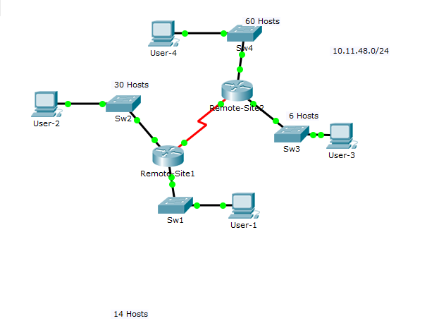

**Completion Status:**

