# Q

import Reinforcement_learning

|  |  |  |
| --- | --- | --- |
| Algorithm | Average number of explorations(all time/  Post half time) | Frequency of exploration |
| Q-Learning | 5.04/ |  |
| Sarsa | 12.55/ |  |
| DQN | 21.25/6.6 |  |
| Doubel DQN | 36.38/ 8.82 |  |
| PERDQN | 50.17/27 |  |
| DuelingDQN | 64.82/29 |  |

All result base on Maze

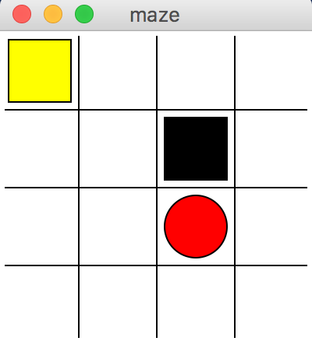

## Q-Learing

### Base

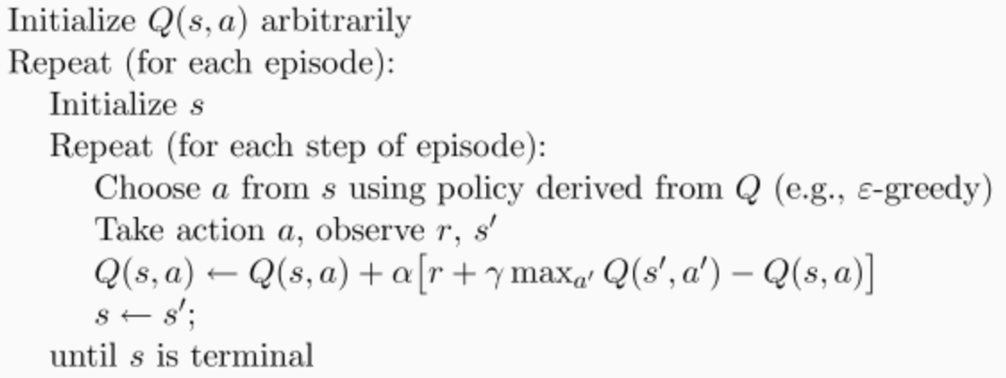

### Object Initialization

from Reinforcement_learning import Q_Learning

Object Initialization

RL = Q_Learning(actions=list(range(n_actions)))

Input: The size of Actions set

### choose_action()

action = RL.choose_action(str(observation))

Input: state observation

Ouput: action

### learn()

RL.learn(str(observation), action, reward, str(observation_))

Input: state observation, action, reward, next state observation

Ouput: null

### Example

import sys

import os

from Reinforcement_learning import Q_Learning

from Reinforcement_learning import Maze

def update():

for episode in range(100):

# initial observation

observation = env.reset()

while True:

# fresh env

env.render()

# RL choose action based on observation

action = RL.choose_action(str(observation))

# RL take action and get next observation and reward

observation_, reward, done = env.step(action)

# RL learn from this transition

RL.learn(str(observation), action, reward, str(observation_))

# swap observation

observation = observation_

# break while loop when end of this episode

if done:

break

# end of game

print('game over')

env.destroy()

if __name__ == "__main__":

env = Maze()

RL = Q_Learning(actions=list(range(env.n_actions)))

env.after(100, update)

env.mainloop()

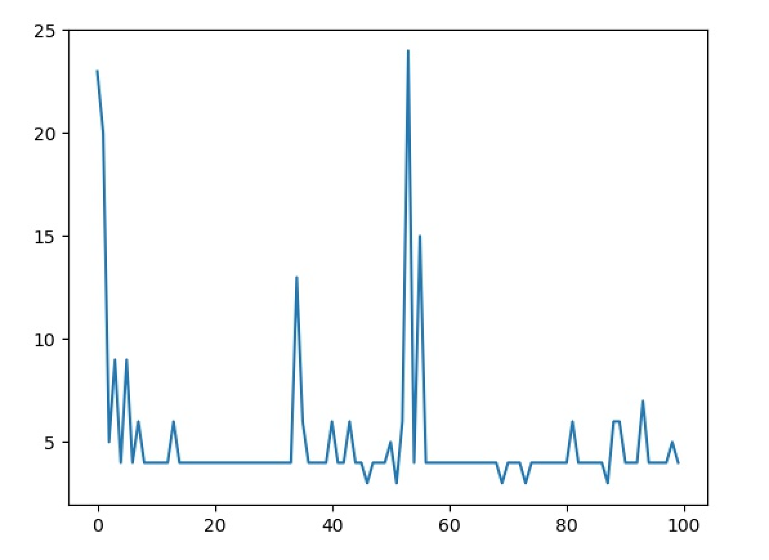

## SARSA

### Base

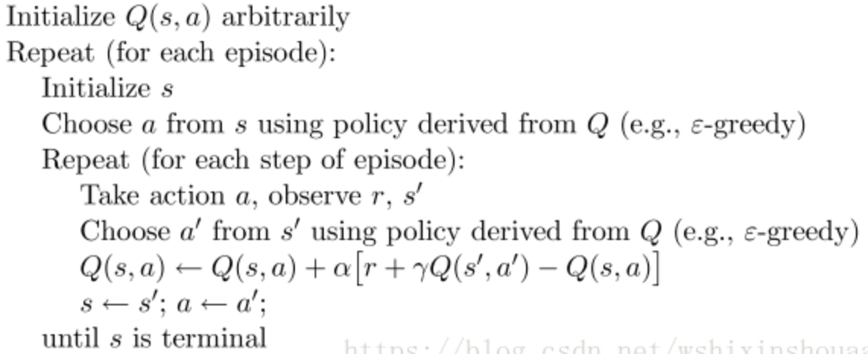

### Object Initialization

RL = SARSA(actions=list(range(env.n_actions)))

### choose_action()

action = RL.choose_action(str(observation))

Input: state observation

Ouput: action

### Learn

RL.learn(str(observation), action, reward, str(observation_))

Input: state observation, action, reward, next state observation

Ouput: null

### Example

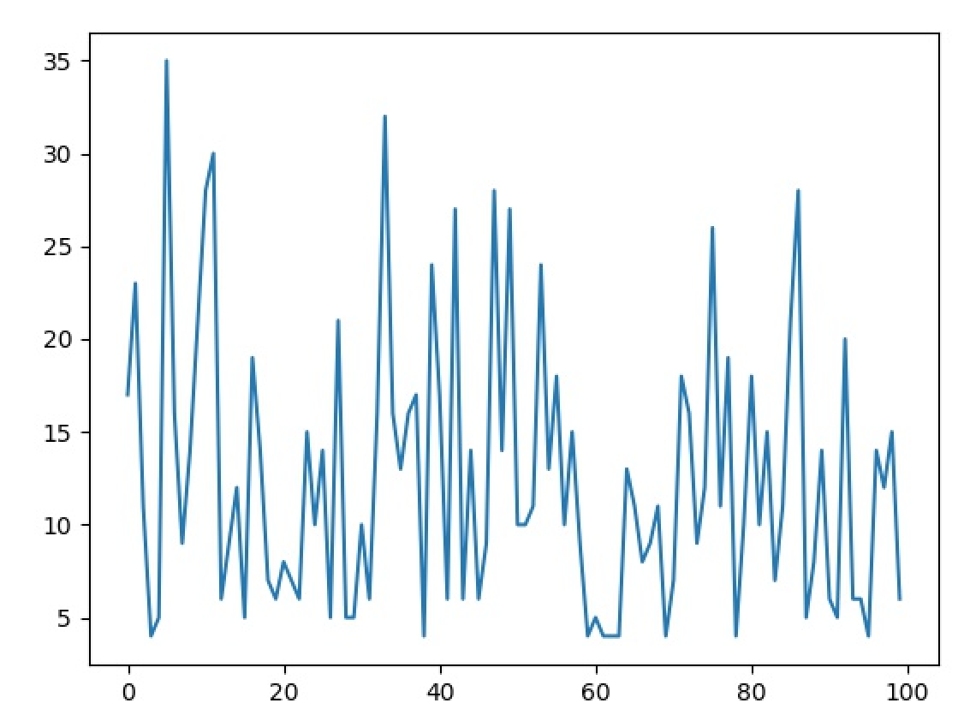

## DQN

### Base

### Object Initialization

RL = DQN(env.n_actions, env.n_features,

learning_rate=0.01,

reward_decay=0.9,

e_greedy=0.9,

replace_target_iter=200,

memory_size=2000,

# output_graph=True

)

### choose_action()

action = RL.choose_action(observation)

### store_transition

RL.store_transition(observation, action, reward, observation_)

### Learn

RL.learn()

### Example

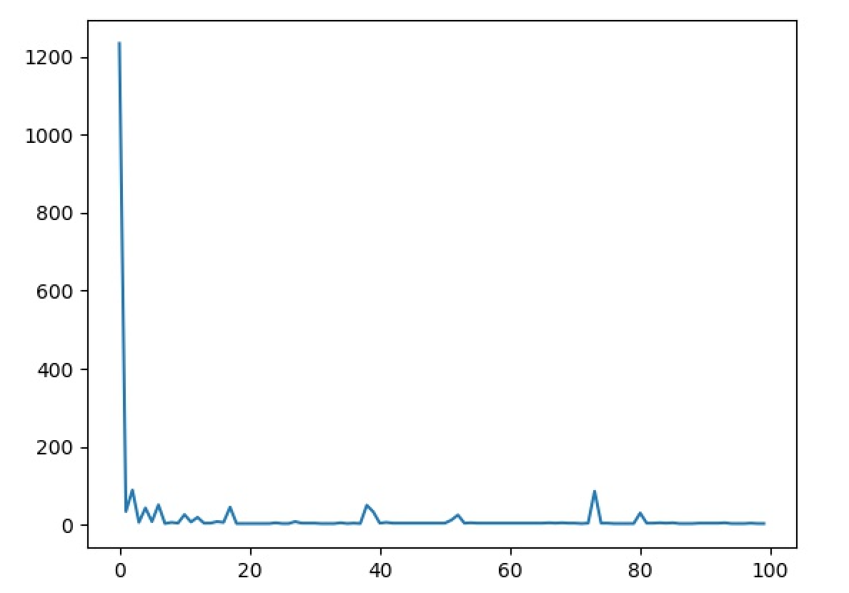

## DDQN

### Base

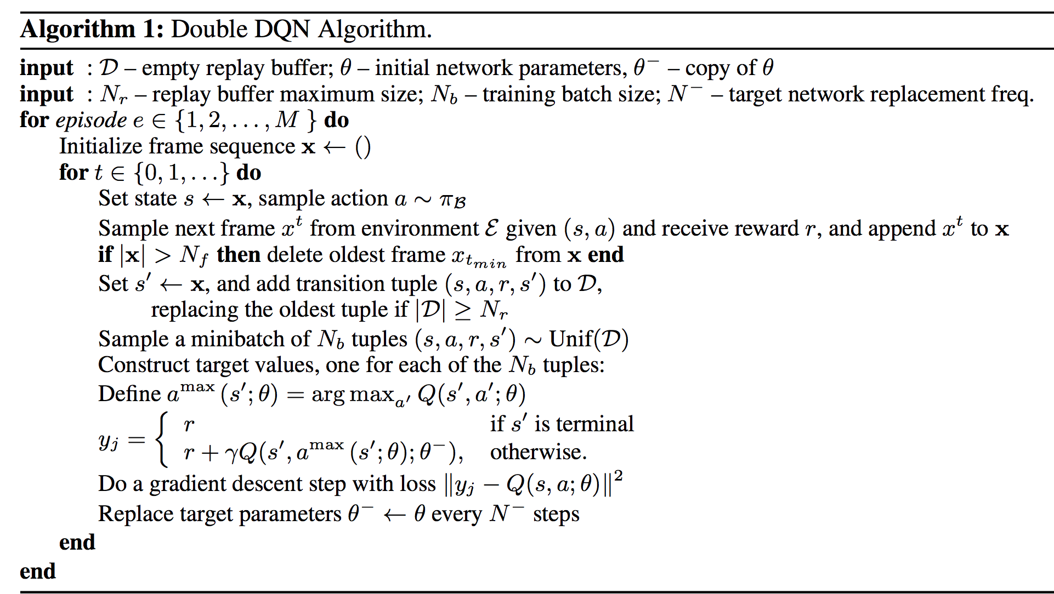

### Object Initialization

RL = DQN(env.n_actions, env.n_features,

learning_rate=0.01,

reward_decay=0.9,

e_greedy=0.9,

replace_target_iter=200,

memory_size=2000,

# output_graph=True

)

### choose_action()

action = RL.choose_action(observation)

### store_transition

RL.store_transition(observation, action, reward, observation_)

### Learn

RL.learn()

### Example

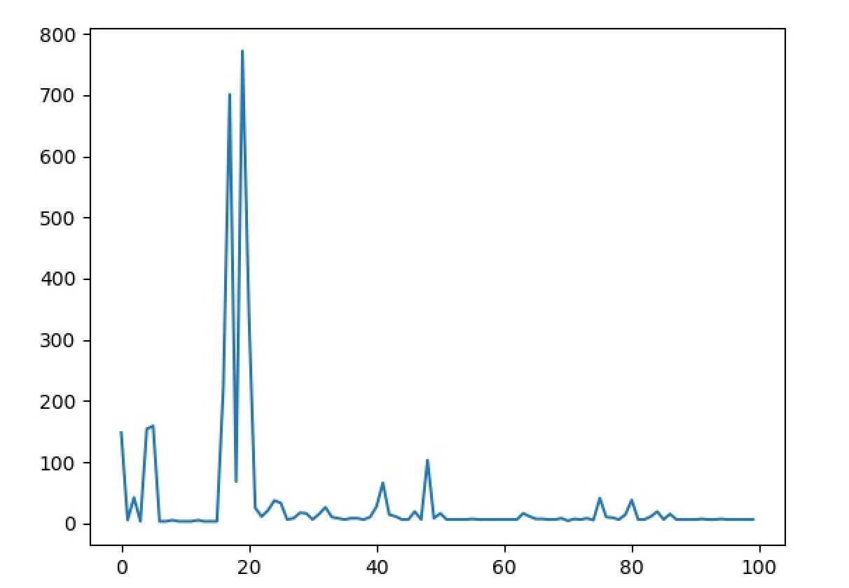

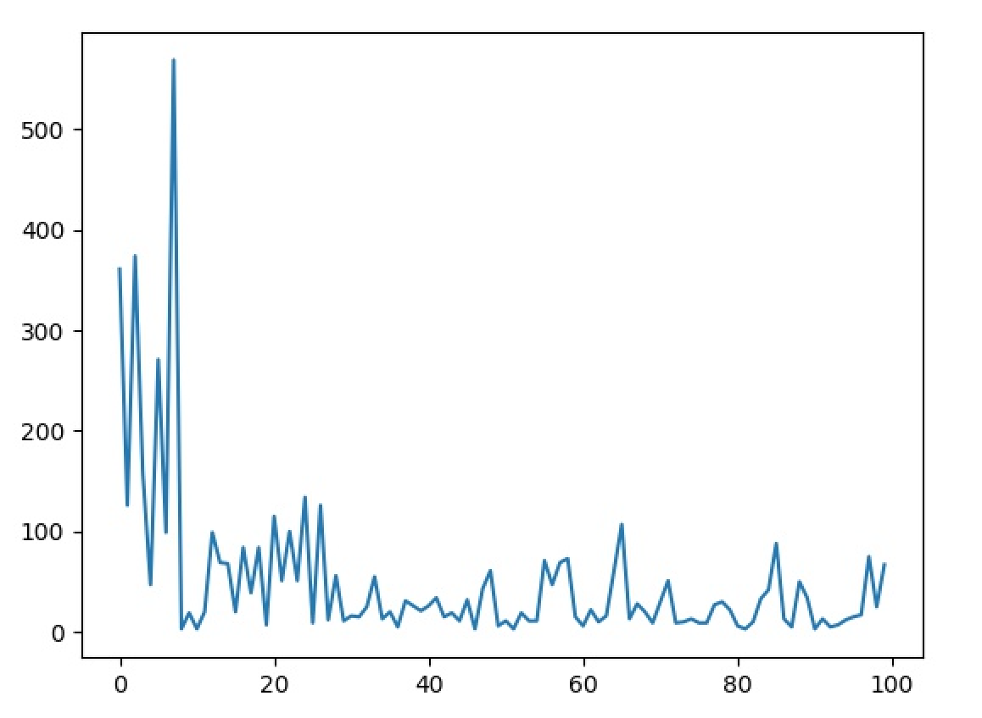

## Dueling DQN

## PERDQN.py

# P

import Reinforcement_learning

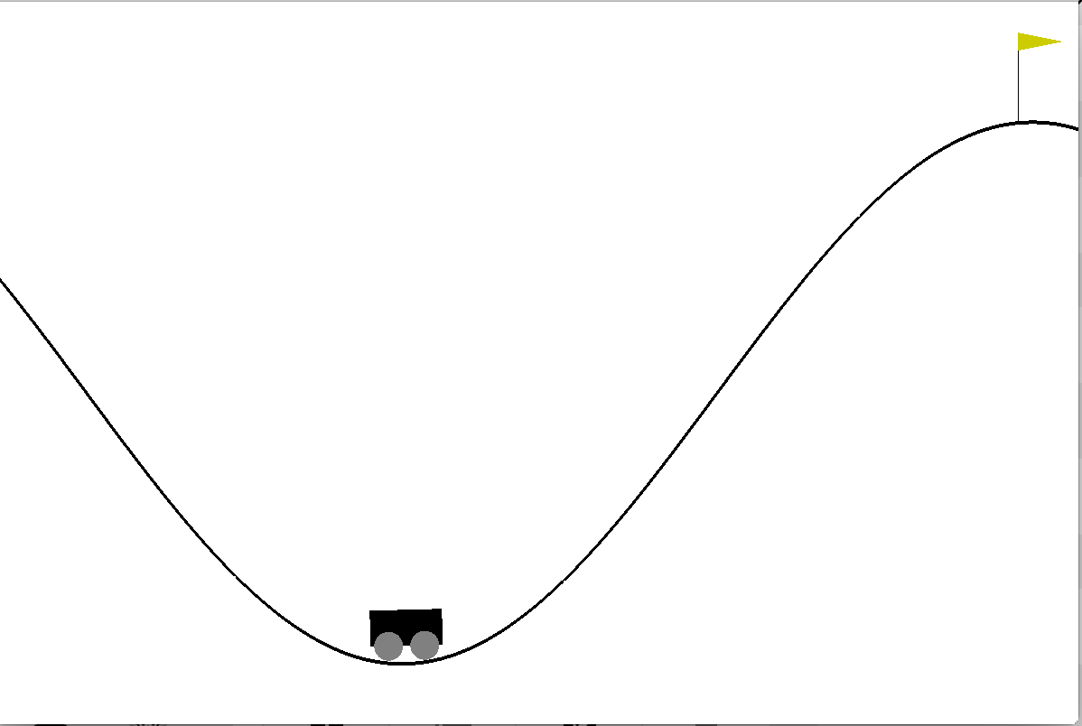

## PolicyGradient

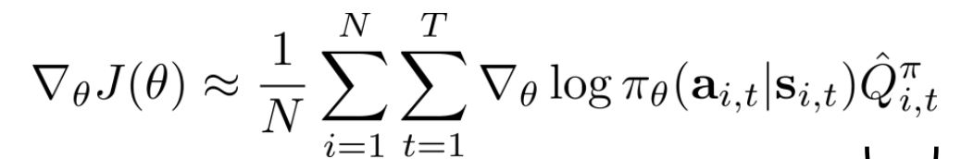

## ActorCritic