Name: Bryce Hendrickson Mark _____________________/50

[**Instructions**: Remove everything that is not a heading below and fill in with your own diagrams, etc.]

## Brief introduction __/3

My feature for the Zombie Dog Outbreak 2 game is the character control, movement, design, animation, and weapon control and interactions.

My job is to create a character sprite equipped with responsive movement and attack(melee) functions that will interact with the enemies in the game. I will also be responsible for controlling player health when attacked. As well as the BC character mode (character subclass) that cannot die and will have different animations based off when they should be dead.

## Use case diagram with scenario __14

### Use Case Diagram

Scenario:

Name: Melee

Summary: The character activates the melee attack.

Actors: Character

Preconditions: player has been initialized.

Basic sequence:

Step 1: Input melee button

Step 2: Check for player motion and enemy detection

Exceptions:

(1)

Step 1: Character is moving toward enemy in range

Step 2: Character lunges with hit animation

(2)

Step 1: character is not moving toward an enemy in range

Step 2: Checks for collision with enemy

Step 3: Plays associated melee animation

Post conditions: Character returns to previous animation / state.

Priority: 2*

ID: MC1

*The priorities are1 = must have, 2 = essential, 3 = nice to have.

## Data Flow diagram(s) from Level 0 to process description for your feature _______14

[Get the Level 0 from your team. Highlight the path to your feature]

Example:

### Data Flow Diagrams

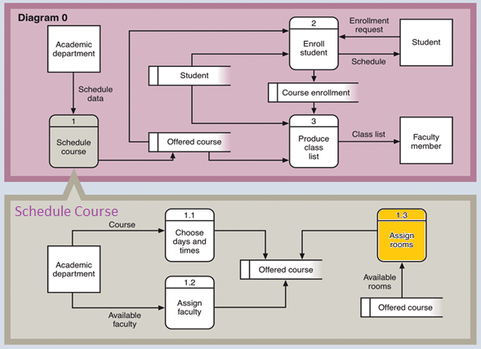

### Process Descriptions

Assign rooms*:

WHILE teacher in two places at once OR two classes in the same room

Randomly redistribute classes

END WHILE

**\*Notes**: Yours should be much longer. You could use a decision tree or decision table instead if it is more appropriate.

## Acceptance Tests ________9

[Describe the inputs and outputs of the tests you will run. Ensure you cover all the boundary cases.]

**Example for random number generator feature**

Run feature 1000 times sending output to a file.

The output file will have the following characteristics:

* Max number: 9
* Min number: 0
* Each digit between 0 and 9 appears at least 50 times
* No digit between 0 and 9 appears more than 300 times
* Consider each set of 10 consecutive outputs as a substring of the entire output. No substring may appear more than 3 times.

**Example for divide feature**

|  |  |  |  |
| --- | --- | --- | --- |
| Output | Numerator  (int) | Denominator  (int) | Notes |
| 0.5 | 1 | 2 |  |
| 0.5 | 2 | 3 | We only have 1 bit precision for outputs. Round all values to the nearest .5 |
| 0.0 | 1 | 4 | At the 0.25 mark always round to the nearest whole integer |
| 1.0 | 3 | 4 | At the 0.75 mark always round to the nearest whole integer |
| 255.5 | 5 | 0 | On divide by 0, do not flag an error. Simply return our MAX_VAL which is 255.5. |

## Timeline _________/10

[Figure out the tasks required to complete your feature]

Example:

### Work items

|  |  |  |
| --- | --- | --- |
| Task | Duration (PWks) | Predecessor Task(s) |
| 1. Requirements Collection | 5 | - |
| 2. Screen Design | 6 | 1 |
| 3. Report Design | 6 | 1 |
| 4. Database Construction | 2 | 2, 3 |
| 5. User Documentation | 6 | 4 |
| 6. Programming | 5 | 4 |
| 7. Testing | 3 | 6 |
| 8. Installation | 1 | 5, 7 |

### Pert diagram

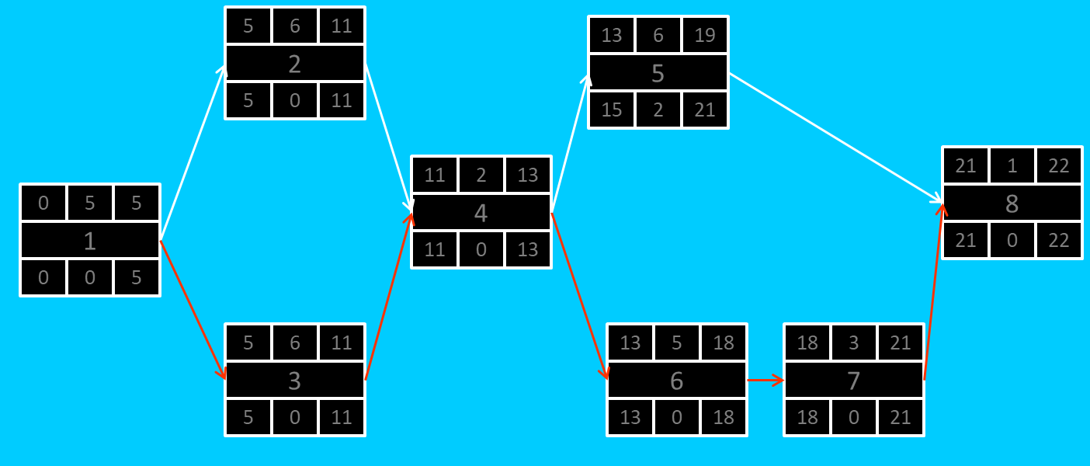

### Gantt timeline

|  |  |  |  |  |  |  |  |  |  |  |  |  |  |  |  |  |  |  |  |  |  |  |  |  |
| --- | --- | --- | --- | --- | --- | --- | --- | --- | --- | --- | --- | --- | --- | --- | --- | --- | --- | --- | --- | --- | --- | --- | --- | --- |
| 1 |  |  |  |  |  |  |  |  |  |  |  |  |  |  |  |  |  |  |  |  |  |  |  |  |
| 2 |  |  |  |  |  | 1 |  |  |  |  |  |  |  |  |  |  |  |  |  |  |  |  |  |  |
| 3 |  |  |  |  |  | 1 |  |  |  |  |  |  |  |  |  |  |  |  |  |  |  |  |  |  |
| 4 |  |  |  |  |  |  |  |  |  |  |  | 3 |  |  |  |  |  |  |  |  |  |  |  |  |
| 5 |  |  |  |  |  |  |  |  |  |  |  |  |  |  |  | 4 |  |  |  |  |  |  |  |  |
| 6 |  |  |  |  |  |  |  |  |  |  |  |  |  |  |  | 4 |  |  |  |  |  |  |  |  |
| 7 |  |  |  |  |  |  |  |  |  |  |  |  |  |  |  |  |  |  |  |  | 6 |  |  |  |
| 8 |  |  |  |  |  |  |  |  |  |  |  |  |  |  |  |  |  |  |  |  |  |  |  | 7 |
|  | 1 | 2 | 3 | 4 | 5 | 6 | 7 | 8 | 9 | 10 | 11 | 12 | 13 | 14 | 15 | 16 | 17 | 18 | 19 | 20 | 21 | 22 | 23 | 24 |