Name__Molly Meadows___ Mark _____________________/50

## Brief introduction __/3

My feature includes making the enemy sprites for our game. In this case they will look like zombie dogs.

By the end of the project, they will be controlled by an AI. They should move towards the character, attack, and change in difficulty as the levels progress. I will be responsible for their attack sequences as well as controlling their health when they are collided with the main character’s bullets.

I will also be making a subclass boss enemy dog at the end of the game that the user must defeat.

## Use case diagram with scenario __14

[Use the lecture notes in class.

Ensure you have at least one exception case, and that the <<extend>> matches up with the Exceptions in your scenario, and the Exception step matches your Basic Sequence step.

Also include an <<include>> that is a suitable candidate for dynamic binding]

Example:

### Use Case Diagrams

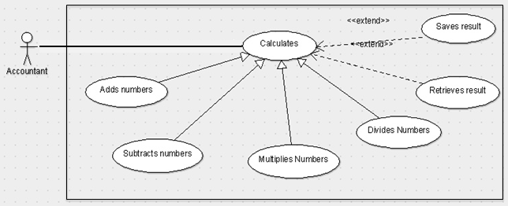

### Scenarios

**[You will need a scenario for each use case]**

**Name:** Add Numbers

**Summary:** The accountant uses the machine to calculate the sum of two numbers.

**Actors:** Accountant.

**Preconditions:** Calculator has been initialized.

**Basic sequence:**

**Step 1:** Accept input of first number.

**Step 2:** Continue to accept numbers until [calculate] is entered.

**Step 3:** Accept calculate command.

**Step 4:** Calculate and show result.

**Exceptions:**

**Step 1:** [calculate] is pressed before any input: Display 0.

**Step 2:** A button other than [calculate] or a number input is pressed: ignore input.

**Post conditions:** Calculated value is displayed.

**Priority:** 2*

**ID:** C01

*The priorities are 1 = must have, 2 = essential, 3 = nice to have.

## Data Flow diagram(s) from Level 0 to process description for your feature _______14

### Data Flow Diagrams

### Process Descriptions

Assign rooms*:

WHILE teacher in two places at once OR two classes in the same room

Randomly redistribute classes

END WHILE

**\*Notes**: Yours should be much longer. You could use a decision tree or decision table instead if it is more appropriate.

## Acceptance Tests ________9

[Describe the inputs and outputs of the tests you will run. Ensure you cover all the boundary cases.]

**Example for random number generator feature**

Run feature 1000 times sending output to a file.

The output file will have the following characteristics:

* Max number: 9
* Min number: 0
* Each digit between 0 and 9 appears at least 50 times
* No digit between 0 and 9 appears more than 300 times
* Consider each set of 10 consecutive outputs as a substring of the entire output. No substring may appear more than 3 times.

**Example for divide feature**

|  |  |  |  |
| --- | --- | --- | --- |
| Output | Numerator  (int) | Denominator  (int) | Notes |
| 0.5 | 1 | 2 |  |
| 0.5 | 2 | 3 | We only have 1 bit precision for outputs. Round all values to the nearest .5 |
| 0.0 | 1 | 4 | At the 0.25 mark always round to the nearest whole integer |
| 1.0 | 3 | 4 | At the 0.75 mark always round to the nearest whole integer |
| 255.5 | 5 | 0 | On divide by 0, do not flag an error. Simply return our MAX_VAL which is 255.5. |

## Timeline _________/10

[Figure out the tasks required to complete your feature]

Example:

### Work items

|  |  |  |
| --- | --- | --- |
| Task | Duration (PWks) | Predecessor Task(s) |
| 1. Create Dog Class |  | - |
| 2. Create Zombie Dog subclass |  |  |
| 3. Design Sprite |  |  |
| 4. Sprite AI movement |  |  |
| 5. Sprite Attack/damage sequence design |  |  |
| 6. Programming |  |  |
| 7. Initialize Boss Dog |  |  |
| 8. Documentation |  |  |
| 9. Testing |  |  |

### Pert diagram

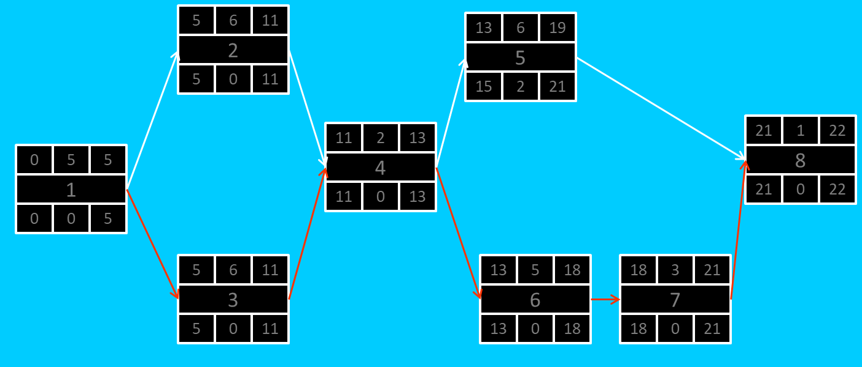

### Gantt timeline

|  |  |  |  |  |  |  |  |  |  |  |  |  |  |  |  |  |  |  |  |  |  |  |  |  |
| --- | --- | --- | --- | --- | --- | --- | --- | --- | --- | --- | --- | --- | --- | --- | --- | --- | --- | --- | --- | --- | --- | --- | --- | --- |
| 1 |  |  |  |  |  |  |  |  |  |  |  |  |  |  |  |  |  |  |  |  |  |  |  |  |
| 2 |  |  |  |  |  | 1 |  |  |  |  |  |  |  |  |  |  |  |  |  |  |  |  |  |  |
| 3 |  |  |  |  |  | 1 |  |  |  |  |  |  |  |  |  |  |  |  |  |  |  |  |  |  |
| 4 |  |  |  |  |  |  |  |  |  |  |  | 3 |  |  |  |  |  |  |  |  |  |  |  |  |
| 5 |  |  |  |  |  |  |  |  |  |  |  |  |  |  |  | 4 |  |  |  |  |  |  |  |  |
| 6 |  |  |  |  |  |  |  |  |  |  |  |  |  |  |  | 4 |  |  |  |  |  |  |  |  |
| 7 |  |  |  |  |  |  |  |  |  |  |  |  |  |  |  |  |  |  |  |  | 6 |  |  |  |
| 8 |  |  |  |  |  |  |  |  |  |  |  |  |  |  |  |  |  |  |  |  |  |  |  | 7 |
|  | 1 | 2 | 3 | 4 | 5 | 6 | 7 | 8 | 9 | 10 | 11 | 12 | 13 | 14 | 15 | 16 | 17 | 18 | 19 | 20 | 21 | 22 | 23 | 24 |