Name____Tosin Bangudu____ Mark _____________________/50

## Brief introduction __/3

My feature for the Zombie Dog Outbreak 2 game is to create and initialize cut scenes and make sure they run smoothly. In the cut scene I will create an NPC version of our character and assign them several actions relating to the lore of the game. To help drive this, I also have the option of creating sprites that live in that cut scene. And it will all be recorded through a script.

## Use case diagram with scenario __14

[Use the lecture notes in class.

Ensure you have at least one exception case, and that the <<extend>> matches up with the Exceptions in your scenario, and the Exception step matches your Basic Sequence step.

Also include an <<include>> that is a suitable candidate for dynamic binding]

Example:

### Use Case Diagrams

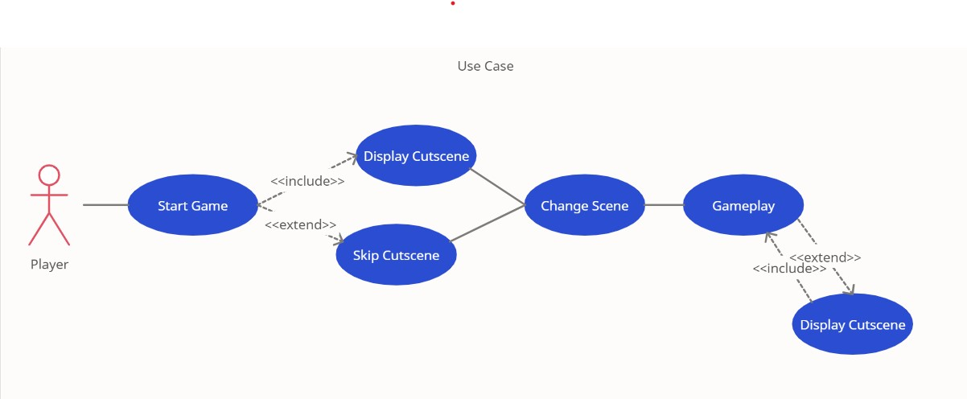

### Scenarios

* **Name:** Start Game

**Summary:** The player has pressed the play button

**Actors:** Player

**Preconditions:** Game initialized.

**Basic sequence:**

**Step 1:** Accept button input.

**Step 2:** Change scene to cutscene.

**Exceptions:**

**Step 1:** Game is quit

**Step 2:** A button other than play is pressed (will be ignored).

**Post conditions:** Cutscene is displayed.

**Priority:** 1*

**ID:** C01

*The priorities are 1 = must have, 2 = essential, 3 = nice to have.

* **Name:** Display Cutscene

**Summary:** The cutscene timeline will be played

**Actors:** Player

**Preconditions:** Play Button Pressed.

**Basic sequence:**

**Step 1:** Play cutscene.

**Step 2:** Change scene to game.

**Exceptions:**

**Step 1:** cutscene is skipped

**Post conditions:** Cutscene runs then changes to game scene.

**Priority:** 2*

**ID:** C02

*The priorities are 1 = must have, 2 = essential, 3 = nice to have.

* **Name:** Skip Cutscene

**Summary:** The player has pressed the designated button to skip cutscene.

**Actors:** Player

**Preconditions:** Play button is pressed.

**Basic sequence:**

**Step 1:** Don’t play cutscene.

**Step 2:** Change scene to game.

**Exceptions:**

**Step 1:** cutscene is not skipped (will run like normal)

**Post conditions:** Play button is pressed.

**Priority:** 3*

**ID:** C03

*The priorities are 1 = must have, 2 = essential, 3 = nice to have.

* **Name:** Change Scene

**Summary:** The scene is changed from cutscene to game

**Actors:** Player

**Preconditions:** The cutscene has run successfully or the cutscene skip button was pressed.

**Basic sequence:**

**Step 1:** Run ChangeScene() script

**Exceptions:**

**Step 1:** error occurs

**Post conditions:** cutscene has run successfully or the cutscene skip button was pressed.

**Priority:** 1*

**ID:** C04

*The priorities are 1 = must have, 2 = essential, 3 = nice to have.

* **Name:** Gameplay

**Summary:** Task accomplishment in gameplay triggers cutscene

**Actors:** Player

**Preconditions:** The objective for that level has been accomplished

**Basic sequence:**

**Step 1:** Run ChangeScene() script to cutscene for that objective

**Exceptions:**

**Step 1:** error occurs

**Post conditions:** cutscene has run successfully or the cutscene skip button was pressed.

**Priority:** 1*

**ID:** C05

*The priorities are 1 = must have, 2 = essential, 3 = nice to have.

## Data Flow diagram(s) from Level 0 to process description for your feature _______14

### Data Flow Diagrams

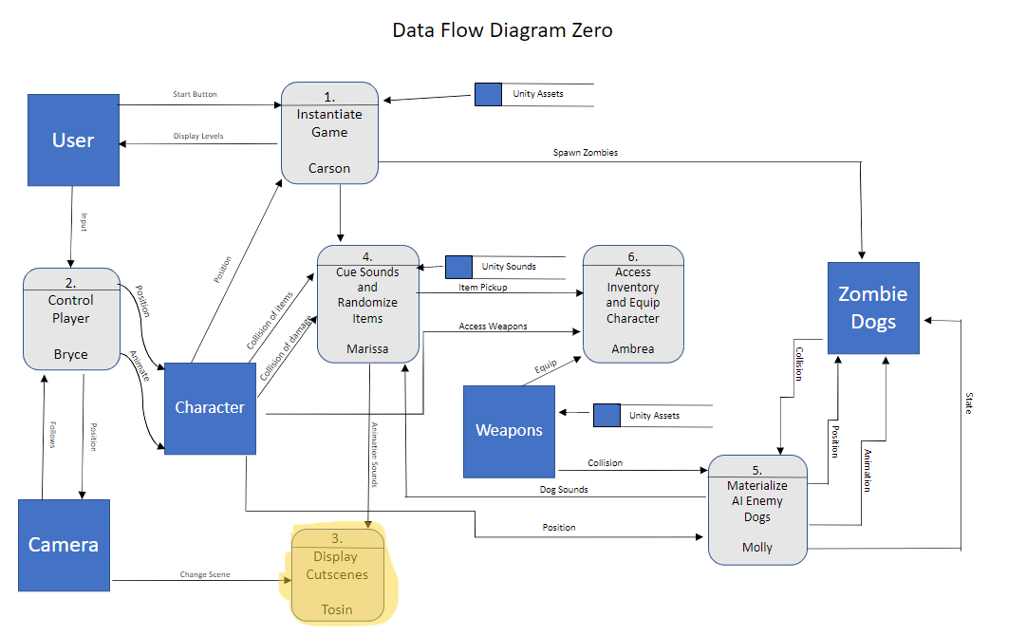

Animation

### Process Descriptions

## 

## Acceptance Tests ________9

The program will be called 100 times and each time, the opening cutscene should be cued then the game scene

## Timeline _________/10

### Work items

|  |  |  |
| --- | --- | --- |
| Task | Duration (PWks) | Predecessor Task(s) |
| 1. Acquire Sprites and Assets related to game | 3 | - |
| 2. Animation | 7 | 1 |
| 3. Scripting | 3 | 1,2 |
| 4. Testing | 3 | 3 |

### Pert diagram

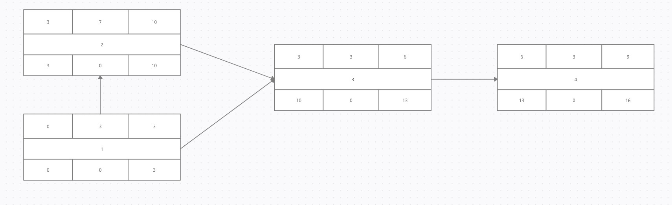

### Gantt timeline

|  |  |  |  |  |  |  |  |  |  |  |  |  |  |  |  |  |  |  |  |  |  |  |  |  |
| --- | --- | --- | --- | --- | --- | --- | --- | --- | --- | --- | --- | --- | --- | --- | --- | --- | --- | --- | --- | --- | --- | --- | --- | --- |
| 1 |  |  |  |  |  |  |  |  |  |  |  |  |  |  |  |  |  |  |  |  |  |  |  |  |
| 2 |  |  |  | 1 |  |  |  |  |  |  |  |  |  |  |  |  |  |  |  |  |  |  |  |  |
| 3 |  |  |  |  |  |  |  |  |  |  | 2 |  |  |  |  |  |  |  |  |  |  |  |  |  |
| 4 |  |  |  |  |  |  |  |  |  |  |  |  |  | 3 |  |  |  |  |  |  |  |  |  |  |
|  | 1 | 2 | 3 | 4 | 5 | 6 | 7 | 8 | 9 | 10 | 11 | 12 | 13 | 14 | 15 | 16 | 17 | 18 | 19 | 20 | 21 | 22 | 23 | 24 |