# Binary Search

## KeY

Eclipse KeY Tool - http://keytool.sourceforge.net/update

Web IDE - Download Web Start executable from <https://www.key-project.org/download/> and run program

Each different java program must be in its own folder as KeY tries to verify every java file in the current directory as opposed to just what was selected

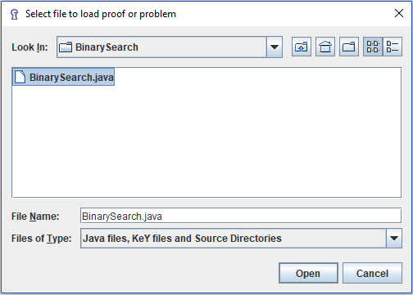

Determine how to verify: by goals or by proof rules

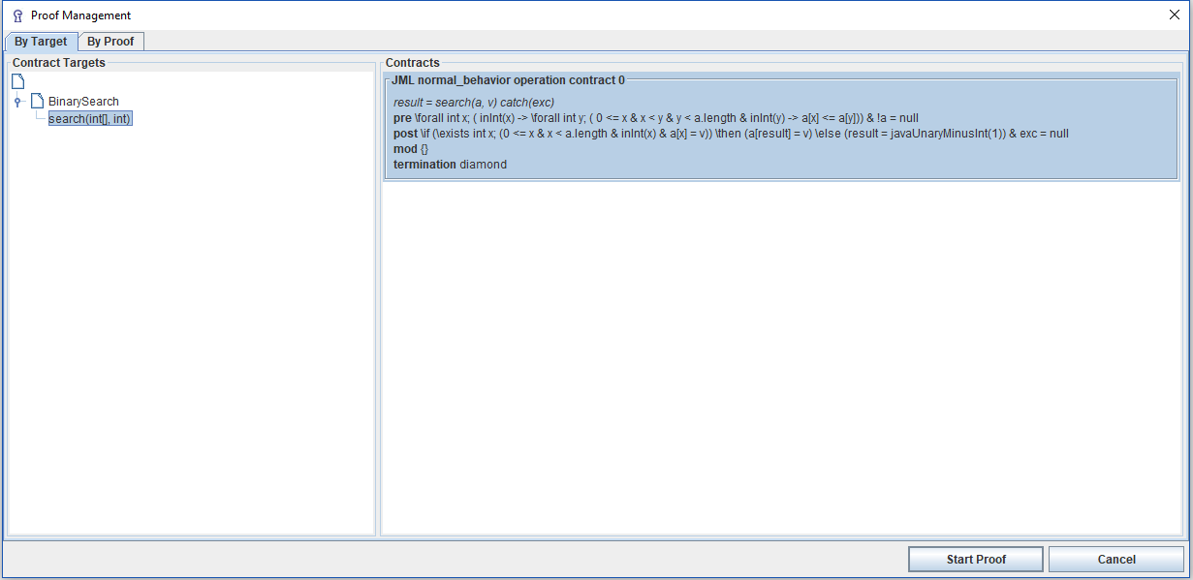

Proof is loaded into KeY IDE

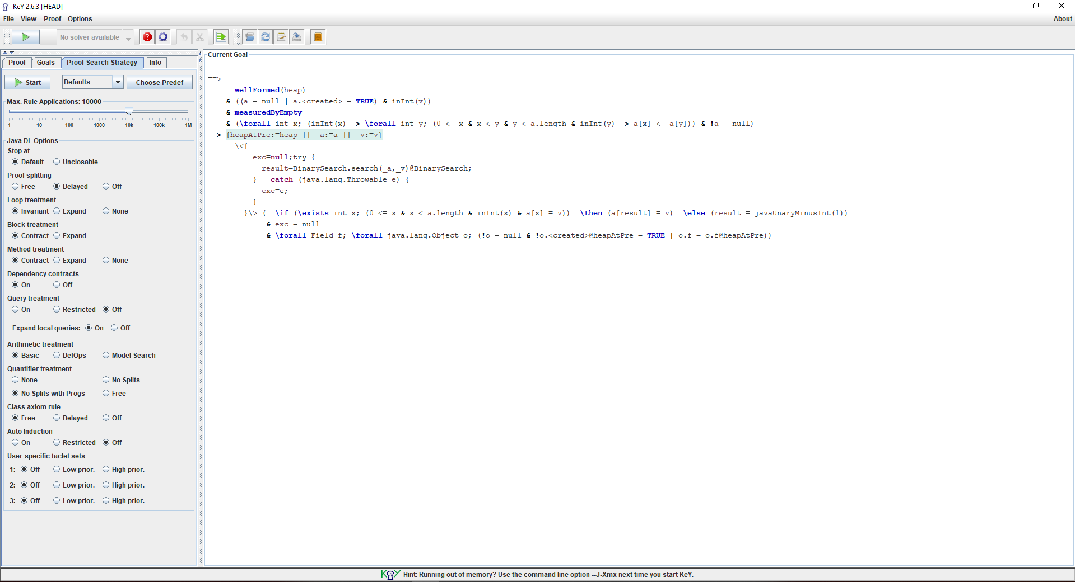

Choose verification options and run prover

Verification failed as we get an Open-Goal so we need to use Symbolic Debugger to find solution

Investigating Open-Goal can be complicated so we prune the goal

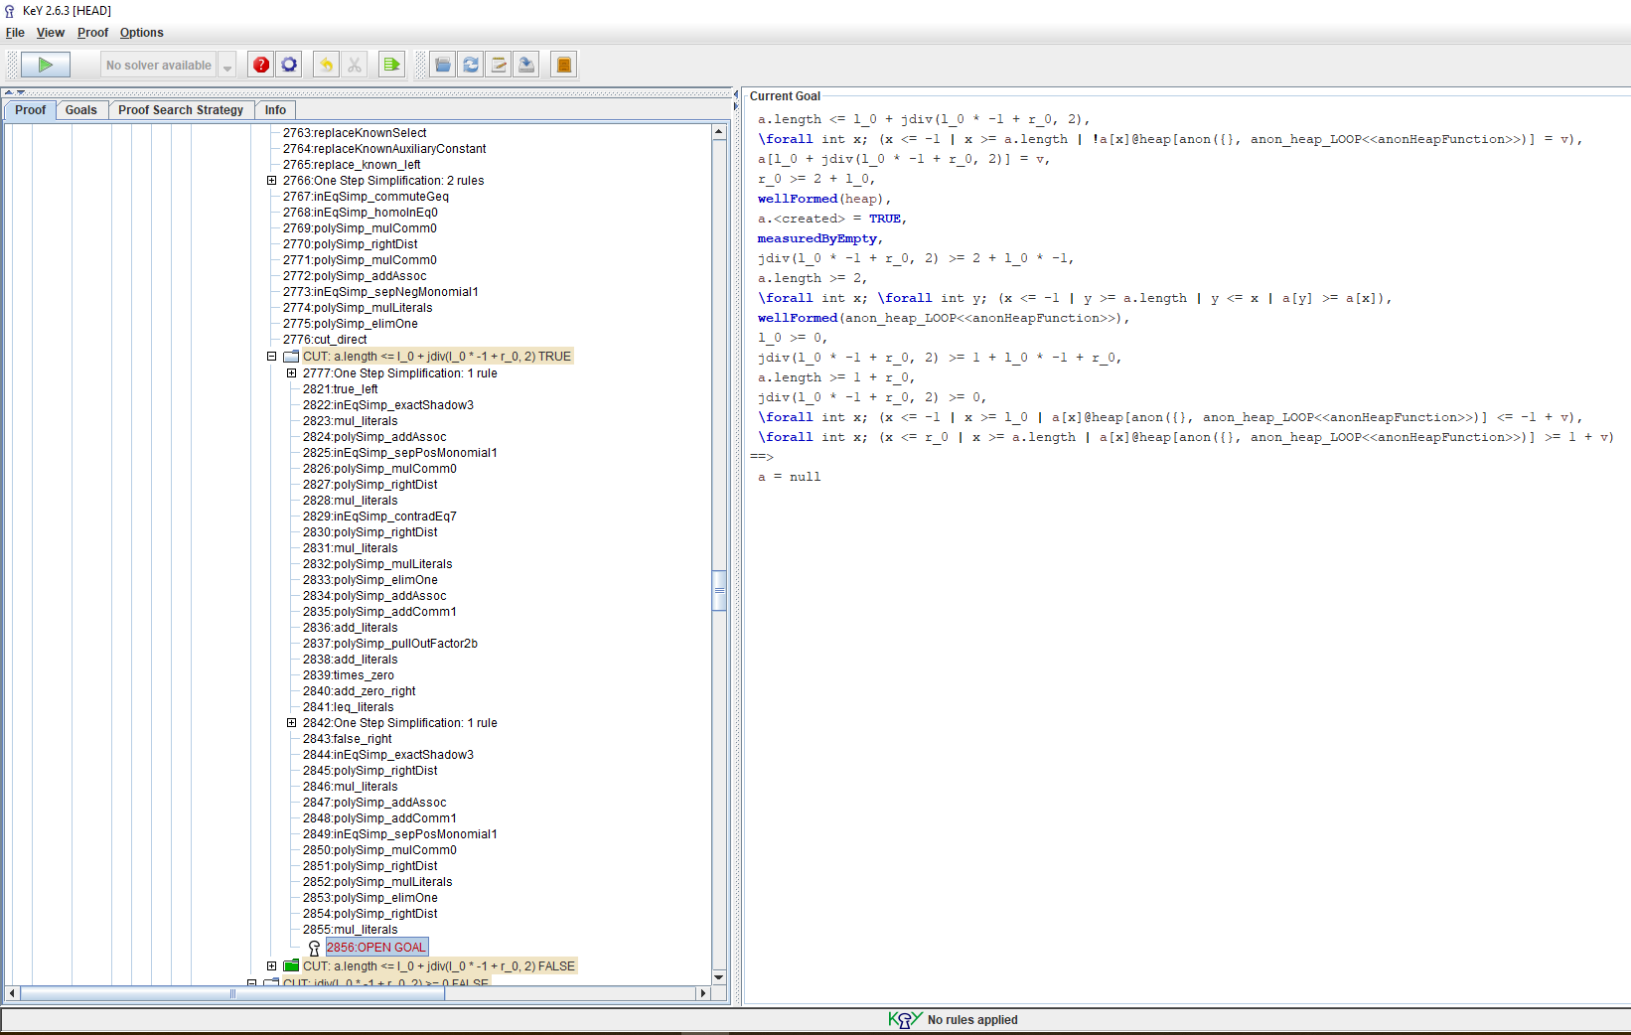

Go back up the symbolic execution tree and find where the current goal started, right click and select "prune proof"

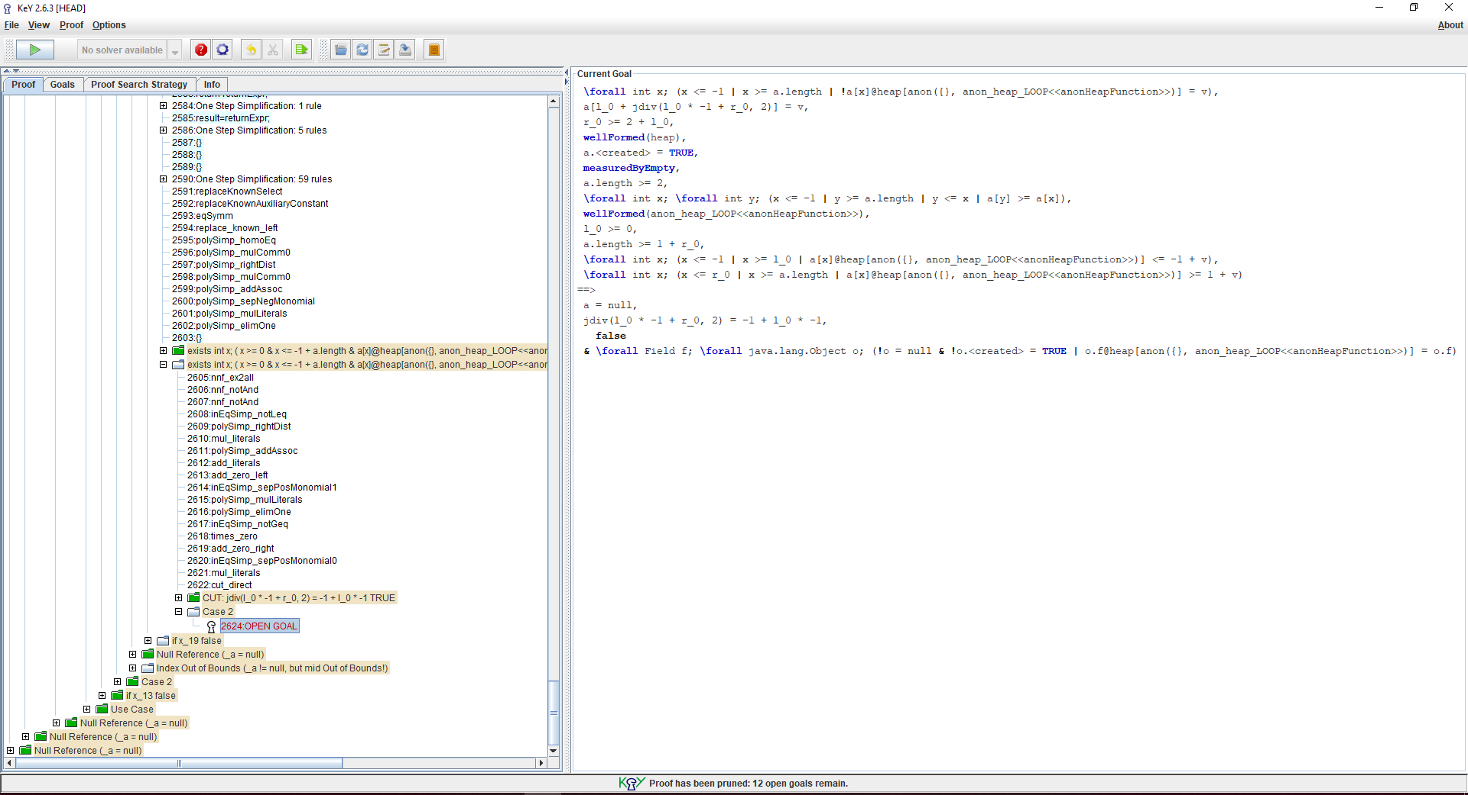

Right click on the Open Goal and select Strategy Macro, AutoPilot, Full Auto-Pilot to split the proof obligation into two separate branches

The left branch closed, so it is the right branch that we must now prove

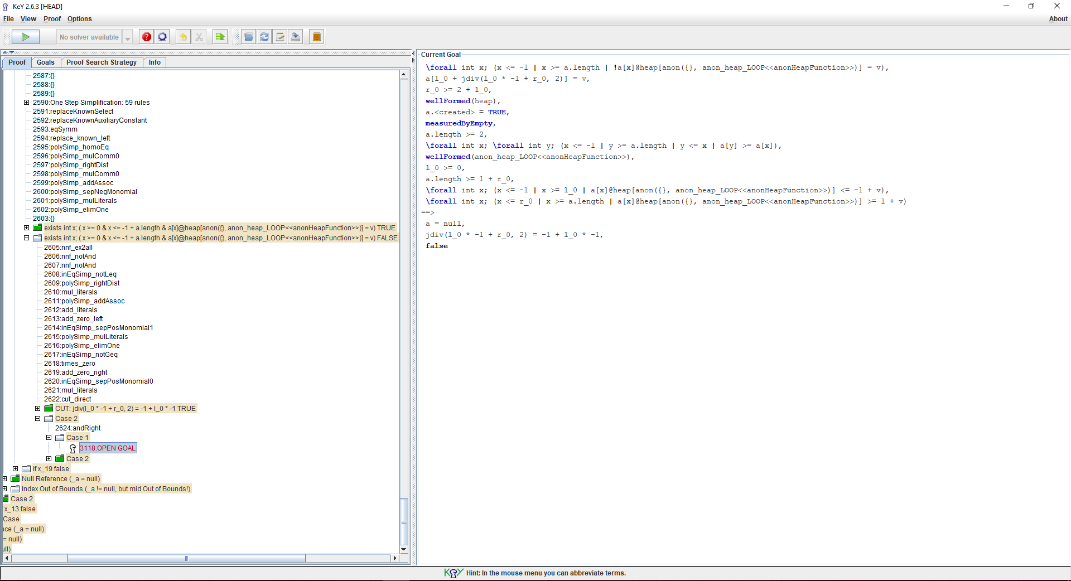

Apply rules and alter variable names to get proof to work.

HOW?