# BinarySearch

## Krakatoa

How to run Krakatoa from command line after adding executable path to environment variables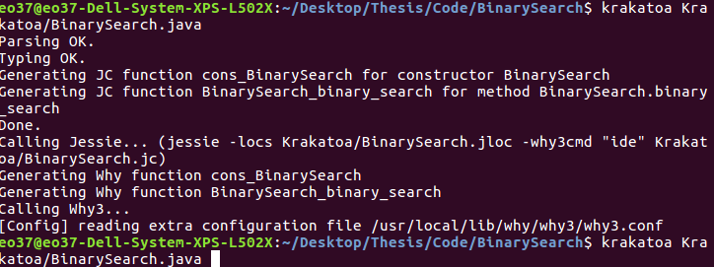

Overall Jessie Model – over 1000 lines

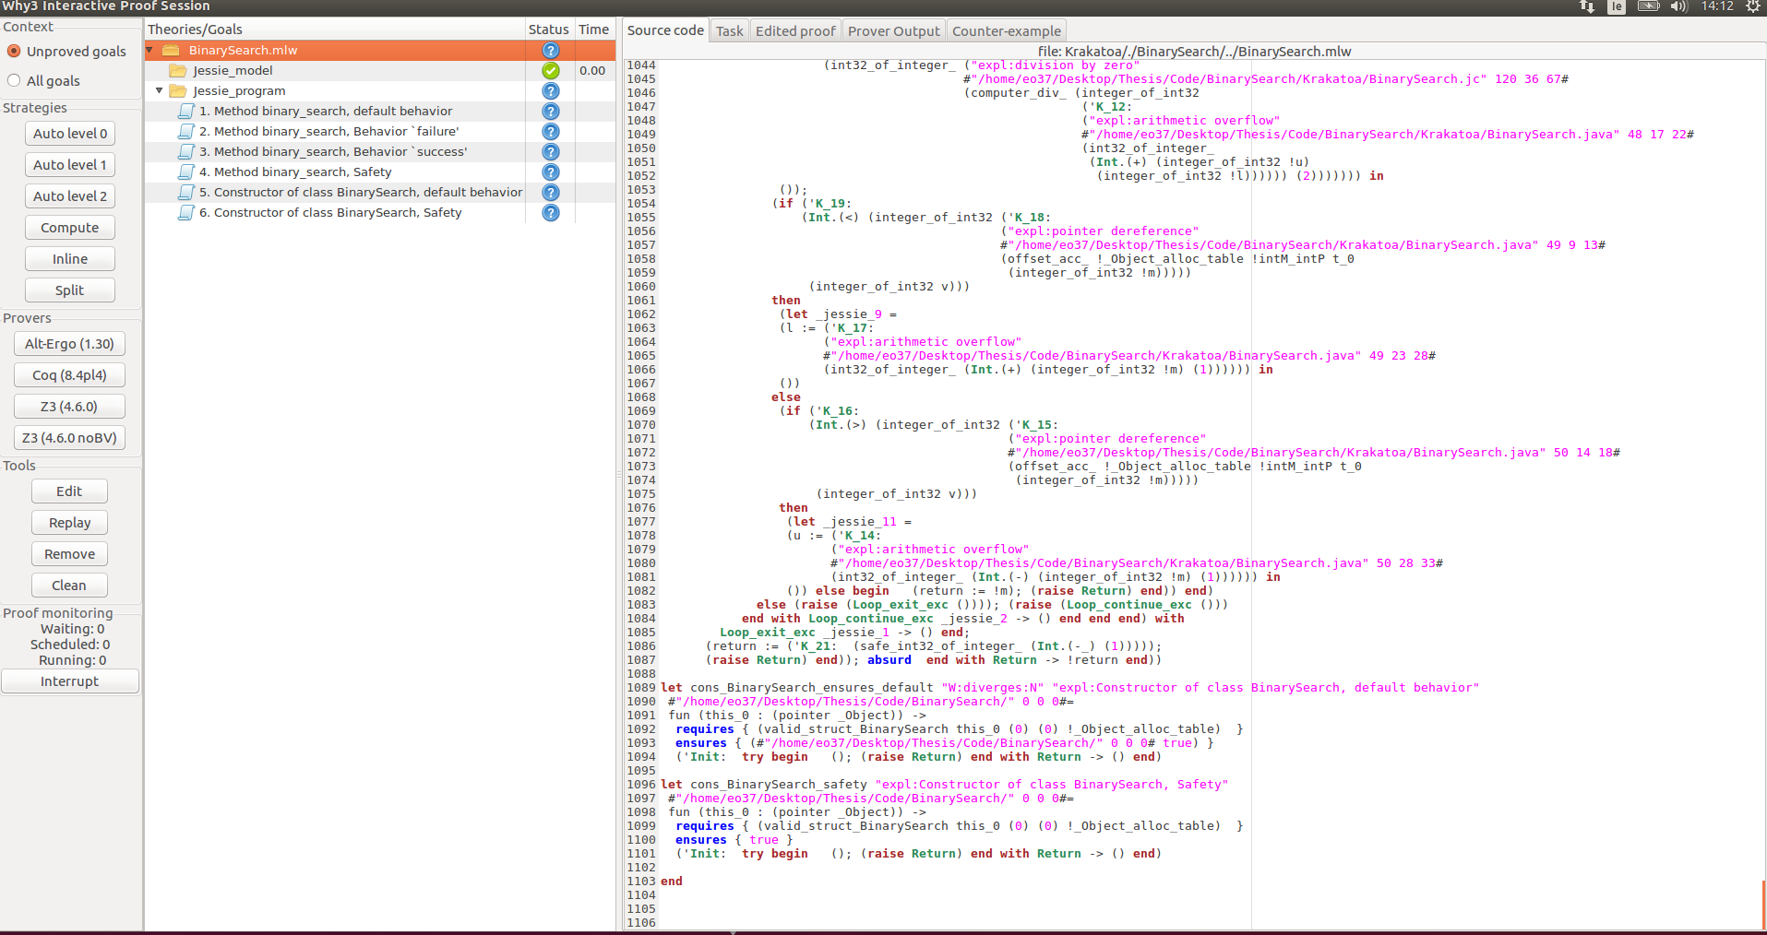

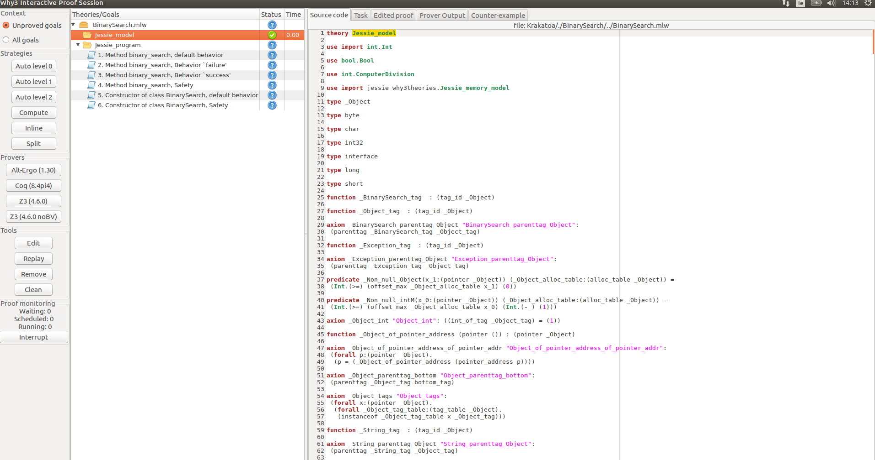

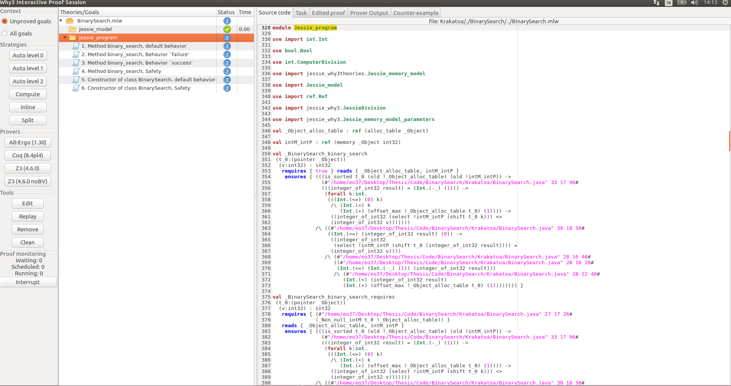

Select individual method to verify – highlights code

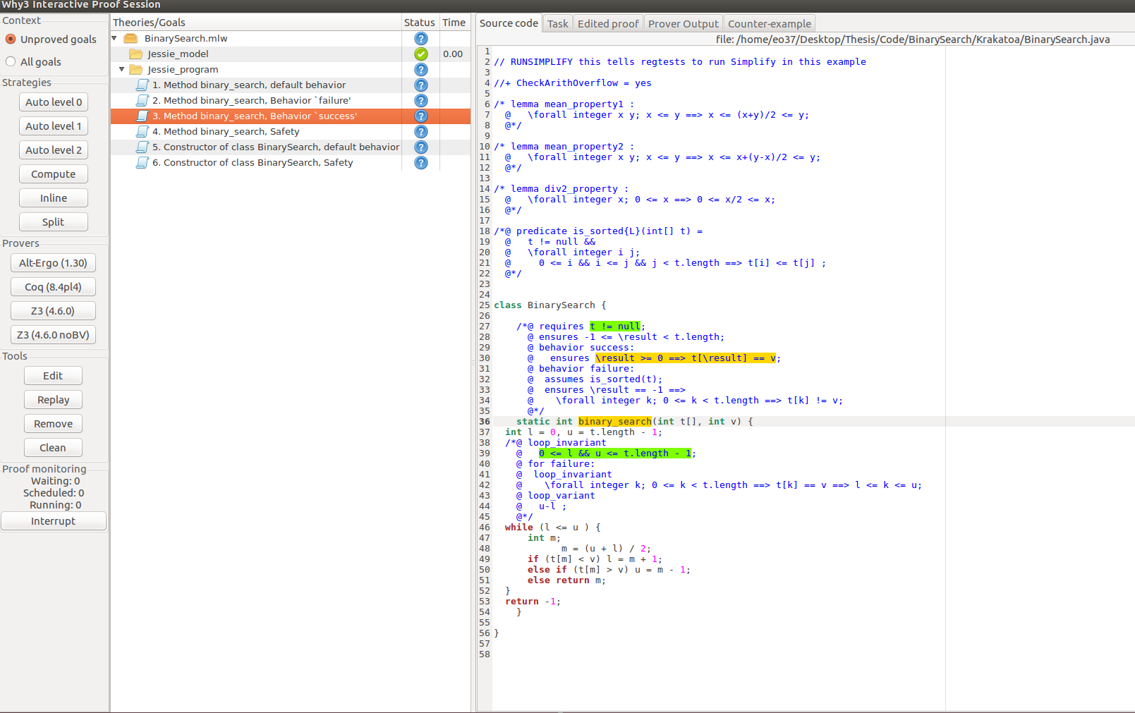

Use auto-level 2 – automatically chooses best solvers and rules to apply

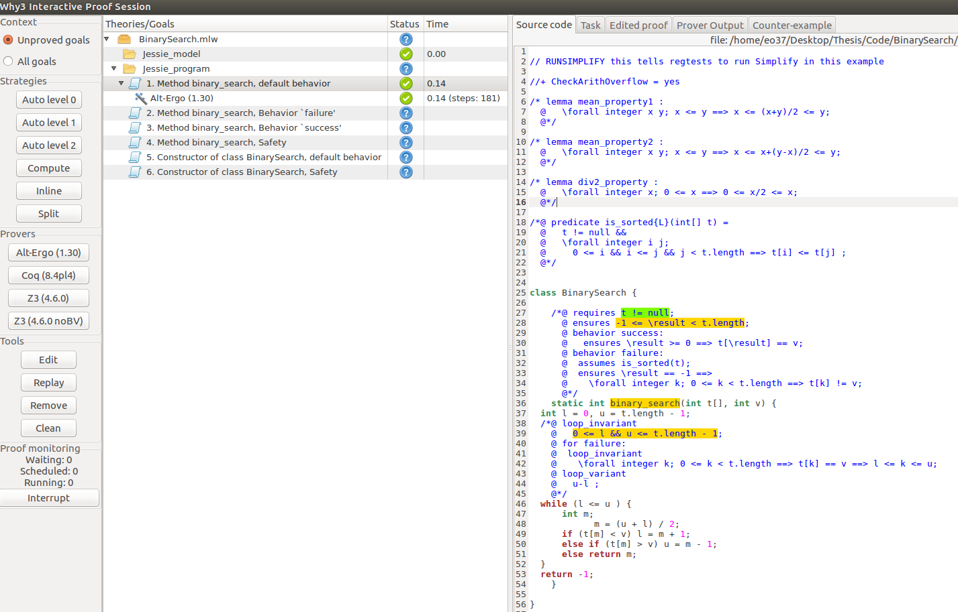

Select method and then choose prover interactively

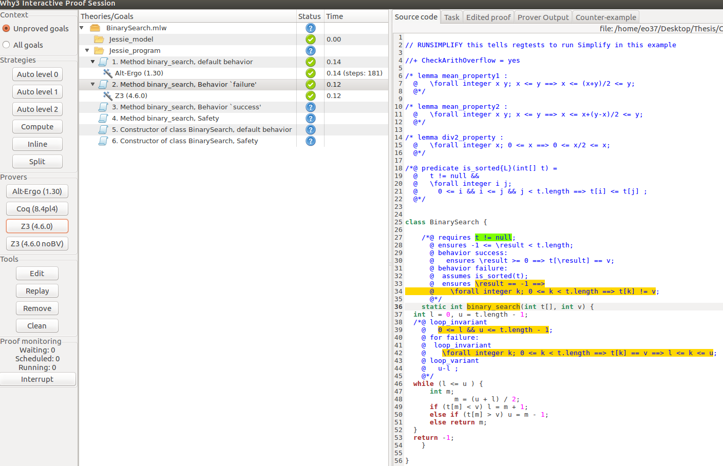

Select jessie model and prove all unproven goals at once – level 2 automatic

Shows what was resolved and unverified programs

Splits all goals that are unverified and applies different rules and provers to them in order to find a valid solution

Possible Arithmetic overflow issues remained unresolved

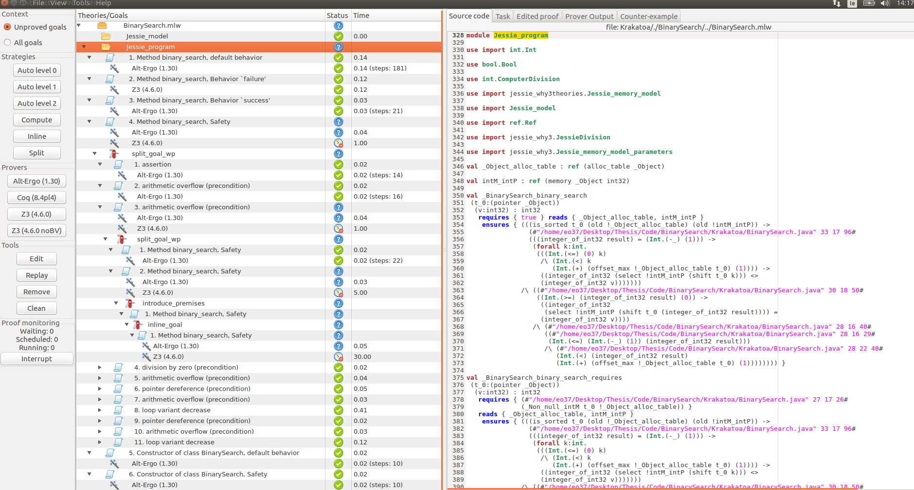

Selecting the method will highlight what specification steps could not be verified

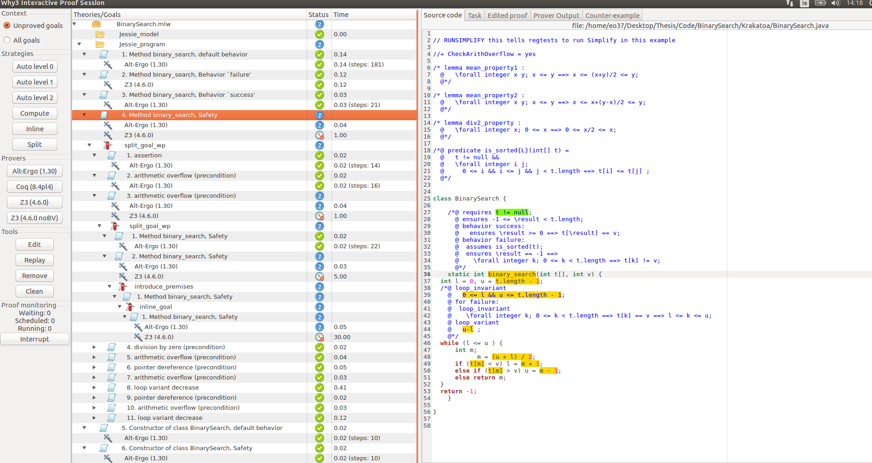

Changing the (//@+ CheckArithOverflow = yes --> //@+ CheckArithOverflow = no) , solves the error however this may not be an optimal solution and a better specification may be needed

