# Longest Repeating Substring

Four Classes

1. LCP
2. Lemmas
3. LRS
4. SuffixArray

## Eclipse

**MAJOR ISSUE**: Once a verification hangs, you cannot get out of it. Even cancelling the operation does not stop Eclipse from hanging. You cannot exit the program or restart to get past it leading to massive amounts of time being lost. Even restarting the computer does not stop it, it just starts all over again once rebooted. Killing the elipse process from the terminal also does not help. VERY ANNOYING.

I cannot start the new program as the PrefixSum is still hanging.

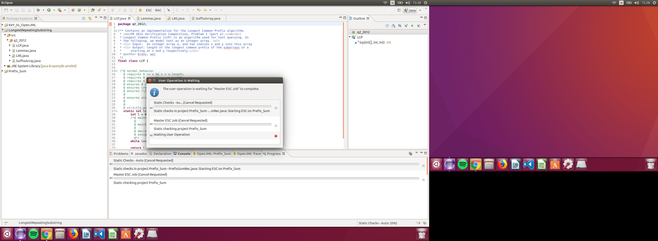

### LCP Class

Type Checking

* Errors:
  + Loop specifications must immediately precede method
  + strictly_pure --> pure
  + \strictly_nothing --> \nothing

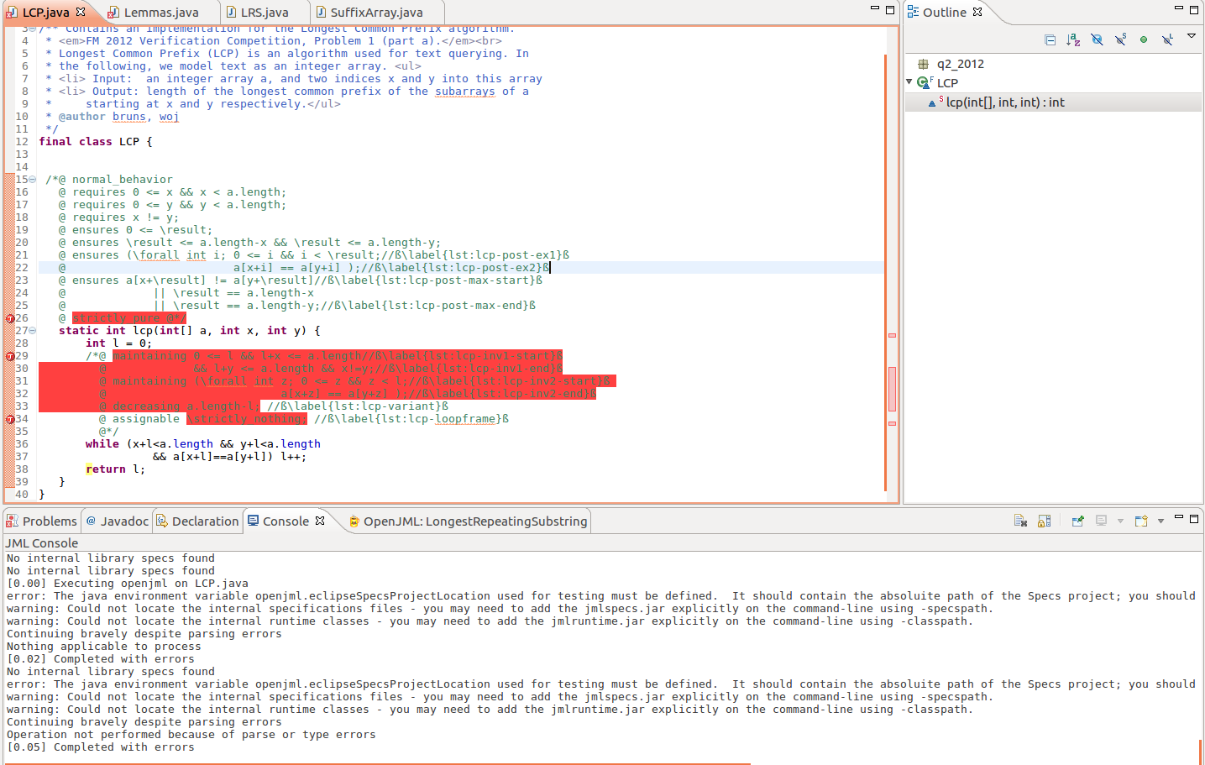

RAC

* No Errors

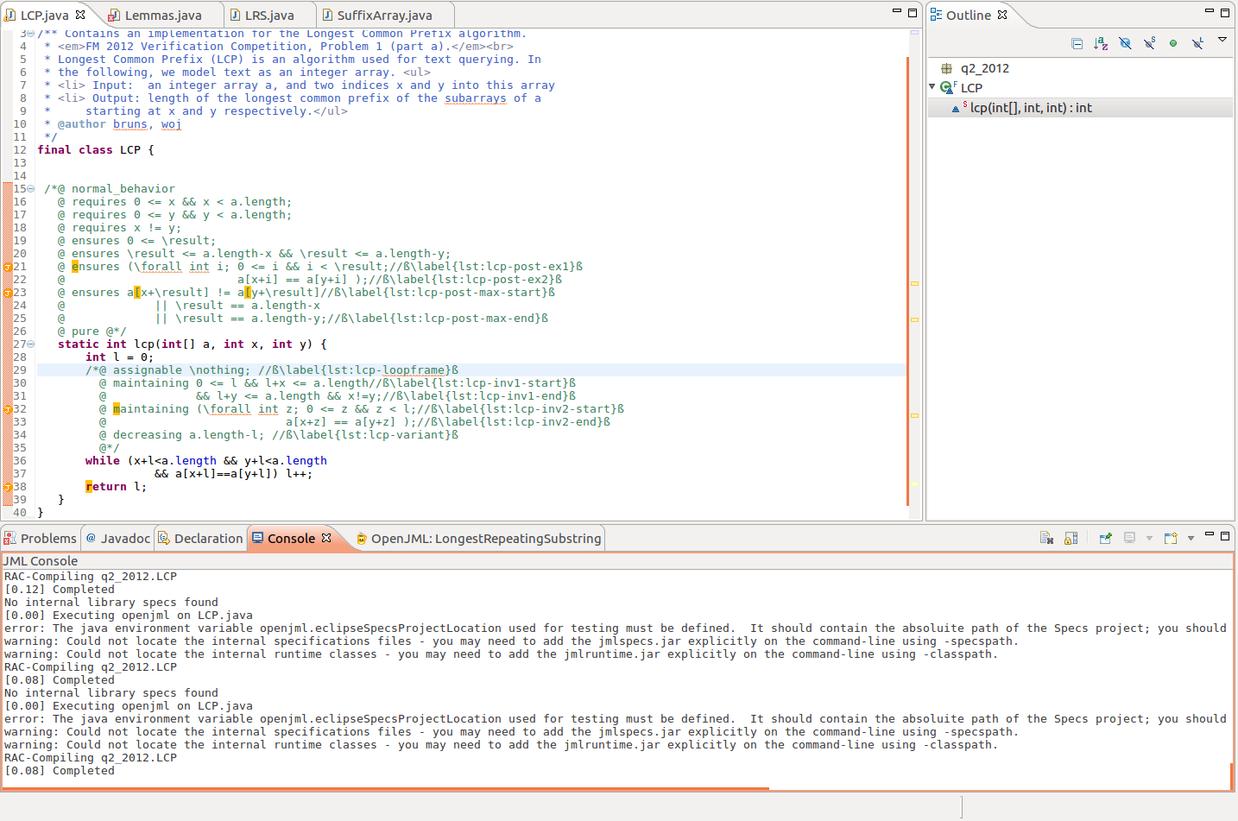

ESC with z3

KeY Tool

* Proof completed in 1666ms

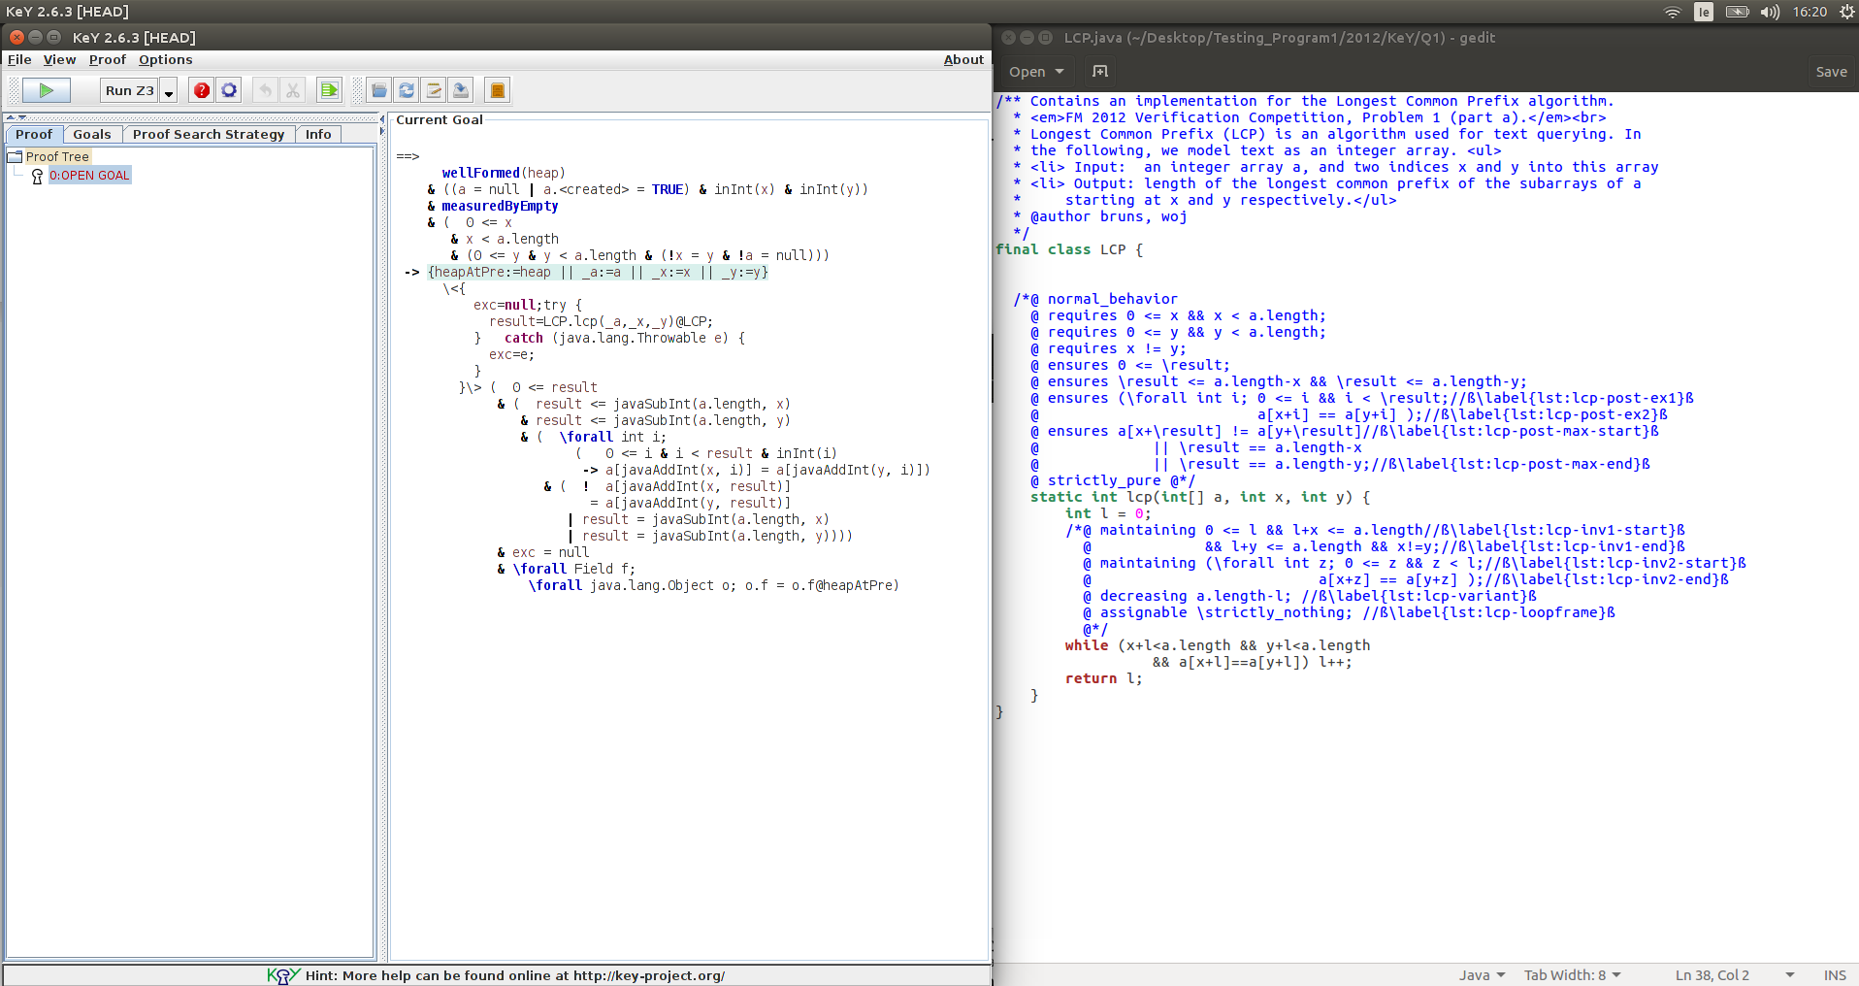

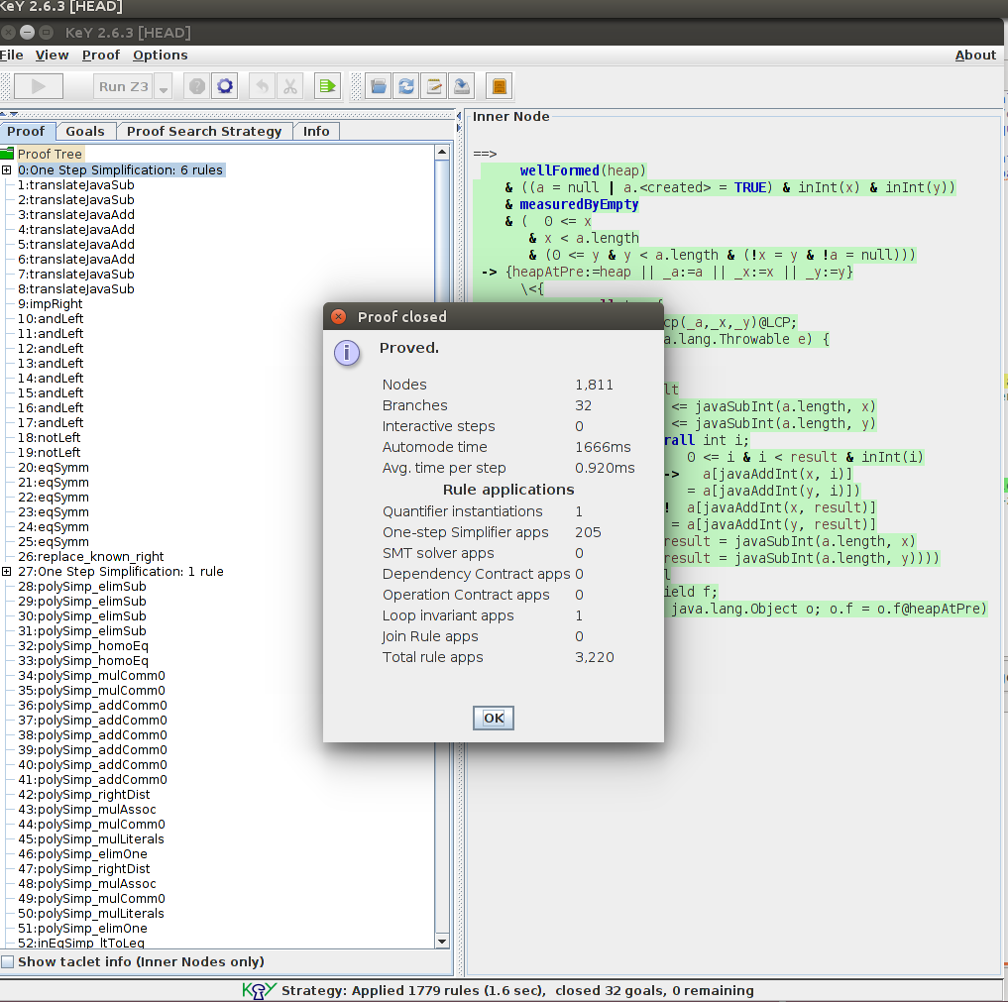

OpenJML with z3

* Errors
  + The prover cannot establish an assertion
    - Line: @ ensures (\forall int i; 0 <= i && i < \result; a[x+i] == a[y+i] );
    - Line: @ maintaining (\forall int z; 0 <= z && z < l; a[x+z] == a[y+z] );
    - Line: @ while (x+l<a.length && y+l<a.length && a[x+l]==a[y+l])

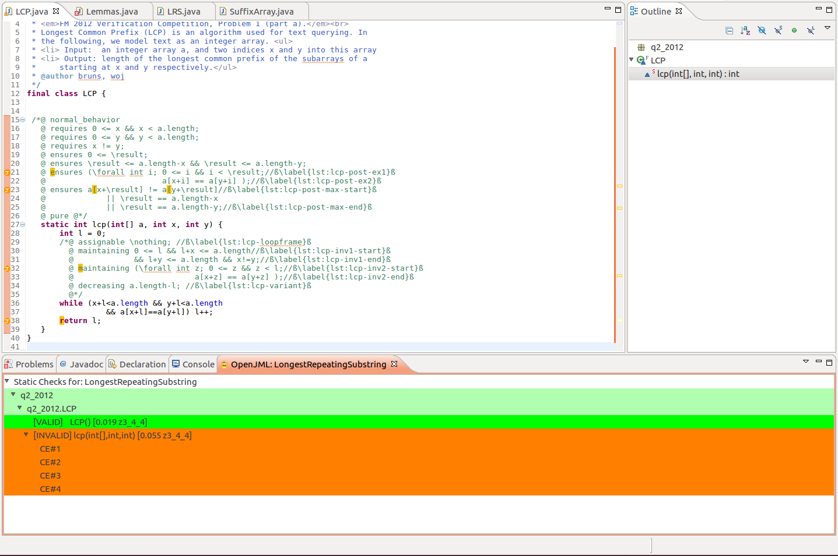

### Lemmas

Type Checking

* Errors
  + The 'pure' compareTrans method trying to access a non-pure compare method in SuffixArray class, change to pure and it works (was \strictly_pure)
  + \strictly_pure --> pure
  + \strictly_nothing --> nothing
  + Loop specifications must immediately precede method

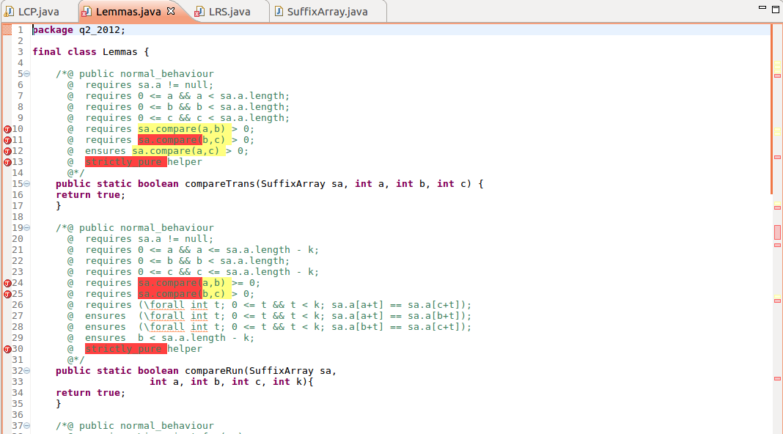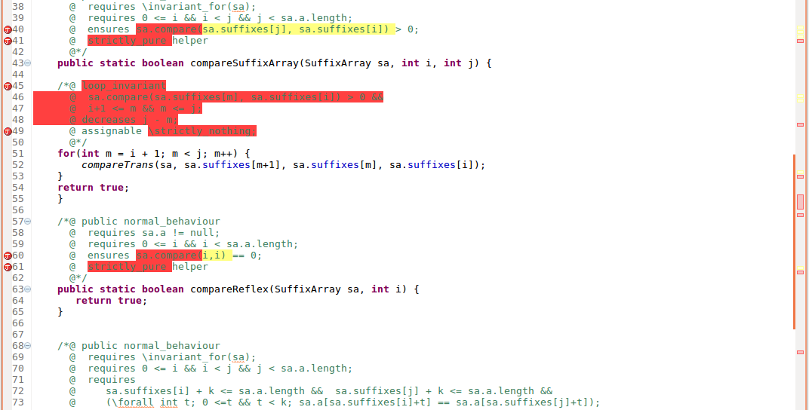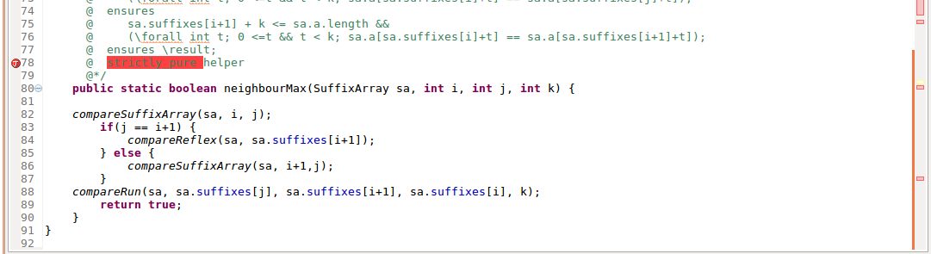

RAC

* Internal Error: code 4

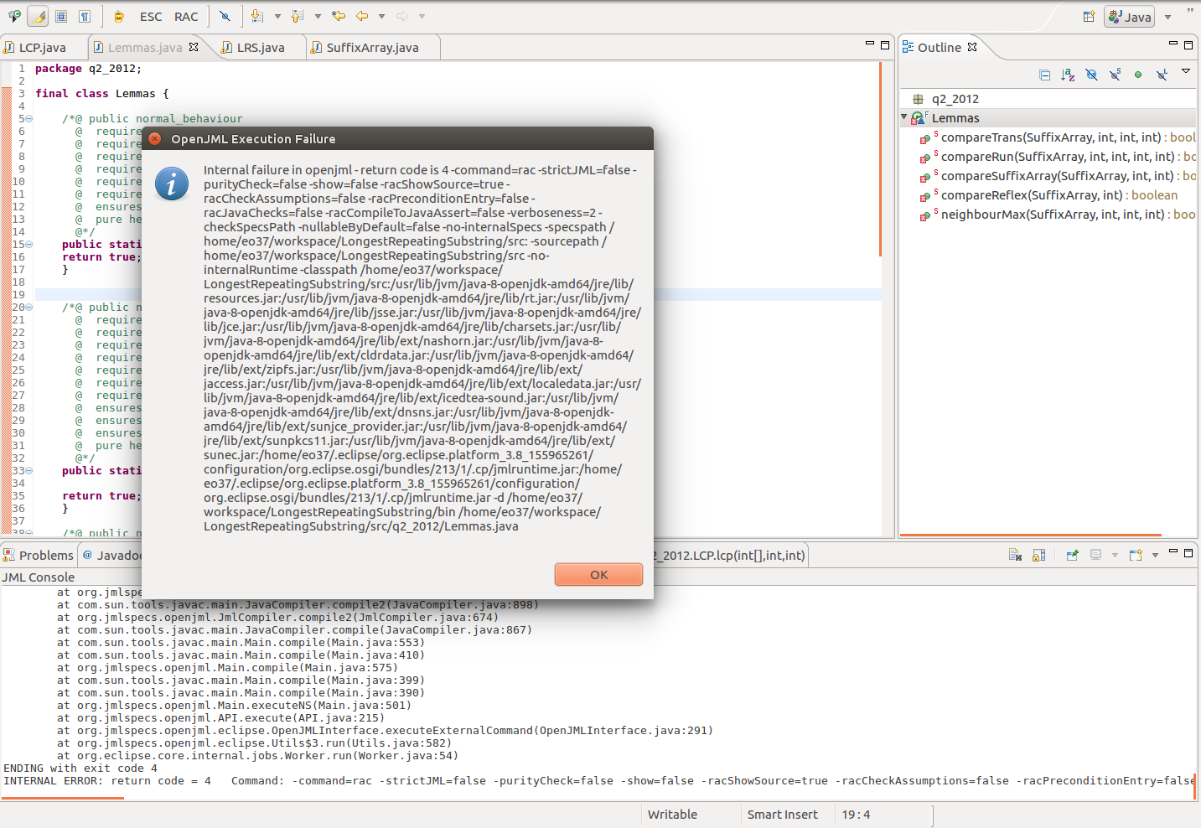

ESC with z3

KeY Tool

OpenJML

* Errors:

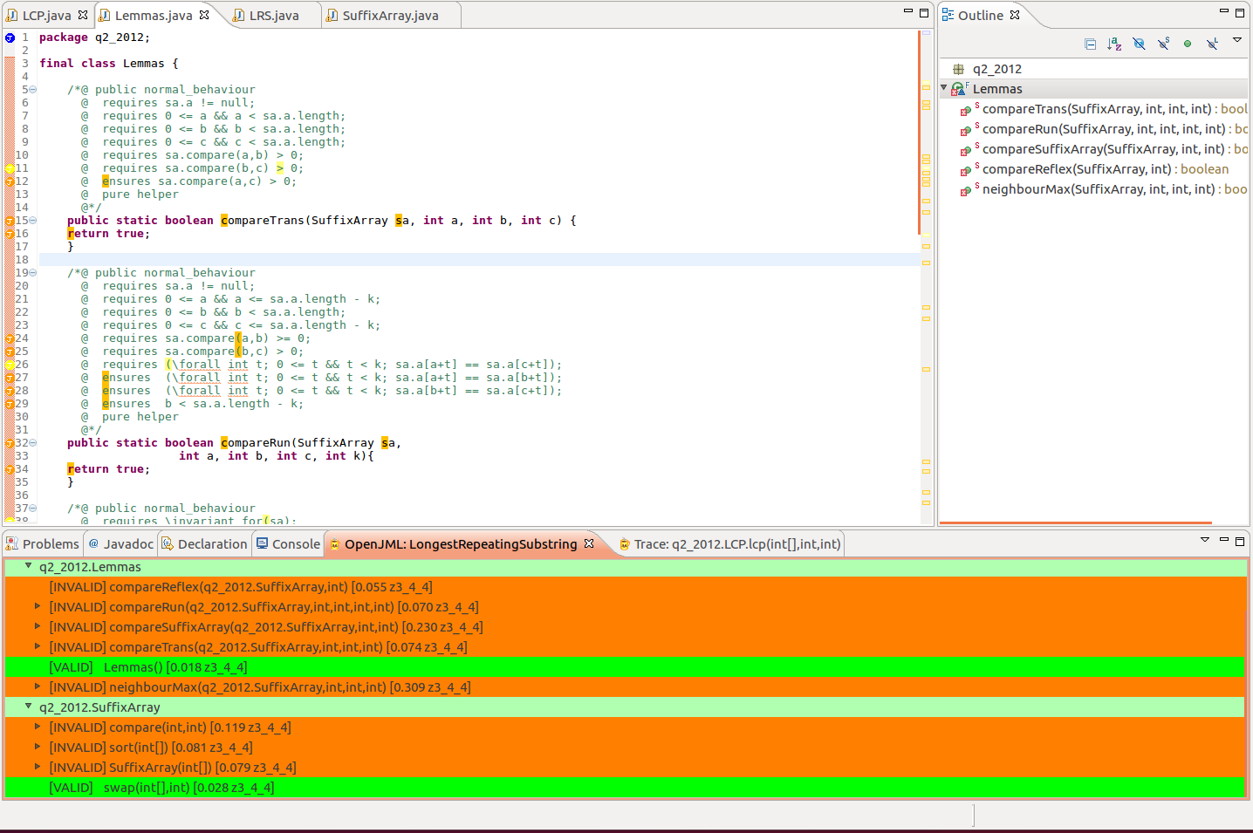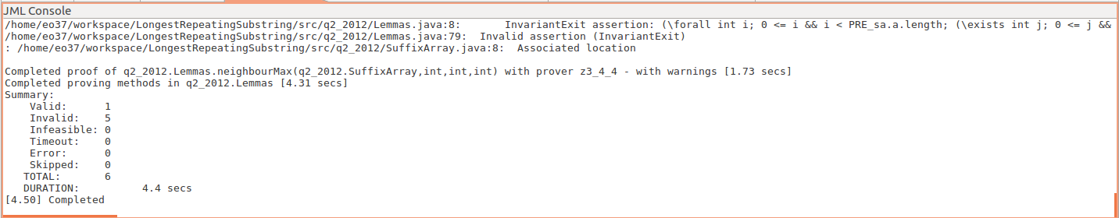

### LRS

Type Checking

* Errors
  + An identifier with private visibility cannot be used in a requires clause with package visibility – add /*@ spec_public @*/ to private variables
  + \strictly_nothing --> nothing
  + Loop specifications must immediately precede method

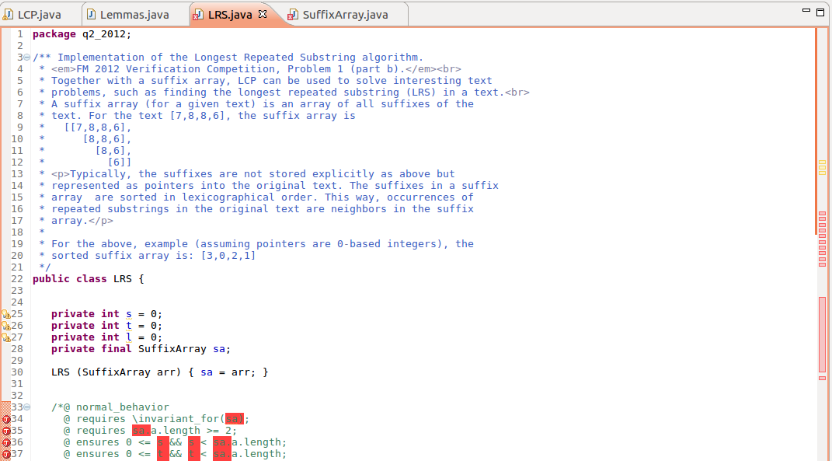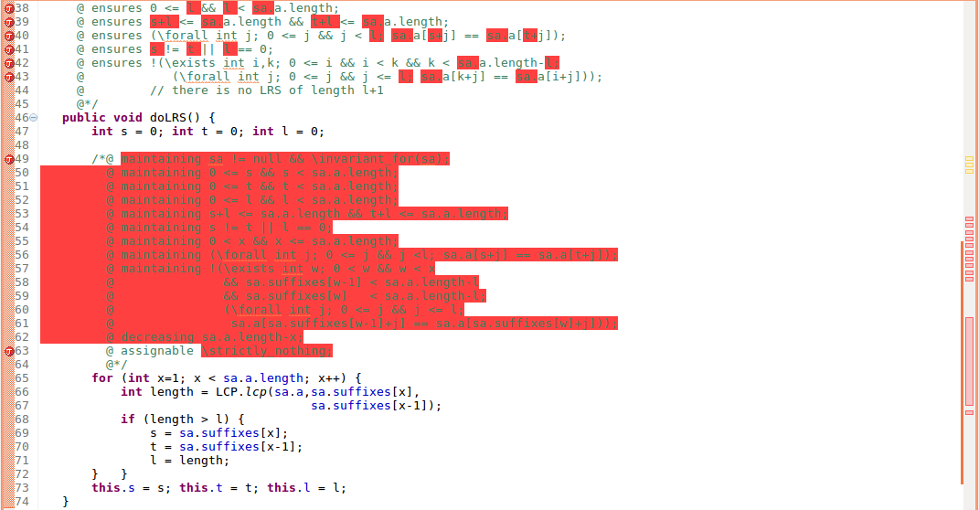

RAC

* Internal Error: Code 4

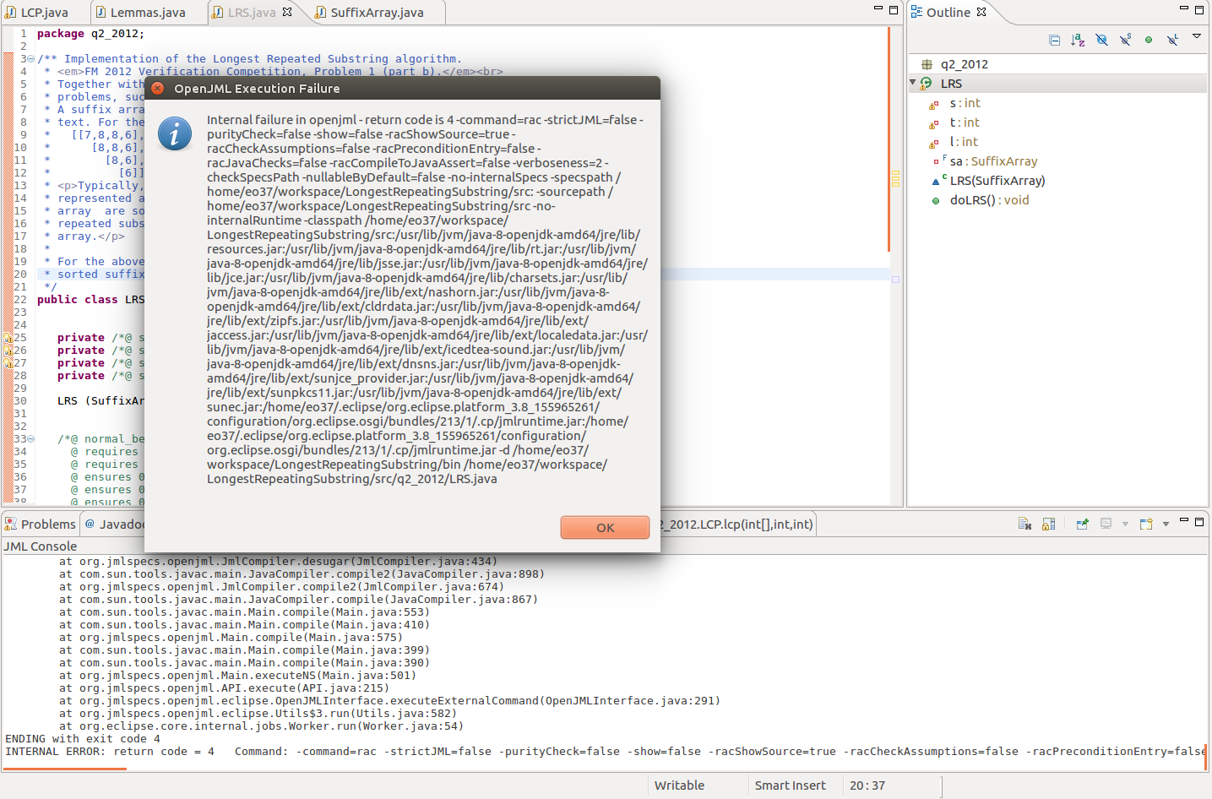

ESC with z3

KeY Tool

OpenJML

* Errors:
  + Infinite verification loop

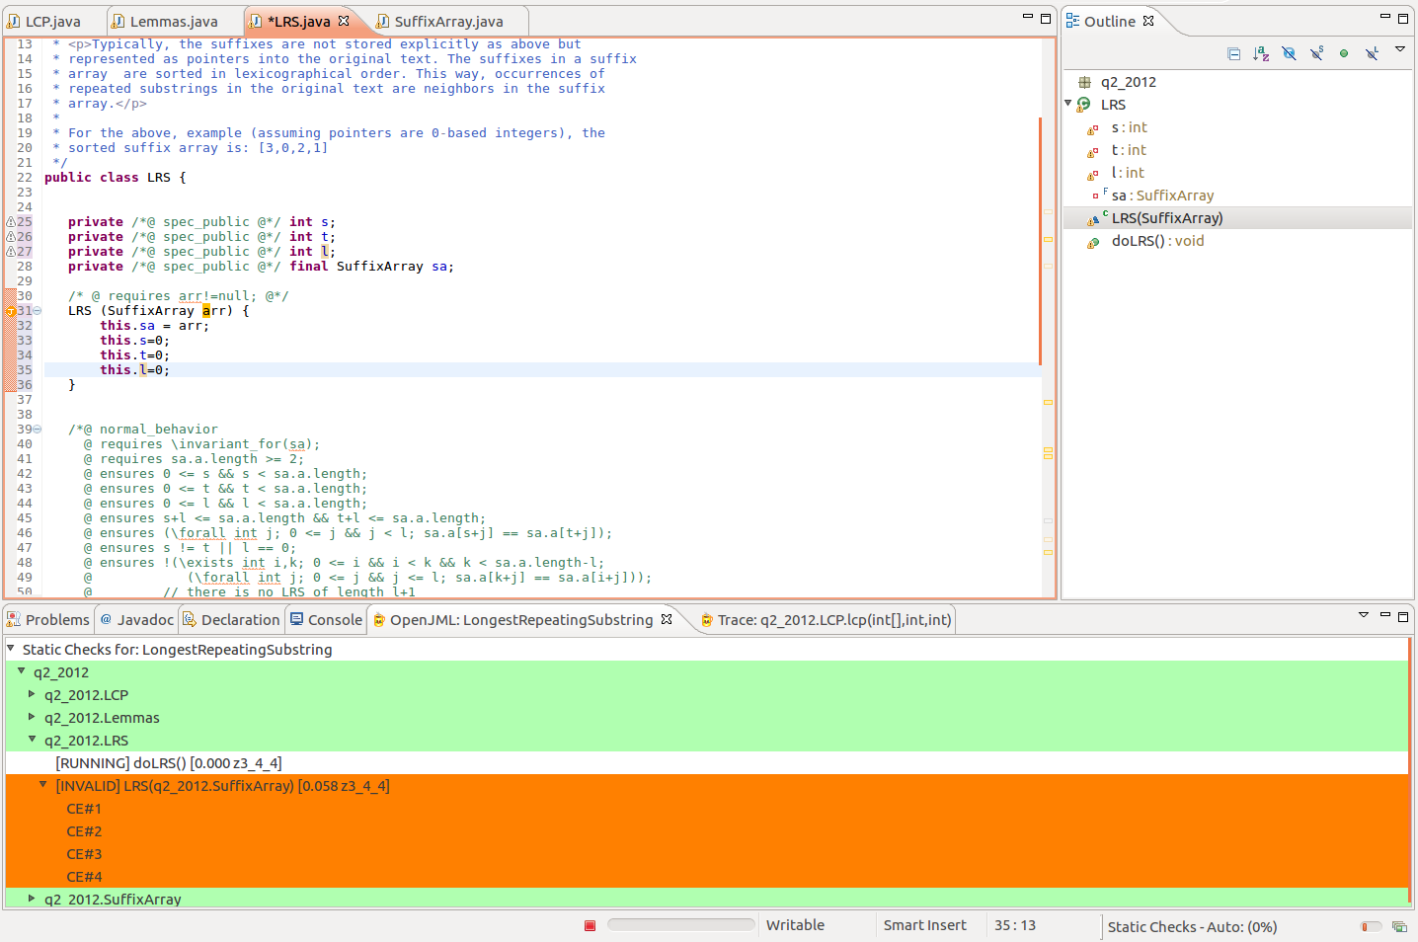

### SuffixArray

Type Checking

* Errors
  + \strictly_pure --> pure
  + Loop specifications must immediately precede method
  + Lines 99,100: Non-static fields are not allowed in \old environments in postconditions: data
  + Method syntax: private void /*@ helper @*/ sort --> private /*@ helper @*/ void sort

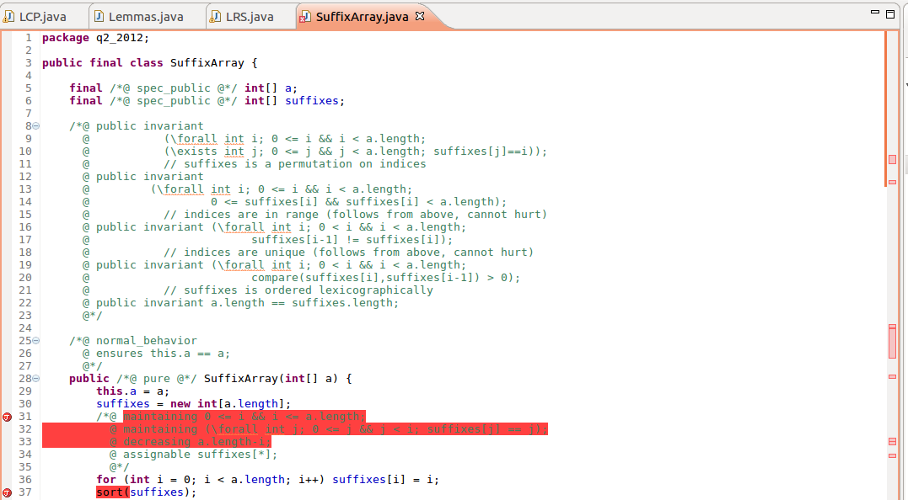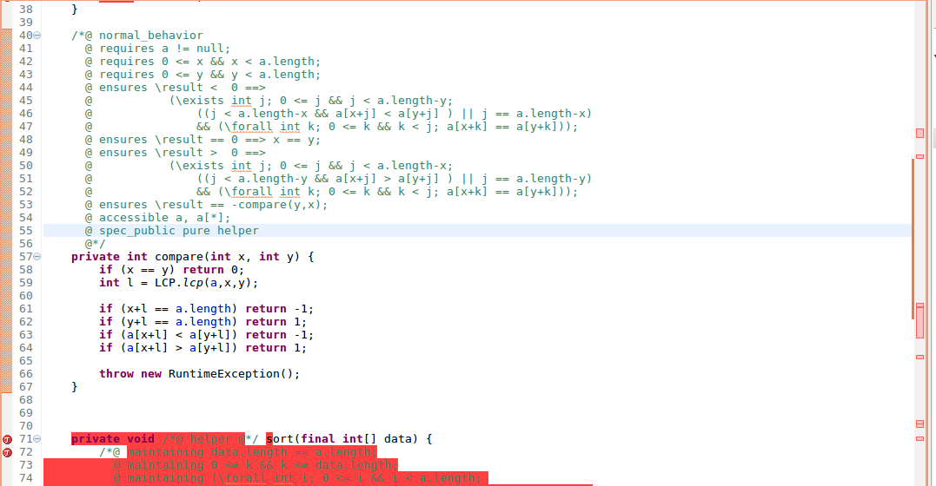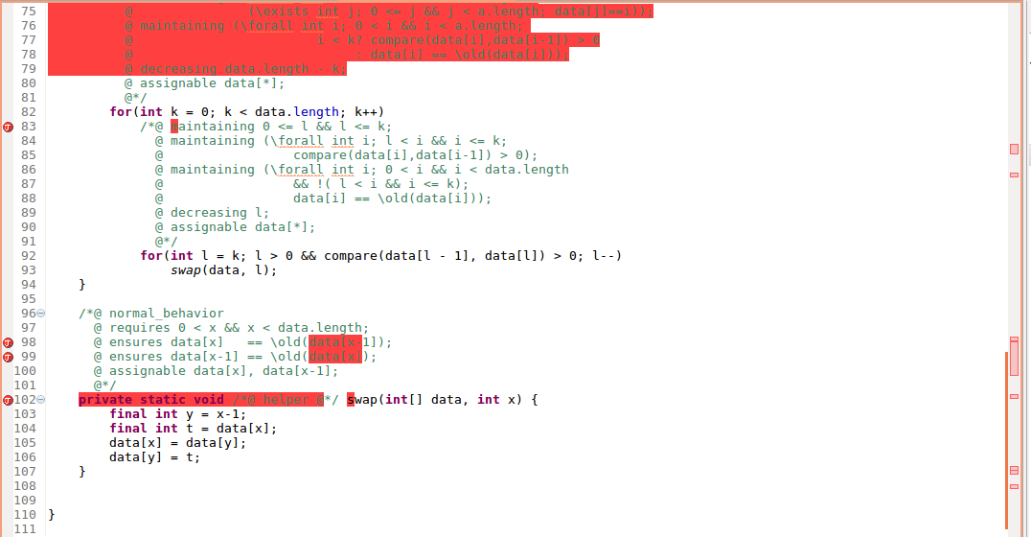

RAC

* No Errors

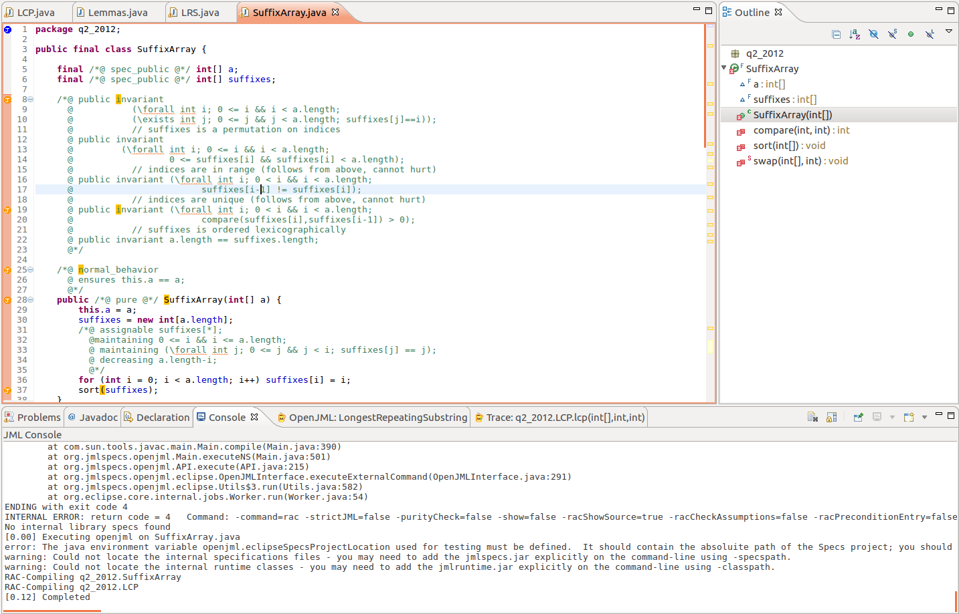

ESC with z3

KeY Tool

OpenJML