PNC Branch Loan Pipeline Tracker
User Requirements Specification / Functional Specification
A loan application intake & officer performance tracking tool for PNC branch staff
Team | Team PNC Pipeline
Live URL | https://pnc-pipeline-demo.hostinger.com
Version / Date | v1.0 / April 16, 2026
Course | GMBA 612 — Web & Database Applications
Team Roles | [Name 1] — DB/SQL | [Name 2] — PHP/Frontend | [Name 3] — QA/Docs

Contents
Contents 1
1) Business Context & Problem 1
2) Objectives & Success Metrics 1
3) Users & Scenarios 1
4) Scope — In / Out 1
In Scope 1
Out of Scope 1
5) Data Model 1
Key Data Rules 1
6) Functional Requirements (User Stories) 1
7) Report Specifications 1
Report A: Operational Report 1
Report B: Summary / Analytics Report 1
8) Non-Functional Requirements 1
9) Test Plan Mini-Matrix 1
10) Implementation Notes & GenAI Use 1
11) Risks & Assumptions 1
Appendix: Screenshots 1
Presentation Template (6–7 Slides) 1

1) Business Context & Problem
PNC Bank branches process dozens of consumer loan applications every week — personal loans, auto loans, and home equity lines. Today, loan officers track these applications across email threads, shared spreadsheets, and paper folders, which causes applications to get "stuck" without follow-up. Customers wait 5–7 business days just to hear back on status, and branch managers have no clear view of which officers are closing applications quickly vs. letting them stall.
This project delivers a lightweight web app that lets branch staff manage loan officers and loan applications in one place, and gives managers two reports: a "Today's Pending Applications" dispatch view and a "Top 5 Loan Officers This Week" performance view. The goal is to shorten application response times and give branch leadership real visibility into officer performance.

2) Objectives & Success Metrics
Success is measured by three specific, testable outcomes:
• Reduce average customer response time from 5–7 business days to less than 2 business days by ensuring all applications are tracked and visible in one system
• Branch staff can add, edit, and delete loan officers and loan applications with zero data-entry errors during demo testing due to enforced input validation rules, with validation preventing invalid phone numbers, loan amounts, and duplicate SSNs
• The "Today's Pending Applications" report loads in under 3 seconds and shows only applications submitted today with status = pending, while the "Top 5 Loan Officers This Week" report correctly ranks officers by approved applications (ties broken by total funded amount)

3) Users & Scenarios
Two primary user roles interact with the system:
User Role | Primary Tasks | Goal
Branch Loan Coordinator | Intake new loan applications; assign applications to loan officers; update application status (pending, approved, rejected); maintain accurate application records | Keep the application pipeline moving, prevent delays, and ensure all applications are properly tracked
Branch Manager | View "Today's Pending Applications" to identify stalled cases; review "Top 5 Loan Officers This Week" to evaluate performance; monitor workload distribution | Reduce application delays, improve response time, and evaluate loan officer productivity

4) Scope — In / Out

In Scope
- Full CRUD (Create, Read, Update, Delete) functionality for Loan Officers
- Full CRUD functionality for Loan Applications
- Operational report: “Today's Pending Applications” (filtered by status = pending and submission date = today)
- Summary report: “Top 5 Loan Officers This Week” (ranked by approved applications and total funded amount)
- Secure database interactions using PDO prepared statements
- Server-side validation including required fields, numeric constraints, and unique SSN enforcement

Out of Scope
- Customer-facing loan application submission portal
- Credit score retrieval or external FICO/credit bureau integration
- Document upload, verification, or e-signature workflows
- Multi-branch system architecture or role-based authentication (SSO/login system)
- Integration with PNC core banking or external financial systems

5) Data Model
The application uses two related tables. [Paste ERD image in the space below before submitting.]
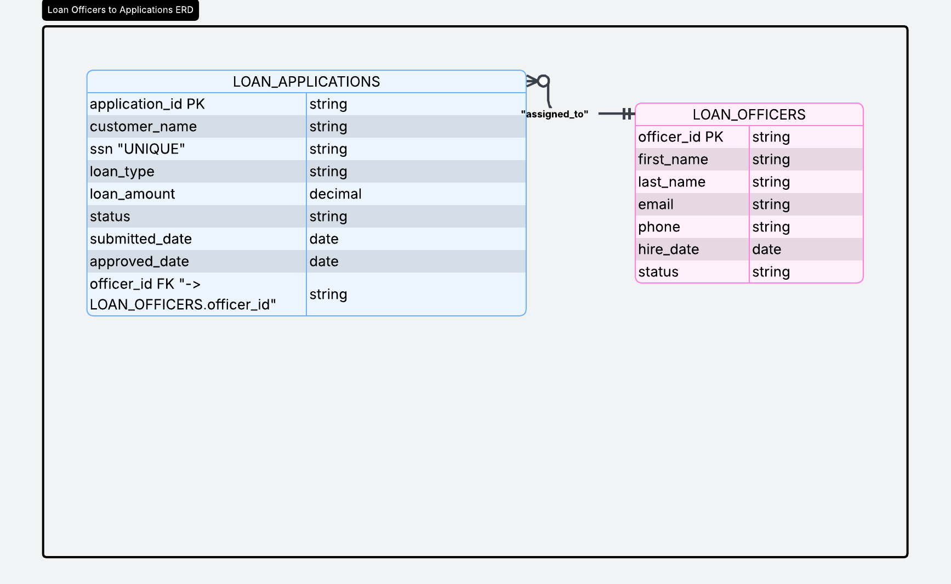

Key Data Rules
- Each Loan Application is assigned to exactly one Loan Officer (foreign key constraint on officer_id)
- A Loan Officer can manage multiple Loan Applications (1:M relationship)
- SSN must be unique across all Loan Applications to prevent duplicate customer records
- Loan status must be restricted to: pending, approved, rejected
- Loan amount must be a positive numeric value greater than zero

6) Functional Requirements (User Stories)
Five user stories with acceptance tests:
# | User Story | Acceptance Test
1 | As a Branch Loan Coordinator, I can create a new loan application so that customer requests are recorded in the system | Enter valid data → record is saved; invalid inputs (e.g., negative loan amount) are rejected with error message
2 | As a Branch Loan Coordinator, I can update the status of a loan application so that progress (pending, approved, rejected) is accurately tracked | Change status → saved successfully and persists after page refresh
3 | As a Branch Loan Coordinator, I can assign a loan application to a loan officer so that responsibility is clearly defined | Select officer → assignment saved and visible in application record
4 | As a Branch Manager, I can view "Today's Pending Applications" so that I can identify applications requiring immediate action | Report shows only today's records with status = pending
5 | As a Branch Manager, I can view "Top 5 Loan Officers This Week" so that I can evaluate performance and recognize top performers | Report ranks officers correctly by approved applications with top 5 displayed

7) Report Specifications
Each report is specified as a business tool — not just a query. The spec captures WHO uses it, WHAT question it answers, and WHAT decision it enables.

Report A: Operational Report
Answers: "What do I need to act on RIGHT NOW?"
Report Name | Today's Pending Applications
Business Question | Which loan applications submitted today still need officer action?
Business User | Branch Loan Coordinator
Decision Enabled | Assign or reassign applications to available officers; escalate any that are sitting too long.
Columns Displayed | Application #, Applicant Name, Loan Type, Loan Amount, Submitted Time, Assigned Officer, Status
Default Filter | submitted_date = CURDATE() AND status = 'pending'
Sort Order | Submitted Date ASC (oldest first, so the most-waiting applications are on top)

Report B: Summary / Analytics Report
Answers: "How are we doing OVERALL?"
Report Name | Top 5 Loan Officers This Week
Business Question | Which loan officers closed the most approved applications this week, and what's their total funded volume?
Business User | Branch Manager
Decision Enabled | Recognize top performers in weekly huddle; identify officers who may need coaching or lighter pipelines.
Columns Displayed | Officer Name, Approved Count, Total Funded ($)
Default Filter | approved_date within current ISO week AND status IN (‘pending’, ‘approved’, ‘rejected’)
Sort Order | Approved Count DESC, then Total Funded DESC — LIMIT 5

8) Non-Functional Requirements
Category | Requirement
Security | All database interactions use PDO with prepared statements to prevent SQL injection; database credentials are stored in a separate configuration file
Validation | All required fields must be completed; numeric fields (loan amount) must be positive; SSN must be unique; invalid inputs return user-friendly error messages
Performance | System supports at least 50–100 loan application records; all reports load in under 3 seconds
Error Handling | System displays clear, user-friendly error messages; no raw SQL errors or stack traces are shown to users
Usability | The interface must be simple and intuitive, allowing users to create, update, and view records with minimal training; forms include clear labels and instructions; reports are easy to read with meaningful column names
Data Integrity | Foreign key constraints ensure every loan application is linked to a valid loan officer

9) Test Plan Mini-Matrix
Feature | Test Data | Expected Result
Create Loan Officer | Name: Sarah Kim, employee_id: PNC-4471, phone: 4125550199, status: active | Record saved; success message displayed; officer appears in list and in application assignment dropdown
Duplicate employee_id | Attempt to create another officer with employee_id: PNC-4471 | Error message: “Employee ID already exists”; record is not saved
Create Loan Application | Applicant: John Doe, SSN: 123-45-6789, loan_type: auto, loan_amount: 28,500, officer: Sarah Kim | Record saved with status = pending and submitted_date = today
Duplicate SSN | Enter SSN: 123-45-6789 for a new application | Error message: “SSN must be unique”; record is not saved
Invalid Loan Amount | loan_amount: 500,000 | Validation error: “Loan amount must be between $1 and $250,000”; record is not saved
Update Application Status | Change status from pending to approved | Status updates successfully and persists after refresh
Today's Pending Report — empty day | No applications submitted today | Report displays: “No pending applications for today” (not blank)
Top 5 Officers — fewer than 5 | Only 3 officers have approvals this week | Report displays 3 officers ranked correctly; no empty rows shown

10) Implementation Notes & GenAI Use
The team used generative AI tools throughout the system development process. All AI-generated outputs were reviewed, tested, and modified to ensure alignment with project requirements and database design rules.
• ChatGPT (OpenAI): Used to generate initial MySQL table structures and PHP CRUD templates using PDO prepared statements. The output was modified to ensure compatibility with phpMyAdmin, enforce correct data types (e.g., DECIMAL precision for loan_amount), and align status values with system constraints (pending, approved, rejected).
• ChatGPT: Assisted in designing SQL queries for reports including “Today's Pending Applications” and “Top 5 Loan Officers This Week.” These queries were adjusted to ensure correct filtering logic and consistency with the defined database schema.
• Claude: Used to validate database design and business rules. Suggestions were reviewed and selectively applied, such as improving constraint definitions (UNIQUE SSN, employee_id) and refining field naming consistency across tables.
• GitHub Copilot: Used during PHP development to assist with CRUD scaffolding and form handling. All generated code was reviewed and simplified to ensure proper use of prepared statements and secure database interactions.
All AI-generated outputs were adapted to meet course requirements, ensure consistency with relational database principles, and maintain functional correctness across CRUD operations and reporting features.

11) Risks & Assumptions
Type | Description | Mitigation / Note
Risk | Hosting environment (e.g., Hostinger) may use a different PHP version than local XAMPP, causing compatibility issues during deployment or demo | Ensure compatibility with standard PHP 8.x syntax and test the application on the hosting environment before final submission
Risk | System may fail during live demonstration due to hosting or internet connectivity issues | Prepare a local XAMPP version as a fallback and record a short (90-second) demo video as backup evidence
Risk | Insufficient or uneven seed data may cause inaccurate results in the “Top 5 Loan Officers” report | Use a controlled seed dataset with at least 8 officers and 30+ applications distributed across the current week
Assumption | The system uses a single shared administrative account without login or role-based authentication | Acceptable for academic scope; a production system would include authentication and role-based access control (RBAC)
Assumption | The system operates within a single time zone (Eastern Time) | Simplifies date-based filtering using CURDATE(); multi-branch deployment would require timezone-aware date handling

Appendix: Screenshots
Add screenshots here showing the working app before submission. Required: phpMyAdmin tables, both CRUD pages, and both reports with sample data.
Screenshot 1: Database Tables (phpMyAdmin)
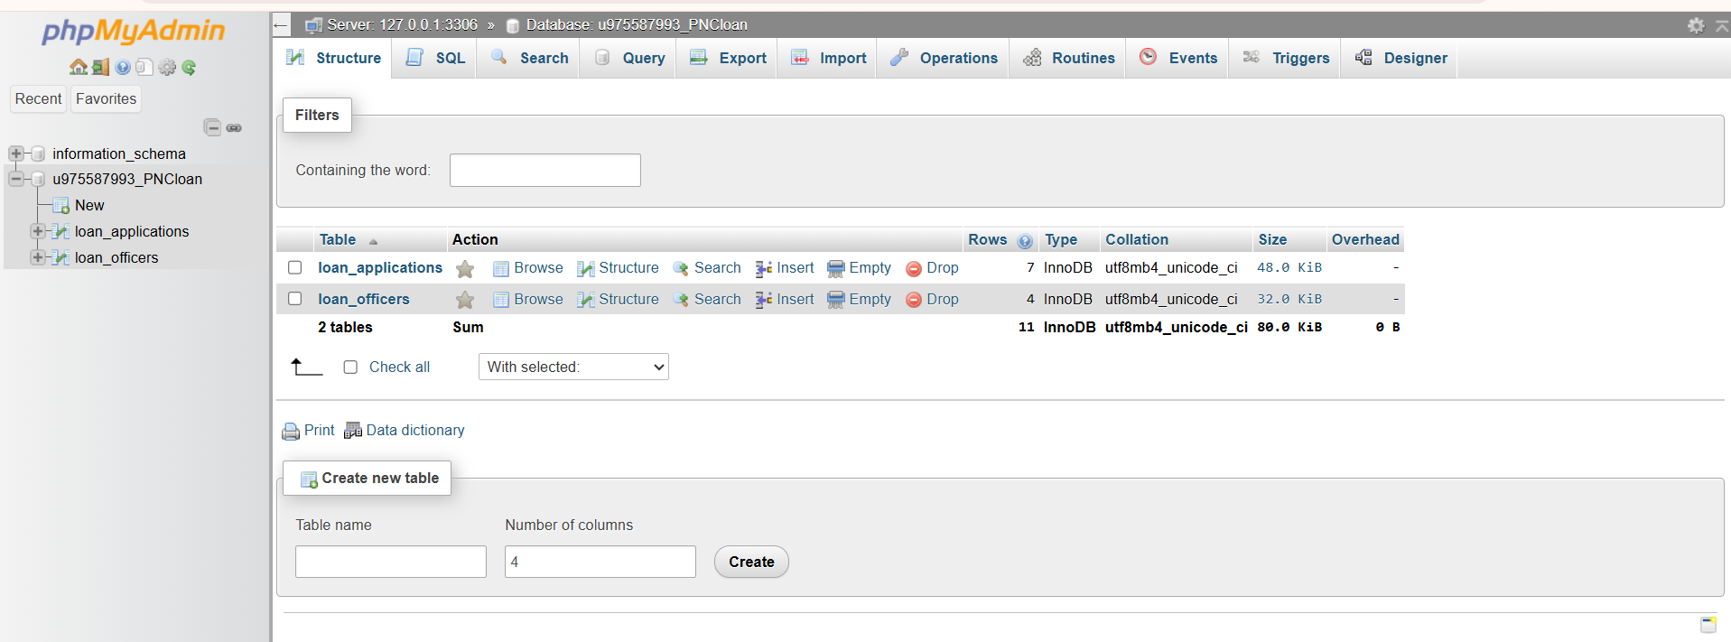Screenshot 2: CRUD Page — Loan Officers
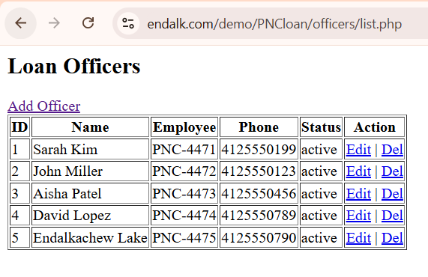
Screenshot 3: CRUD Page — Loan Applications
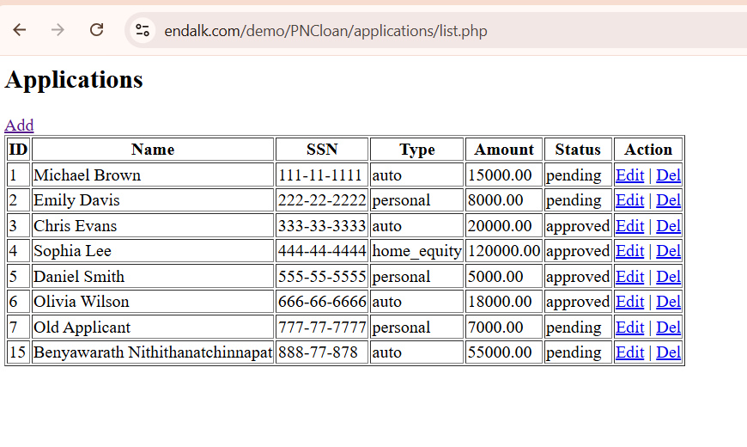 Screenshot 4: Operational Report — Today's Pending Applications (with data)
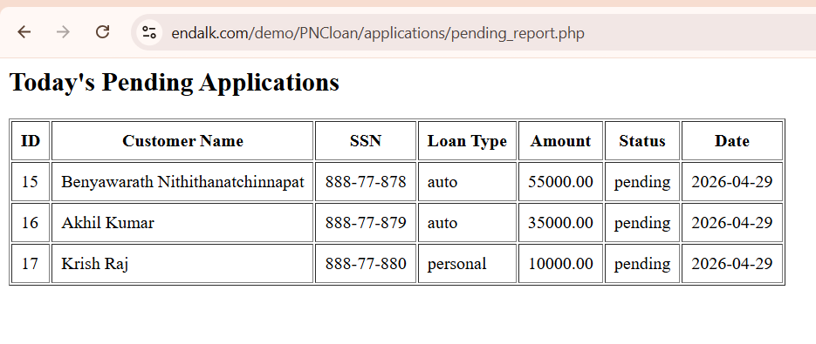Screenshot 5: Summary Report — Top 5 Loan Officers This Week (with data)
