

Spike’s Rewritten Guide

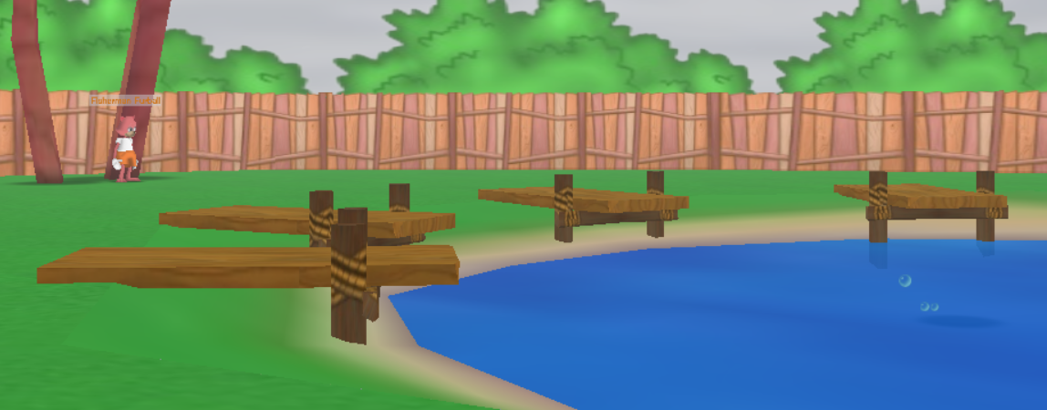A toon can fish at any available fishing pond in any of the playgrounds and streets in Toontown Rewritten. Ponds can be recognized with four docks surrounding an area of water with shadow circles swimming around, as pictured below.



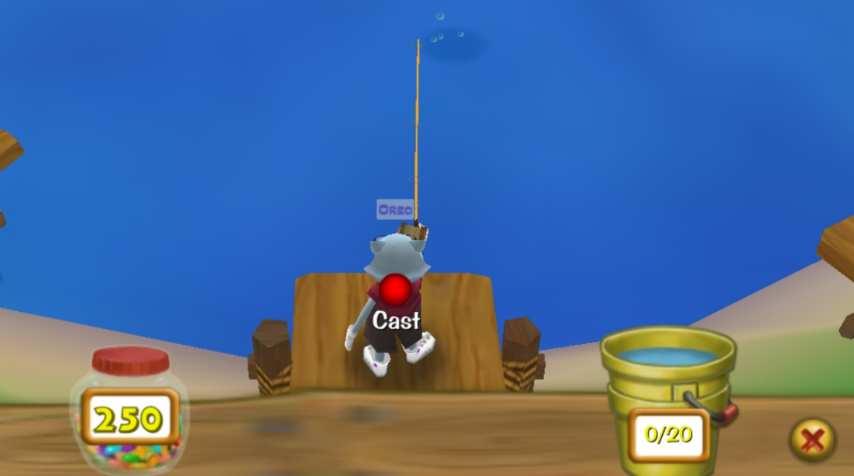To begin fishing, walk on top of one of the four fishing docks. Upon walking on top of the chosen dock, the fishing dashboard should appear, and your toon should be holding their fishing rod.

The fishing dashboard is a tool that helps keep track of how many fish are caught, when the fishing bucket should be sold, and how many jellybeans are left to use as bait. The fishing bucket is displayed on the right, showing a capacity of 20. Once the bucket is 20/20, a toon cannot continue fishing until the fish are sold. On the left is the jellybean jar, showing how many jellybeans are left to use as bait for fishing. Once that reaches 0, a toon must go get more jellybeans to fish more.



To throw a fishing line, click on the Cast button. Click and pull back to maneuver the arrow to point in the direction you want to throw a fishing line. The redder the arrow is, the farther the fishing line will be thrown.

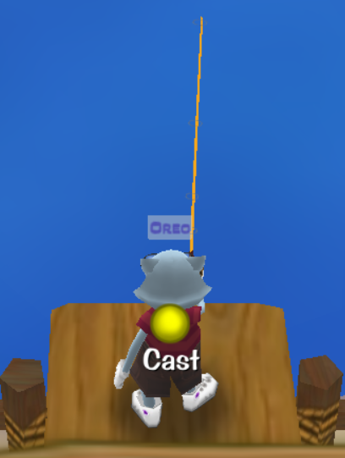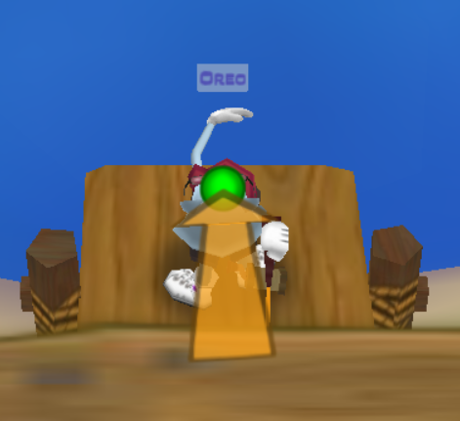

To sell your fish, approach the Fisherman that is standing next to any pond (or the yellow fishing bucket at the toon estate pond).

A screen will appear that shows all the fish caught in the bucket and the total worth of the bucket. To sell the bucket, select “Sell All.” Once capacity is reached, the fishing bucket must be sold to continue catching fish.

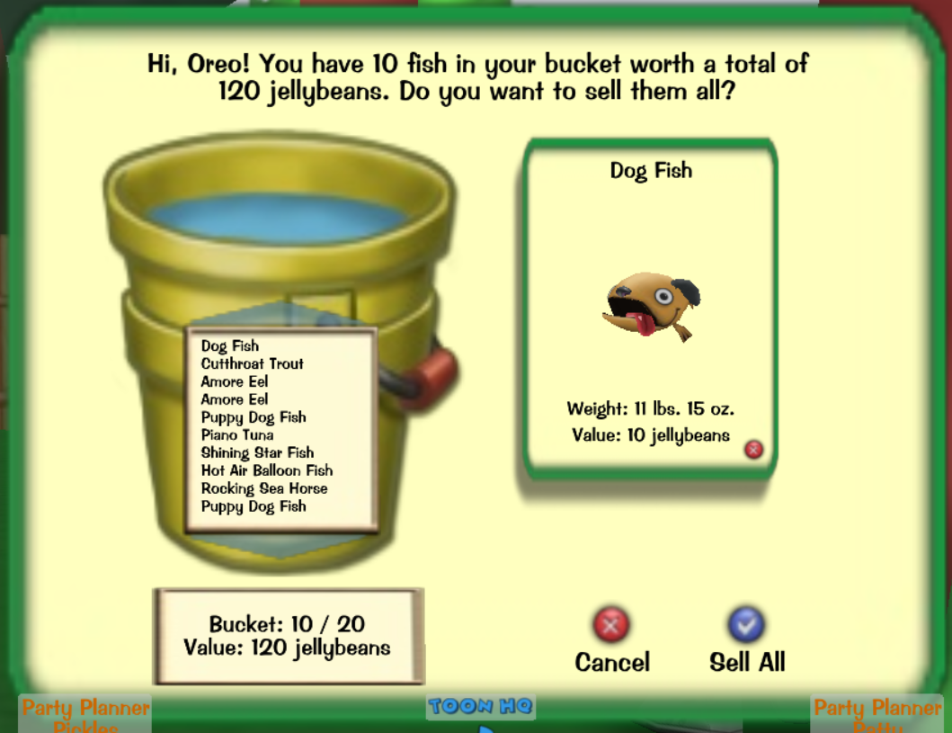



*Happy Fishing! ~Spike*