

Spike’s Rewritten Guide



To begin planting flowers, approach one of the flower spots surrounding the toon estate. Upon approach, an option to plant a flower will appear in a box panel to the left of the screen. Click “Planet Flower” to start planting a flower.



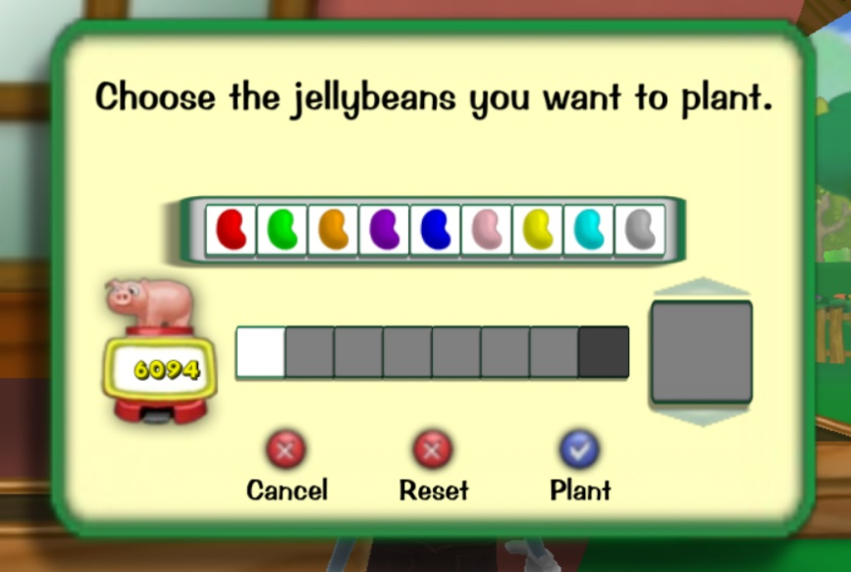After clicking “Plant Flower,” the jellybean chooser will appear.



Select the jellybean colors to generate a jellybean combination of the desired plant species. Jellybean combos can be found on the Gardening page on Spike’s Rewritten Guide website. Click “Plant” to plant the flower.

After planting a flower, do not forget to water it! It will wilt over and never grow.



The following day, the flowers planted will be fully grown and will be ready to harvest! To pick a flower, approach the flower and select “Pick” in the left side panel that appears.



To sell the flowers collected in the flower basket, approach the wheelbarrow in the sandy area in the toon neighborhood (close to the red and yellow estates).

A screen will appear that shows all the flowers collected and the total worth of the basket. To sell the basket, click “Sell All.” The basket capacity is 20 flowers, so flowers must be sold once capacity is reached, in order to continue picking flowers.

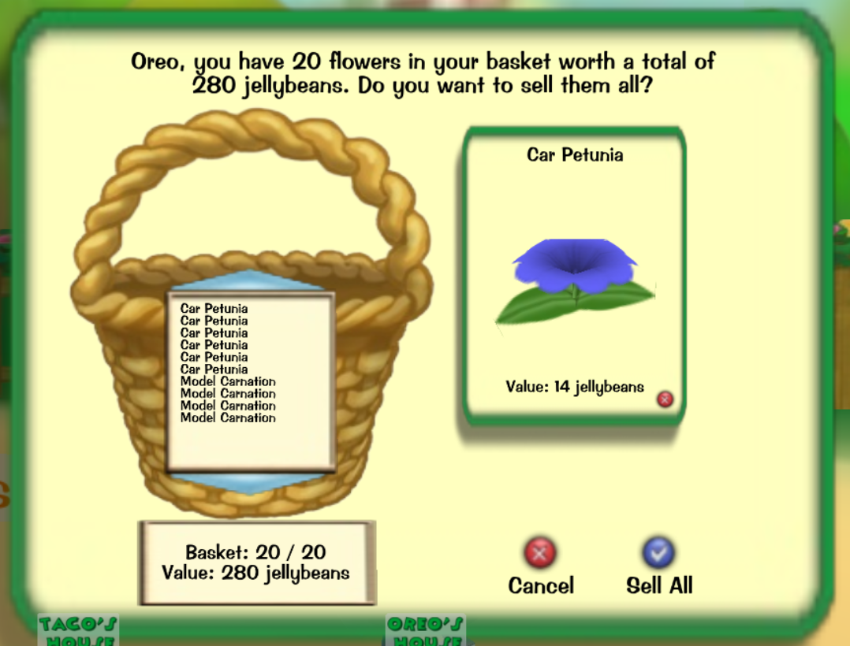





To plant a gag tree, approach a dirt mound that can be found in the surrounding property of a toon estate. Click “Plant Tree” to start planting a gag tree.



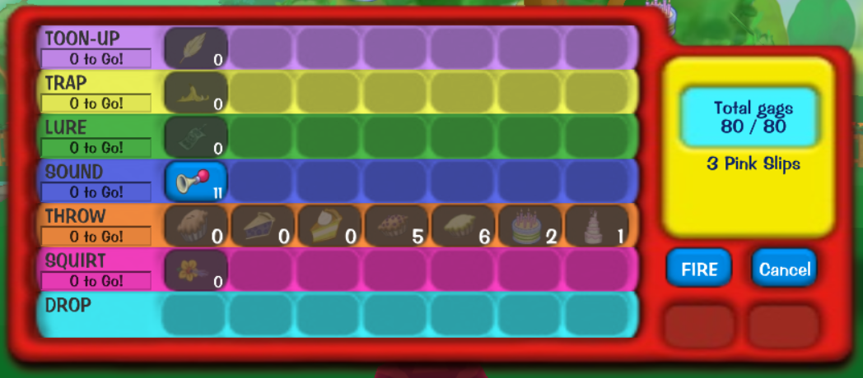After clicking “Plant Tree,” the gag chooser will appear, which looks very similar to the gag table in the Shticker Book!

When starting out, only level one gags can be planted. But after planting a level one gag, i.e. a Bike Horn, the next tree planted can be the level 2 gag of the same track, i.e. Whistle.

To plant the desired gag, simply click the gag in the gag chooser. Plantable gags will be blue.

Just like planting flowers, after planting a gag tree, do not forget to water it! It will not grow and will wilt over.

The higher level gag trees planted take a longer amount of time to grow than the lower level gag trees. The following chart is a great reference when determining how long a newly planted gag tree will take to completely grow and be harvested.

|  |  |
| --- | --- |
| Gag Level | Number of Days to Grow |
| 1 | 3 |
| 2 | 6 |
| 3 | 9 |
| 4 | 12 |
| 5 | 15 |
| 6 | 18 |
| 7 | 21 |

*Happy Gardening! ~Spike*