Write an automated test, following the steps listed below. Use the **Selenium WebDriver** framework and supported **language of your choice** (e.g. Java, C#, Python), with the appropriate **test framework** (e.g. JUnit, NUnit, TestNG). Structure your code and organize your files as you would in any real project. Archive all files used together and submit the archive.

Steps:

1. Navigate to <https://www.amazon.com/>

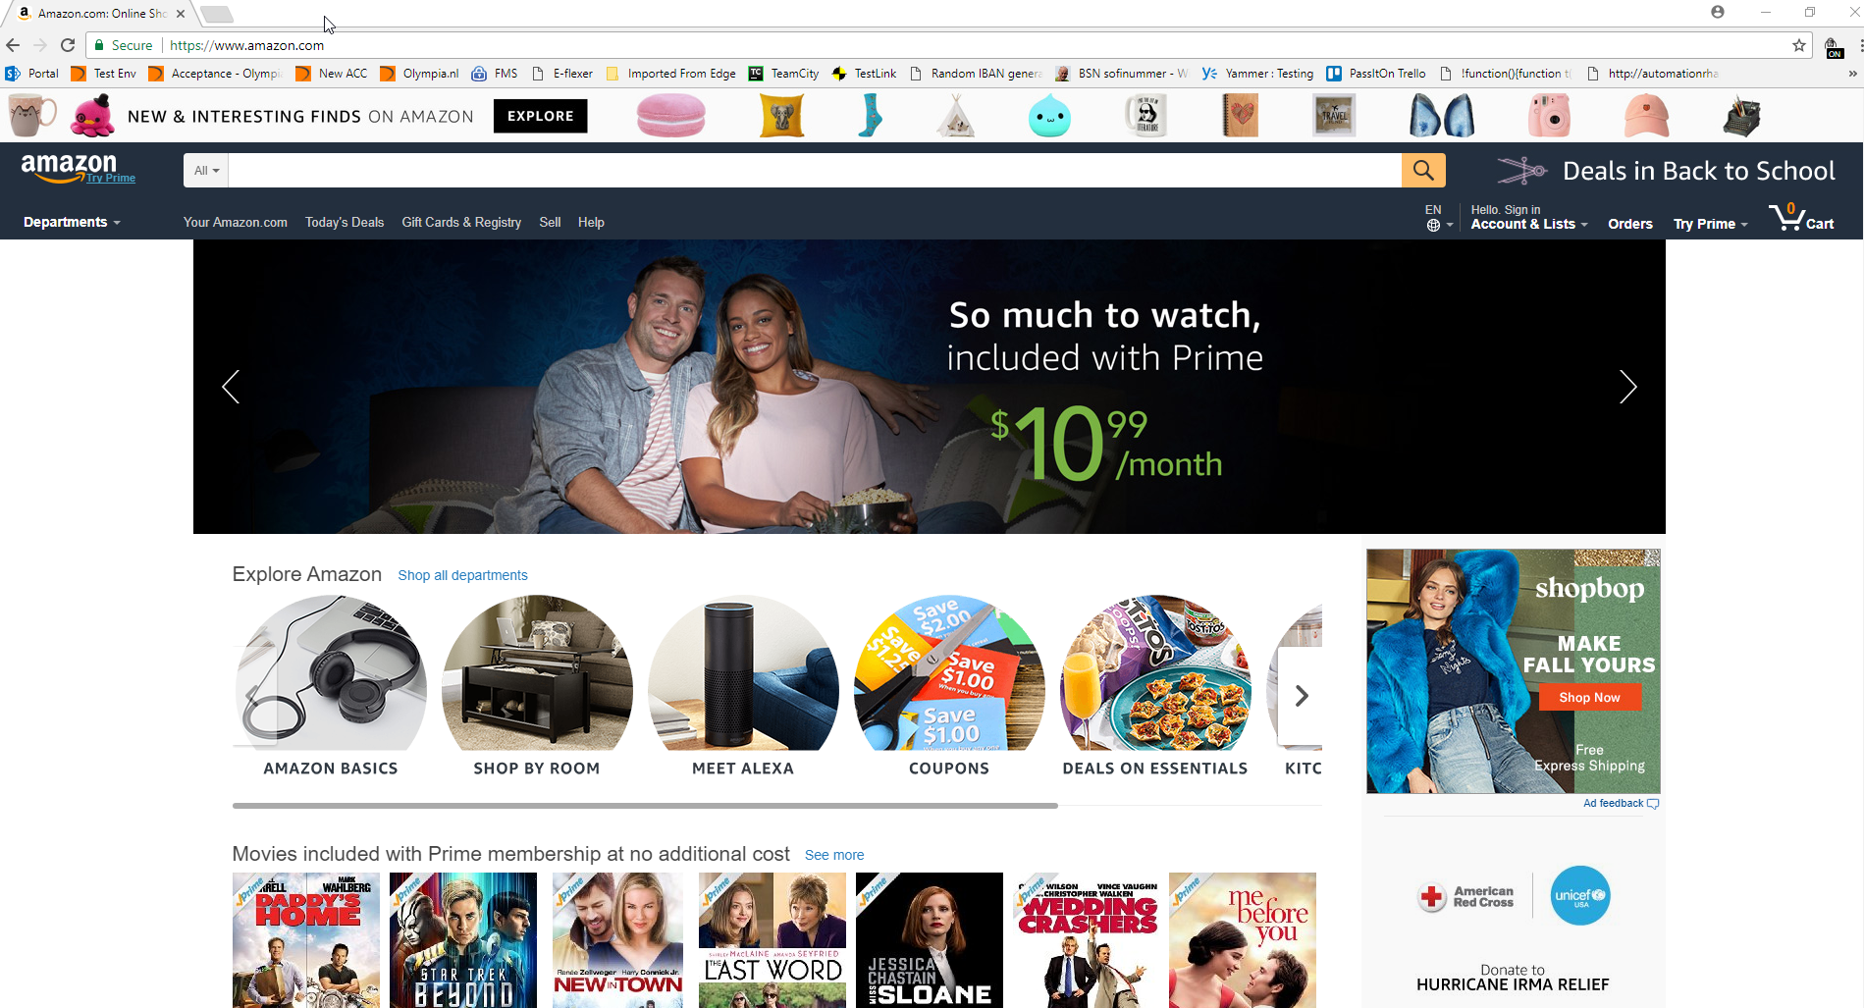

1. In the “Search” text field, enter “Harry Potter” and click the search button to perform a search.

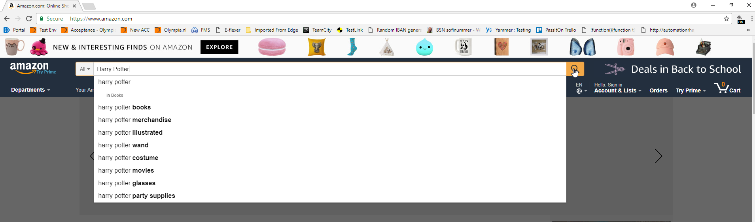

1. Expand the departments list by clicking on “See All # Departments”

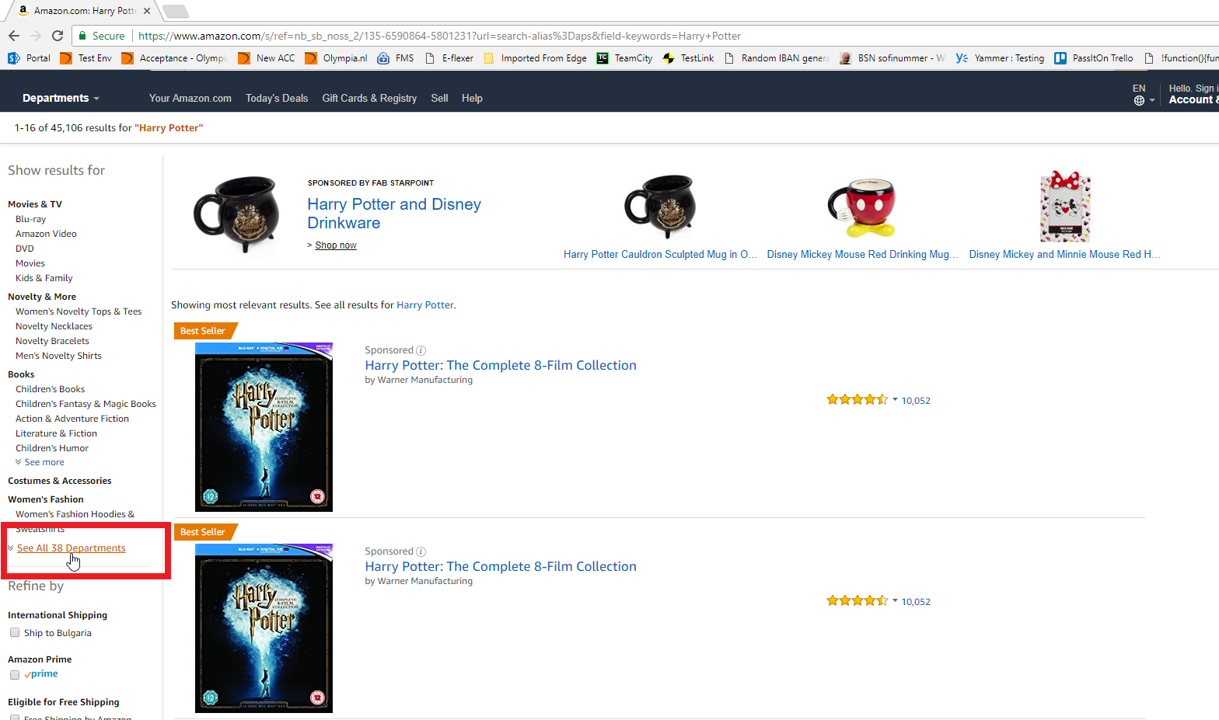

1. Click on the “Video Games” category to filter the results.

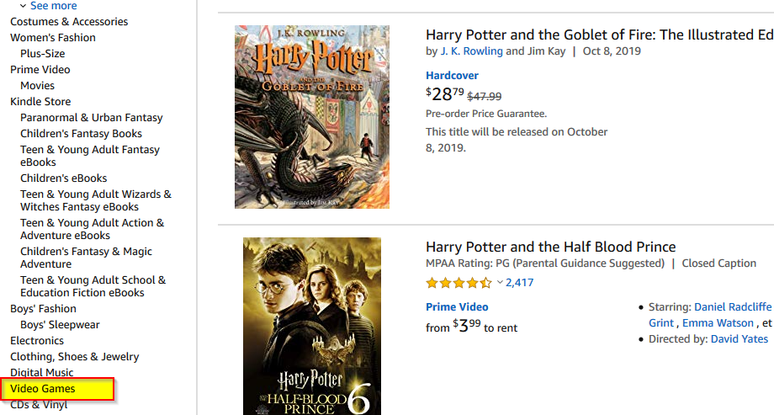

1. Further down, find the “Price” section, and enter 10 in the min price and 150 in the max price text boxes, then click “Go” to apply the changes.

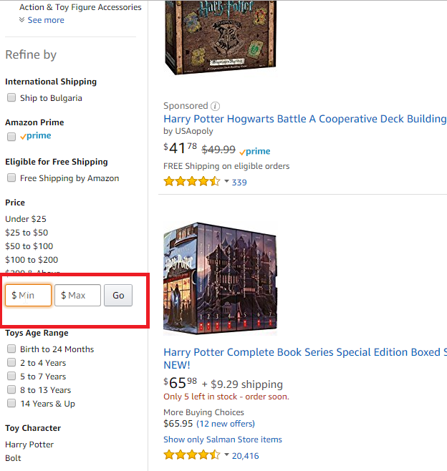

1. From the “Brand” section select the “Warner Bros” checkbox.

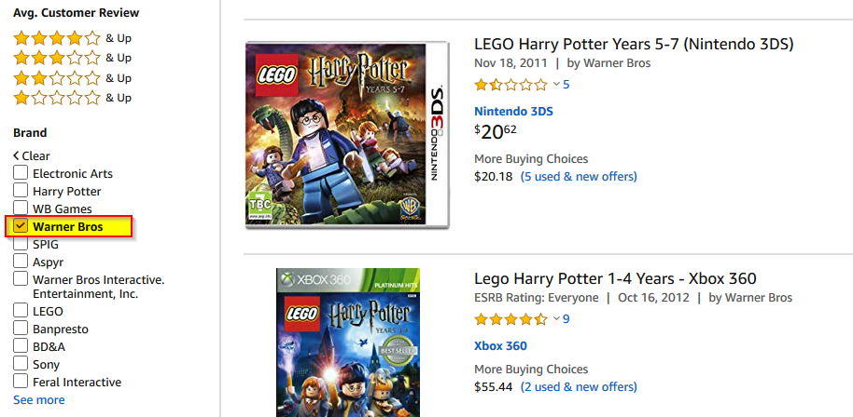

1. Click on the **FIRST** result link to open a product details page.

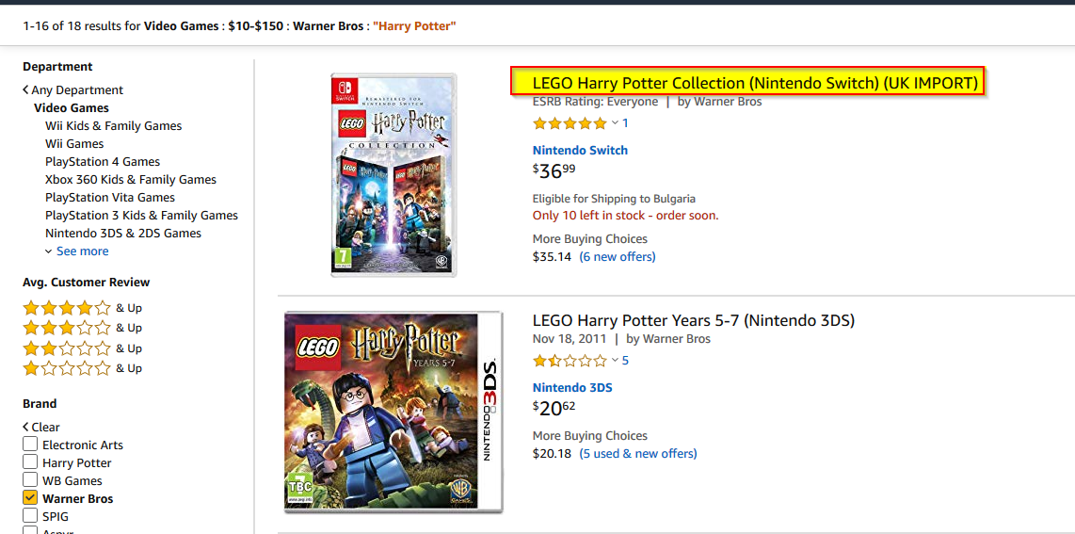

1. From the “Qty” dropdown select a number that is different from 1, e.g. 4.

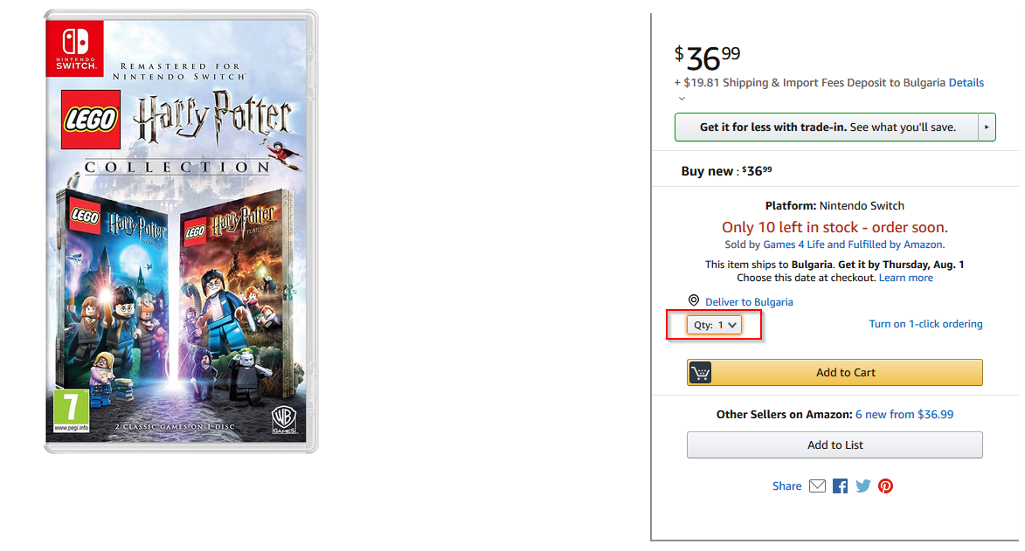

1. Click the “Add to cart” button.

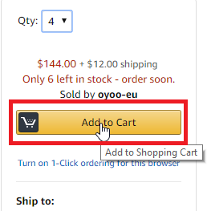

1. Click on the “Cart” button to view the contents of the cart.

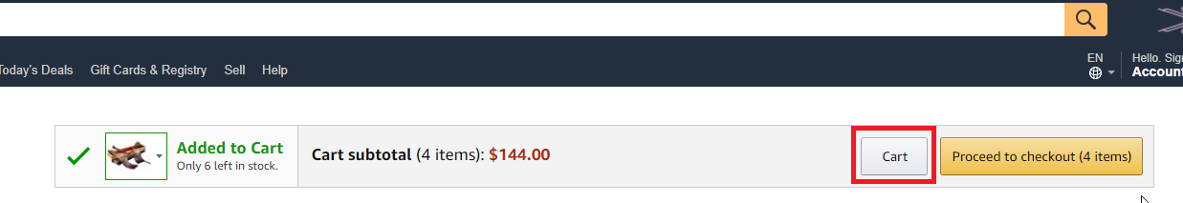

1. **Assert that the item in the shopping cart is the same item selected in the previous steps.** (Use whatever assert statement you deem most appropriate).
2. **Assert that the calculated subtotal price is correct.** (Use whatever assert statement you deem most appropriate).