|  |  |
| --- | --- |
|  | **School of Engineering** |

|  |  |  |
| --- | --- | --- |
| **ELC333-L1** |  | **Spring 2020** |

**Lab 1**

**Basic Operational Amplifier Circuit**

**Date: February 17th, 2020**

**Submitted by: Jeffrey Blanda, Alexander Bolen, Miguel Flores**

**Instructor: Joseph Jesson**

**1. Introduction (JB)**

## **1.1 Objectives:**

* Re-familiarize using Pspice to create and test circuit diagrams.
* Become comfortable with the new laboratory and equipment.
* Design, construct, and test a multi-stage operational amplifier circuit that meets the design requirements described in the lab.

## **1.2 Importance:**

Creating a reliable circuit using amplifiers to detect a change in voltage or current can be extremely important in applications such as smoke detectors, where a failure could be lethal. Amplifiers are still used in many analog sensors and understanding how to use them is fundamental to electrical engineering.

## **1.3 Theory:**

Operational amplifiers are amplifiers with an ideally infinite open-loop gain and infinite input resistance, amplifying the sum of the first input and the inverse of the second input. A negative feedback can give the amplifier a closed-loop gain that isn’t infinite, determined by one of the equations below.

$$A=1+\frac{R_{2}}{R_{1}} for a voltage input on V1 (non-inverting)$$

$$A=1-\frac{R_{2}}{R_{1}} for a voltage input on V2 (inverting)$$

**2. Materials and Devices (JB)**

* uA741 Operational Amplifier
* uA741 Data Sheet
* Various Resistors and wires
* VirtualBench Power supply, oscilloscope, and multimeter
* Quad Power Vdc source with ±12v rails

**3. Procedure and Analysis (JB, MF, AB)**

**Step 1:** Design an alarm that informs the user when the current drawn by a load $R_{L}$ exceeds the nominal value $i_{L_{nom}}$ of 50mA by 10% or more.

* 1. Determined that using a voltage divider, a voltage can be computed using known resistance values when the current exceeds 55mA (50mA * 110%)
  2. Using an $R_{L}$ value of 250Ω and an $R_{M}$ value of 10Ω the nominal voltage can be found using Ohm’s law.
     1. V = I * R
     2. Vs = (260Ω) * (0.055A) = 14.3 V
  3. Using a voltage divider equation, the voltage of the output of the divider can be found.
 $V_{o}=V_{i}\frac{R_{M}}{R_{L}+R_{M}}$

 $V_{o}=14.3\frac{10}{260}$   1. = 0.55 V
  4. A non-inverting operational amplifier can be used with a negative feedback loop to amplify the voltage output from the voltage divider.
 $A=1+\frac{R_{2}}{R_{1}}$

 $A=1+\frac{2k}{1k}=3$

$V_{i}*A=V_{o}$

$0.55*3=1.65V$

5. A differential amplifier can be used with a power supply of 1.65V at the inverting input and the output from the first amplifier at the non-inverting input. This allows the amplifier to check if the output from the first amplifier is below the inverting input (resulting in a negative output voltage) or higher than the inverting input (resulting in a positive output voltage).
  6. After adding a high impedance resistor to lower the output voltage, two LEDs of different colors can be connected to the circuit in opposing polarities. Since LEDs are diodes, they only light up when current flows from their positive terminal to their negative terminal, allowing us to see if the voltage on the connected rail is positive or negative.

**Question #1:** Why is it important, to properly measure load current draw, that RM<< RL?

**Answer #1:** It’s important to properly measure load current draw thus that $R_{M}≪R_{L}$, as a value of $R_{M}$ will affect the normal current flow of the device and if $R_{M}$ is within a magnitude of 10 of $R_{L}$, the current across the load will be reduced, causing the circuit to not trip even if it should.

**Question #2:** Using the formula provided for $R_{L}^{nom}$ using $V_{s}^{nom}=12v$ and $I_{L}^{nom}=50mA$

**Answer #2:**

1. $R_{L}^{nom}=\frac{V_{s}^{nom}}{I_{L}^{nom}}-R_{M}$ (assume $R_{M}=0$)

$R_{L}^{nom}=\frac{12}{0.05}=240Ω$

**Question #3:** Calculate the nominal power dissipation of the load resistance (nomLP). Show all work, using one of the three equations below.

**Answer #3:** Using one of the formulas provided for power dissipation of load resistance

$P_{L}^{nom}={(I_{L}^{nom})}^{2}*R_{L}^{nom}$

$P_{L}^{nom}={\left(0.5\right)}^{2}*\left(240\right)=60W$

**Step 2:** Design a circuit, similar to that presented in Figure 1, to current drawn by the load (iL) and trigger one of two LED’s as defined below.

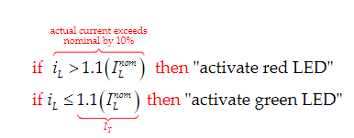

1. With the circuit values found and the process laid out for step 1, a circuit can be created. Using Pspice the circuit was built and tested. (Fig. 1)

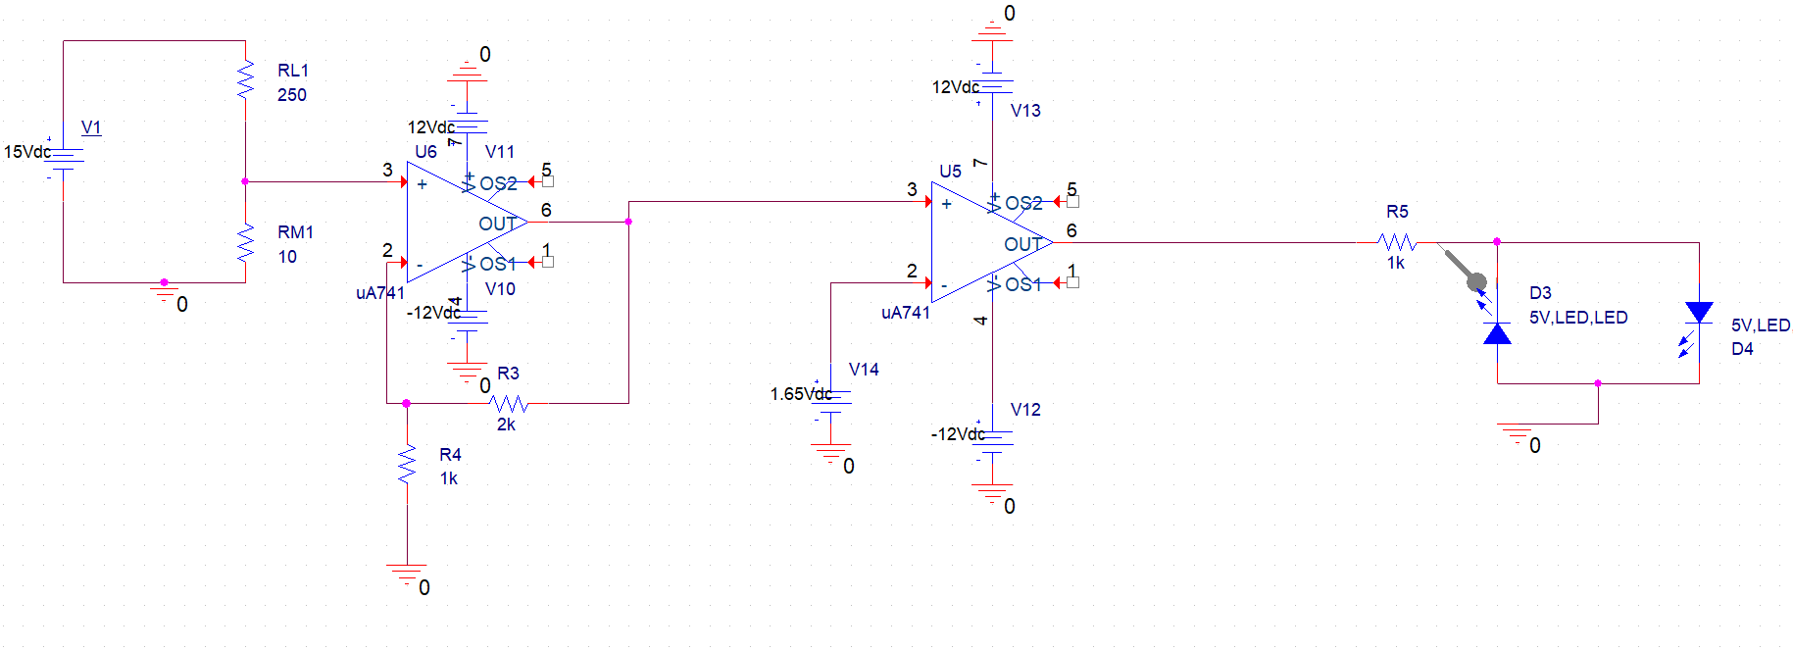

Figure 1. Pspice schematic for the design.

|  |  |  |
| --- | --- | --- |
|  | Ideal | Measured |
| Nominal Voltage | 14.3V | 13.85V |
| Resistance | 260Ω | 258.35Ω |
| Nominal Current | 55mA | 53.6mA |

Table 1. Ideal and Measured parameters

**Step 3:** Provide a sketch and brief explanation of design in the lab report. Define all parameters and component values.

1. The sketch is shown in Figure 1. The function of our design is that when a current greater than 55 mA passes through the circuit, the LEDs change from green to red. If the current is less than 55 mA, then the green LED stays lit.

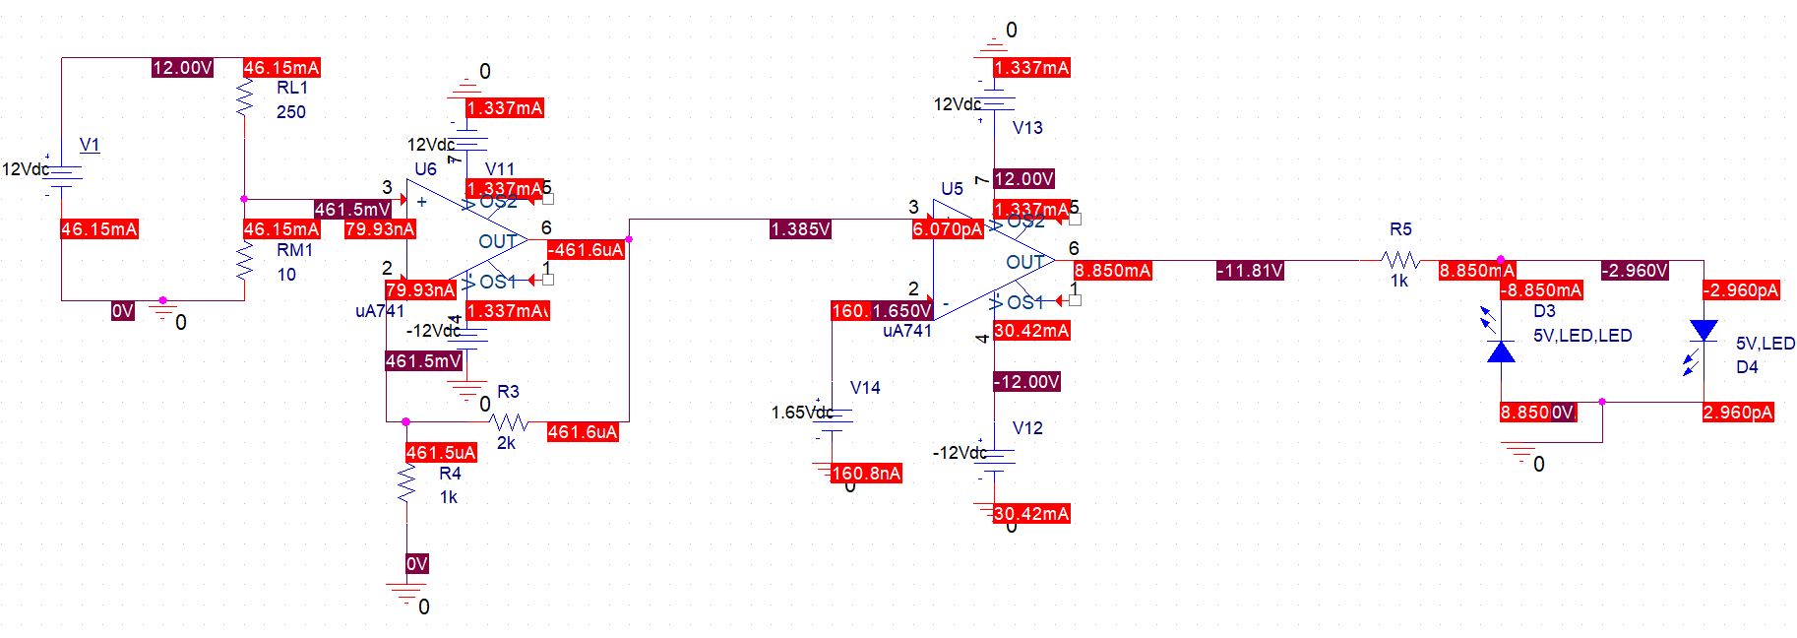

Figure 2. Pspice schematic for a 12v input showing voltages and currents at every node.

**Question #4:** Why should the user be concerned with excessive current draw?

**Answer #4:** The user should be concerned with excessive current draw since it produces heat, and the circuit could not function properly.

**Step 4:** Construct alarm circuit in PSpice. In the lab report, include a screenshot of this schematic.

1. See Figure 2 above.

**Step 5:** Perform “dc sweep” simulation in PSpice. Source voltage should range from vS= 6Vdc to vS= 18Vdc. In the lab report, include a graph demonstrating output voltage (vO) vs. load current draw (iL). Highlight on this graph when the alarm fires.

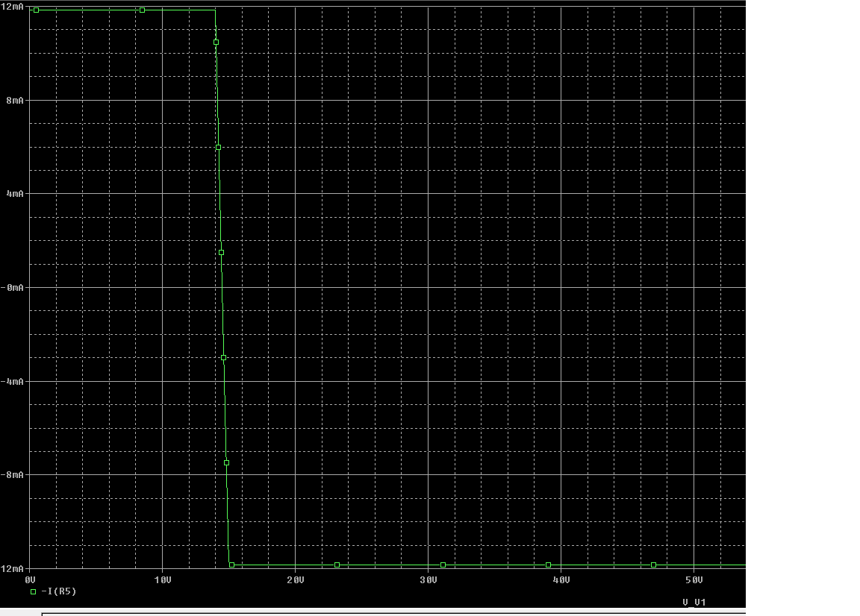

Figure 3. Pspice Simulation showing the behavior of the output of the circuit with a DC sweep parameter changing the voltage of the source Vs (Alarm goes off where highlighted)

**Step 6:** Construct the alarm circuit in hardware. A revised version of Figure 1 is provided below.

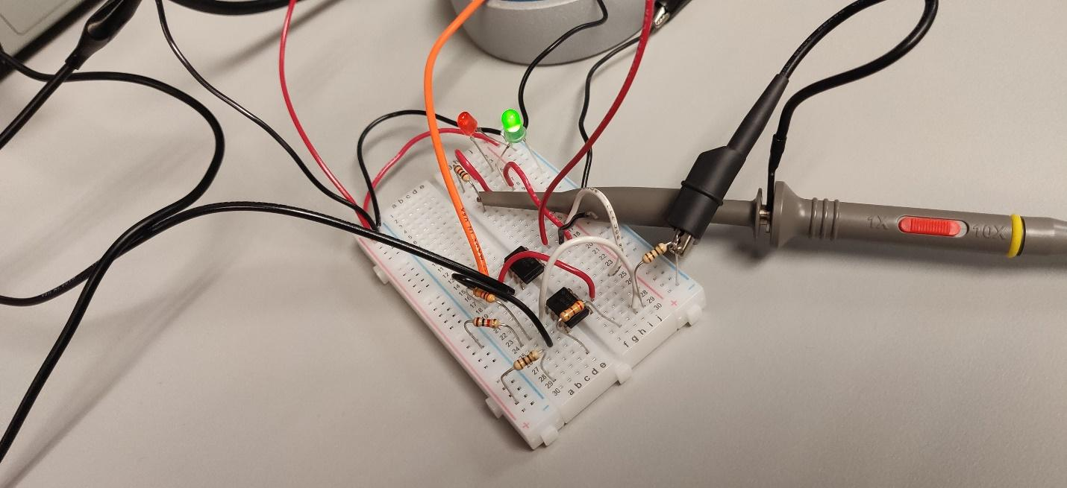

Figure 3. Circuit when $i_{L}<55mA$ (Green LED)

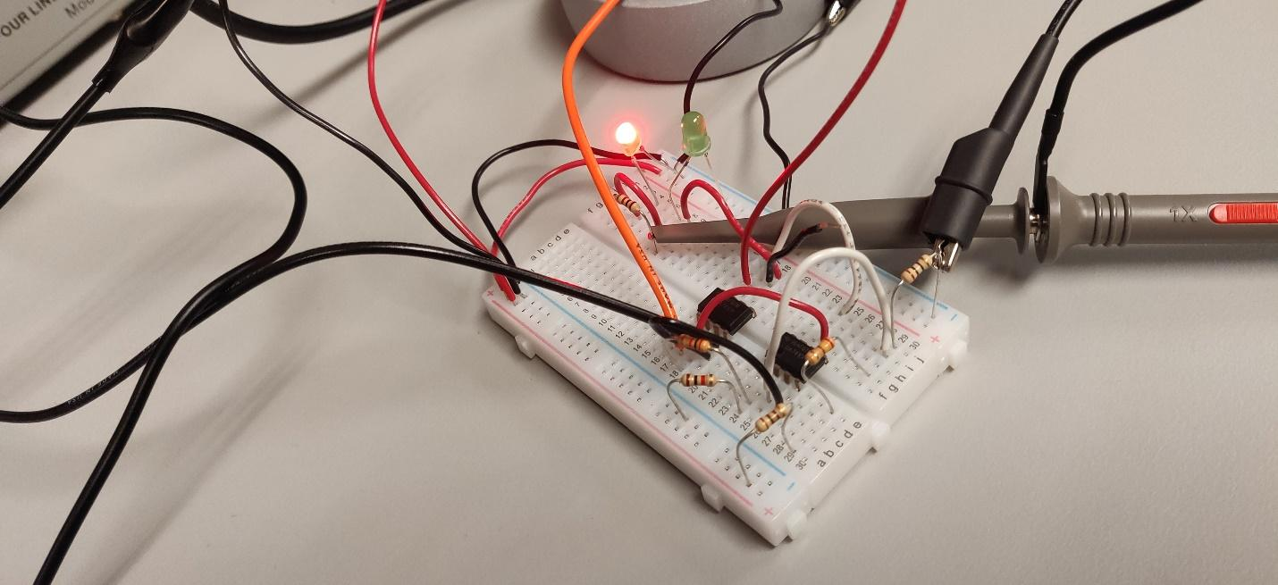

Figure 4. Circuit when $i_{L}>55mA$ (Red LED)

**Step 7:** Test the circuit. Complete the table below.

|  |  |  |  |
| --- | --- | --- | --- |
| Observed Load Current | Load Resistance Used | Green LED status | Red LED status |
| Approx. 50mA | 240 | On | Off |
| Approx. 55mA | 218 | Off | On |
| Approx. 60mA | 200 | Off | On |

Table 2. Red and Green LED status vs Observed Load Current for the circuit at 12v

**Question #5:** How may the circuit be adapted to generate an alarm (aka. red LED) when observed load current is either 10% above or below the nominal value?

**Answer #5:** The circuit may be adapted to observe the load current below 10% of the nominal value by creating another open loop amplifier which would compare $I_{l}$ to another value which is below the 10% threshold

**Step 8:** Calculate the error introduced by the measurement resistor. Show work below.

$$error= \frac{ideal-actual}{ideal}=\left|\frac{\left(\frac{V_{L}^{nom}}{R_{L}^{nom}}\right)-(\frac{V_{L}^{nom}}{R_{L}^{nom}+R_{M}})}{(\frac{V_{L}^{nom}}{R_{L}^{nom}})}\right|$$

$$\left|\frac{\left(\frac{14.3}{240}\right)-\left(\frac{14.3}{240+10}\right)}{\left(\frac{14.3}{240}\right)}\right|$$

= 0.04, or 4% error

The theoretical error of using a voltage divider and increasing the total resistance of the circuit, thus reducing the current passing through the load resistor is 4%.

$$error=\frac{ideal-actual}{ideal}=\frac{14.3-13.85}{14.3}=0.0315=3.15\%$$

The error of our physical circuit’s voltage trigger is 3.15%, much of this can be explained by the actual resistance of the resistors we were using and the internal capacitance of the amplifiers we were using.

**4. Conclusion (JB, MF, AB)**

**4.1 Background Research and Hypothesis**

This experiment did not require much research outside of reading the text, Microelectronic Circuits – 6th edition, where the information about both negative feedback and difference amplifiers was given. The hypothesis of this lab was that if the current in the circuit exceeded 55 mA, then the LEDs would switch. The objectives from the students’ perspective were to create the circuit in both PSpice and on hardware. Another objective was to become more familiar with the ua741 operational amplifier.

**4.2 Procedure**

To complete this lab, the group designed and simulated a multi-stage amplifier design shown in figures 1, 2, and 3. After simulations were complete and correct, the physical circuit was built. Some problems encountered include a problem with the breadboard, grounding issues, not accounting for the capacitance of the op-amps we used, and mistakenly using a 250Ω resistor for $R_{L}$ instead of a 240Ω resistor. Despite these problems, our circuit functioned almost perfectly (see table 1.). One suggestion for this lab is that all the parts should be readily available before the lab period starts. The most interesting step of this lab was step 10, which was constructing the hardware circuit.

**4.3 Analysis and Results**

The results of this lab showed that it’s possible to create a device using amplifiers to detect current exceeding a specific threshold. The results are shown in table 1. which compares the ideal and measured nominal voltage, current, and resistor. The circuit would perform which would cause a red LED alarm to occur when the current would reach a value greater than 55mA and when the circuit was less than 55mA then the green LED would be lit. The students would have a small percent error as observed with step 8 of the procedure and analysis. The most interesting data observed from the lab was changing the voltage in the circuit to prove that the LED would change from green to red when the current was greater than 55mA.

**4.4 Closing Ideas**

One lesson learned from this experiment was that you don’t have to learn the hard way that one of your resistors is really hot, or that it will shock you. Another lesson learned is that you should always make sure all your equipment works properly before starting. This experiment will help students to excel because it enforces basic circuit construction concepts that are helpful going forward. The most positive comment on this experiment is that our determination to find the initial problem(s) with our circuit paid off in the long run as our circuit worked very well after it was fixed. The most negative comment on this experiment is that we had many equipment errors while performing this lab.

**5. References (AB, MF)**

* Microelectronics Circuits by Sedra and Smith; OxfordUniversity Press; Latest Edition
* Ua741 data sheet <http://www.ti.com/lit/ds/slos094g/slos094g.pdf>