|  |  |
| --- | --- |
|  | **School of Engineering** |

|  |  |  |
| --- | --- | --- |
| **ELC333-L1** |  | **Spring 2020** |

**Lab 4**

**Introduction to Bipolar Junction Transistors**

**Date: 4/3/2020**

**Submitted by: Jeffrey Blanda, Alexander Bolen, Miguel Flores**

**Instructor: Joseph Jesson**

1. **Introduction (JB)**

**1.1 Objectives: (JB)**

* Become familiar with Bi-polar junction transistors.
* Measure the characteristics of a physical NPN Bi-polar junction transistor.
* Understand the difference between an NPN and PNP BJT.
  1. **Importance:**
* BJTs are one of, if not, the most popular transistors used in modern electronics.
* BJTs allow engineers to simplify otherwise complex circuits.
  1. **Theory:**

NPN BJTs are devices that allow current to amplify between two terminals based on the current flowing into the base terminal.

1. **Materials and Devices (JB)**

* Keithley 4200 Semiconductor Characterization System
* 2N2222 NPN BJT
* USB Drive

1. **Procedure (JB, MF, AB)**
2. Set up and configure the Keithley 4200 Semiconductor Characterization System to measure an NPN BJT.
3. Run the test on the BJT and save the data on a USB drive. Plot using Excel. (See Appendix A)
4. Based on our physical results, using the equation

The current gain was found to be 0.7 A/A.

This varies greatly from the datasheet, as they use much higher voltages and currents for comparison. The lowest base current tested was 1mA with a collector voltage of 10v, our equipment measured up to 0.5mA at 2v

1. Building a piecewise linear model to match the physical data:
$$I_{c}\left\{\begin{aligned}if {8μA<I}_{B}<12μA, I_{c}= 0.3I_{B}+0.250{μV}_{c} \\ if {6μA<I}_{B}<7μA, I_{c}= 0.3I_{B}+0.13{μV}_{c} \\ if {5μA<I}_{B}<6μA,I_{c}= 0.3I_{B}+0.07{μV}_{c}\end{aligned}\right.$$

2. Design a circuit which allows the BJT to be used as a switch (for activation of an LED).use the following guidelines:

VCC=5V

ID=10 mA (LED diode current, when on)

VD=2.1 V (LED diode voltage, when on)

V_(CE(SAT))=0.4V (collector-emitter voltage when on)

$I_{B}=I_{C}/10$ (corresponds to forced β of 10, a common approach for strong ON with BJT)

Design $R_{B}$ and $R_{c}$ for the “ON” state (VI=5V)

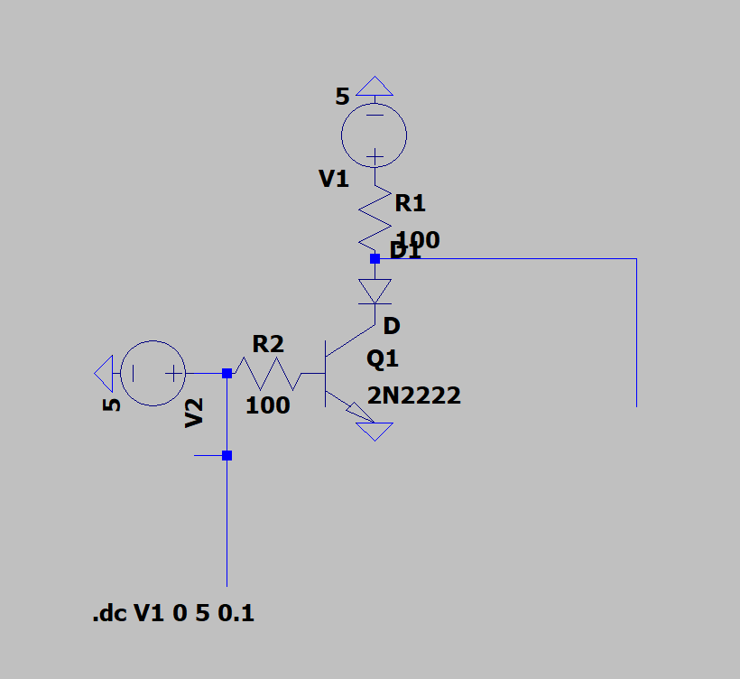

Figure 1: LTSpice Schematic

1. Construct this circuit in hardware as well as implement in PSpice. Answer the following questions.
2. What is the minimum ID required to turn the LED on? You can determine this by powering the LED through a 100Ω series resistor, and slowly increase the supply voltage until the diode begins to light (see Figure 1).

0.007A ID is required.

1. Fill out the following table from measurements

Table 1 can be found in the appendix.

**Appendix:**

Figure 2: Transistor Output Current Hardware

**Appendix A:** Physical BJT collector current in respect to collector voltages for varying base currents.

~~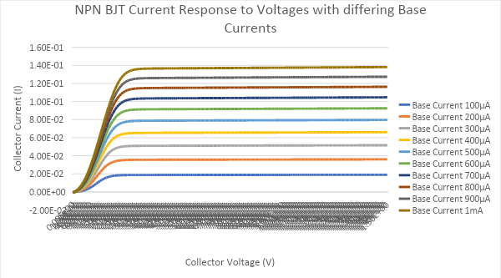~~

Figure 3: Transistor Output Current Simulation

**Appendix B:** Simulated BJT collector current in respect to collector voltages for varying base currents.

|  |  |  |  |  |  |
| --- | --- | --- | --- | --- | --- |
| VI | VBE (Measured) | I**B =** (VI-VBE)/RB | VR (Measured) | VRC = VCC - VR | ID = VRC/RC |
| 0V | 0.7V | -0.007A | 0V | 5V | 0.05A |
| 5V | 0.7V | 0.043A | 0.800V | 4.2V | 0.042A |

Table 1: Simulation Values

**4. Conclusion (MF, AB)**

**4.1 Background Research**

In order to complete the lab, students would need to research bipolar junction transistors (BJT’s) and Keithley 4200 Semiconductor Characterization System. By researching how to use the Keithley 4200 measure the current-voltage characteristics of the BJT and convert it to excel to make a graph. The book Microelectronic Circuits – 6th edition, is useful to understand the bipolar junction transistor. In the students' eyes, the objective of the lab was to learn about the BJT.

**4.2 Procedure**

To complete this lab, students would need to read the background on setting up and using the Keithley 4200 Semiconductor Characterization System. After the group used Keithley 4200 they would measure the current-voltage characteristics of the BJT such as measured current gain. From the measured current gain, students would create a piece-wise linear model of the BJT. Finally, the group would Design a circuit that allows the BJT to be used as a switch and implement it using PSpice. Some challenges that occured from this experiment were learning how to use LTspice for the first time and also learning how to use Keithley 4200. Some suggestions that might be needed for this lab is to include more steps in how to do this lab. The step that students would find most interesting is using the Keithley 4200.

**4.3 Analysis and Results**

Our design worked correctly and displayed values that were close to what was expected. Although we did not get to actually do the hardware portion, our simulated schematics worked well. All the values we recorded from the simulation were correct or very close to being so. This was all expected however, since as stated previously the hardware values were not actually measured. Overall I would give it high marks on an evaluation because everything matches up very well.

**4.4 Closing Ideas**

One lesson that we will take away from this experiment is that LTSpice is even more annoying and unintuitive than regular Pspice. This led to actually constructing the schematics taking longer than expected because we had to figure out the software. Another lesson we took away from this experiment was how to properly use the bipolar junction transistor. This will help us in future classes and labs because we will have a better understanding of that type of transistor. What we liked the most about this lab was trying to figure out how to use the Keithley 4200. If we were to do this lab differently then we propose that LTSpice should not be used.

**5. References:**

* Microelectronics Circuits by Sedra and Smith; OxfordUniversity Press; Latest Edition
* Bi-Polar Junction Transistor lecture notes; hmc.edu, http://fourier.eng.hmc.edu/e84/lectures/ch4/node3.html
* LTSpice Technical Articles; https://www.analog.com/en/