|  |  |
| --- | --- |
|  | **School of Engineering** |

|  |  |  |
| --- | --- | --- |
| **ELC333-L1** |  | **Spring 2020** |

**Lab 5**

**Advanced Operational Amplifier Design Project**

**Date: 4/17/2020**

**Submitted by: Jeffrey Blanda, Alexander Bolen, Miguel Flores**

**Instructor: Joseph Jesson**

1. **Introduction (MF)**

**1.1 Objectives:**

* Provide students with experience in the design of electronic circuitry, and the application of operational amplifiers (op-amps) and similar IC electronic components in practical instrumentation circuitry.
* Design a complex system where multiple conditions from different types of signal sources must be considered to determine if a process is functioning within specified limits.
  1. **Importance:**

Advanced operational amplifiers are mainly used for electronic circuitry, which this lab provides useful experiences in how to design. By studying the opamps there are ways to mimic the supplied behavior parameter.

* 1. **Theory:**

Advanced operational amplifiers consist of many different types of amplifiers such as a summing operational amplifier. There are also other different types of op-amps which could be used for different types of problems and questions.

1. **Materials and Devices (MF, AB)**

* Computer with Pspice or LTSpice
* Instructor Provided Hardware Data

1. **Procedure (JB)**
2. Using the supplied parameters, design an op-amp based circuit that mimics the behavior supplied. Use an Rf=10kΩ
   1. Given Vout = -0.5V1-2V2-V3
   2. Using the summing amplifier model, since the final product is being inverted, we can say Vout=-(0.5V1+2V2+V3)
   3. Resistance values for the summing amplifier must be R3 = ½ R2 = 2R1
3. Provide a sketch and brief explanation of your design below. Define all parameters and component values.
   1. Given that we defined our resistances previously and are told to use Rf=10kΩ, R1 must also be 10kΩ and thus R2 must be 5kΩ and R3 must be 20kΩ. A sketch of this design can be seen in Figure 1.
4. Construct your circuit in LTSpice. Copy and paste a screen capture of your schematic below.

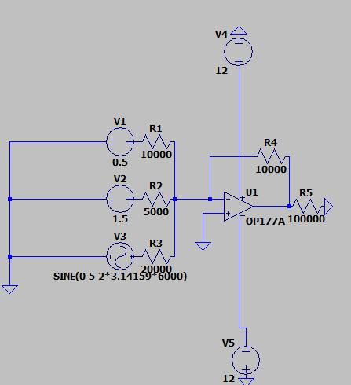

Figure 1. LTSpice schematic

1. Simulate your circuit in Pspice with the following inputs and load. Verify proper operation.
   1. Simulating with the given inputs V1=5sin(2*pi*1000)

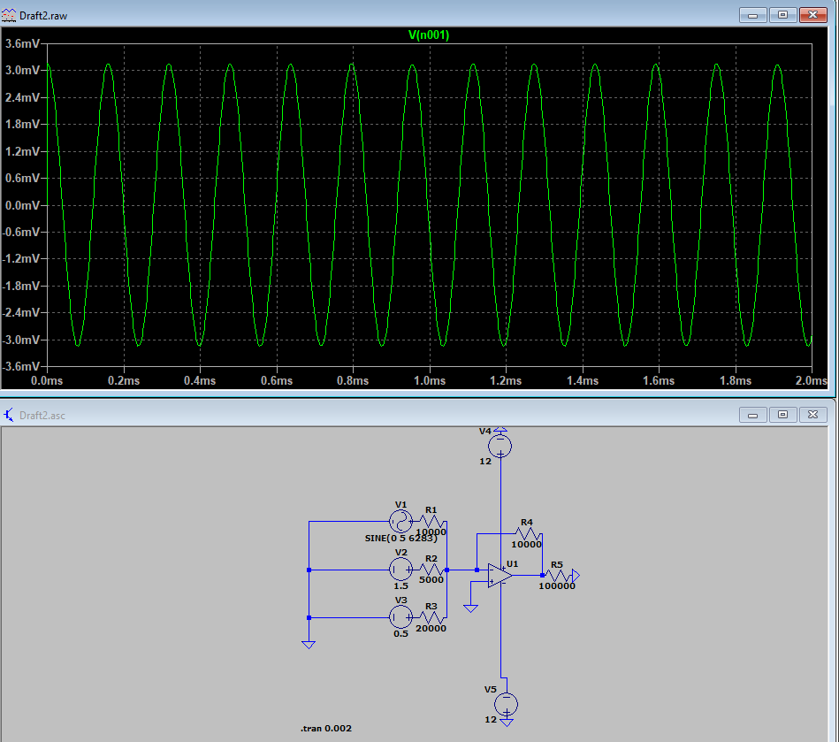

Figure 2. LTSpice simulation

1. Construct your circuit in hardware. Place a picture of your circuit below.
   1. Image provided by Professor Jesson.

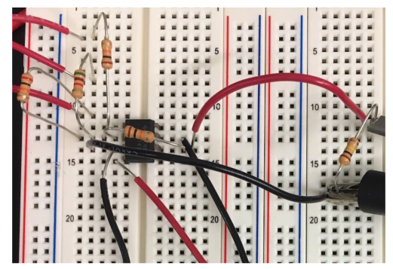

Figure 3. The hardware of the circuit

1. Observe the instantaneous voltage across the load in simulation and hardware.

|  |  |  |
| --- | --- | --- |
|  | Output | RMS Voltage |
| Freq | Sim | Hardware |
| 1kHz | 1.7678 | 1.764 |
| 2kHz | 1.7678 | 1.763 |
| 3kHz | 1.7678 | 1.758 |
| 4kHz | 1.7678 | 1.748 |
| 5kHz | 1.7678 | 1.725 |
| 6kHz | 1.7678 | 1.667 |
| 7kHz | 1.7678 | 1.564 |

Table 1: Hardware vs. Simulation Summing Amplifier Output Voltage

1. Alter your design to include a band-pass filter between ac input V1 and the summing op-amp. This filter should only allow frequencies between 2.5kHz and 5kHz. Examine via simulation and hardware the relationship between frequency of V1 and RMS output voltage. Fill in the table below.

|  |  |  |
| --- | --- | --- |
|  | Output | RMS Voltage |
| Freq | Sim | Hardware |
| 1kHz | 0.159 | 0.200 |
| 2kHz | 0.3182 | 0.316 |
| 3kHz | 0.37215 | 0.358 |
| 4kHz | 0.37215 | 0.360 |
| 5kHz | 0.37215 | 0.344 |
| 6kHz | 0.3359 | 0.322 |
| 7kHz | 0.3182 | 0.298 |

Table 2: Hardware vs. simulation summing amplifier and bandpass filter

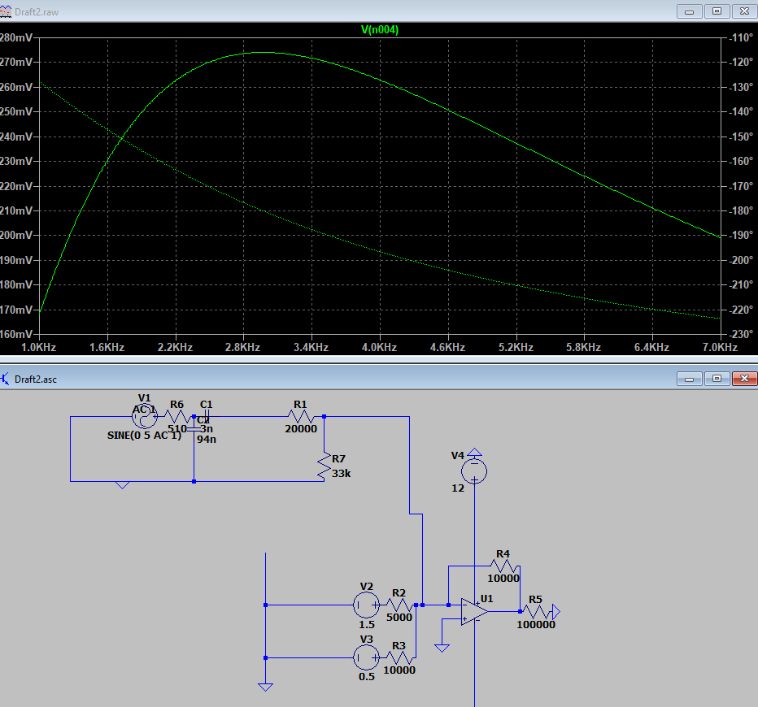

Figure 4. The simulated output of op-amp and bandpass filter.

**4. Conclusion: (JB, AB)**

Our design operated as expected within the conditions and tests of the lab assignments. To properly evaluate it, more extreme voltages should be applied to ensure its durability. There were no significant discrepancies between the simulation, theoretical, or hardware results. Any differentials can be explained by the tolerances of the components used. This lab increased our knowledge of op-amps, specifically summing op-amps. We also got a slight amount of more experience with bandpass filters. This will help in the future because these concepts will certainly be recurring in upcoming classes. This lab will also help prepare us for the future because of the increased experience with LTSpice. Some difficulties included choosing the proper op-amp and sinusoidal sources in LTSpice. Since we were not familiar with the software, it took some time to set up the AC Sweep analysis.

**5. References (MF, AB)**

* Lab 5 PDF
* Microelectronics Circuits by Sedra and Smith; OxfordUniversity Press; Latest Edition
* Professor Jesson (For lab data)
* <https://spiceman.net/ltspice-dc-sweep-analysis/>
* [#140: Basics of an Op Amp Summing Amplifier](https://www.youtube.com/watch?v=juQtVIx1a8g)