|  |  |
| --- | --- |
|  | School of Engineering |

|  |  |  |
| --- | --- | --- |
| **ELC321-02** |  | **Spring 2020** |

**Assignment 1**

**Date: January 31st, 2020**

**Submitted by: Jeffrey Blanda**

**Instructor: John MacDonald**

Problem 1. For the signal x(t) shown in text Fig. 2.1(b), plot the following functions:

$x(4t-3)$

$x\left(-\frac{t}{2}\right)+3$

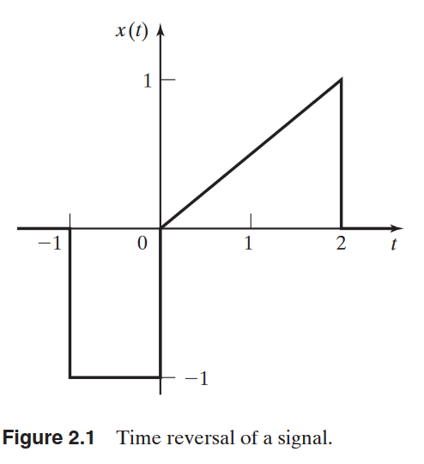

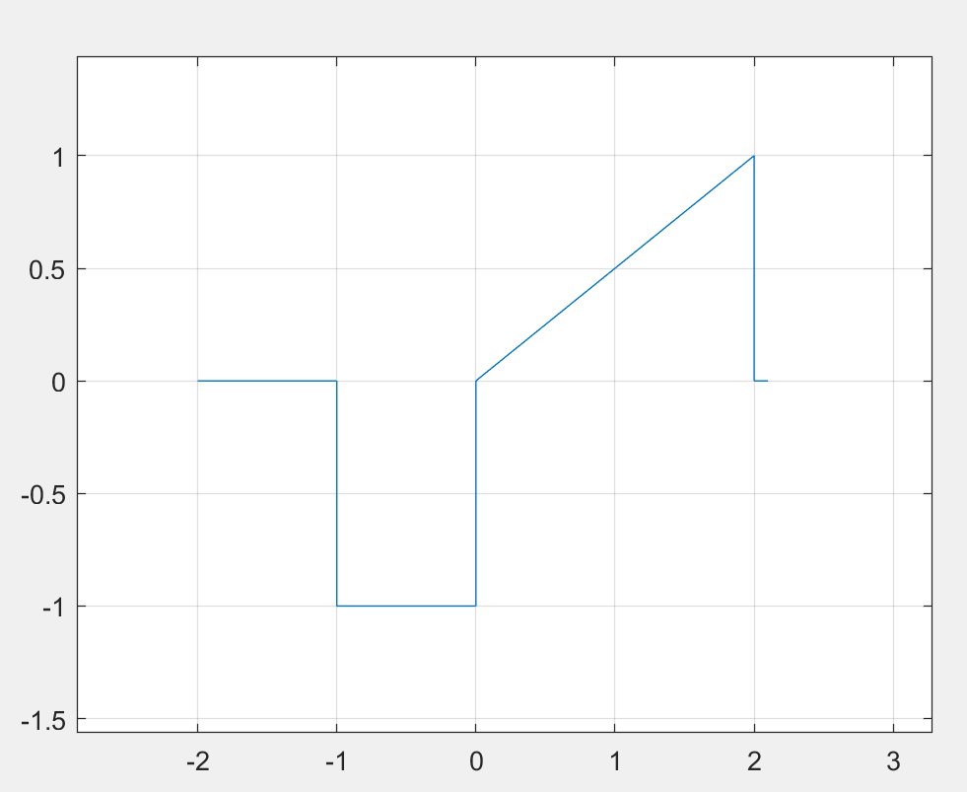

Figure 1. MatLab plot of function x(t).

Creating a MatLab script, the equation can be plotted and easily manipulated.

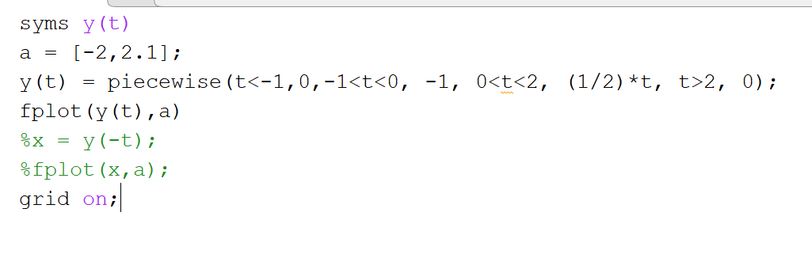

Figure 2. MatLab script for function x(t).

Manipulating x(t) to $x(4t-3)$ will yield a similar graph with an offset of 3 and horizontally shrunk.

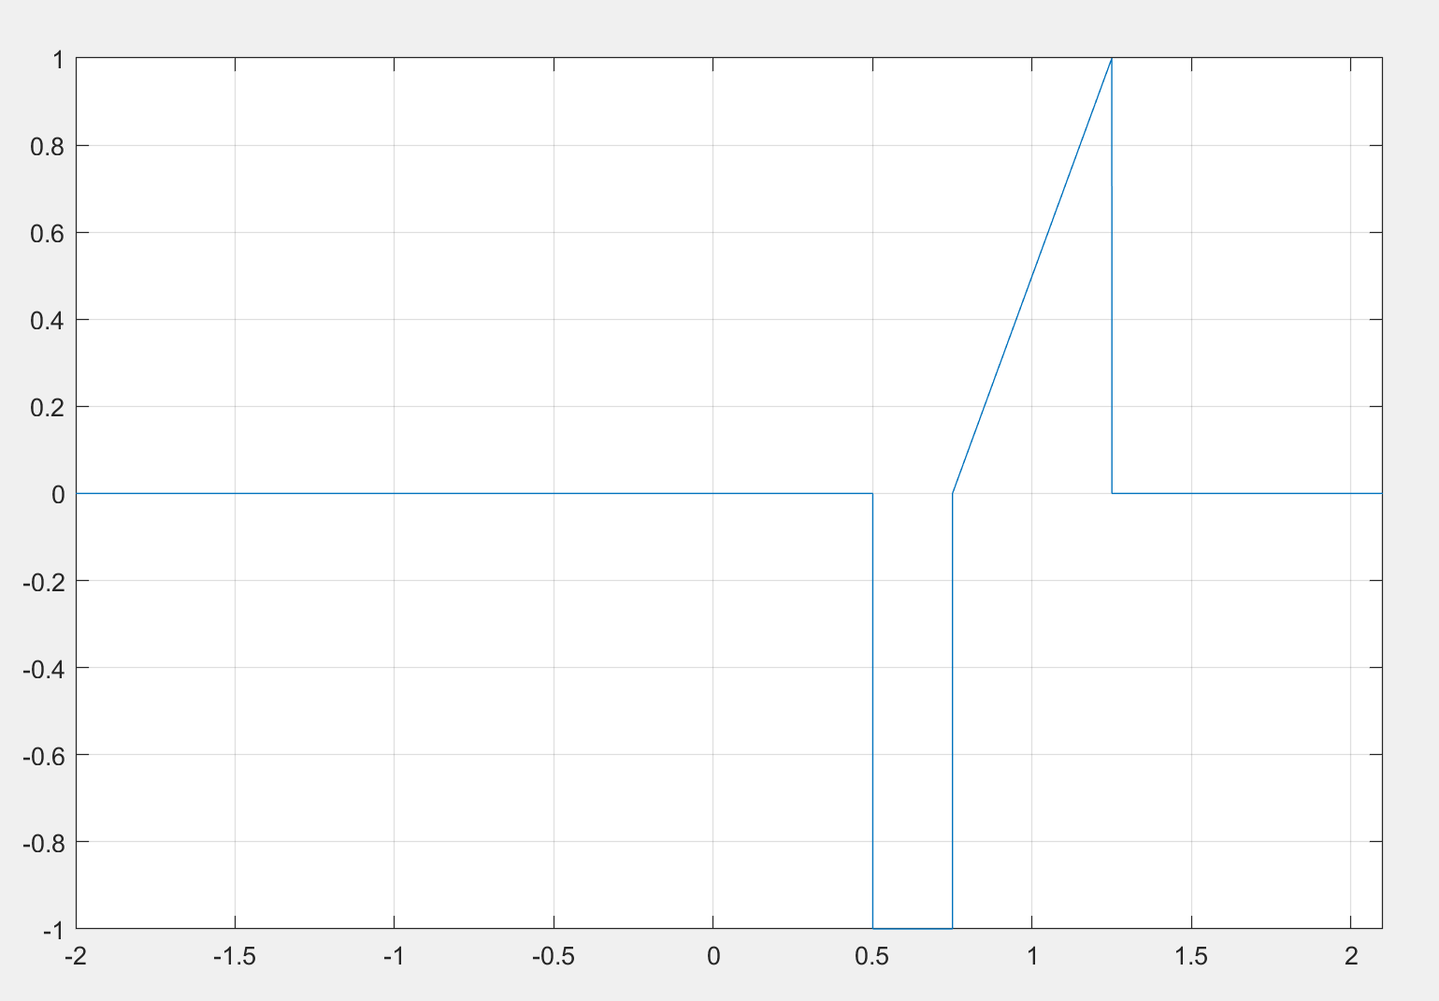

Figure 3. Function $x(4t-3)$ plot.

Similarly, the function can be manipulated to $x\left(-\frac{t}{2}\right)+3$. Since the 3 is added outside the function it will act as a y-intercept and the negative t will cause the graph to flip with the ½ widening the graph.

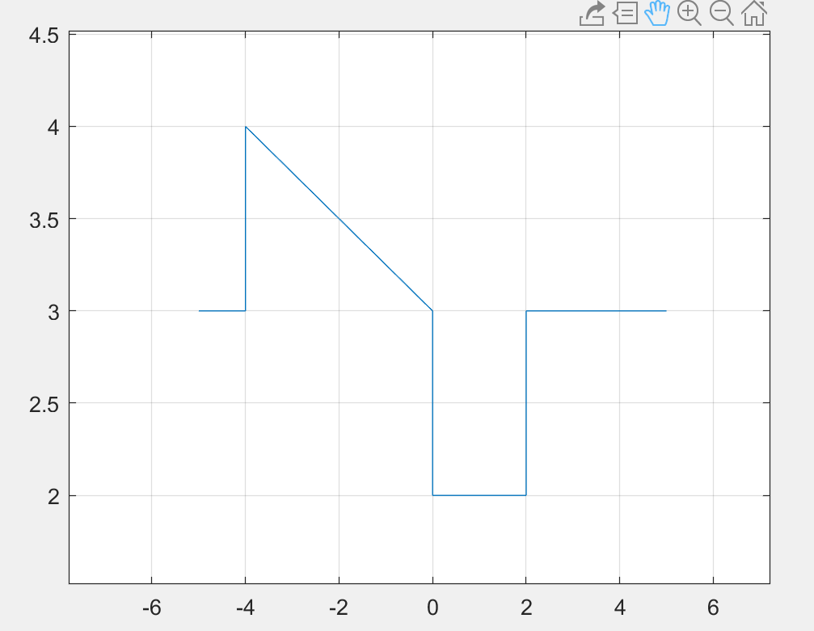

Figure 4. Function $x\left(-\frac{t}{2}\right)+3$ plot

Problem 2. For each of the signals given below,

1. Determine if the signal is even or odd.
2. Plot the even part and the odd part of each signal.
$x\left(t\right)=-u\left(t-2\right)+u(-t-2)$

$x\left(t\right)=e^{-2\left|t\right|}\cos\left(10t\right)$

$x\left(t\right)=cos⁡(2t+\frac{π}{4})$

3. If x(t) = x(-t) the signal is even, if x(-t) = -x(t) the signal is odd. (Signals, Systems, and Transforms page 32.)
4. $-u\left(t-2\right)+u\left(-t-2\right)=-u\left(-t-2\right)+u\left(t-2\right)$ setting x(t) = x(-t)

$$u(t-2)=-u(t-2)$$

Therefore x(-t) = -x(t) and the signal is odd.

1. Using the following equations, the even and odd parts of the signal can be found:

$X_{e}=\frac{1}{2}\left[x\left(t\right)+x\left(-t\right)\right]$ (Signals, Systems, and Transforms page 33.)

$X_{o}=\frac{1}{2}[x\left(t\right)-x\left(-t\right)]$ (Signals, Systems, and Transforms page 33.)

$X_{e}=\frac{1}{2}[u\left(t-2\right)-u(t-2)$] = 0

$$X_{o}=\frac{1}{2}\left[u\left(t-2\right)+u(t-2)\right]=u(t-2)$$

$$The even signal doesn^{'}t exist while the odd signal is u\left(t-2\right).$$

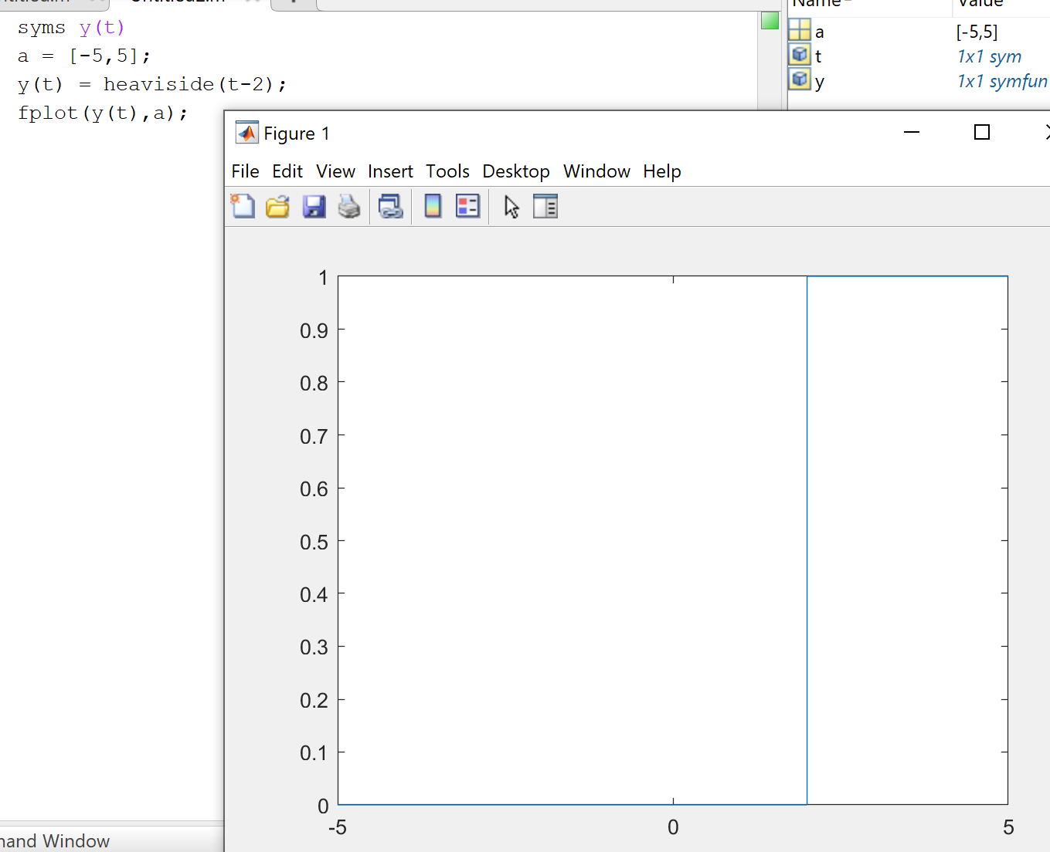

Figure 5. Matlab code and plot for x(t-2).

1. a) Using the above formula, we can find $\cos\left(10t\right)=cos⁡(-10t)$ is the result of x(t) = x(-t). Therefore, the signal is even.

b) $X_{e}=\frac{1}{2}\left[2e^{-2\left|t\right|}\cos\left(10t\right)\right]=e^{-2\left|t\right|}cos⁡(10t)$

$$X_{o}= \frac{1}{2}[e^{-2\left|t\right|}\cos\left(10t\right)-e^{-2\left|t\right|}\cos\left(-10t\right)]=0$$

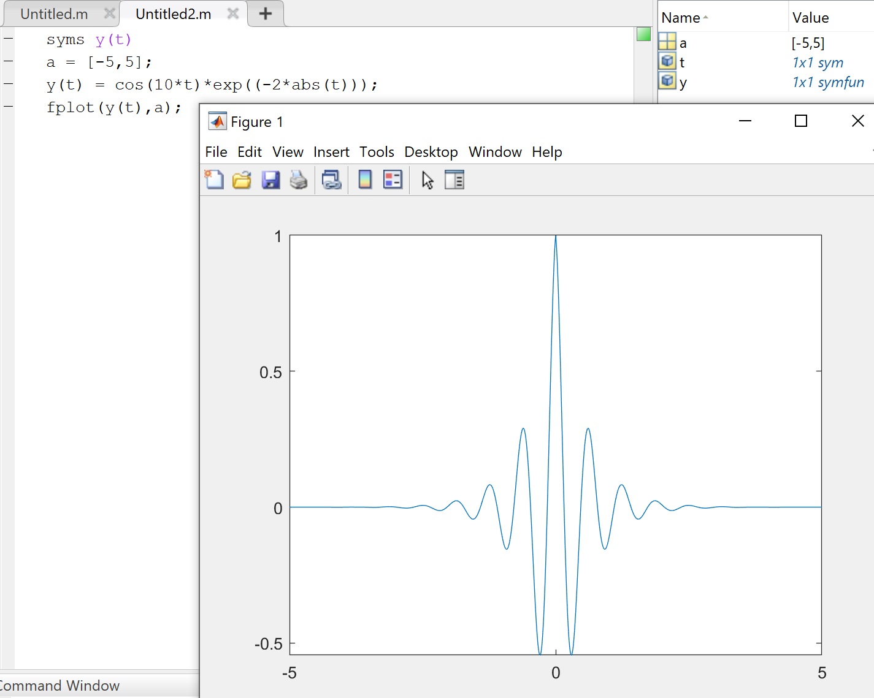

Figure 6. MatLab code and plot for the even signal.

1. a) setting x(t) = x(-t) to test the signal; $\cos\left(2t+\frac{π}{4}\right)=cos⁡(-2t+\frac{π}{4})$ determines the signal is neither even or odd.

b) $X_{e}=\frac{1}{2}\left[cos⁡(2t+\frac{π}{4})+cos⁡(-2t+\frac{π}{4})\right]=\sqrt{2}cos⁡(2t)$

$X_{o}=\frac{1}{2}\left[\cos\left(2t+\frac{π}{4}\right)-cos⁡(-2t+\frac{π}{4})\right]=-\sqrt{2}sin(2t)$

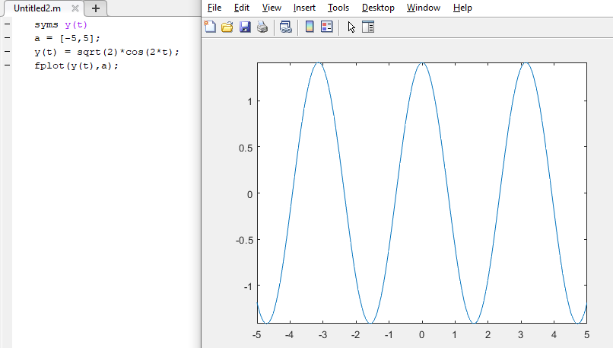

Figure 7. Matlab code and plot for the even signal.

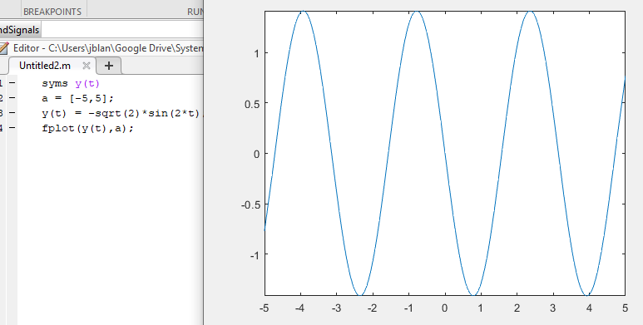

Figure 8. Matlab code and plot for the odd signal.

Problem 3. For each of the signals given below

$cos(4πt) + sin(3πt) + cos(7t)$

$cos(4πt) + sin(3πt) + e^{j7πt}$

$cos(4t) + sin(3t) + cos(7t)$

a) Determine whether the signal is periodic or not. If it is periodic, determine the fundamental frequency, ω0, and

b) Plot each signal over the range -10 ≤ t ≤ 10

Periodicity check: x(t + nT) = x(t) (Signals, Systems, and Transforms page 36.)

1. a)

$$\cos\left(4πt\right)+\sin\left(3πt\right)+cos⁡(7t)=\cos\left(4πt+4πnT\right)+\sin\left(3πt+3πnT\right)+cos⁡(7t+7nT)$$

The result is not periodic, as cos(7t) doesn’t have pi in its function, thus a quantity of the nT cannot be achieved without n or T being a decimal.

b)

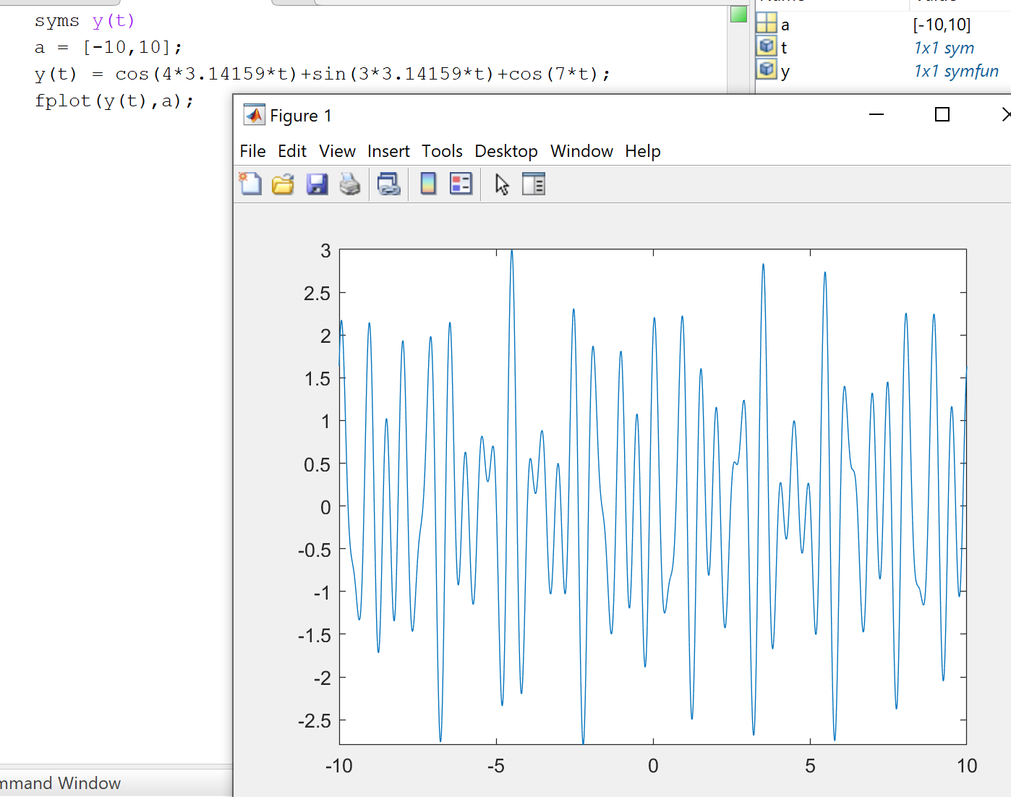

Figure 9. Matlab code and plot for the signal $\cos\left(4πt\right)+\sin\left(3πt\right)+cos⁡(7t)$.

1. a- $\cos\left(4πt\right)+\sin\left(3πt\right)+e^{j7πt}$

using Euler’s Identity, the function can be rewritten as $\cos\left(4πt\right)+\sin\left(3πt\right)+\cos\left(7πt\right)+jsin⁡(7πt)$

From there the T values can be found as ½, 2/3, 2/7, and 2/7. Therefore, a To value of 2 can be found and an ωo value of $π$.

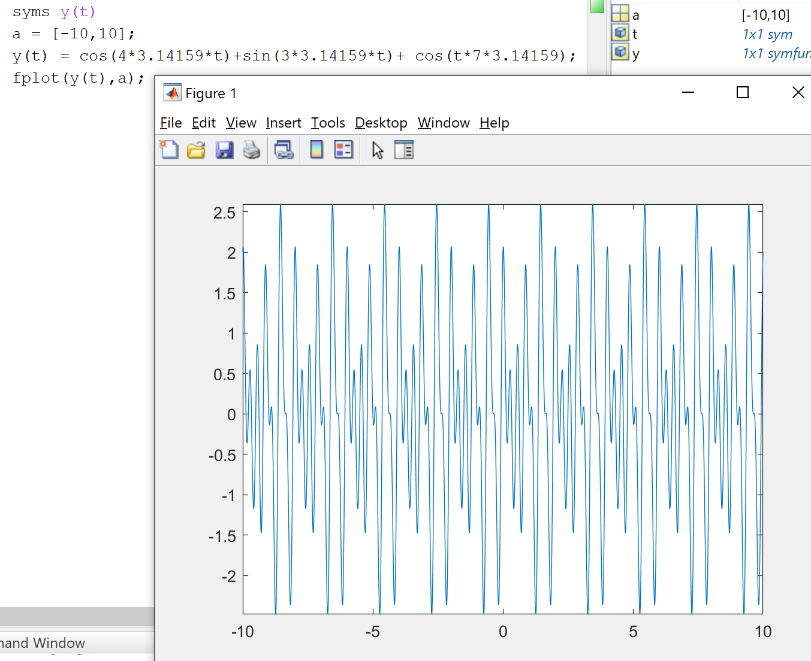

Figure 10. Matlab code and plot of the signal $\cos\left(4πt\right)+\sin\left(3πt\right)+e^{j7πt}$

$cos(4t) + sin(3t) + cos(7t)$

$$T1=\frac{2π}{4}, T2=\frac{2π}{3}, T3=\frac{2π}{7}$$

$$\frac{T1}{T2}=\frac{3}{4}, \frac{T2}{T3}=\frac{7}{3},\frac{T3}{T1}=\frac{4}{7} the least common denominator To=84$$

Therefore, the signal is periodic and repeats every 84 seconds.

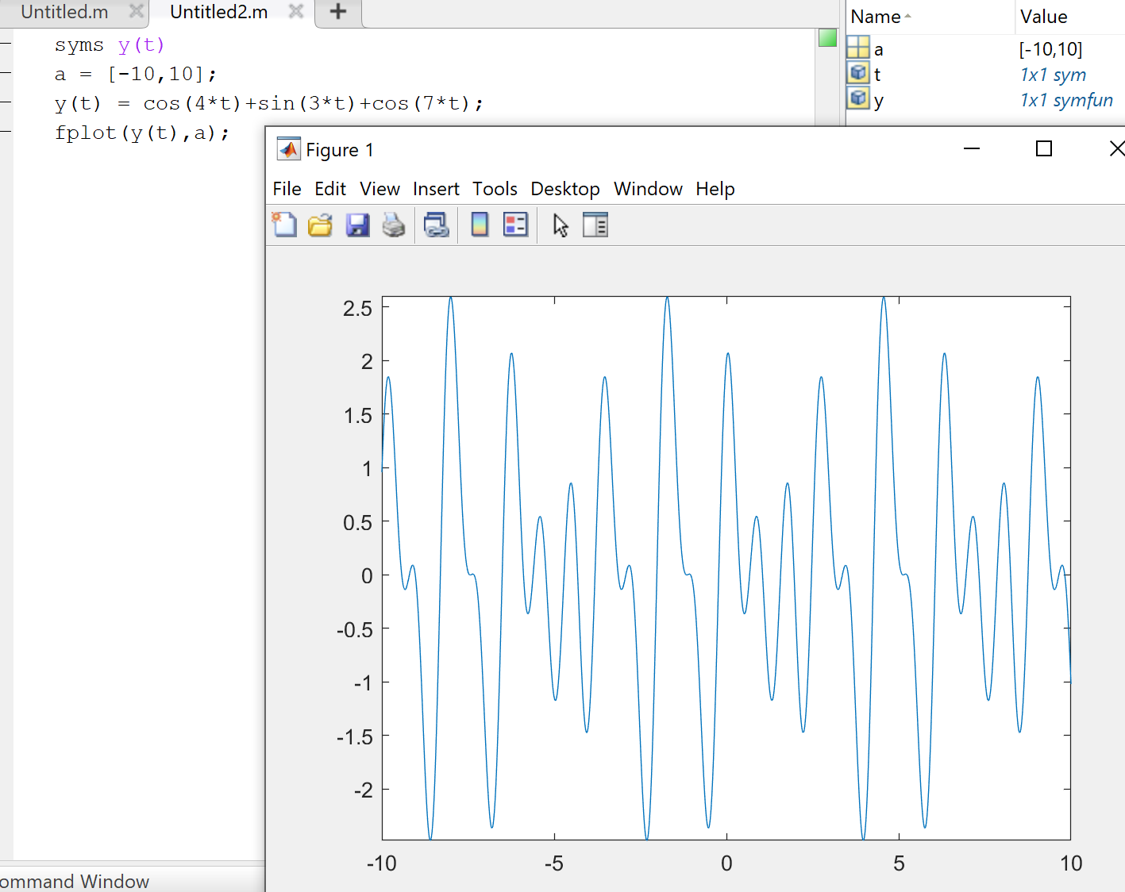

Figure 11. Matlab code and plot for the signal $cos(4t) + sin(3t) + cos(7t)$

Problem 4. Given the signal

$$x\left(t\right)=Acos\left(ωt+α\right)+Bcos(ωt+β)$$

1. Using Euler’s Formula, show that x(t) can be written as
$$x\left(t\right)=Mcos(ωt+θ)$$

$$where M= \sqrt{{(Acos\left(α\right)+Bsin\left(β\right))}^{2}+{(Asin\left(α\right)-Bcos\left(β\right))}^{2}}$$

$$θ=\tan^{-1}\left[\frac{Asin\left(α\right)-Bcos(β)}{Acos\left(α\right)+Bsin(β)}\right]$$

2. Use this result to write the standard form of the following signals:

$x\left(t\right)=3\cos\left(2t\right)+sin⁡(2t+π/6)$

$x\left(t\right)=4\cos\left(4πt+30°\right)+3sin⁡(4πt+15°)$

Euler’s Formulas are given as: (Systems and Signals page 40.)

$$e^{jθ}=\cos\left(θ\right)+jsin\left(θ\right)$$

$$\cos\left(θ\right)=\frac{e^{jθ}+e^{-jθ}}{2}$$

$$\sin\left(θ\right)=\frac{e^{jθ}-e^{-jθ}}{2j}$$

Using Trigonometric identities, the function can be expanded to remove α and β from the equation thus that;

$$x\left(t\right)=Acos\left(ωt\right)\cos\left(α\right)-Asin\left(ωt\right)\sin\left(α\right)+Bsin\left(ωt\right)\cos\left(β\right)+Bcos\left(ωt\right)sin⁡(β)$$

From here the function can be factored out to remove ωt from α and β;

$$x\left(t\right)=\cos\left(ωt\right)\left[Acos\left(α\right)+Bsin\left(β\right)\right]-sin⁡(ωt)[-Asin\left(α\right)+Bcos\left(β\right)]$$

This equation can be further simplified by using Euler’s equation and manipulating it;

$$x\left(t\right)=\frac{e^{jωt}+e^{-jωt}}{2}\left[Acos\left(α\right)+Bsin\left(β\right)\right]+\frac{e^{jωt}-e^{-jωt}}{2j}\left[-Asin\left(α\right)+Bcos\left(β\right)\right]$$

$$x\left(t\right)=\left(\frac{e^{-jωt}+e^{jωt}}{2}\right)[Acos\left(α\right)+Bsin\left(β\right)+j(\sin\left(α\right)-Bcos\left(β\right))]$$

Using Euler’s equation, the function can be changed back to all sine and cosine functions.

$$x\left(t\right)=cos⁡(ωt)[Acos\left(α\right)+Bsin\left(β\right)+j(\sin\left(α\right)-Bcos\left(β\right))]$$

The vector inside the brackets can be expressed in terms of magnitude and angle, thus that

$$x\left(t\right)=\cos\left(ωt\right)\sqrt{{\left(Acos\left(α\right)+Bsin\left(β\right)\right)}^{2}+{\left(\sin\left(α\right)-Bcos\left(β\right)\right)}^{2}}*\tan^{-1}(\frac{Asin\left(α\right)-Bcos(β)}{Acos\left(α\right)+Bsin(β)})$$

In the problem we’re given $M= \sqrt{{(Acos\left(α\right)+Bsin\left(β\right))}^{2}+{(Asin\left(α\right)-Bcos\left(β\right))}^{2}}$ and $$θ=\tan^{-1}\left[\frac{Asin\left(α\right)-Bcos(β)}{Acos\left(α\right)+Bsin(β)}\right]$$

Thus, the equation can be rewritten as $x\left(t\right)=Mcos\left(ωt\right)*e^{jθ}$

Using Euler’s equation to transform the cosine function,

$$x\left(t\right)=M\frac{e^{jωt+jθ}+e^{-j(ωt+θ)}}{2}$$

And once again to transform the function back to a cosine function.

$$x\left(t\right)=Mcos(ωt+θ)$$

b) 1. $x\left(t\right)=3\cos\left(2t\right)+sin⁡(2t+π/6)$

Using the relationship proved in part A, the equation can be written as;

$$x\left(t\right)=Mcos\left(2t+θ\right)$$

Where $M=\sqrt{{(3cos\left(0\right)+sin\left(\frac{π}{6}\right))}^{2}+{(3sin\left(0\right)-cos\left(\frac{π}{6}\right))}^{2}}$

And $θ=\tan^{-1}(\frac{3\sin\left(0\right)-cos⁡(\frac{π}{6})}{3\cos\left(0\right)+sin⁡(\frac{π}{6})})$

Simply by replacing A, B, α, β, and ω with what is given in the function.

2. $x\left(t\right)=4\cos\left(4πt+30°\right)+3sin⁡(4πt+15°)$

A=4, B=3, α=30̊, β=15̊, ω=4π

Therefore, the equation can be rewritten as:

$$x\left(t\right)=Mcos(4πt+θ)$$

Where $M= \sqrt{{(4cos\left(30°\right)+3sin\left(15°\right))}^{2}+{(4sin\left(30°\right)-3cos\left(15°\right))}^{2}}$

And $θ=\tan^{-1}\left[\frac{4sin\left(30°\right)-3cos(15°)}{4cos\left(30°\right)+3sin(15°)}\right]$

Problem 5. Evaluate the following Integrals.

$\int_{-∞}^{∞}{δ\left(at-b\right)\sin^{2}\left(t-c\right)dt}$

$\int_{-∞}^{∞}{\sin\left(t-\frac{π}{3}\right)δ\left(3t-\frac{π}{6}\right)dt}$

$\int_{-∞}^{∞}{δ\left(at-b\right)\sin^{2}\left(t-c\right)dt}$

$f\left(t\right)=\sin^{2}(t-c)$

$\int_{-∞}^{∞}{δ\left(at-b\right)dt}=\frac{1}{|a|}\int_{-∞}^{∞}{δ(\frac{t-b}{a})}dt$ (Systems and Signals Page 52)

$$\frac{\int_{-∞}^{∞}{f(t)δ(\frac{t-b}{a})}dt}{|a|}=\frac{f(\frac{b}{a})}{|a|}=\frac{\sin^{2}(\frac{b}{a}-c)}{|a|}$$

$\int_{-∞}^{∞}{\sin\left(t-\frac{π}{3}\right)δ\left(3t-\frac{π}{6}\right)dt}$

$$f\left(t\right)=sin⁡(t-\frac{π}{3})$$

$$δ\left(3t-\frac{π}{6}\right)=\frac{1}{3}δ(\frac{t-π/6}{3})$$

$$\int_{-∞}^{∞}{\frac{f(t)δ(\frac{t-π/6}{3})dt}{3}=\frac{f(\frac{π}{2})}{3}=\frac{sin⁡(\frac{π}{2}-\frac{π}{3})}{3}}$$

Problem 6. Write an equation for the following waveform.

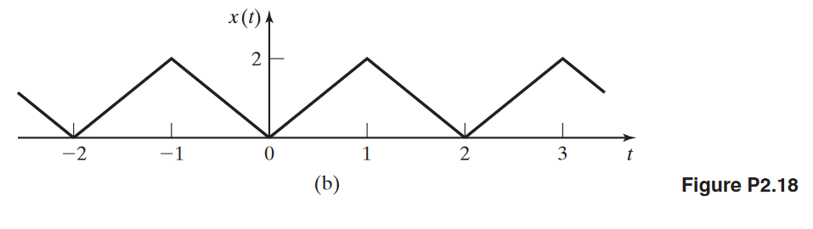

Using the unit step function, we can write an equation for a single period of the function.

$$x\left(t\right)=2tu\left(t\right)-4\left(t-1\right)u\left(t-1\right)+2\left(t-2\right)u(t-2)$$

Where $2tu\left(t\right)$ is the rising slope that starts at $\lim_{t→0+}{2tu(t)}$ (the function can’t be defined where the step occurs in the unit step function)

$-4\left(t-1\right)u\left(t-1\right)$ brings the function back down to the x-axis starting at $\lim_{t→1+}{4(t-1)u(t-1)}$ and $+2\left(t-2\right)u(t-2)$ stops the function from continuing to change, resulting in the first period

Lastly, a summation can be written to infinitely repeat the waveform.

$$\sum_{k=-∞}^{∞}{x(t-2k)}$$

Problem 7. Determine whether the system $y\left(t\right)=\int_{t}^{t+1}{x\left(τ-α\right)dτ}$

1. Has memory
2. Is invertible
3. Is stable
4. Is time invariant
5. Is linear

For what values of a constant α is the system causal?

1. The output offsets based on α; therefore, the system must have memory.
2. The input can be determined uniquely from the output, as the function is not periodic at all.
3. The function is stable as $\left|x\left(t\right)\right|≤M$ for all values of t.
4. The function is time invariant, as t-to yields the same results as t.
5. The function is not linear, as it doesn’t satisfy superposition.

References

Phillips, C. L., Parr, J. M., and Riskin, E. A, Signals, Systems, and Transforms (4th ed), ISBN: 978-0-13-198923-8, Pearson, 2008.