|  |  |
| --- | --- |
|  | School of Engineering |

|  |  |  |
| --- | --- | --- |
| **ELC321-02** |  | **Spring 2020** |

**Assignment 2**

**Date: February 25th, 2020**

**Submitted by: Jeffrey Blanda**

**Instructor: John MacDonald**

# Problem 1

A system has an input, x(t) and an impulse response, h(t). Using the convolution integral, find and plot the system output, y(t), for each of the combinations given below.

1. x(t) is given in text Fig. P3.2(b), and h(t) is given in Fig. P3.2(d)
2. x(t) is P3.2(e) and h(t) is P3.2(f).

a.

Using MatLab to plot the function provided:

$$h\left(t\right)=2\sin\left(πt\right)for 0≤t≤1$$

$$x\left(t\right)=u\left(t-2\right)-u(t-4)$$

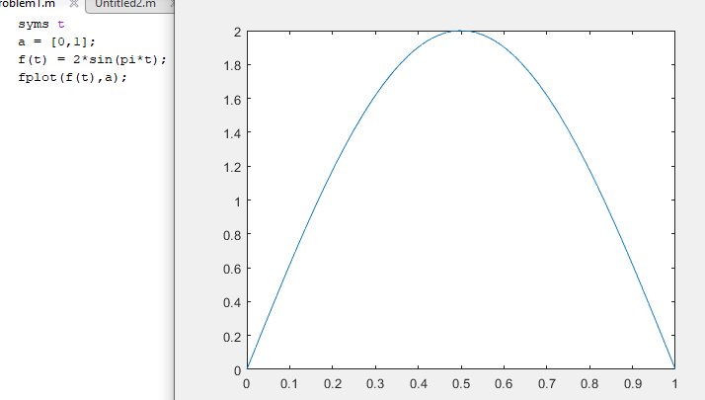

Fig 1. MatLab plot and code for the equation $h\left(t\right)=2\sin\left(πt\right)for 0≤t≤1$

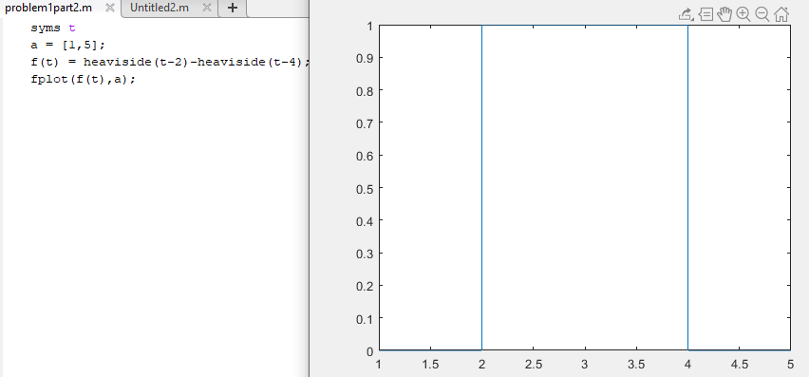

Fig 2. Matlab plot and code for the equation $x\left(t\right)=u\left(t\right)-u(t-2)$

To take the response using the convolution integral, x(t) can be flipped and put in terms of τ and equations can be written over different intervals. For x(τ), the two sides are written as t-2 and t-4.

1. For t < 2 there is no overlap, so the area is 0.
2. For 2 < t < 3 the x( τ ) function starts to overlap with h(t) so an integral can be written.
   1. $4\int_{0}^{t-2}{\sin\left(πα\right)dα}$ where the antiderivative of the h(t) function is the area of h(t) within the bounds given (from 0 to t-2 on this interval) multiplied by the height of the rectangle.
3. For 3 < t < 4 the x( τ ) function is fully overlapping with h(t) so an integral can be written over the full period of h(t) multiplied by the height of x(t)
$4\int_{0}^{1}{\sin\left(πα\right)dα}$

4. For 4 < t < 5 the x( τ ) function is no longer fully overlapping so an integral can be written for the rectangle leaving the curve.

$4\int_{t-4}^{1}{\sin\left(πα\right)dα}$

Thus, a graph can be plotted for the convolution.

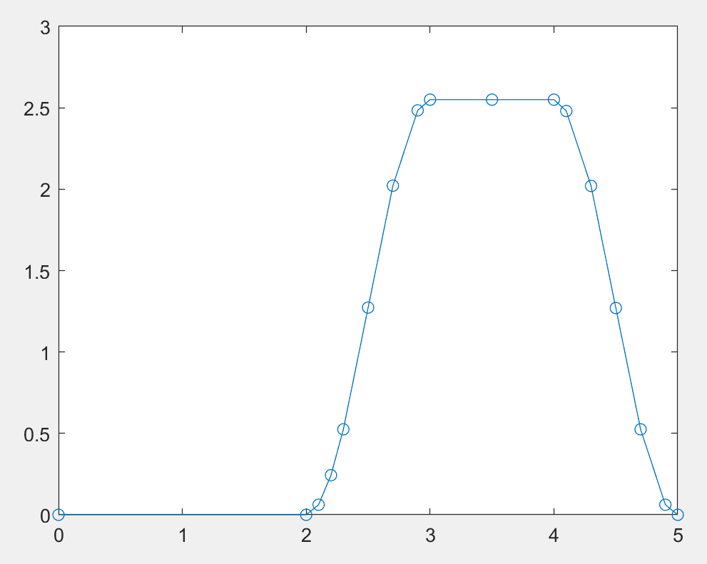

Fig. 3 Convolution of the two functions

b.

Using MatLab to graph the provided functions:

$$x\left(t\right)=2cos⁡(πt)$$

$$h\left(t\right)=u\left(t\right)-u(t-2)$$

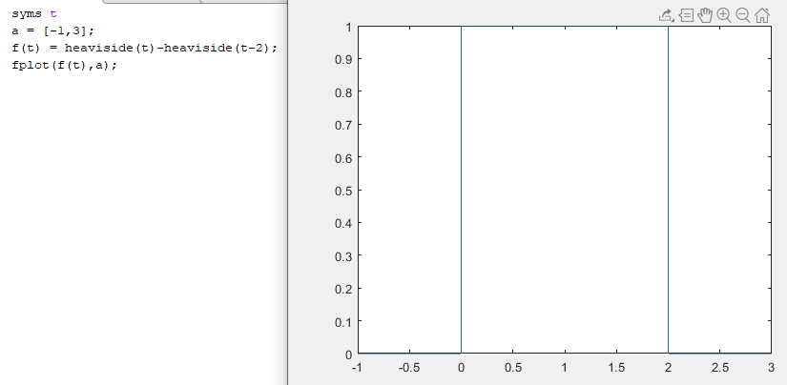

Fig 4. MatLab plot of $h\left(t\right)=u\left(t\right)-u(t-2)$

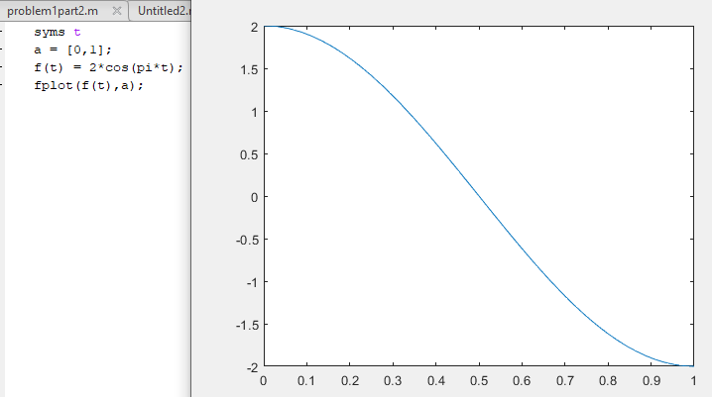

Fig 5. MatLab plot of $x\left(t\right)=2cos⁡(πt)$

To take the response using the convolution integral, h(t) can be flipped and put in terms of τ and equations can be written over different intervals. For h(τ), the two sides are written as t and t-2.

1. For t < 0, there is no intersection, so the value of the convolution is 0.
2. As 0 < t < 1 the integral can be formed by multiplying the antiderivative of the function with the bounds 0 to t and multiplied by the height of the rectangle function.
$4\int_{0}^{t}{\cos\left(πt\right)dt}$

3. As 1 < t < 2 the integral can be found by using the bounds 0 to 1, as the rectangle will encompass the entire curve over this integral.
   1. $4\int_{0}^{1}{\cos\left(πt\right)dt}$ = 0
4. As 2 < t < 3 the integral can be found by integrating from the left side of the rectangle to the end of the curve, as the rectangle is leaving the curve.

$4\int_{t-2}^{1}{\cos\left(πt\right)dt}$

Thus, a graph for the convolution can be generated.

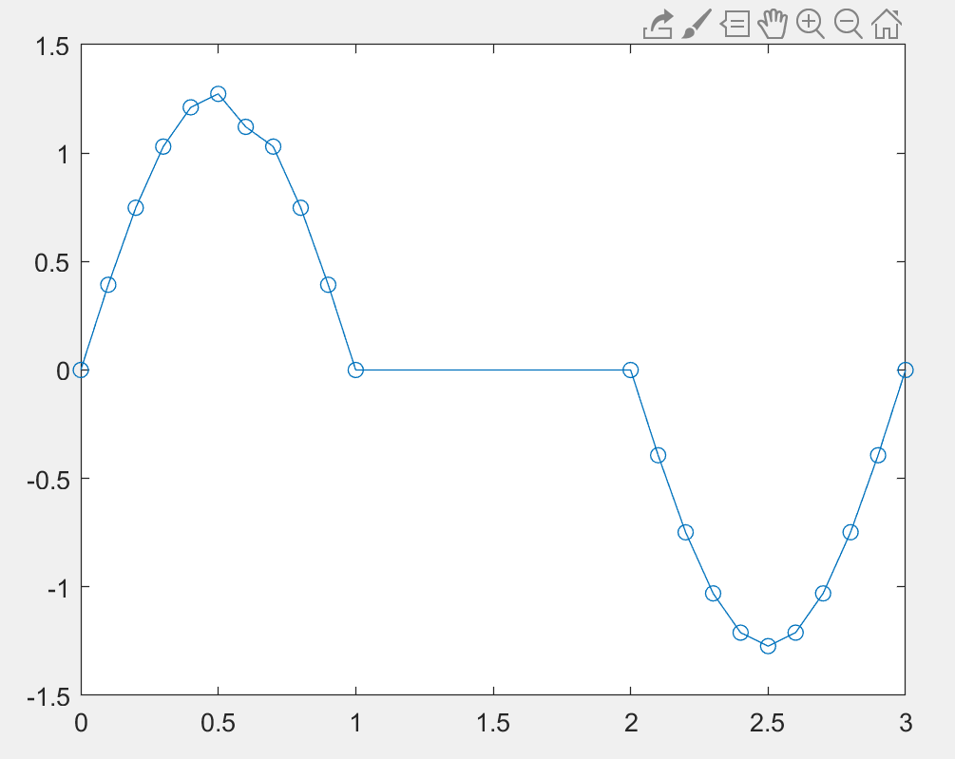

Fig 6. MatLab plot for the convolution

# Problem 2.

For each system defined below, find and sketch the impulse response, h(t), by letting x(t) = δ(t).

$y\left(t\right)=x\left(t-3\right)$

$y\left(t\right)=\int_{-∞}^{t}{x\left(τ-3\right) dτ}$

$y\left(t\right)= \int_{-∞}^{t}{\left\{\int_{-∞}^{∝}{x\left(τ-7\right)dτ}\right\}dα}$

1. $y\left(t\right)=x\left(t-3\right) where x\left(t\right)=δ\left(t\right), then y\left(t\right)=δ(t-3)$, or an offset delta function at 3.

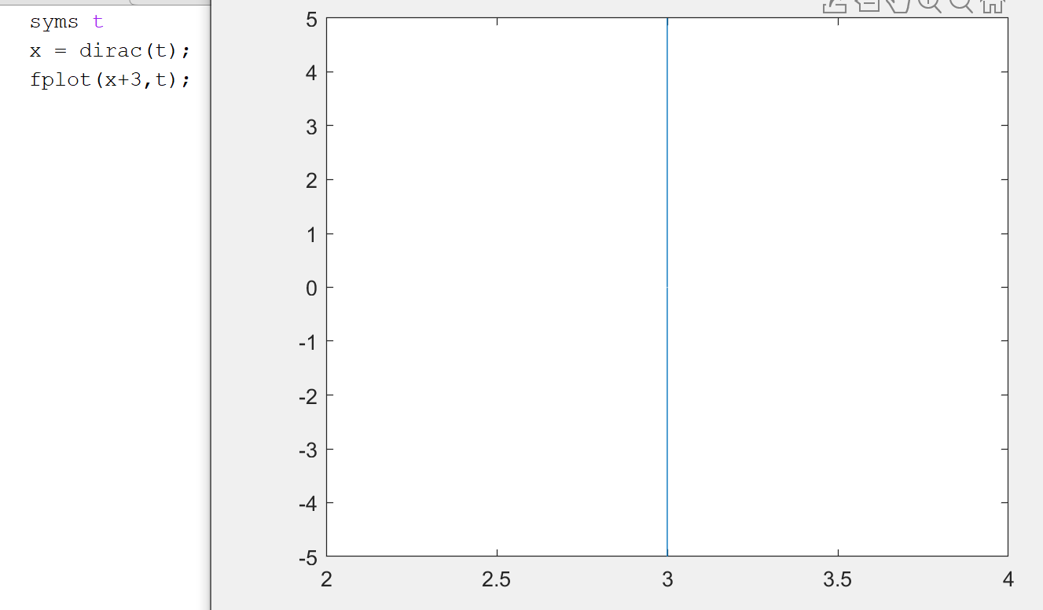

Fig. 7 MatLab code and function of a Delta Function offset by 3

1. $y\left(t\right)=\int_{-∞}^{t}{x\left(τ-3\right) dτ}=u(t-3)$ as the antiderivative of the delta function is 1 after it occurs.

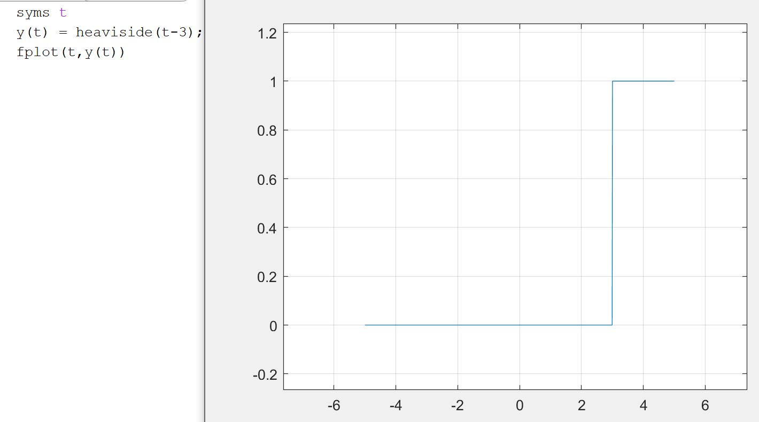

Fig. 8 MatLab code and function of the Unit Step resulted from the integral.

1. $y\left(t\right)= \int_{-∞}^{t}{\left\{\int_{-∞}^{α}{x\left(τ-7\right)dτ}\right\}dα}=\int_{-∞}^{t}{u\left(α-7\right) dα}=tu(t-7)$ as the integral of the unit step function is simply t after the step occurs.

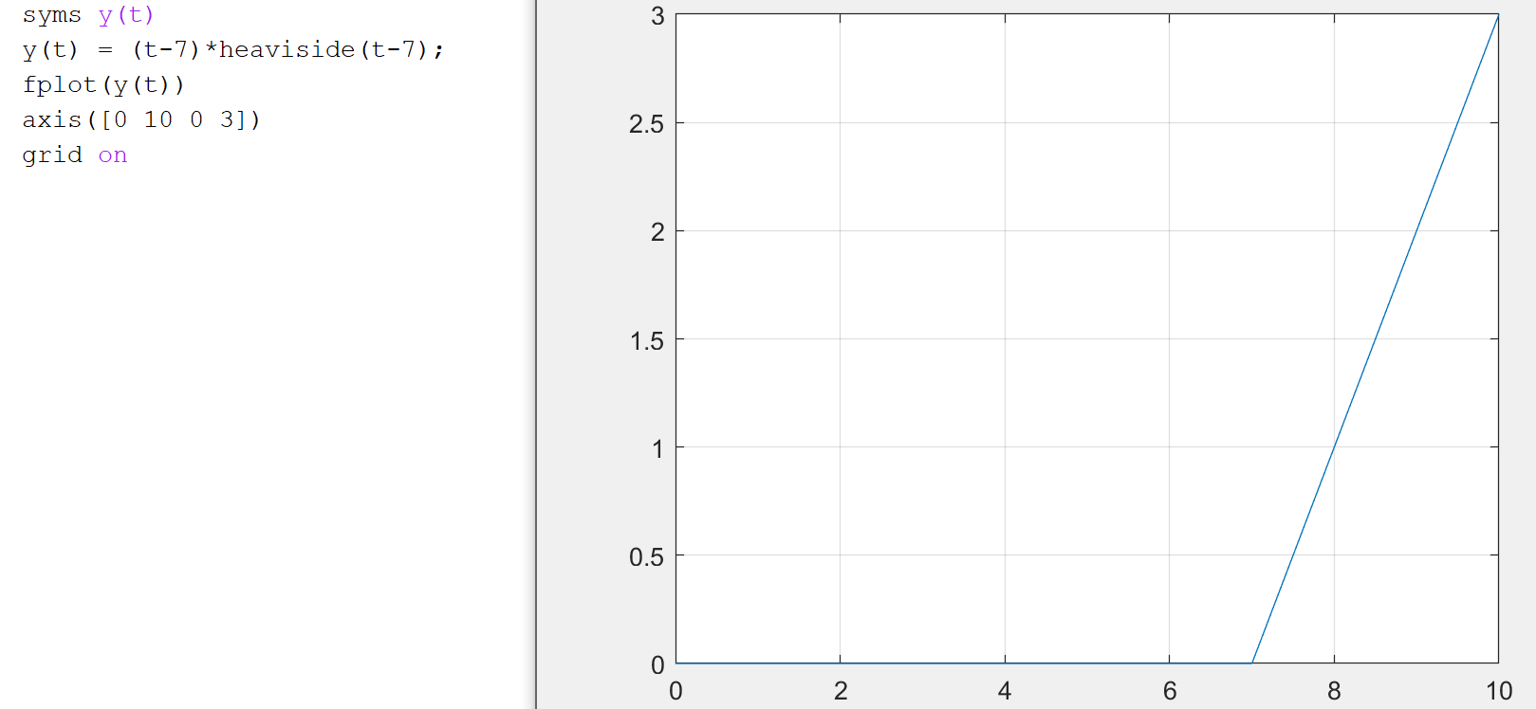

Fig. 9 MatLab script and plot for the evaluation of the integral.

# Problem 3

Given an LTI system impulse response:

$$h\left(t\right)= e^{-\frac{t}{2}}u(t-1)$$

Find and plot the system step response, s(t), when the input x(t) = u(t)

For s(t) when x(t) is the unit step function, the response will be exactly equal to the h(t) provided.

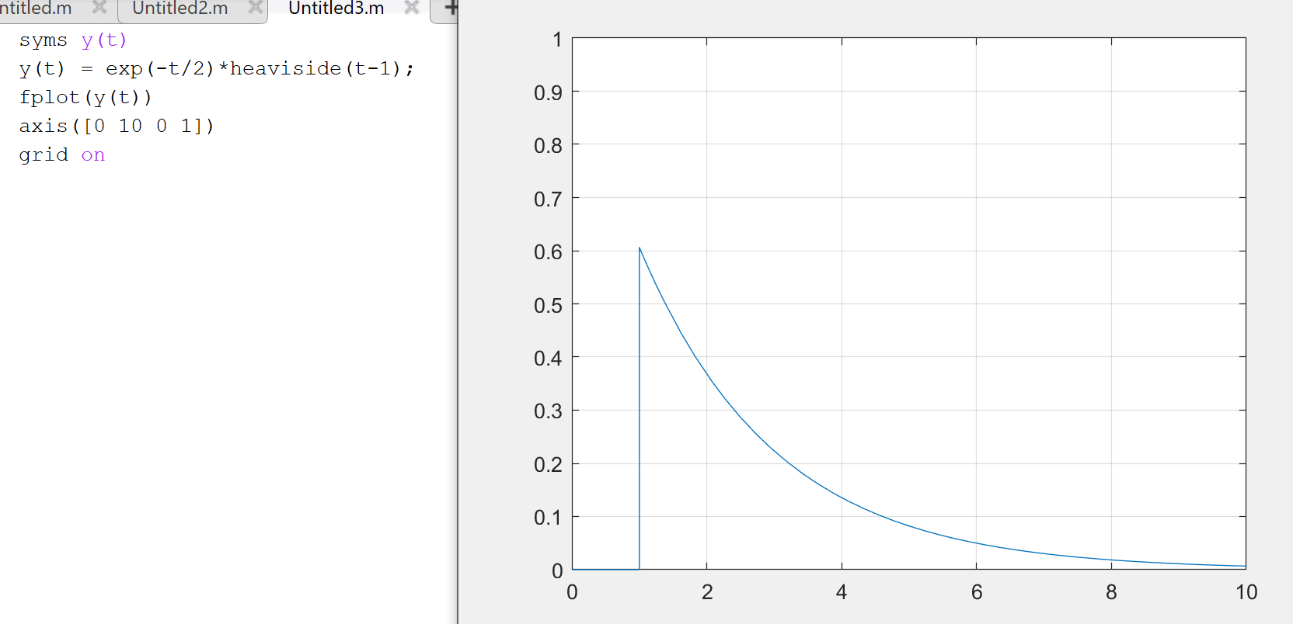

Fig. 10 MatLab script and plot for the evaluation of the response.

# Problem 4

For each of the characteristic equations of system models given below, determine the natural response (or mode) and tell whether the system is stable.

a) $s^{3}+2s^{2}+4s+16=0$

b) $s^{3}+3s^{2}-5s-10=0$

1. $s^{3}+2s^{2}+4s+16=0$ to find the characteristic equations, we need to find the roots of the function. Using a MatLab function the three roots can be determined.

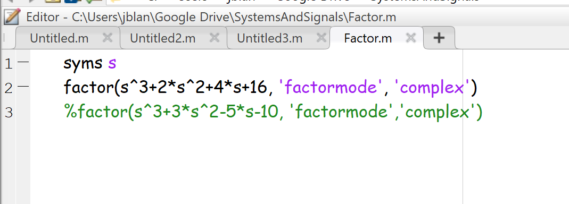

Fig. 11 MatLab script to determine roots of both equations

For this function the roots are found as -2.706, 0.353+2.4056i, and 0.3532-2.4056i. Thus, the characteristic equation can be determined.

$C_{1}e^{-2.706t}+C_{2}e^{0.353t+2.4056it}+C_{3}e^{0.3532t-2.4056it}$

Stability can be determined by the sign of the real value of the root, for the second and third root both real values are positive, so the equation is unstable.

1. $s^{3}+3s^{2}-5s-10=0$ Using the same code as above, the roots of this function can be found as -3.618, -1.382, and +2. The characteristic equation can then be expressed by:

$$C_{1}e^{-3.618t}+C_{2}e^{-1.382t}+C_{3}e^{2t}$$

Since there is a positive real root, this system is also unstable.

# Problem 5

Considering the LTI system of figure P3.13, a) express the system impulse response as a function of the impulse responses of the subsystems.

b) Let $h_{1}\left(t\right)=h_{3}\left(t\right)=2δ(t)$, $h_{2}\left(t\right)=h_{4}\left(t\right)=u\left(t\right), and h_{5}\left(t\right)=2u(t)$ Find the impulse response of the system.

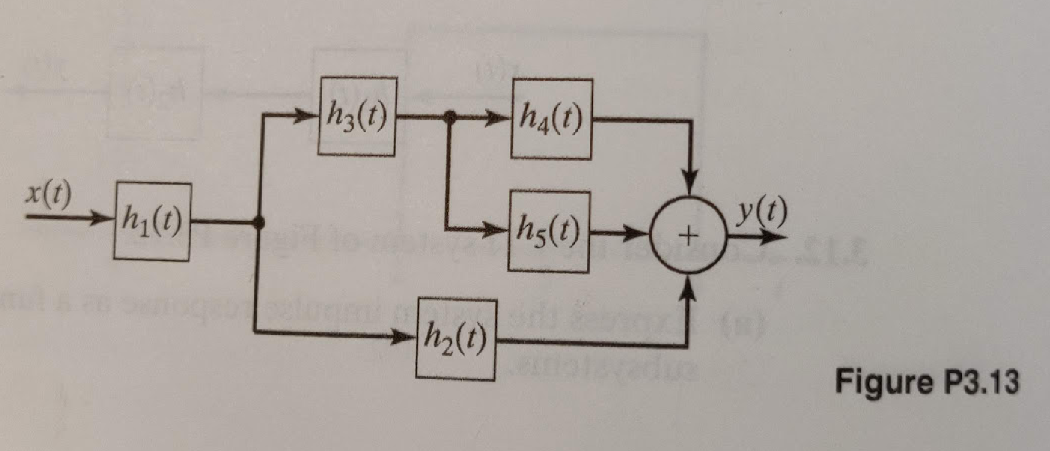

1. Given this system, we can form an equation by adding any functions in parallel and convoluting any equations in series. Thus, the integral

$$y\left(t\right)=\int_{-∞}^{∞}{h_{1}(t-α)\left[h_{2}\left(α\right)+\int_{-∞}^{∞}{h_{3}(α-τ)(h_{4}\left(τ\right)+h_{5}(τ))dτ}\right]dα}$$

can be used to represent the system.

1. Given $h_{1}\left(t\right)=h_{3}\left(t\right)=2δ(t)$, $h_{2}\left(t\right)=h_{4}\left(t\right)=u\left(t\right), and h_{5}\left(t\right)=2u(t)$,

$$y\left(t\right)=\int_{-∞}^{∞}{2δ(t-α)\left[u\left(α\right)+\int_{-∞}^{∞}{2δ(α-τ)(u\left(τ\right)+2u(τ))dτ}\right]dα}$$

Using the sifting property, the first integral can be simplified after adding $u\left(τ\right)+2u(τ)$

$$6\int_{-∞}^{∞}{δ\left(-τ+α\right)\left(u\left(τ\right)\right)dτ=6u(-α)} (δ is an even function)$$

Next the second integral can be broken up into two

$$y\left(t\right)=\int_{-∞}^{∞}{2δ\left(t-α\right)\left[u\left(α\right)+6u\left(-α\right)\right]dα}= 2\int_{-∞}^{∞}{δ\left(t-α\right)u\left(α\right) dα+12\int_{-∞}^{∞}{δ\left(t-α\right)u\left(-α\right)dα}}$$

Using the even properties of the delta function, the second function can be manipulated such that

$$2\int_{-∞}^{∞}{δ\left(-α+t\right)u\left(α\right) dα+12\int_{-∞}^{∞}{δ\left(+α-t\right)u\left(-α\right)dα}}$$

Which can equate to $2u\left(-t\right)+12u\left(-t\right)=14u(-t)$

References

Phillips, C. L., Parr, J. M., and Riskin, E. A, Signals, Systems, and Transforms (4th ed), ISBN: 978-0-13-198923-8, Pearson, 2008.