|  |  |
| --- | --- |
|  | School of Engineering |

|  |  |  |
| --- | --- | --- |
| **ELC321-02** |  | **Spring 2020** |

**Assignment 3**

**Date: March 26th, 2020**

**Submitted by: Jeffrey Blanda**

**Instructor: John MacDonald**

# Problem 1

Referring to Figure P4.35 in the text,

1. Mathematically determine the Fourier Series for f(t)
2. Plot the first 10 terms of the series over the range

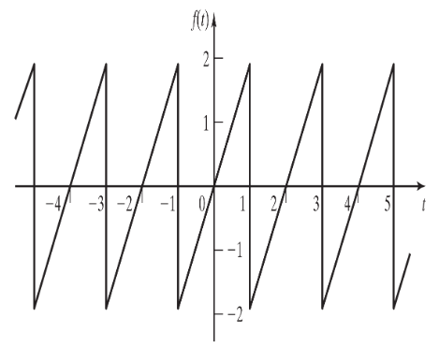

Figure P4.35, a Sawtooth function

## Part A.

1. Given this graph, we can determine it is periodic and obeys the following parameters:
   1. Over one period,
2. Thus, the function can be transformed into a Fourier Series using the equations:
3. First, solving for , or the Average value of the function:
   1. By inspection, we see that the average value should be 0.
   2. Check using equation
   3. Substitute 2 for and
   4. Integrate over a full period, we will use -1 to 1
   5. Thus
4. Next, solving for the cosine part of the function:
   1. Substituting 2 for , for , and and changing the bounds to one period
   2. Integrating the function yields
   3. However, when computing by inserting the bounds, sine of any multiple of is 0, and since cos(-x) = cos(x), the cosine part will also be 0. Therefore, the value of is 0.
5. Solving for the Sine part of the function:
   1. Substituting 2 for , for , and and changing the bounds to one period
   2. Integrating the function yields
   3. Plugging in the bounds yield
6. We now know the Fourier series function is made entirely of sine waves; thus, an equation can be written:

## Part B

1. Knowing the equation for the infinite summation of the Fourier series, for the first 10 terms of the series we can simply plug in for n.
2. Inserting this information into MatLab, the series can be plotted by using the code shown below.

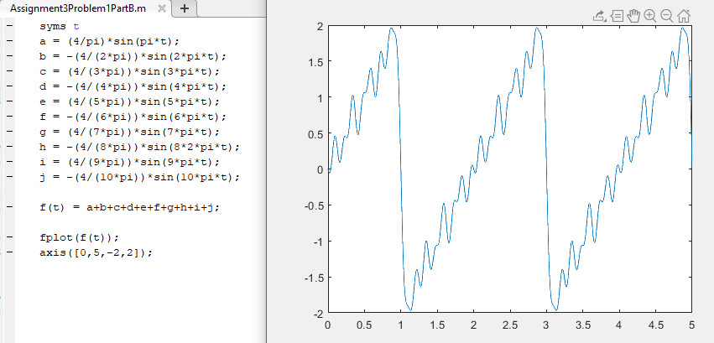

Figure 1. MatLab code and plot for the first 10 values of n in the Fourier series found in part A.

# Problem 2

For each of the signals given below, 1) determine the equation for the Fourier Transform, , and 2) plot || over the range

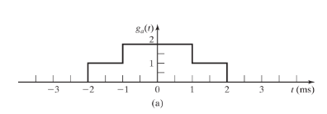

Figure 5.10(a)

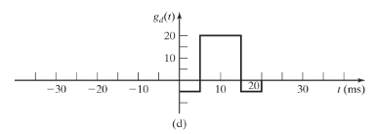

Figure 5.10(d)

## Part 1A

1. The graph given above cannot easily be expressed as a single function, so we will represent it as a sum of two functions.
2. We can add two rectangles together, to form the rectangle supplied.

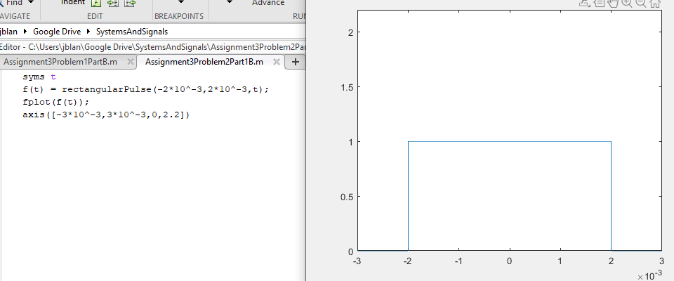

Figure 2. Matlab code and graph for

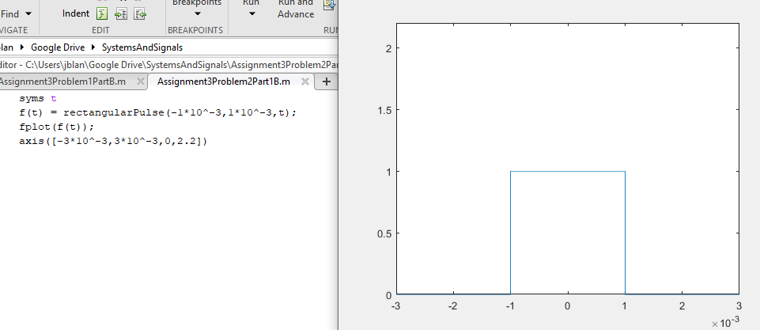

Figure 3. Matlab code and graph for

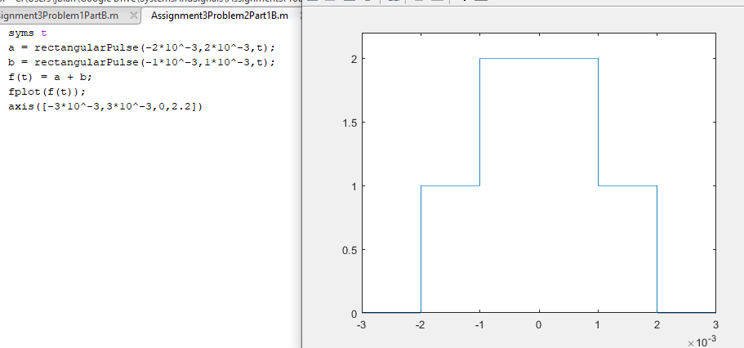

Figure 4. MatLab code and graph for the sum of the two rectangle functions that reproduce the original graph.

1. Knowing an expression for the graph, the Fourier transform can be applied.
2. Using integral laws, the function can be broken up into two parts.
3. Thus, the bounds can be recomputed as the rectangle has no area outside of its bounds.
4. The integration results with:
5. If we then multiply by
6. With this result, we can see that the Fourier Transform obeys superposition as when the transform of the rectangle function was derived in class yielded and our results are the sum of two rectangle functions that obey that identity.

## Part 1B

1. The transform above can be plotted in MatLab.

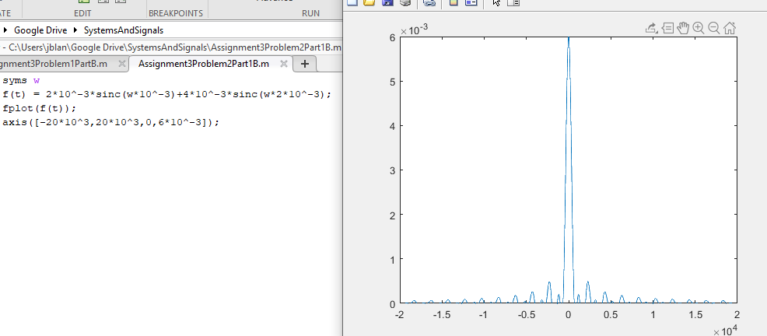

Figure 5. MatLab code and plot for the Fourier Transform of the function from -20k Rads/Sec to 20k Rads/Sec.

## Part 2A

1. From the graph, we can see that the function is primarily a rectangle function, sunk below the x-axis. The function goes to 0 after 20ms however, so an equation can be written to represent the graph:

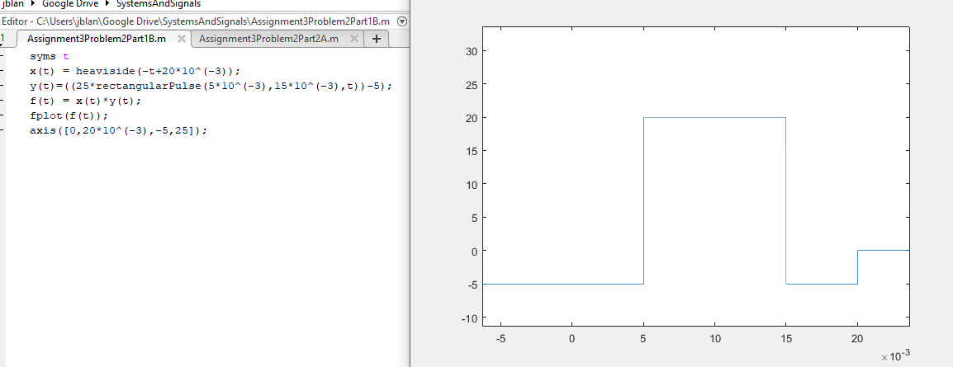

Figure 6. MatLab code and plot for the graph above.

1. Since superposition applies to the Fourier Transform, we can break this signal up into two discrete signals and add their transforms.
   1. The negative part of the signal can be represented as

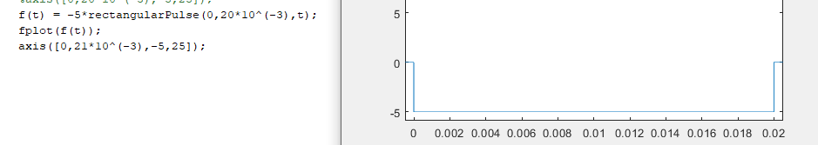

Figure 7. MatLab code and plot for the negative part of the signal

1. The positive part of the signal must be 5 more than the max amplitude, as adding -5 will reduce the amplitude.
   1. The positive part of the signal can be represented as

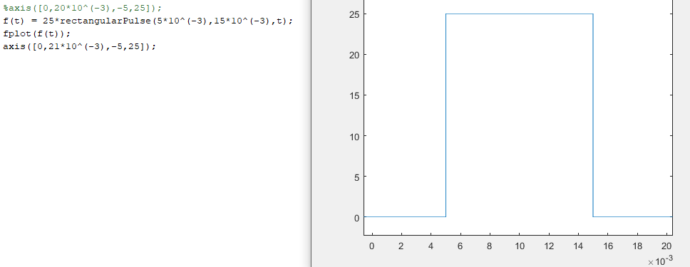

Figure 8. MatLab code and plot for the positive part of the signal.

1. Knowing the Fourier Transform of a rectangle from previous derivations
2. Since we know the Fourier transform of the function without an offset, we can now apply the Fourier time shift identity.
3. Applying superposition to F() and G() yields

## Part 2B

Since the transform is complex, we need to plot both the amplitude and the phase of the transform.

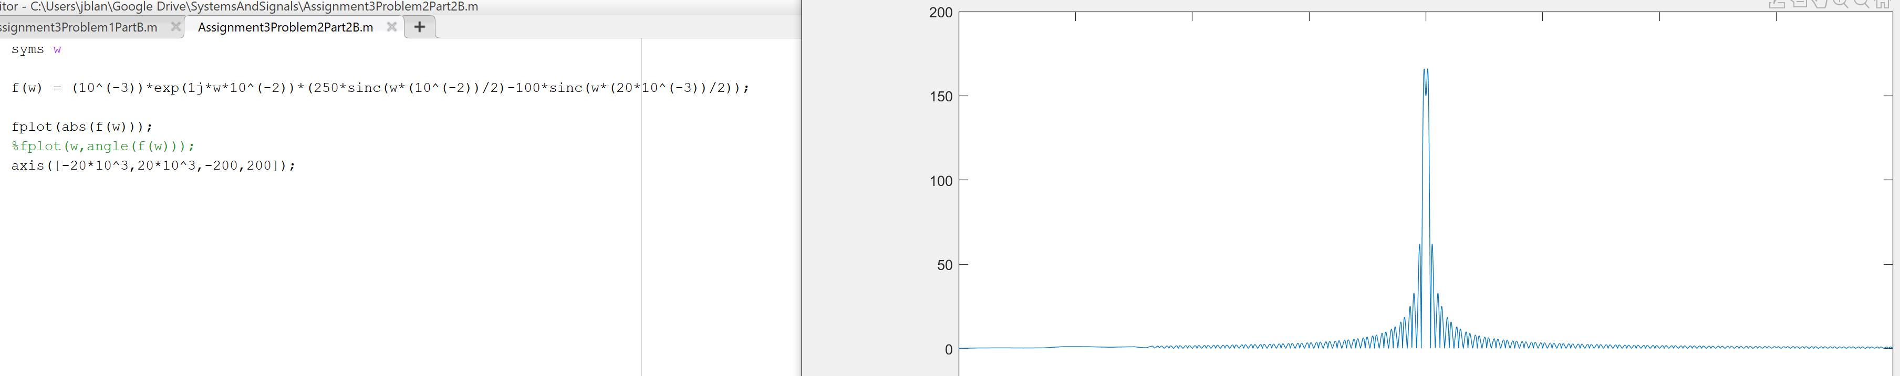

Figure 9. Matlab code and plot for the Fourier Transform from -20k rad/s to 20k rad/s

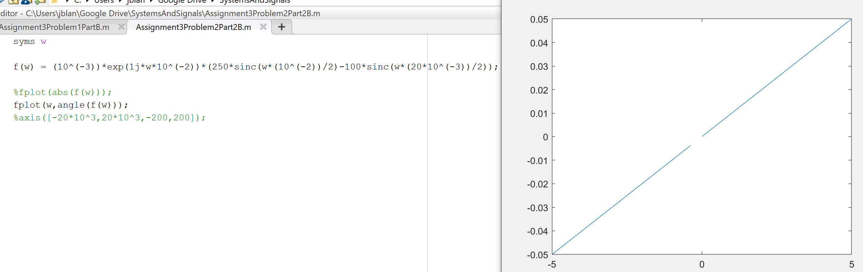

Figure 10. Matlab code and plot for the angle of the transform

# Problem 3

Referring to Figure P6.6(a),

1. Mathematically determine the transfer function
2. Using the values L=C =R = 1, Plot over the range from
3. Briefly describe what happens as R is varied over the range

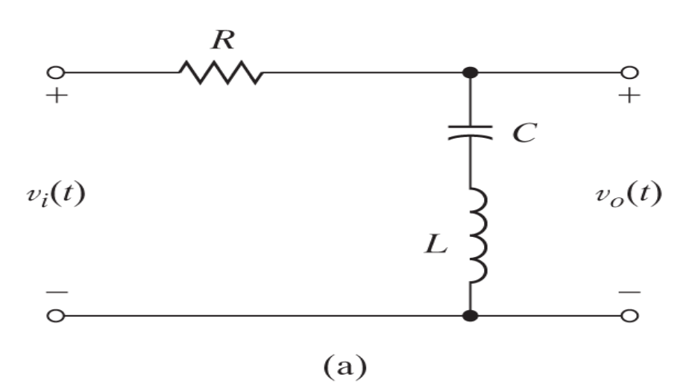

Figure P6.6(a)

## Part A

1. The transfer function can be found by transforming then finding the ratio of the two, as was defined in the problem.
2. Using Kirchhoff’s Voltage Law:
3. Transforming these functions using table 5.1 in the text yields:
4. Thus, the transfer function can be found as:
5. Which can be simplified to:
6. This answer can be checked using the voltage divider equation substituting impedance for resistance, as impedance is already in the Fourier domain.

## Part B

1. Using the given values R=L=C=1

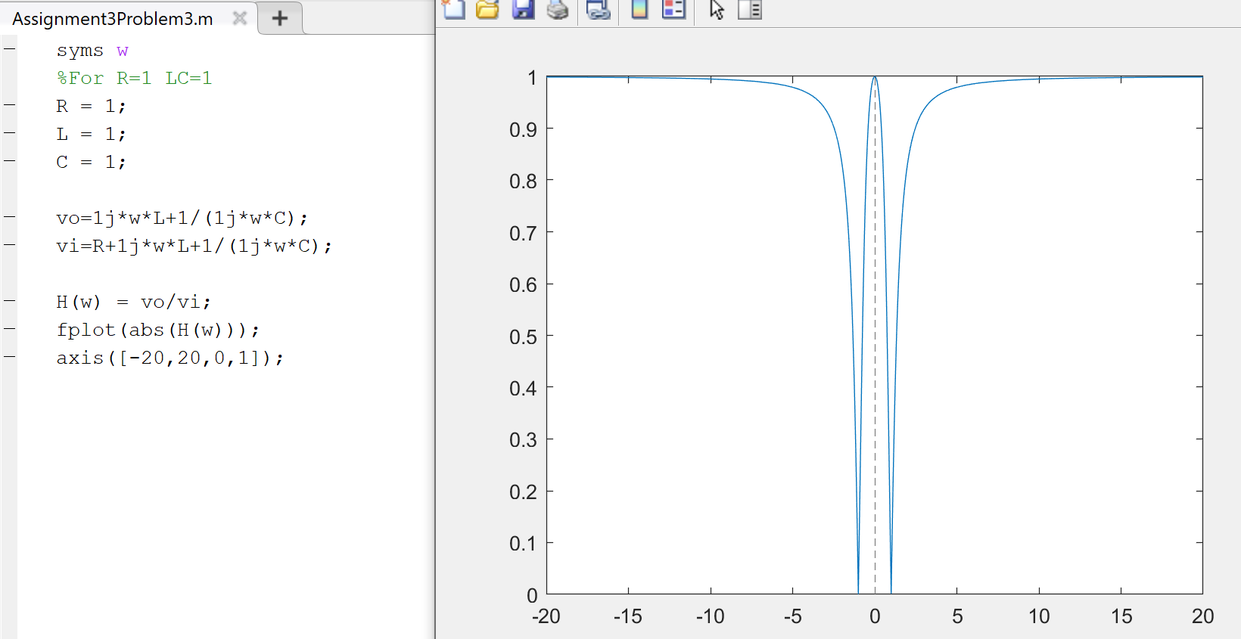

Figure 11. MatLab code and plot for the transfer function

## Part C

As R is lowered, the peak is wider, and the two sides come inward while a greater R reduces the width of the central peak and widens the area between it and the sides. What this translates to is the effective gain of the function at a respective ω. The lower R value, the lower frequencies can pass through and the higher R value rejects lower frequencies for a constant C and L.

## Problem 4

6.23. Two signals with an amplitude frequency spectra shown in Figure P.623(a) and (b) are to be sampled using an ideal sampler.

1) Sketch the spectra of the resulting signals for when sampling periods of 10, 25, and 50ms are used.

2) Which of the sampling frequencies is acceptable for use if the signal of Figure 6.23(a) is to be reconstructed using an ideal low-pass filter?

3) Which of the sampling frequencies is acceptable for use if the signal of Figure 6.23(b) is to be reconstructed using an ideal low-pass filter?

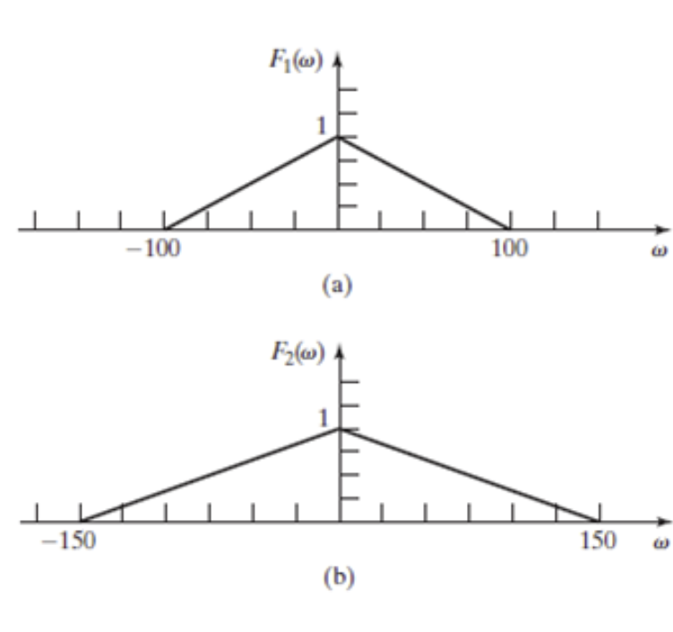

Figure P6.23(a) and (b)

1. The frequency spectrum of sampled data changes in the following ways:
   1. The amplitude is now divided by the sampling period
   2. The signal repeats at every
   3. Aliasing can occur if is too small.

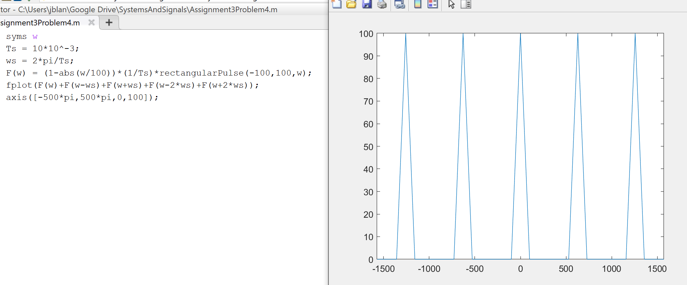

Figure 12. MatLab Code and Plot (a) for the sampled signal at 10ms

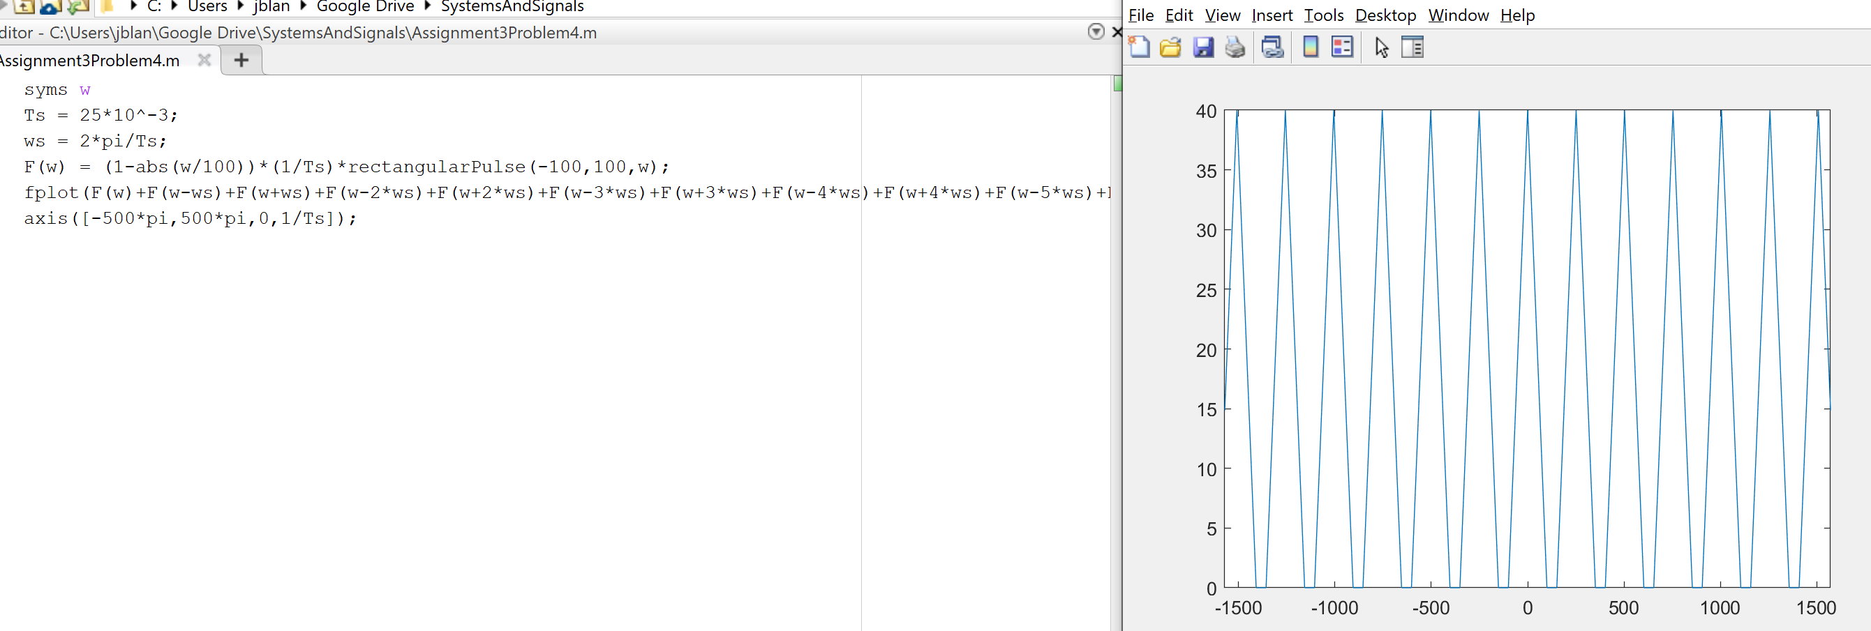

Figure 13. MatLab Code and Plot (a) for the sampled signal at 25ms

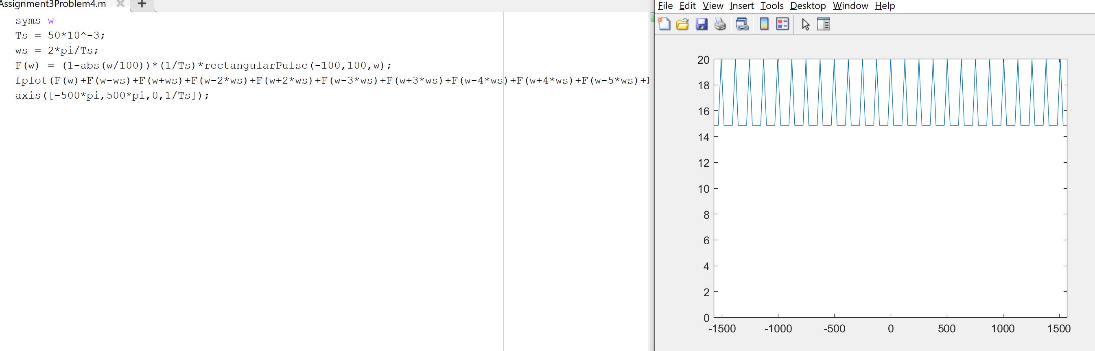

Figure 14. MatLab Code and Plot (a) for the sampled signal at 50ms. Note that lots of aliasing occurs for such a small frequency.

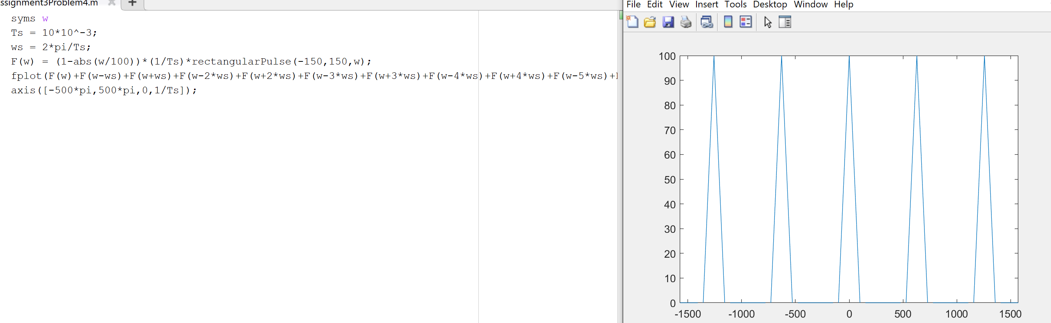

Figure 15. MatLab Code and Plot (b) for the sampled signal at 10ms

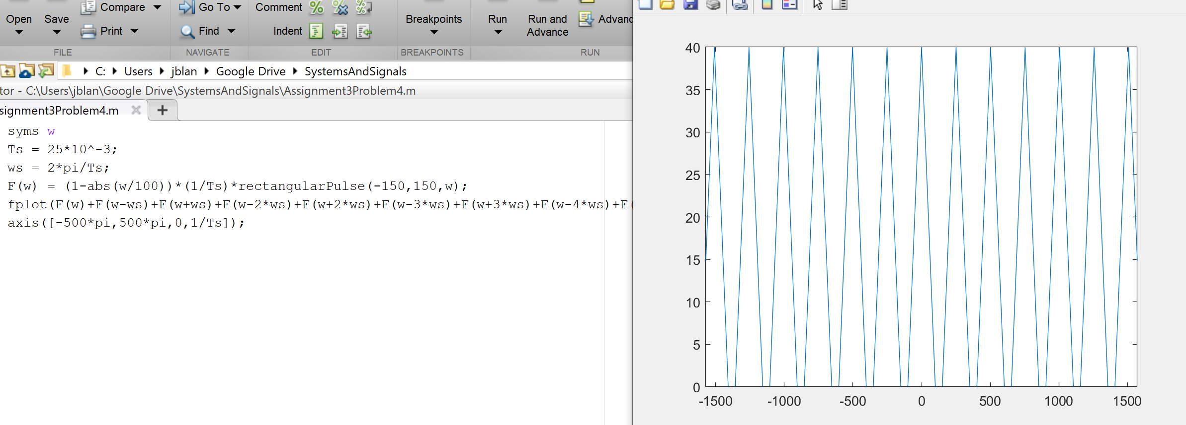

Figure 16. MatLab Code and Plot (b) for the sampled signal at 25ms

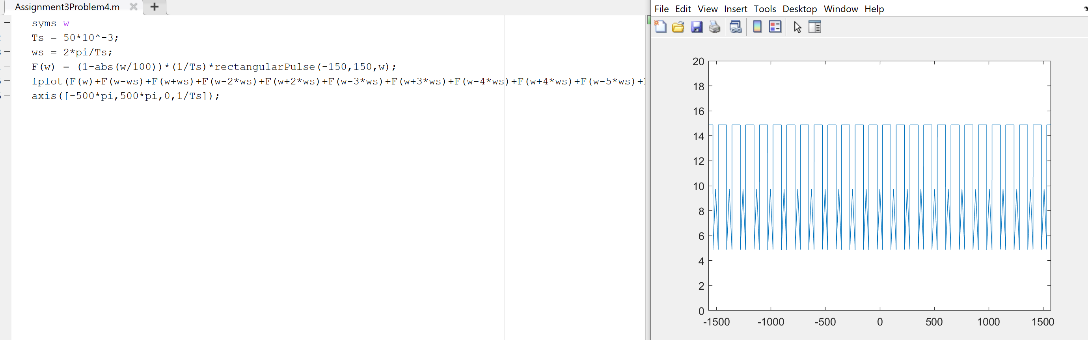

Figure 17. MatLab Code and Plot (b) for the sampled signal at 50ms. Note the high amount of aliasing.

## Part 2

If the signal a is to be reconstructed using an ideal low-pass filter, it is best to choose one without aliasing and one that will contain the full information from the signal. Sampling times of 10 and 25ms both show these characteristics, however if the 25ms sampling were to be used in a low pass filter it would be difficult to isolate a single period of the signal, as they repeat so closely. A sampling time of 10ms (figure 12) would be best for this situation.

## Part 3

If the signal b is to be reconstructed using an ideal low-pass filter, aliasing should once again be avoided. Once again, a 10ms sampling time would be ideal, as it is much easier to isolate the original signal using a low pass filter.

References

Phillips, C. L., Parr, J. M., and Riskin, E. A, Signals, Systems, and Transforms (4th ed), ISBN: 978-0-13-198923-8, Pearson, 2008.