|  |  |
| --- | --- |
|  | School of Engineering |

|  |  |  |
| --- | --- | --- |
| **ELC321-02** |  | **Spring 2020** |

**Assignment 4**

**Date: April 14th, 2020**

**Submitted by: Jeffrey Blanda**

**Instructor: John MacDonald**

Problem 1. For the signal $x_{d}\left[n\right]$ of figure 9.3(d) plot

$x_{d}\left[2n\right]$

$x_{d}\left[-\frac{n}{2}\right]$

$x_{d}\left[-n\right]$

$x_{d}\left[2-n\right]$

$x_{d}\left[n-2\right]$

$x_{d}\left[-2-n\right]$

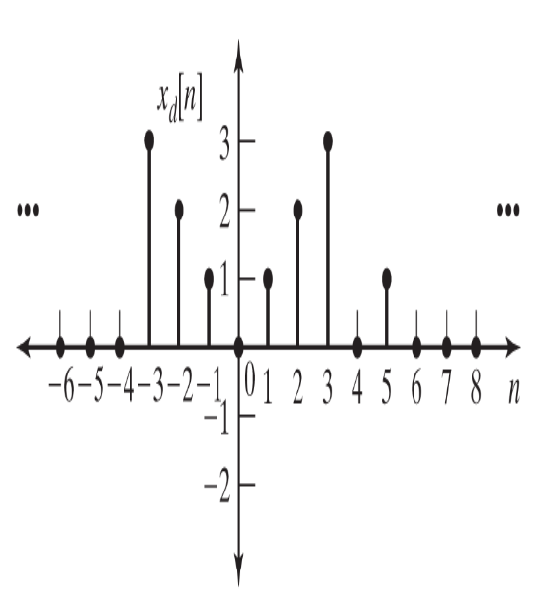

Prior to manipulating the discrete signal, reproducing it in MatLab yields the graph:

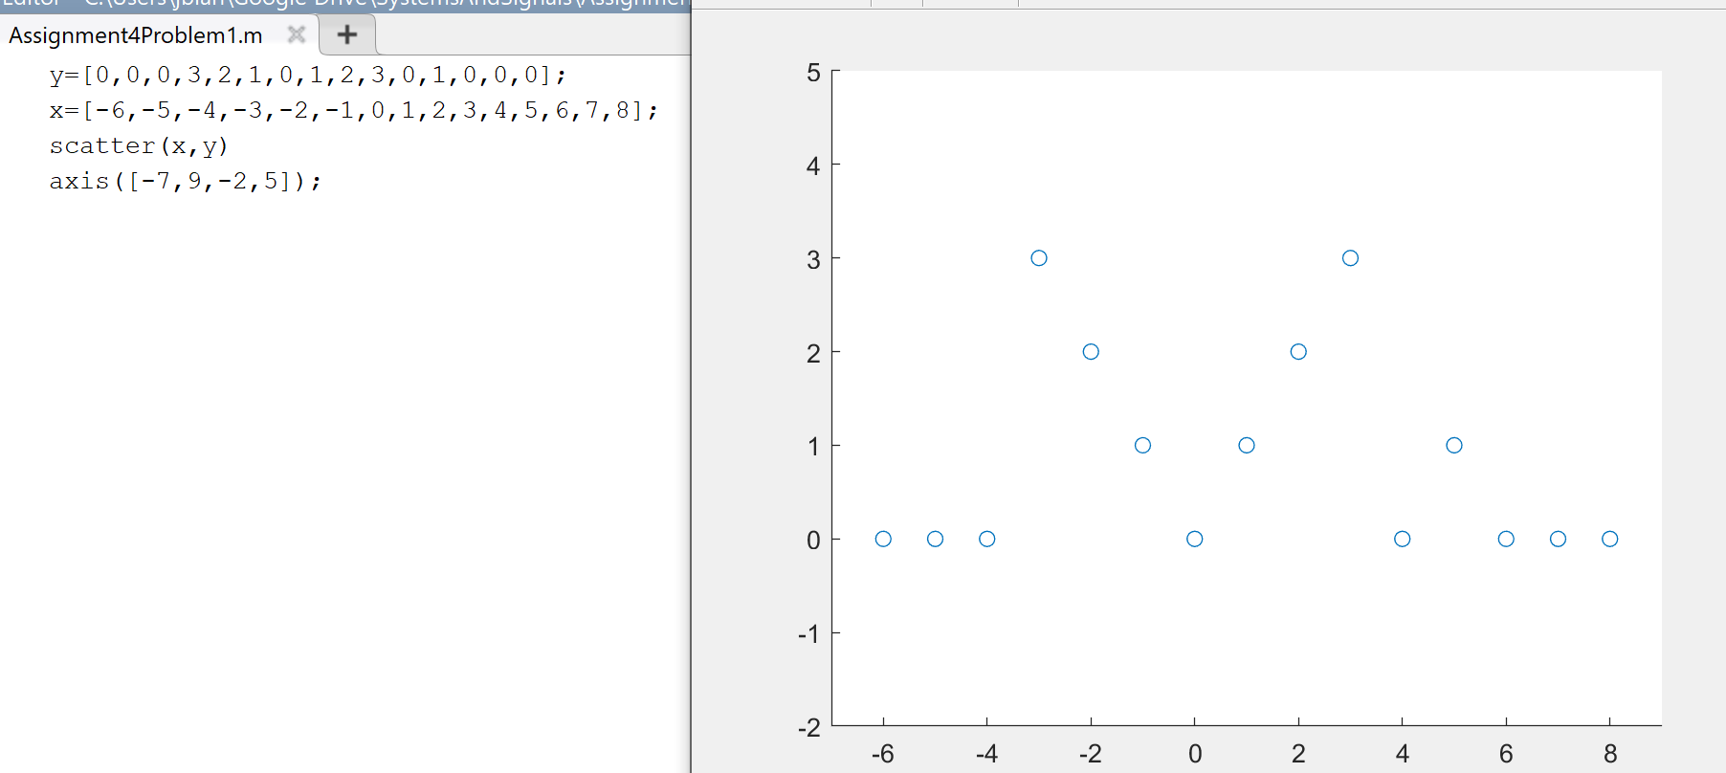

Figure 1: MatLab code and plot for the given discrete signal.

1. $x_{d}\left[2n\right]$ can be expressed by doubling the x axis of the signal, however since data is unavailable for every other point these can be expressed as blank, averages, or zeros. Here they will be left blank.

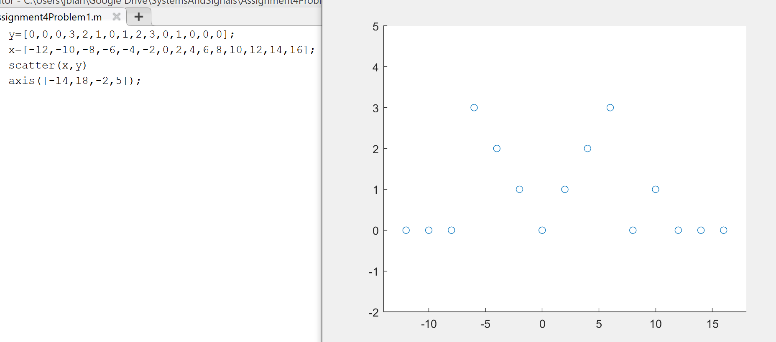

Figure 2. MatLab code and plot for $x_{d}\left[2n\right]$

1. $x_{d}\left[-\frac{n}{2}\right]$ can be represented as the inversion of the original signal with the x axis shrunk by ½, losing every other data point.

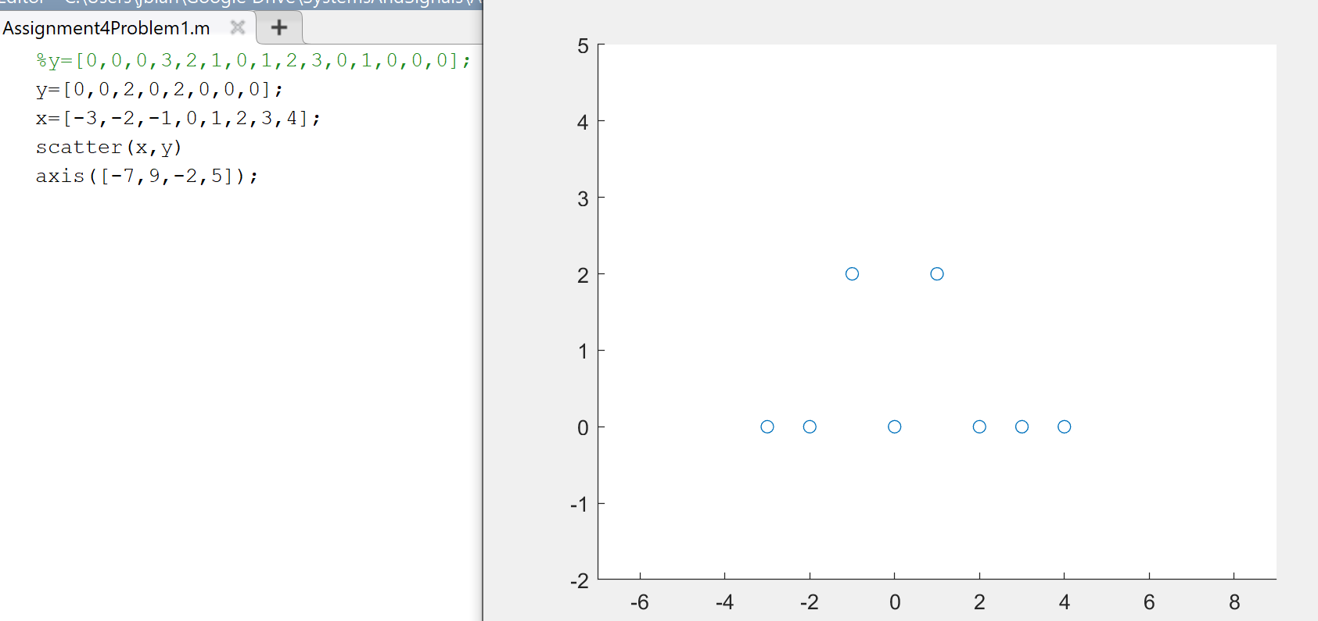

Figure 3. MatLab code and plot for $x_{d}\left[-\frac{n}{2}\right]$

1. $x_{d}\left[-n\right]$ is simply the original signal, inverted.

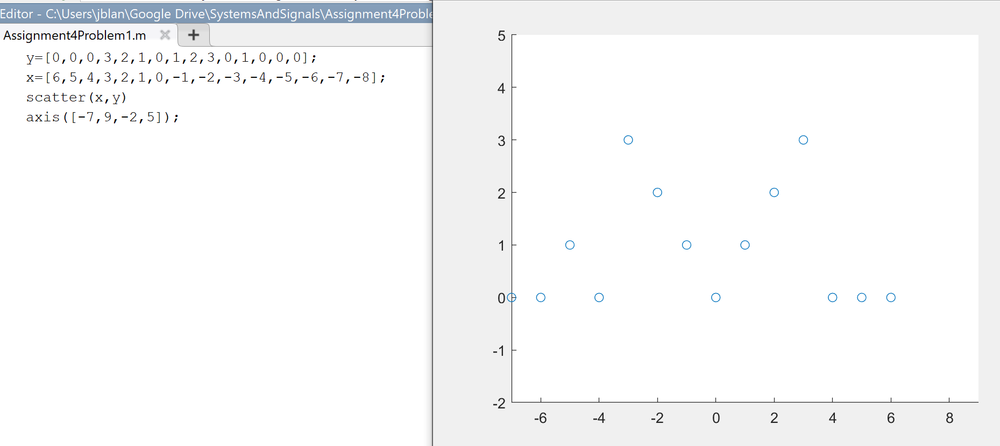

Figure 4. MatLab code and plot for $x_{d}\left[-n\right]$

1. $x_{d}\left[2-n\right]$ can be rewritten as $x_{d}\left[-(n-2)\right]$, or the original signal offset by two, then inverted.

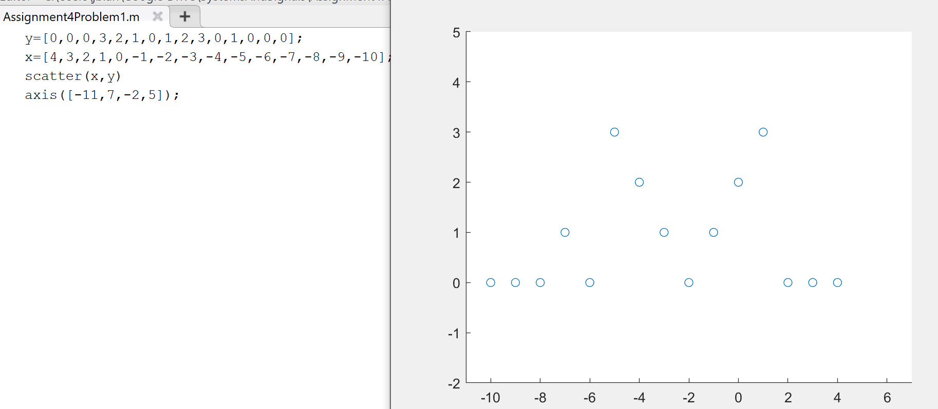

Figure 5. MatLab code and plot for $x_{d}\left[2-n\right]$

1. $x_{d}\left[n-2\right]$ is the original signal, offset by 2.

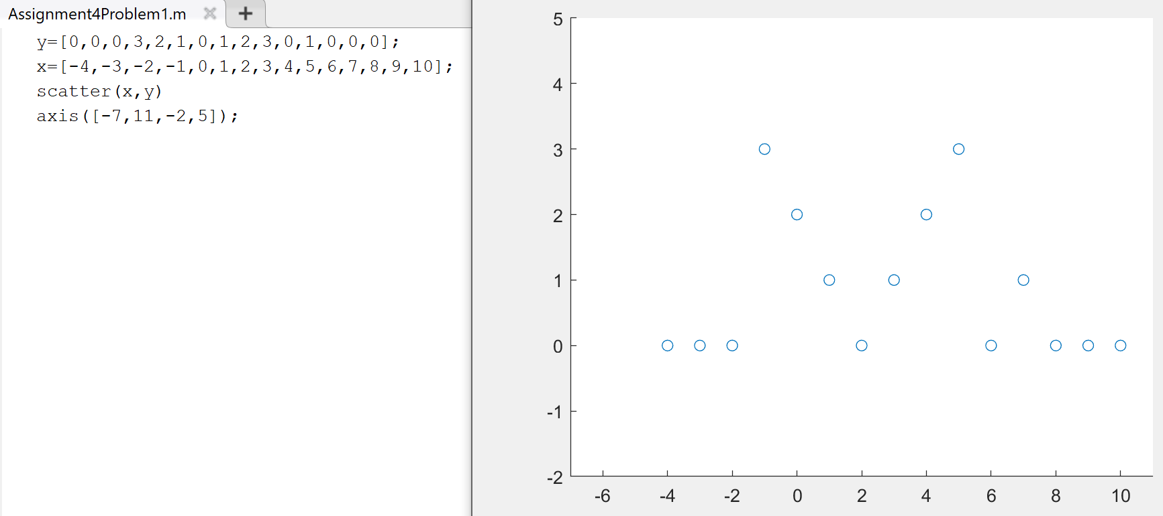

Figure 6. MatLab code and plot of $x_{d}\left[n-2\right]$

1. $x_{d}\left[-2-n\right]$ can also be written as $x_{d}\left[-(n+2)\right]$, or the signal shifted two to the left then inverted.

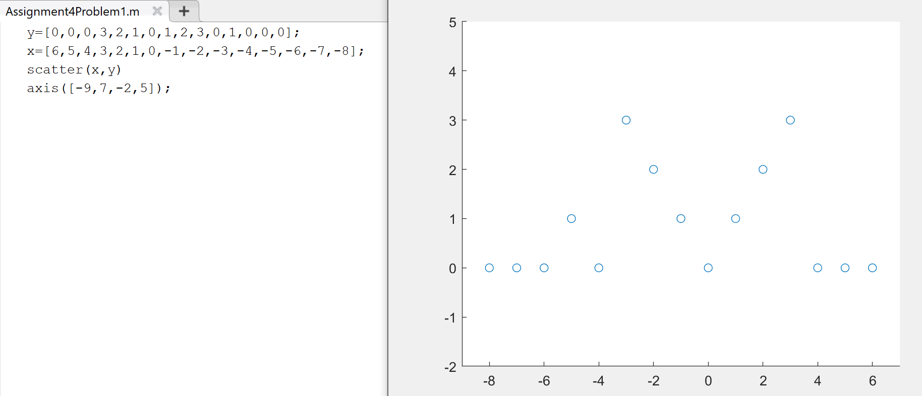

Figure 7. MatLab code and plot of $x_{d}\left[-2-n\right]$

Problem 2.

The signals in P9.4a are zero except as shown. Plot the following for $x_{a}\left[n\right]$

$x_{a}\left[-n\right]u\left[n\right]$

$x_{a}\left[n\right]u[-n]$

$x_{a}\left[n\right]u\left[n-2\right]$

$x_{a}\left[n\right]u\left[2-n\right]$

$x_{a}\left[n\right]δ\left[n-1\right]$

$x_{a}\left[n\right](δ\left[n\right]+δ\left[n-2\right])$

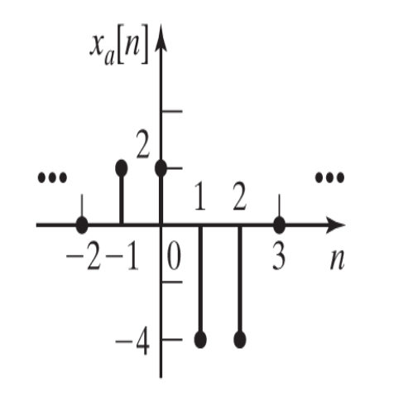

Figure P9.4a

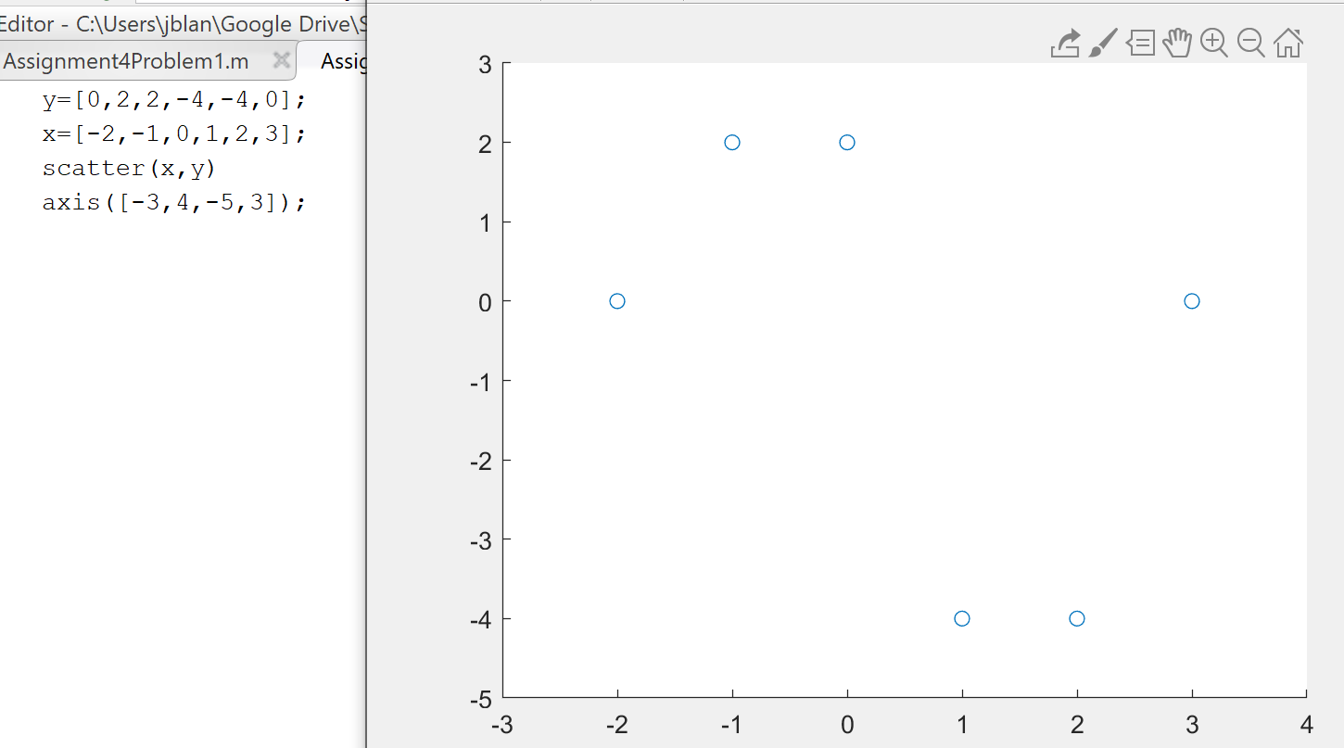

Figure 8. P9.4 recreated in MatLab

$x_{a}\left[-n\right]u\left[n\right]$

Since the unit step function is 0 except for $n≥0$ where the function is 1, the discrete signal can be plotted as the inverted signal at and past 0.

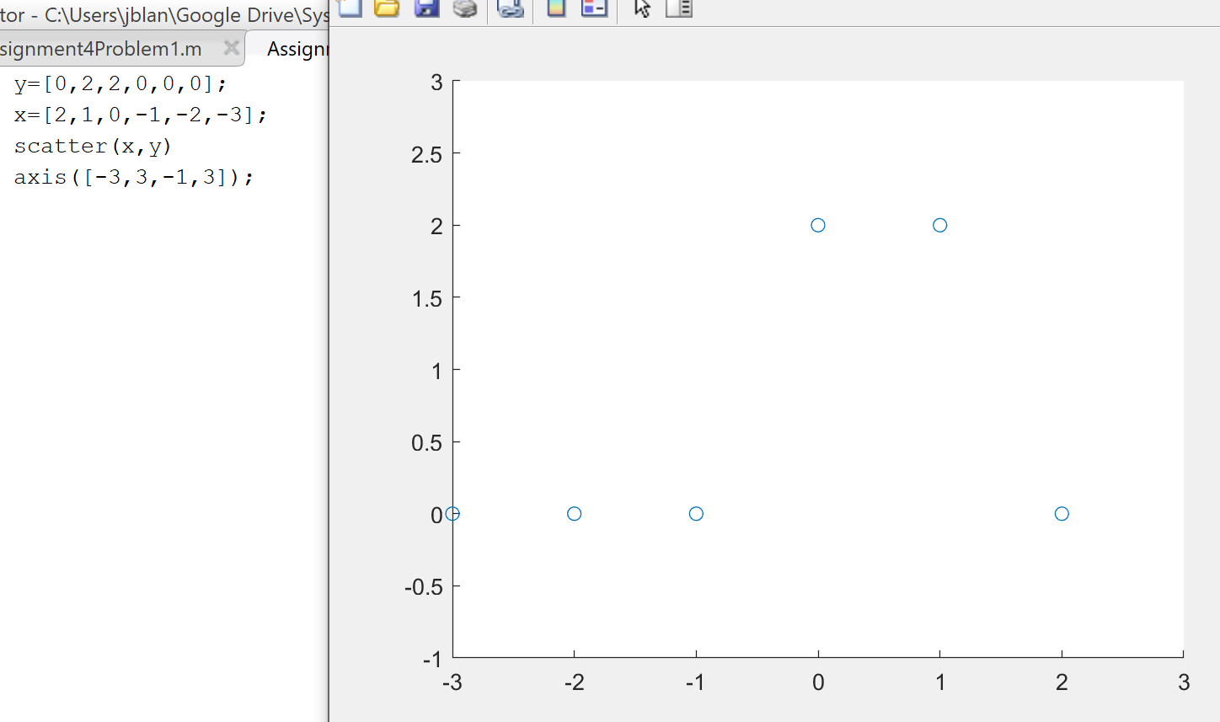

Figure 9. $x_{a}\left[-n\right]u\left[n\right]$ plotted in MatLab

$x_{a}\left[n\right]u\left[-n\right]$

The inverted unit step function evaluates to 1 at any $n≤0$ and 0 at $n>0$.

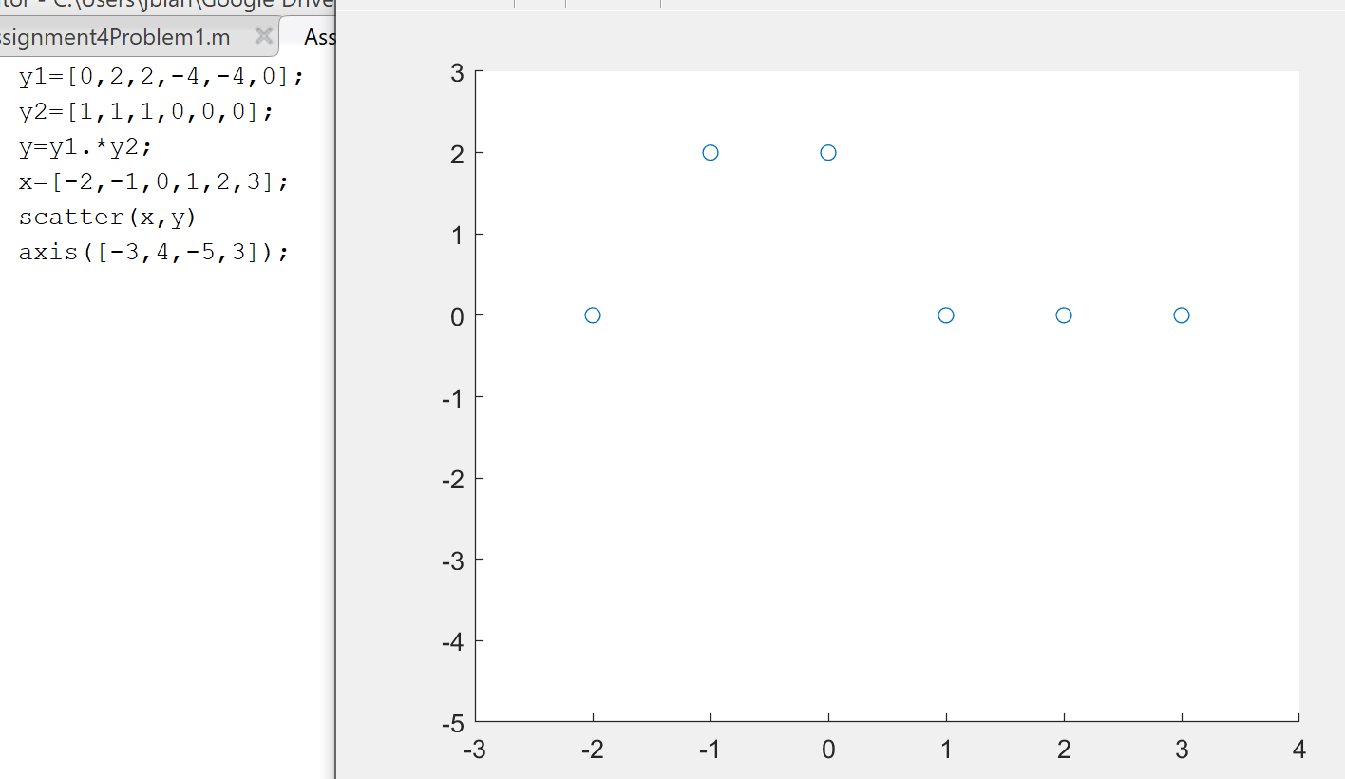

Figure 10. MatLab code and plot of $x_{a}\left[n\right]u\left[-n\right]$

$x_{a}\left[n\right]u\left[n-2\right]$

The offset unit function will evaluate to 1 when $n≥2$ or 0 when $n<2$.

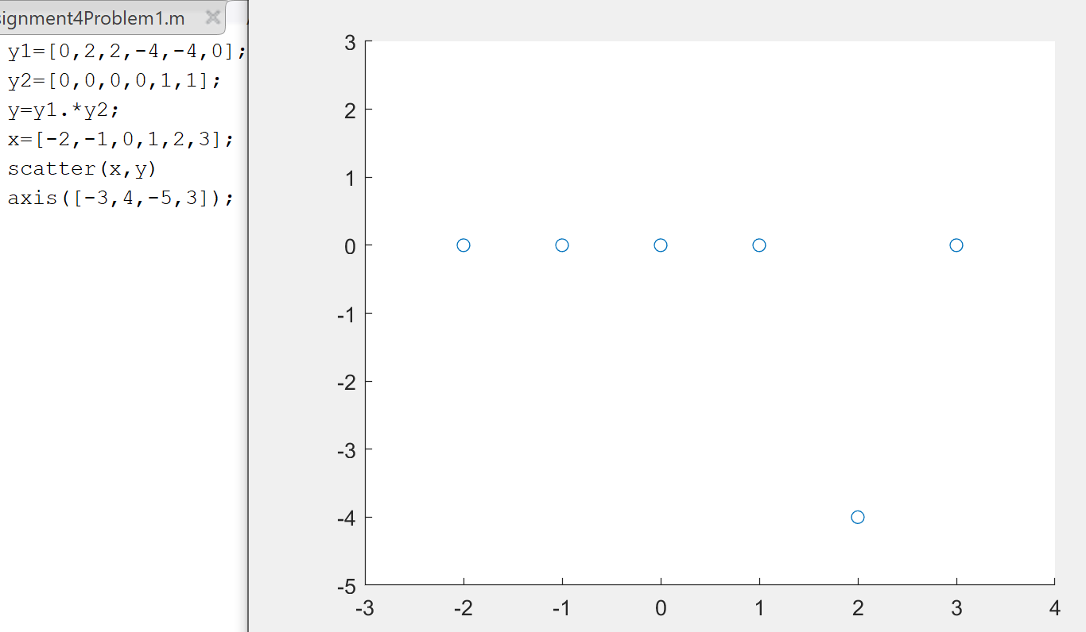

Figure 11. MatLab code and plot of $x_{a}\left[n\right]u\left[n-2\right]$

$x_{a}\left[n\right]u\left[2-n\right]$

This can also be written as $x_{a}\left[n\right]u\left[-(n-2)\right]$, or the inverted offset unit step function. This when $n≤-2$ the function will evaluate to 1, otherwise it will be 0.

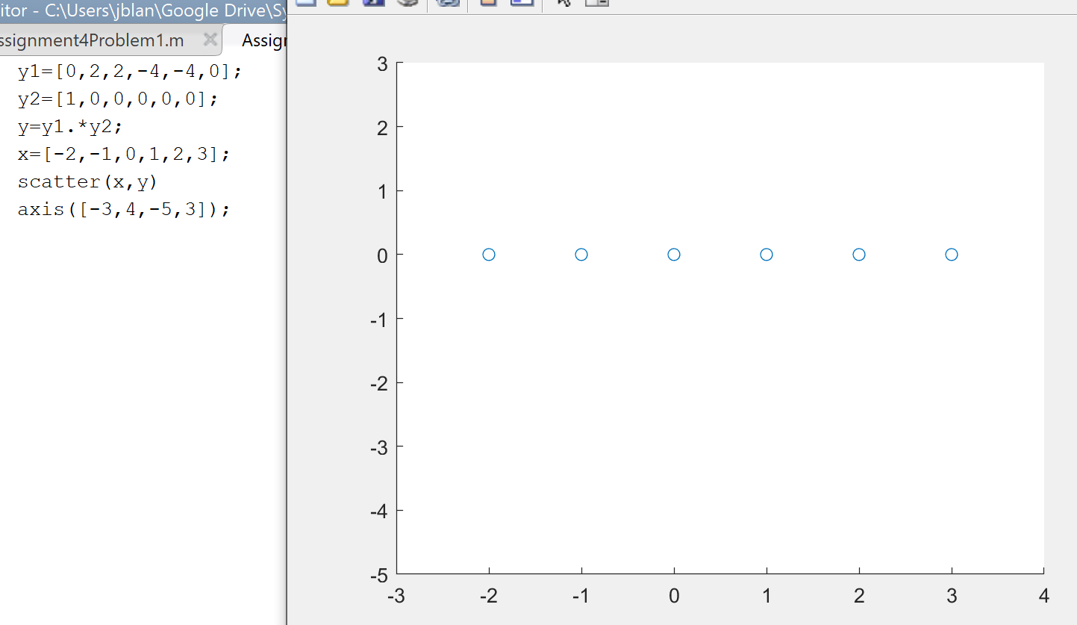

Figure 12. MatLab code and plot for $x_{a}\left[n\right]u\left[2-n\right]$

$x_{a}\left[n\right]δ\left[n-1\right]$

The delta function only evaluates to 1 at point n=1.

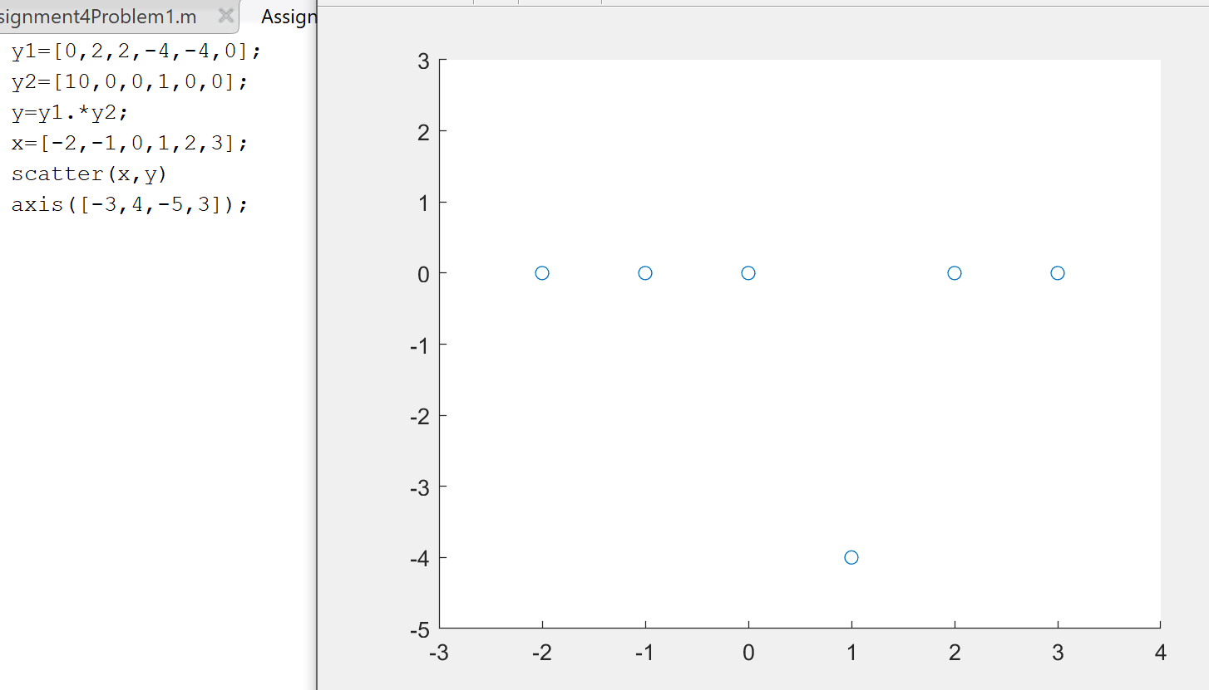

Figure 13. MatLab code and plot for $x_{a}\left[n\right]δ\left[n-1\right]$

$x_{a}\left[n\right](δ\left[n\right]+δ\left[n-2\right])$

Inside the parentheses, the function will evaluate to 0 everywhere except at points n=0 and n=2 where it’ll evaluate to 1.

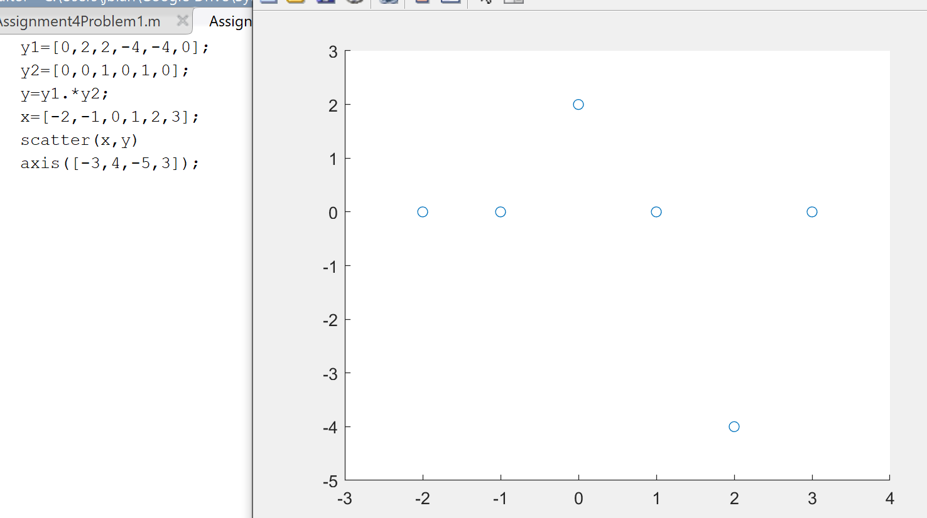

Figure 14. MatLab code and figure for $x_{a}\left[n\right](δ\left[n\right]+δ\left[n-2\right])$

Problem 3.

Given the LTI system of Figure P10.6 with the impulse response $h\left[n\right]=∝^{n}u[n]$ where α is a constant. This system is excited with the input $x\left[n\right]=β^{n}u[n]$ with β != α and β is a constant.

1. Find the system response y[n]. Express y[n] in closed form, using the formulas for geometric series in Appendix C.
2. Evaluate y[4], using the results of Part a.
3. Verify the results of Part b by expanding the convolution sum for y[4], as in (10.15).

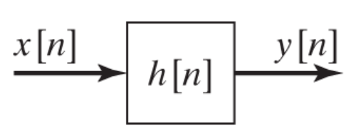

Figure P10.6

1. The convolution sum from the text is

$$y\left[n\right]=\sum_{k=-∞}^{∞}{x\left[k\right]h\left[n-k\right]=x\left[n\right]*h\left[n\right]}$$

$$y\left[n\right]=\sum_{k=n}^{∞}{β^{k}∝^{n-k}}$$

Using the formulas for geometric series found in the text,

$$y\left[n\right]=\frac{β^{n}}{1-β}\sum_{k=0}^{∞}{-∝^{k}}$$

$$y\left[n\right]=-\frac{β^{n}}{1-β}×\frac{1}{1-α}$$

$y\left[n\right]=-\frac{β^{n}}{1-β}×\frac{1}{1-α}$

$$y\left[4\right]=-\frac{β^{4}}{1-β}×\frac{1}{1-α}$$

1. As stated in 10.15, the convolution sum can also be expressed as

$$y\left[n\right]=\sum_{k=-∞}^{∞}{h\left[k\right]x\left[n-k\right]=x\left[n\right]*h\left[n\right]}$$

Thus

$$y\left[n\right]=\sum_{k=n}^{∞}{β^{n-k}∝^{k}}=-\frac{1}{1-β}×\frac{∝^{n}}{1-α}$$

$$y\left[4\right]=-\frac{1}{1-β}×\frac{∝^{4}}{1-α}$$

Problem 4. Consider the LTI system of Figure P10.6, with the input x[n] and the impulse response h[n], where

$$x[n]\left\{\begin{aligned}2, \\ 0, \end{aligned} {1≤n≤10 and 20≤n≤29 \atop otherwise}\right.$$

$$h\left[n\right]=\left\{\begin{aligned}1, \\ 0,\end{aligned}\right. {2≤n≤20 \atop otherwise}$$

Find and plot y[n].

$$x\left[n\right]=2\left(u\left[n-1\right]-u\left[n-11\right]\right)+2(u\left[n-20\right]-u[n-30])$$

$$h\left[n\right]=u\left[n-2\right]-u[n-21]$$

$$y\left[n\right]=\sum_{k=-∞}^{∞}{x\left[k\right]h\left[n-k\right]=x\left[n\right]*h\left[n\right]}$$

$$y\left[n\right]=\sum_{k=-∞}^{∞}{\begin{aligned}\left\{2\left(u\left[n-1\right]-u\left[n-11\right]\right)+2\left(u\left[n-20\right]-u\left[n-30\right]\right)\right\} \\ \{u\left[\left(n-k\right)-2\right]-u[(n-k)-21]\}\end{aligned}}$$

$$y\left[n\right]=\sum_{k=-∞}^{∞}{\begin{aligned}\left\{2\left(u\left[n-1\right]-u\left[n-11\right]\right)+2\left(u\left[n-20\right]-u\left[n-30\right]\right)\right\} \\ \{u\left[n-\left(2+k\right)\right]-u[(n-(21+k)]\}\end{aligned}}$$

Doing convolution by hand,

At $n-k<3, 0$

At $3≤n-k≤10$, $\sum_{3}^{n-k}{2}$

At $11≤n-k≤18, 20$

At $n-k=19, 18$

At $20≤n-k≤29, 18$

At $30≤n-k≤48, 20$

At $48≤n-k≤58, 20-\sum_{48}^{n-k}{2}$

At $n-k>58, 0$

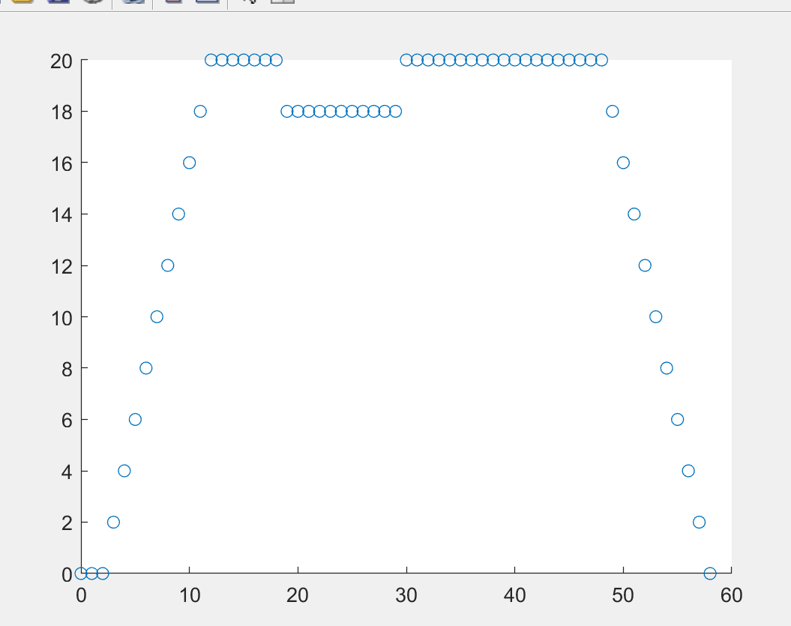

Figure 15. Convolution plot for y[n]

Problem 5.

Consider the discrete-time LTI system of Figure P10.6. This system has the impulse response

$$h\left[n\right]=u\left[n\right]-u[n-2]$$

$$and the input signal is given by$$

$$x\left[n\right]=δ\left[n+2\right]+3{\left(0.7\right)}^{n}(u\left[n\right]-u[n-5])$$

Find and plot y[n].

Using h[n-k] convolving the functions results in

0 at $n-k<-2$

2 at $-2≤n-k≤-1$

6 at $n-k=0$

$$6{\left(0.7\right)}^{n}+6{\left(0.7\right)}^{n-1} at n-k>0$$

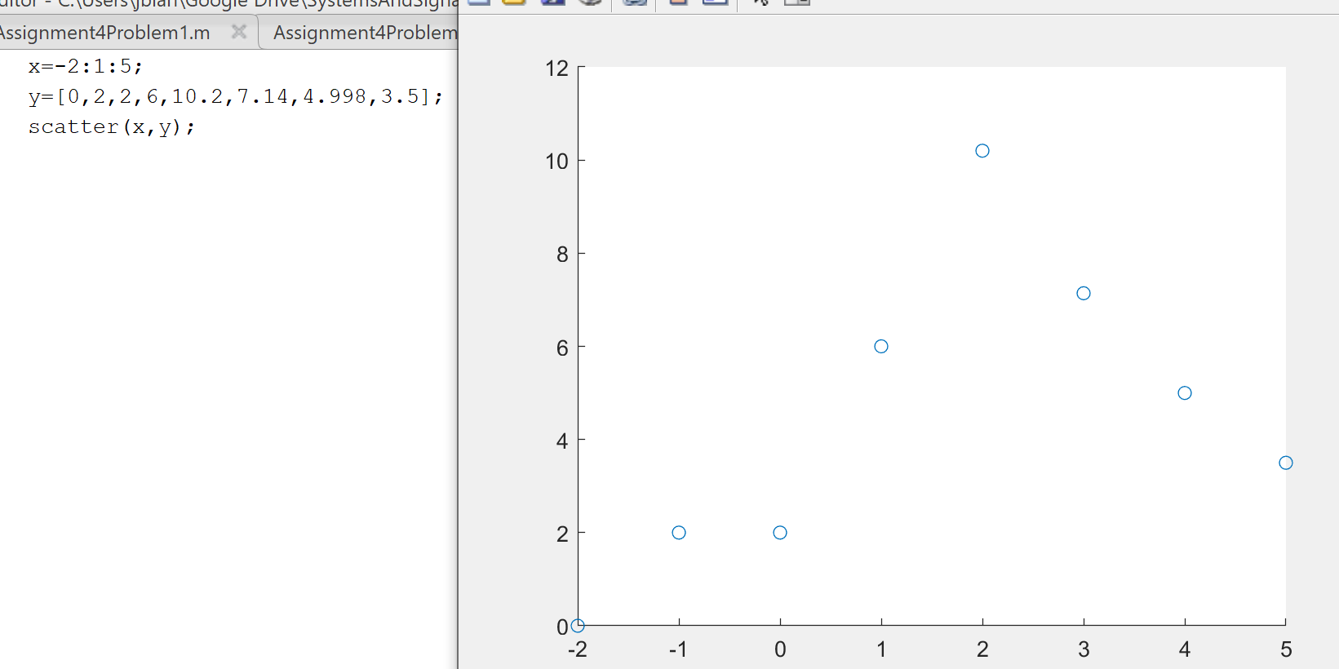

Figure 16. MatLab code and plot for y[n]

Problem 6.

Suppose that the discrete-time LTI system of Figure P10.6 has the impulse response h[n] given in Figure P10.10a. The system input is given in P10.10b. Find the output y[n].

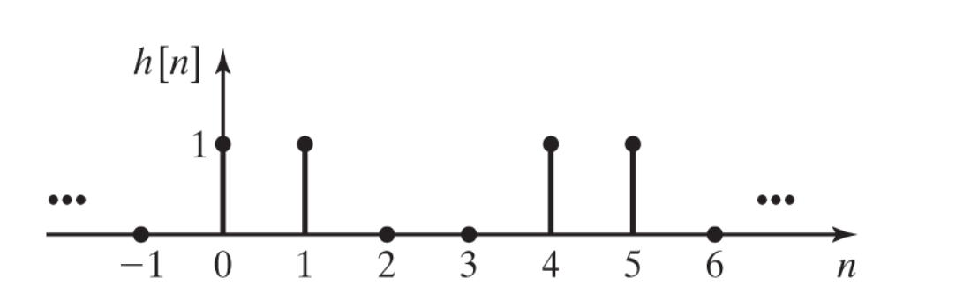

Figure P10.10a

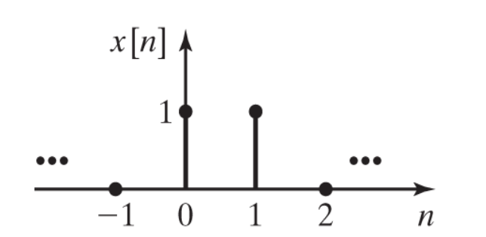

Figure P10.10b

Convolving the two discrete signals yields

0 at $n-k<0$

1 at $n-k=0$

2 at $n-k=1$

1 at $n-k=2$

0 at $n-k=3$

1 at $n-k=4$

2 at $n-k=5$

1 at $n-k=6$

0 everywhere else

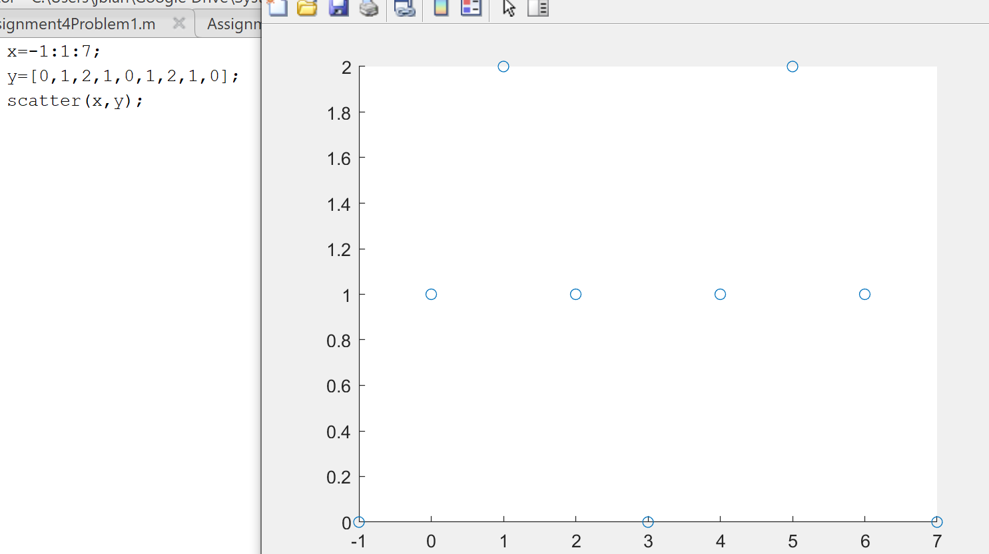

MatLab code and plot for y[n]

References

Phillips, C. L., Parr, J. M., and Riskin, E. A, Signals, Systems, and Transforms (4th ed), ISBN: 978-0-13-198923-8, Pearson, 2008.